Hayden Feddock

ECE 1395 – Dr. Dallal

HW 4

2/13/2023

**Question 1: Regularization**

**Part b**

* Text output: The size of feature matrix X is: (1001, 501)

**Part c**

* Output:

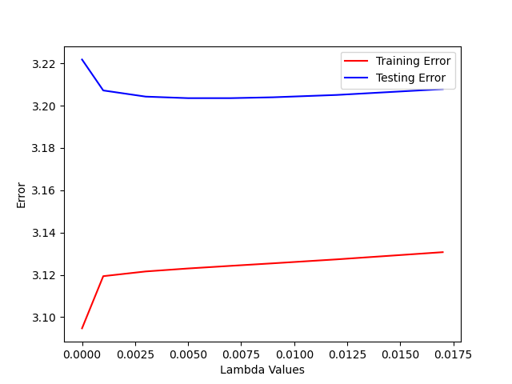

(ps4-1-c.png)

* Text response: I'd suggest a value of lambda between 0.005 and 0.0125 since the difference between the testing and training error is lowest and it has the lowest testing error.

**Question 2: KNN – Effect of K**

**Part a**

* Output:

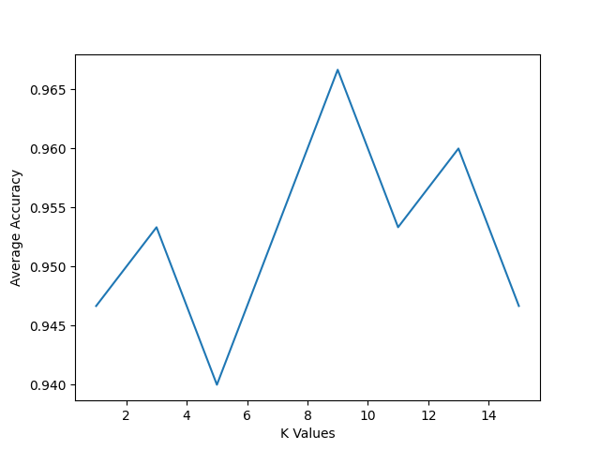

(ps4-2-a.png)

* Text output: I suggest a value of 9 for K according to the graph. This value would need to be redetermined for another problem since the accuracy of that K value is specifically determined for this data.

**Question 3: One-vs-all**

**Part b**

* Output: Training accuracy: 0.936, Testing accuracy: 0.84
* Text output: The accuracy of the predictions of the training data are higher than the accuracy of the predictions of the testing data. Both are pretty high accuracies.