Hayden Feddock

ECE 1395 – Dr. Dallal

Assignment 5

3/4/2023

**Question 1: Weighted KNN**

**Part b**

| Sigma | Accuracy |

|-------|----------|

| 0.01 | 0.68 |

| 0.05 | 0.92 |

| 0.2 | 0.92 |

| 1.5 | 0.8 |

| 3.2 | 0.72 |

The sigma value shows that at there is a range for sigma at which the testing accuracy will be greatest and above or below this range will result in a lower accuracy.

**Question 2.0: Data Preprocessing**



**Question 2.1: PCA Analysis**

**Part a**

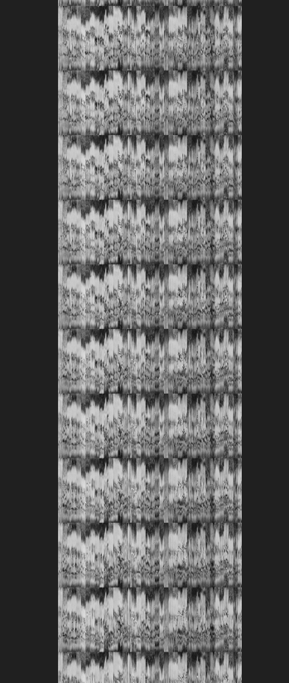 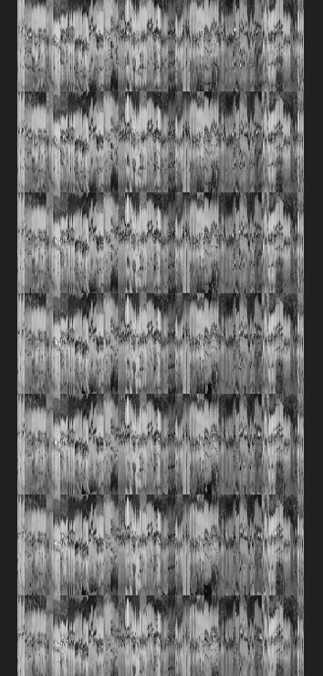 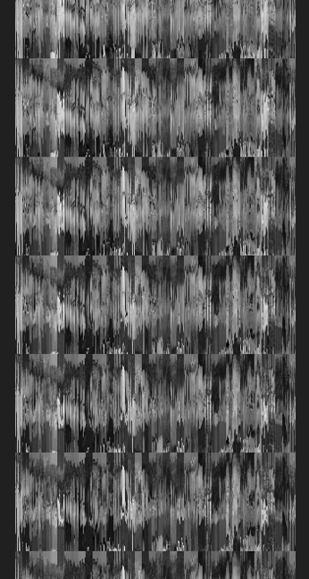

**Part b**



The averaged values that have been re-assembled into a face resemble a blurry and faded generic facial structure

**Part c**

 

**Part d**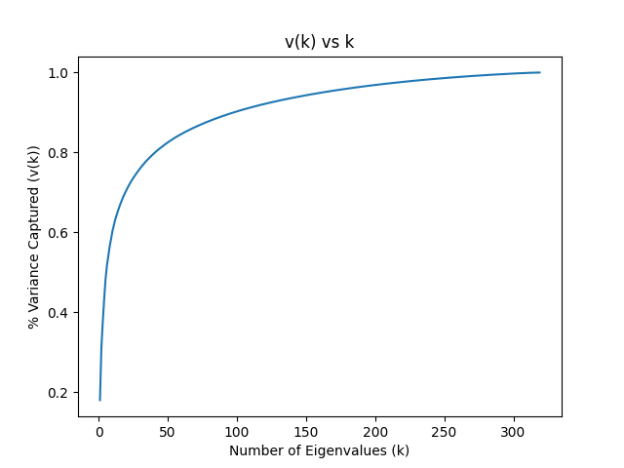

The minimum number of eigenvalues needed to capture 95% variance is: 162

**Part e**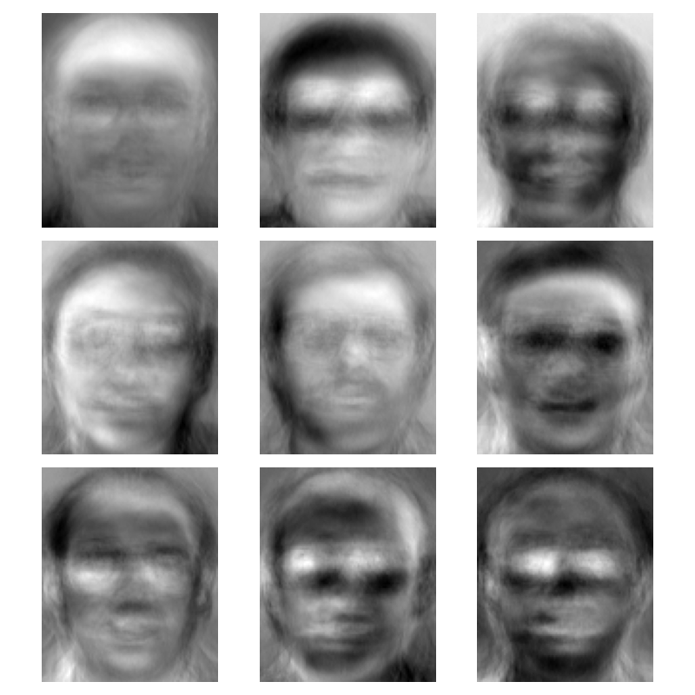

The dimensions of matrix U are: (10304, 162)

The eigenfaces appear as very blurry non-distinctive images of people’s faces

**Question 2.2: Feature Extraction for Face Recognition**

**Part b**

Dimensions of W_training: (320, 162)

Dimensions of W_testing: (80, 162)

**Question 2.3: Face Recognition**

**Part a**

| K | Accuracy |

|----|----------|

| 1 | 0.9375 |

| 3 | 0.9125 |

| 5 | 0.8 |

| 7 | 0.75 |

| 9 | 0.7125 |

| 11 | 0.6875 |

As the number of K values used in the classifier increases, the accuracy decreases.

**Part b**

| Training Accuracies |

|------------------------------------------|

| | One-vs-One | One-vs-All |

|------------|--------------|--------------|

| Linear |1.0 |1.0 |

| Polynomial |0.88125 |0.88125 |

| Gaussian |0.925 |0.925 |

| Training Times |

|------------------------------------------|

| | One-vs-One | One-vs-All |

|------------|--------------|--------------|

| Linear |0.015956163406|0.015928268433|

| Polynomial |0.018978118896|0.018918752670|

| Gaussian |0.023934364319|0.026927947998|

| Testing Accuracies |

|------------------------------------------|

| | One-vs-One | One-vs-All |

|------------|--------------|--------------|

| Linear |0.9625 |0.9625 |

| Polynomial |0.8125 |0.8125 |

| Gaussian |0.85 |0.85 |

On average the linear kernels take the shortest amount of time to train and the Gaussian kernels take the longest. The accuracy between using one vs one and one vs all is identical and the training time is also nearly identical. The testing accuracy was below the training accuracy on average, but interestingly the accuracy using the Gaussian kernel showed no difference.

The best fit for this dataset is definitely the linear algorithm since it takes the shortest amount of time to train and has the highest accuracy. The one vs one and one vs all appear to have nearly identical accuracies but the one vs one seems to take a little longer to train than the one vs all (at least for the linear kernel).

**Question 3: Case Study**

For a model to determine where to place electric car chargers there are a few things we can consider. It would make the most sense to locate these chargers in areas where the population of electric car owners it higher (this may include more urban areas). Similar to how gas stations are usually located in high traffic areas, we may want to also target high traffic areas and potentially the same types of locations that gas stations currently target (maybe could even partner with gas stations to provide electric vehicle power too). Since electric charging takes longer, another option would be to search for places where cars can be parked for long periods of time (such as a parking garage). The population density is another factor that we could consider. We would want our chargers to be in areas with lots of people so that they have the highest potential of getting the most use. A final idea that comes to mind is close to businesses or work locations. People could park their cars and charge them over the course of the workday if charging is something that takes a while. There are a lot of factors to consider in this topic, but I’d say that its important to know whether or not the charging will be a rapid process (equivalent to filling up a gas tank) or a longer process. This would narrow locations down to places that cars can come and go quickly and places where cars are able to sit for awhile.