Hayden Feddock

ECE 1395 – Dr. Dallal

Assignment 7

4/7/2023

**Question 0: Read Data**

Part a

* Verify dimensions of feature matrix X and label vector y

Dimensions of X: (150, 4)

Dimensions of y: (150, 1)

**Question 1: Forward Propagation**

Part a

* Function predict.py

Part b

* Accuracy of prediction on entire dataset

Accuracy: 0.98

**Question 2: Cost Function**

Part a

* Function nnCost.py

Part b

* Value of J when lambda = 0, 1, and 2

The cost when lambda = 0 is: 0.20252633908551312

The cost when lambda = 1 is: 1.0326189817073517

The cost when lambda = 2 is: 1.8627116243291904

**Question 3: Derivative of the Activation Function (Sigmoid Gradient)**

Part a

* Function sigmoidGradient.py
* Sigmoid Gradient when z = [-10, 0, 10]’

The sigmoid gradient of z = [-10, 0, 10] is: [4.53958077e-05 2.50000000e-01 4.53958077e-05]

**Question 4: Backpropagation for Gradient of Cost Function and Stochastic Gradient Descent**

Part d

* Report the alpha used

The value used for alpha: 0.005

Part e

* Figure showing the training cost versus the iteration

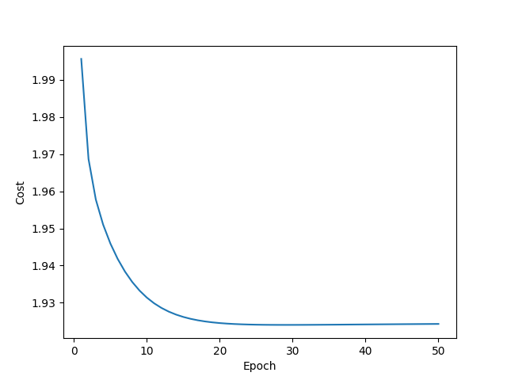

**Question 5: Testing the Network**

Part a

* Complete table 1

+---------------+--------------------------------------+-------------------------------------+---------------------------------------+--------------------------------------+

| lambda | Training Data Accuracy @ 50 Epochs | Testing Data Accuracy @ 50 Epochs | Training Data Accuracy @ 100 Epochs | Testing Data Accuracy @ 100 Epochs |

+===============+======================================+=====================================+=======================================+======================================+

| lambda = 0 | 0.984252 | 0.956522 | 0.952756 | 0.956522 |

+---------------+--------------------------------------+-------------------------------------+---------------------------------------+--------------------------------------+

| lambda = 0.01 | 0.984252 | 0.956522 | 0.96063 | 0.956522 |

+---------------+--------------------------------------+-------------------------------------+---------------------------------------+--------------------------------------+

| lambda = 0.1 | 0.692913 | 0.521739 | 0.826772 | 0.695652 |

+---------------+--------------------------------------+-------------------------------------+---------------------------------------+--------------------------------------+

| lambda = 1 | 0.354331 | 0.217391 | 0.354331 | 0.217391 |

+---------------+--------------------------------------+-------------------------------------+---------------------------------------+--------------------------------------+

* Compute the cost for each case in the table

+---------------+----------------------------------+---------------------------------+-----------------------------------+----------------------------------+

| lambda | Training Data Cost @ 50 Epochs | Testing Data Cost @ 50 Epochs | Training Data Cost @ 100 Epochs | Testing Data Cost @ 100 Epochs |

+===============+==================================+=================================+===================================+==================================+

| lambda = 0 | 0.990026 | 1.0253 | 0.72837 | 0.795481 |

+---------------+----------------------------------+---------------------------------+-----------------------------------+----------------------------------+

| lambda = 0.01 | 1.01836 | 1.05664 | 0.904252 | 0.951721 |

+---------------+----------------------------------+---------------------------------+-----------------------------------+----------------------------------+

| lambda = 0.1 | 1.47089 | 1.49899 | 1.39411 | 1.42158 |

+---------------+----------------------------------+---------------------------------+-----------------------------------+----------------------------------+

| lambda = 1 | 1.90705 | 1.94862 | 1.90705 | 1.949 |

+---------------+----------------------------------+---------------------------------+-----------------------------------+----------------------------------+

* Discuss the results

In our tables, we received a higher accuracy with a lower value of lambda. This indicates that the model is performing well on the data with a lower effect of the regularization parameter. As the lambda value is increased, we can see the accuracy decrease which indicates that the model is no longer fitting the data well. The regularization parameter may be causing the data to be underfit in these cases (assumption made since the training data accuracy does not seem to be overfit). The table of cost values shows that as the accuracy is lower the cost is greater. This all shows that choosing the correct value for lambda has a big impact on the effectiveness of the model.