
Department of Computer Science

Software Requirements Specification

Project Title

Supervisor
Supervisor Name Mr S Zwane

Submitted by Group 12
Student Name | Student Number
- MM Mkhize | 202289706
- AA Xulu | 202294363
- MB Mathaba | 202294026
- M Sithole | 202261833
- M Mazibuko | 202289082
- NN Ngubane | 202294799

Date

Table of Contents
1.PROJECT SUMMARY 5
1.1 Purpose, scope and objectives 5
1.1.4 Goal 6
1.2Assumptions and Constraints 6
Project deliverables 7
1.3.1 Project documentation 7
1.3.2 Web Application 7
1.4 Internal Structure and External interface 7
1.4.1 Database design 7
1.4.2 External Interface 7
1.5 Roles and responsibilities 8
1.6 Managerial Processes Plan 9
1.6.1 Communication 9
1.6.2 Risk Management 9
1.6.3 Quality Management 9
1.6.4 Resource Management 9
1.6.5 Change Management 9
1.7 Control Plan 10
1.7.1 Control Objectives 10
1.7.2 Control Scope 10
1.7.3 Control Mechanisms 10
1.7.4 Monitoring and Reporting 10
1.7.5 Continuous Improvement 10
1.7.5 Schedule 10
1.8 Risk Management Plan 11
1.8.1. Risk Identification 11
1.8.2 Risk Assessment 11
1.8.3 Risk Prioritization 11
1.8.4 Risk Mitigation 11
1.8.5 Risk Monitoring 12
1.9 Project Closeout Plan 12
1.9.1 Finalize Web Application Development 12
1.9.2 Final Testing and Quality Assurance 12
1.9.3 Deploy Web Application 12
1.9.4 Documentation 12
1.9.5 Evaluate Project Success 12
1.10Technical Process Plan 13
1.10.1 Process Model 13
1.10.2 Methods, Tools, and Techniques 13
1.10.3 Infrastructure Plan 13
1.10.4 Project Acceptance Plan 14
1.11 Internal Structure**** 15
1.11.1 Database Design 15
1.12 Appendices 16

Table of Figures
Figure 1 Login page 18
Figure 2 Discussion forum 19
Figure 3 Study materials page 19
Figure 4 Homepage 20
Figure 5-Question 1 21
Figure 6-Question 2 22
Figure 7-Question 3 22
Figure 8-Question 4 23
Figure 9-Question 5 24
Figure 10-Question 6 25
Figure 11-Question 7 26
Figure 12-Question 8 27
Figure 13-Question 9 28
Figure 14-Question 10 29

1.PROJECT SUMMARY

1.1 Purpose, scope and objectives
1.1.1 Purpose
This Software Project Management Plan (SPMP) outlines the strategy, process, and structure for developing a peer-to-peer academic support platform tailored for university students. It defines the project scope, objectives, deliverables, timeline, resources, risks, and quality control measures to ensure the project is delivered successfully on time, and within budget.

Project Overview
Students often struggle to find reliable academic help outside formal teaching environments. Existing platforms like Facebook or WhatsApp are informal, unstructured, and often ineffective for academic collaboration. University LMS platforms like Moodle provide formal course materials but lack peer-to-peer engagement capabilities. This project aims to bridge this gap by creating a dedicated, user-friendly platform where students can request help, share study materials, and communicate privately with knowledgeable peers.
The platform will serve as an informal, free, and accessible academic support tool, fostering collaboration, knowledge sharing, and academic success within the student community.

1.1.2 Objectives
- To conduct a survey
- To design and develop a user-friendly platform
- To create a fictional student database
- Implement peer-to-peer connection system
- To develop a prototype
- To evaluate and test the platform’s functionality

1.1.3 Scope
- The web application will be used by students.
- The platform will allow students to advertise their academic skills and ask questions about specific modules.
- Students will create their profiles using their student numbers and passwords.
- The platform will allow students to engage privately.
- Students will be able to upload and download study materials.
- The project will not include any institution admin involvement or confidential institution database information.
- The platform will not include a payment system for buying or selling study materials.
It will the restricted to not allow an information that is not relevant to the purpose of the project

1.1.4 Goal
The goal of this project is to develop a platform that improve the process of seeking academic help and support, empowering students to succeed through peer-to-peer connection and resources sharing.

1.2Assumptions and Constraints
1.2.1Assumptions

- Only registered Students will create account to log in and access system.
- Students will actively use the platform to post question, share resources in responsive manner and necessary permissions.
- No one will need to be paid for helping or sharing resources.
- Technical issues will be minimal, and the platform will be stable and functional.
- The devices that will be needed to access the platform are computers and smartphones.
- After downloading learning resources (books and past exam papers) on a platform they will be saved in the device
- The platform will be free to use.
- The project will be done on schedule.

1.2.2Constraints

- The platform will be developed within 6 weeks.
- Students must be able to download and upload the documents, post questions and ask for help, and message each other privately.
- The platform must be able to handle any amount of data that is being downloaded and uploaded.
- Different user roles (admin and students) will have different levels of access and rights.
- Students will receive notification for new message posts and update relevant to them (they subscribe to).

Project deliverables

1.3.1 Project documentation
Software Project Management Plan
Software Requirements Specifications
Software Design Document
Software Testing Plan

1.3.2 Web Application
Functional front-end and back-end implementation
Secure login system
Discussion forums
Study materials sharing modules
Messaging system

1.4 Internal Structure and External interface

1.4.1 Database design
The platform’s database will be designed to store, manage, and retrieve user and resource information efficiently and securely. It will consist of multiple interrelated tables, with proper indexing and relationships to optimize performance.
>User profiles (student numbers, names, modules, passwords, email, level of study, faculty, department)
>Upload resources (module, title, description)

1.4.2 External Interface
The external interface defines how end-users will interact with the system through a web-based application. It prioritizes simplicity, accessibility, and security.
- Web Browser Interface for Student Interaction
  - Accessible on all major browsers (Chrome, Edge) without additional installations.
  - Fully responsive design for desktop, tablet, and mobile viewing.
  - Intuitive navigation with dedicated sections for:
    - Home / Dashboard
    - Help Requests
    - Uploaded Resources
    - Messaging
    - Profile Management
- Secure File Upload and Download Modules
  - File uploads will be encrypted during transfer (using HTTPS).
  - Server-side validation to restrict file types (e.g., PDF, DOCX, PPTX).
  - File storage paths will be inaccessible directly from the browser, ensuring security.
  - Download links will expire after a set time to prevent unauthorized sharing.
- Real-Time Messaging System
  - Peer-to-peer private chat for academic discussions.
  - ******Instant delivery and read receipts using WebSocket or similar technology.
  - Ability to share links or short text-based resources.
  - End-to-end encryption for privacy.
  - Notification system for new messages.

1.5 Methodology
The project will follow an iterative development approach, breaking down the platform into manageable features for phased implementation and continuous improvement.
1.5.1 Data Collection
A structured questionnaire will be distributed to a representative sample of students to understand their academic challenges, help-seeking behaviours, and feature expectations.
1.5.2 Design
- User-centred design principles will guide wireframing and prototyping, focusing on simplicity, clarity, and responsiveness.
- Tools such as Pencil will be used to create design mock-ups.
- Usability testing sessions will be conducted to refine interface design.
1.5.3 Development
- Front-end development will utilize JavaScript with React, HTML, and CSS to build a responsive user interface.
- Back-end development will be handled using Node.js and Express.js, ensuring robust API services and database connectivity.
- MySQL will serve as the relational database system.
- A fictional student database will simulate real-world data to test functionality and security.
1.5.3 Testing
- Functional testing will verify feature performance, data handling, and security.
- Usability testing with student volunteers will help identify interface issues and gather feedback for improvements.
- Artificial intelligence tools will be implemented to detect and manage inappropriate content such as hate speech.

1.6 Roles and responsibilities

Team Member | Role | Expertise
MM Mkhize | Team Leader & Programmer | Full-stack development
AA Xulu | Project Manager & Documentation Specialist | Project coordination and reporting
MB Mathaba | Database Specialist | Database design and management
M Sithole | Developer | Front-end and back-end coding
M Mazibuko | Researcher | Data gathering and analysis
NN Ngubane | Documentation Specialist | Documentation and quality assurance

1.7 Managerial Processes Plan

1.7.1 Communication
Effective communication will be maintained primarily through scheduled weekly team meetings in the D3/D4 computer lab to review progress, assign tasks, and resolve any emerging issues. Supplementary communication via WhatsApp will support rapid coordination and informal updates between meetings, ensuring continuous engagement and responsiveness.

Communication Plan
Communication Type | Purpose | Frequency | Participants | Method/Tools | Responsible Party
Weekly Team Meetings | Review progress, assign tasks | Weekly (Lab D3/D4) | All team members | In-person | Project Manager
Daily Informal Updates | Quick coordination, urgent issues | Daily as needed | All team members | WhatsApp group chat | All members
Progress Reports | Document accomplishments, issues | Weekly | Project team, Supervisor | WhatsApp group chat, Document share, in-person | Documentation Specialist
Milestone Review Meetings | Evaluate milestone completion | After major milestones | Project team, Supervisor | In-person | Project Manager
Usability Testing Sessions | Collect user feedback | Bi-weekly (as scheduled) | Select student testers | In-person / Online | Researcher
Change Request Meetings | Review and approve scope changes | As needed | Project Manager, Team Leads | In-person | Project Manager

1.7.2 Risk Management
The team will continuously identify risks and address them immediately to minimize impact. Risks will be logged and tracked in a dedicated risk register document. This proactive management approach aims to prevent delays or quality issues arising from foreseeable challenges.

1.7.3 Quality Management
Regular code reviews and usability tests involving student participants will form the core of the quality assurance process. The team will collect actionable feedback to improve system features, interface design, and performance, ensuring the platform meets user needs effectively.

1.7.4 Resource Management
The project manager will oversee resource allocation, ensuring appropriate distribution of personnel effort, software tools, hardware, and server capacity. Adequate planning will ensure that all resources are available when required to maintain steady project progress.

1.7.5 Change Management
Any proposed changes to the project’s scope, timeline, or functionalities must be submitted as formal change requests. Each request will be assessed for impact on deadlines, costs, and technical feasibility prior to approval, preventing uncontrolled project drift.

1.8 Control Plan

1.8.1 Control Objectives
To ensure that all project activities remain aligned with the approved scope, timeline, and quality expectations, thereby delivering the intended results.

1.8.2 Control Scope
Focus on monitoring key project phases, including design, coding, testing, and documentation, to maintain quality and completeness of deliverables.

1.8.3 Control Mechanisms
Weekly team reviews will be conducted to monitor progress and discuss any obstacles. These meetings will enable timely corrective actions.

1.8.4 Monitoring and Reporting
Weekly progress reports will summarize completed tasks, status, and upcoming activities. After each milestone, a detailed review will be conducted and reported to the project supervisor to facilitate oversight and guidance.

1.8.5 Continuous Improvement
Feedback from testing sessions, user input, and team retrospectives will be used to improve both the product and development processes throughout the project lifecycle.

1.8.6 Schedule

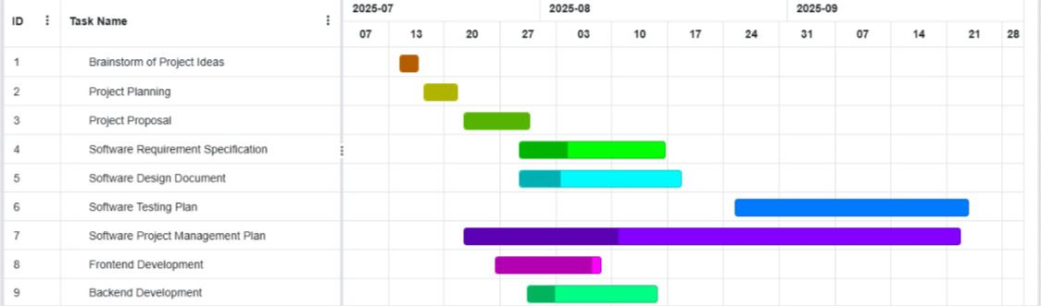
Work plan

Phase | Duration | Dates (Est.) | Milestones
Requirements Gathering | 1 week | [21 July-27 July] | Survey completed
Design & Prototyping | 1 week | [28 July-03 August] | Wireframes & prototype done
Development | 3 weeks | [11August-31 August] | Feature completion
Testing & Evaluation | 1 week |  | Usability tests completed
Deployment | 1 day |  | Platforms live

Week | Activity | Deliverables
14 - 16 July | Project initiation and scope definition | Project charter and scope document
17 - 21 July | Project planning | Detailed project plan and timeline
22 July - 30 July | Front-end design and development | Wireframes, initial front-end prototype
27 July - 12 Sept | Back-end development and integration | API services, database setup
29 July - 18 Aug | Requirement and design documentation | Software Requirements Spec, Design Docs
25 Aug - 23 Sept | Testing planning and execution | Test plans, usability reports
1 - 5 Sept | Mid-project presentation and feedback | Presentation materials

1.9 Risk Management Plan
Risks
- Failing to pre-plan the entire project adequately the whole project may end up missing deadlines and fail to execute as expected.
- Failing to correctly identify risking factors will expose the system to threats.
- Team skills are still at a developing/growing level, the team might lack some of necessary project development skills to make this project perfect.
- Failing to define objectives and scope, that can lead to confusion, misunderstanding, frequent changes, and difficulties when measuring project progress.
- Spending too much time on one task can lead to delays and inefficiencies.

1.9.1. Risk Identification
We start by carefully thinking through everything that could go wrong or slow us down in the project. For example, since our team is still building skills, there might be technical challenges when developing the platform features like private messaging or resource sharing. We also consider risks like delays due to unclear requirements or team members being unavailable. Another risk is if students don’t actively use the platform after launch, which would affect the platform’s success. Lastly, scope creep adding features outside our plan could stretch our limited 6-week timeline.

1.9.2 Risk Assessment
Next, we look at each risk and ask: How likely is this to happen? And, if it does, how badly could it impact us? For instance, team skill gaps are quite likely, but we can reduce impact with support. Platform bugs might happen but could delay the release if serious. On the other hand, scope creep could seriously delay us if unchecked. By rating these risks as low, medium, or high in both likelihood and impact, we focus on the biggest threats first.

1.9.3 Risk Prioritization
After assessing, we rank the risks, so we know where to focus our energy. High-priority risks for us are the lack of skills in the team, scope creep, and any technical problems that block progress. Lower priority risks include minor communication issues or delays in feedback. This prioritization helps the team spend time on preventing or solving the biggest problems first.

1.9.4 Risk Mitigation
For each high-priority risk, we plan specific actions:
- Skill gaps: We will organize peer learning sessions and use online tutorials to get up to speed quickly. If needed, we’ll ask for help from knowledgeable friends or mentors.
- Scope creep: We will clearly define the platform’s features at the start and resist adding extra features until after the first release. Any new ideas will be noted for future updates.
- Technical issues: Early development of a prototype will help identify bugs early. We will do regular testing throughout development, not just at the end.
- User engagement: We will involve students during design and testing to ensure the platform meets their needs and encourage active use after launch.

1.9.5 Risk Monitoring
Risk management isn’t a one-time thing. We’ll keep an eye on risks throughout the project by checking in during weekly meetings. If new risks pop up, we’ll assess and plan for them immediately. If a risk seems to be growing, like delays creeping in, we’ll reallocate resources or adjust the schedule. This ongoing monitoring helps us stay on track and respond quickly.

1.10 Project Closeout Plan

1.10.1 Finalize Web Application Development
In the last development phase, we will wrap up all remaining coding tasks. This means making sure students can register, post questions, upload or study materials, and message each other privately without errors. We will double-check that all intended features are included and working as expected.

1.10.2 Final Testing and Quality Assurance
Before going live, we’ll test everything thoroughly. This includes checking that all buttons and pages work, the platform looks good on phones and computers, and security features protect student data. We’ll also ask a group of students to try the platform and give feedback on how easy and helpful it is. Any bugs or confusing parts will be fixed quickly.

1.10.3 Deploy Web Application
Once testing is done and the platform is stable, we will deploy it on a live server where all students can access it. We’ll verify that the deployment is successful by logging in, posting questions, and uploading files from different devices. The team will be ready to fix any last-minute issues users might report.

1.10.4 Documentation
We will create clear and simple documentation for users and future developers. This will include a user guide explaining how to create an account, post questions, and use private messaging. Technical documentation will describe how the platform was built and how to maintain it. Having this information organized will make ongoing support and future improvements easier.

1.10.5 Evaluate Project Success
After deployment, we’ll gather feedback from students and project sponsors to see if the platform meets its goals. Did it make finding help easier? Are students using it actively? We’ll also review what went well during the project and what could be improved next time. This reflection helps everyone learn and prepares us for future projects.

1.11 Technical Process Plan

1.11.1 Process Model
For this project, we will use an iterative and incremental development approach. This means we’ll build the platform step-by-step, focusing first on essential features like user registration and posting questions, then gradually adding more complex features such as private messaging and study material sharing. After each iteration, we’ll test what’s built, gather feedback, and improve. This approach helps us stay flexible, catch problems early, and deliver a usable product within our limited 6-week timeline.

1.11.2 Methods, Tools, and Techniques
- Methods: We will follow Agile-inspired practices, including regular team check-ins, continuous integration, and quick feedback loops to keep the project moving smoothly. We’ll also apply user-centred design principles to ensure the platform is easy and enjoyable for students to use.
- Tools:
  - Development: Visual Studio Code as the main code editor.
  - Front-end: React.js for building dynamic user interfaces.
  - Back-end: Node.js with Express.js for handling server logic and APIs.
  - Database: MySQL to store user data, posts, and resources securely.
  - Prototyping: Pencil to create wireframes and mock-ups before development.
  - Communication: WhatsApp for quick team discussions and coordination.
- Techniques: We will use wireframing and prototyping to visualize the platform before coding, unit and integration testing to ensure code quality, and automated tools where possible to maintain consistency.

1.11.3 Infrastructure Plan
To support the development and deployment of the platform, the following infrastructure will be used:
- Development machines: Each team member will use their laptop or desktop computer to write and test code.
- Servers: The platform will be hosted on a reliable web server that supports Node.js and MySQL. This server will handle all student data and platform operations.
- Internet connectivity: Stable internet is essential for development collaboration, accessing libraries and APIs, and deploying the application online.
- Backup and security: Regular backups of the code and database will be made to prevent data loss. Security measures, including user authentication and AI-based hate speech detection, will be implemented to protect users and data.

1.11.4 Project Acceptance Plan
To ensure the project meets expectations and is accepted by stakeholders, we will follow these steps:
- Acceptance Criteria: The platform must allow students to register securely, post academic questions, share study materials, and send private messages without errors. It should be accessible on common devices (phones, laptops) and perform reliably under normal use.
- Testing: We will conduct thorough functional, usability, and security testing. A small group of students will be invited to use the platform and provide feedback.
- Review Meetings: At key milestones (after prototype completion, after final testing), we will present progress to project sponsors or supervisors for review and approval.
- Documentation: Clear user guides and technical documents will be delivered alongside the platform.
- Sign-off: Final acceptance will be granted once all agreed features are implemented, tested, and stakeholder feedback is positive. Any unresolved issues will be logged for future updates.

1.12 Prototype

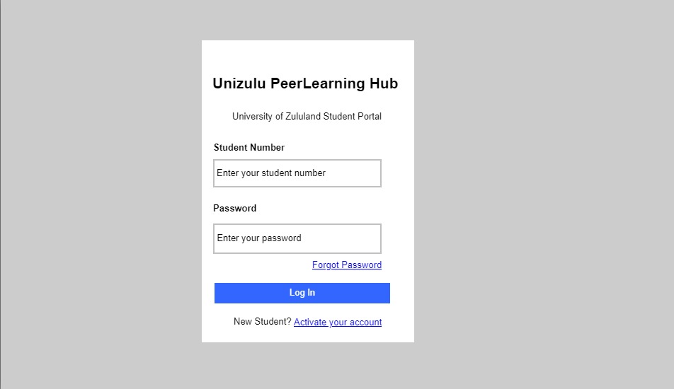
Figure 1 Login page
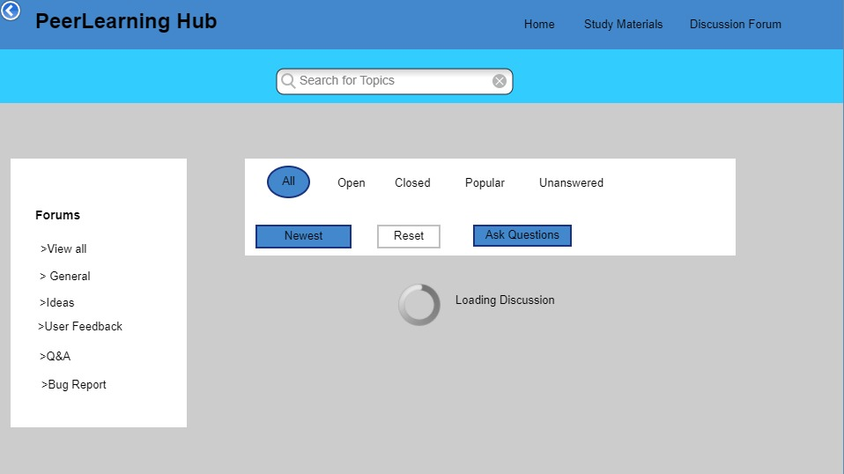
Figure 2 Discussion forum
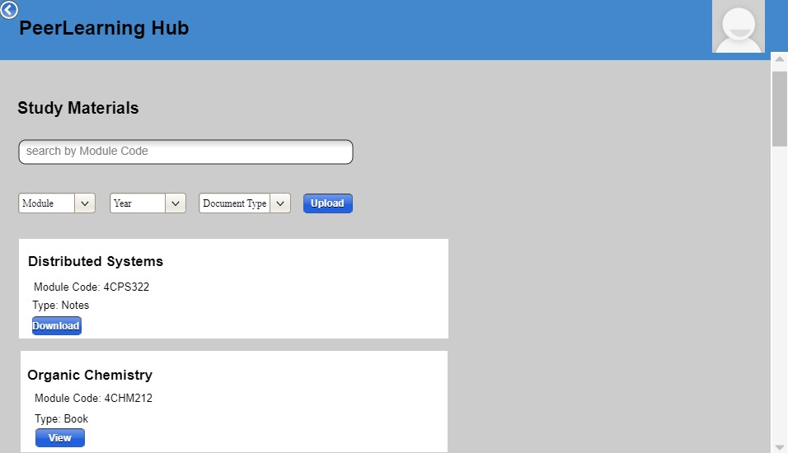
Figure 3 Study materials page
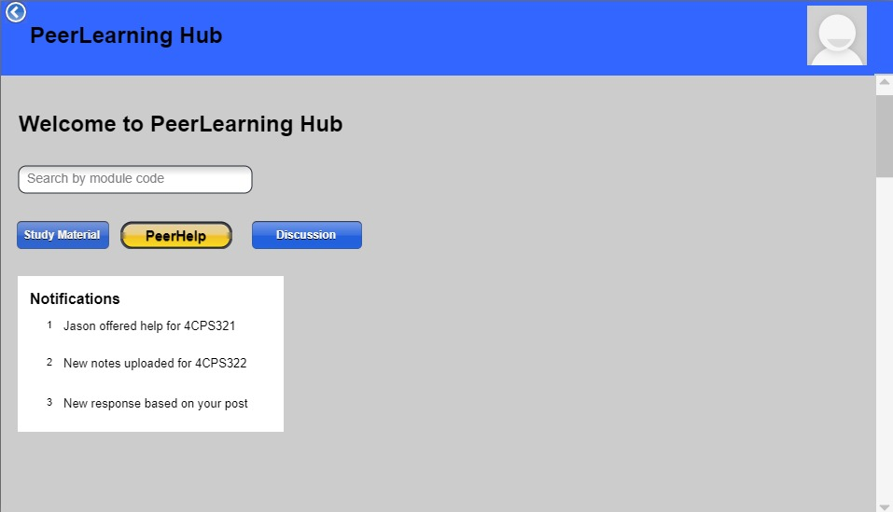
Figure 4 Homepage

1.13 References
Log in page: https://youtu.be/LiomRvK7AM8?si=qT7-hTRROwyaTCAU
Frontend: https://youtu.be/AiFfDjmd0jU?si=TdtzG17ziTTC05d
https://youtu.be/NljIHlZRTTE?si=Z4Jrfi7LTBGMcVc4

1.14 Appendices

We're committed to creating a platform that truly supports students' academic success. To do this, we'll be conducting a survey to gather insights into the challenges students face and what they expect from our platform. By asking the right questions, we'll be able to design a platform that meets students' needs and helps them achieve their goals. We'll use a mix of question types to gather both quantitative and qualitative data and then analyse the results to identify key themes and patterns. This will help us create a platform that's tailored to students' needs and provides the support they need to succeed.
We created the questionnaire using Survey Monkey website 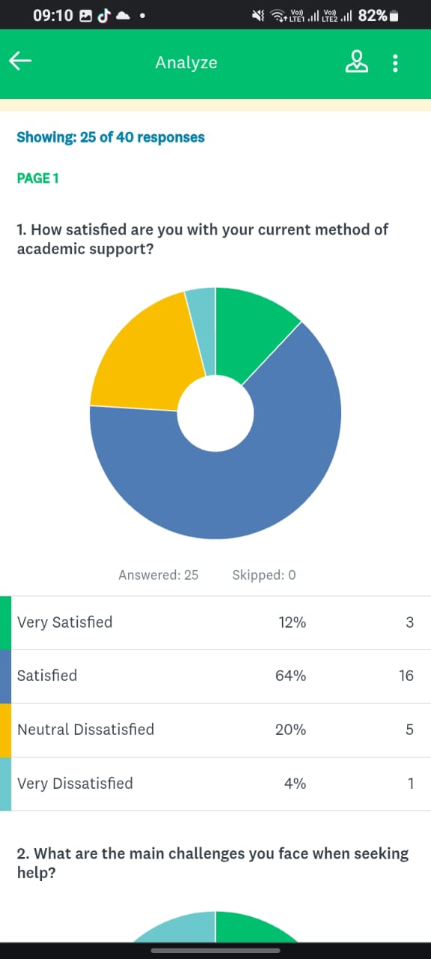
Figure 5-Question 1

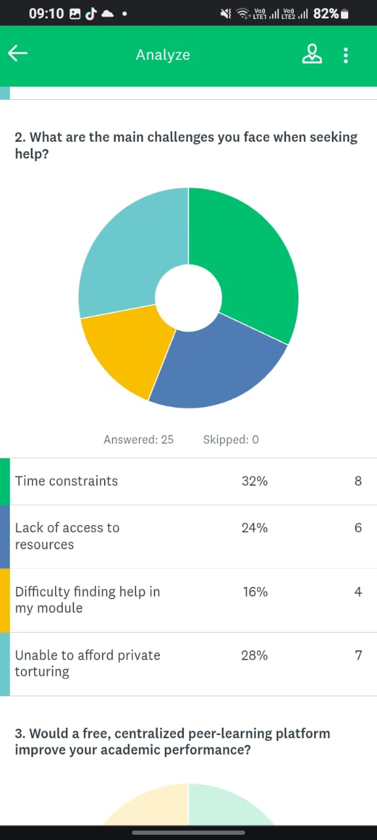
Figure 6-Question 2
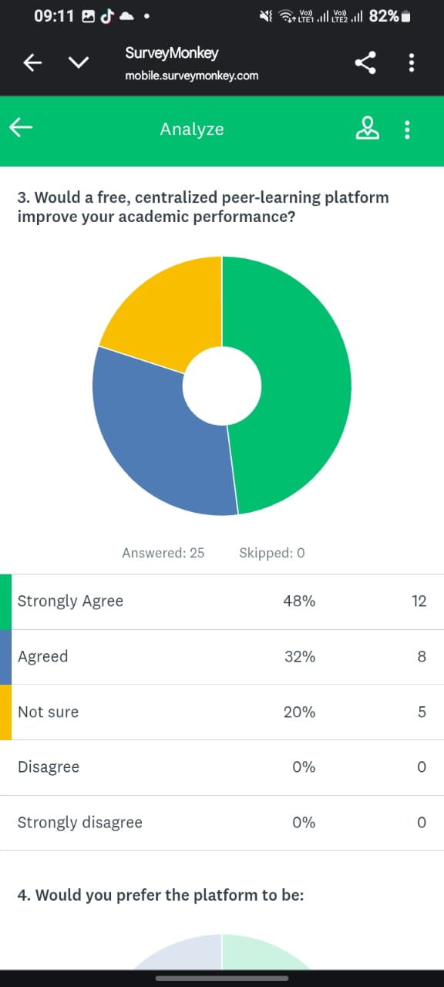
Figure 7-Question 3
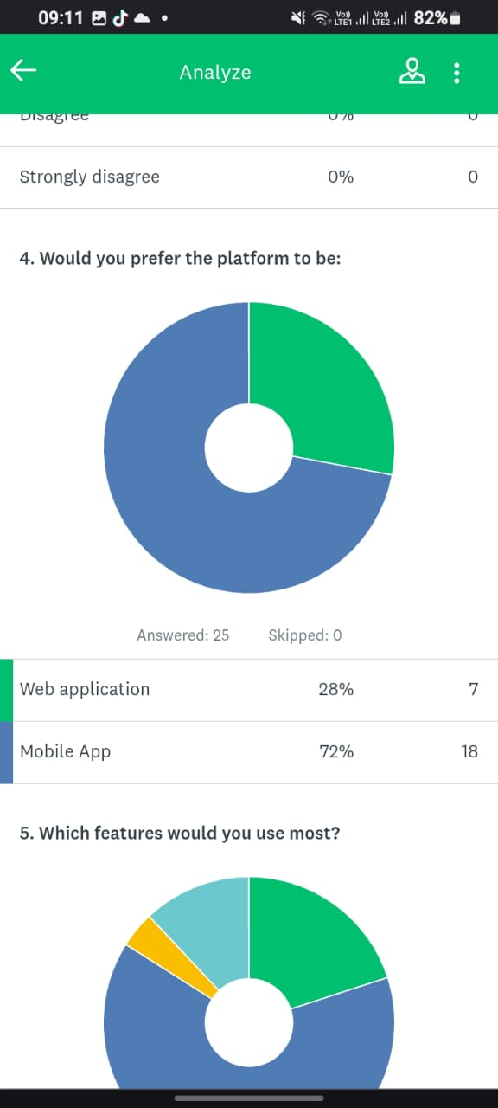
Figure 8-Question 4
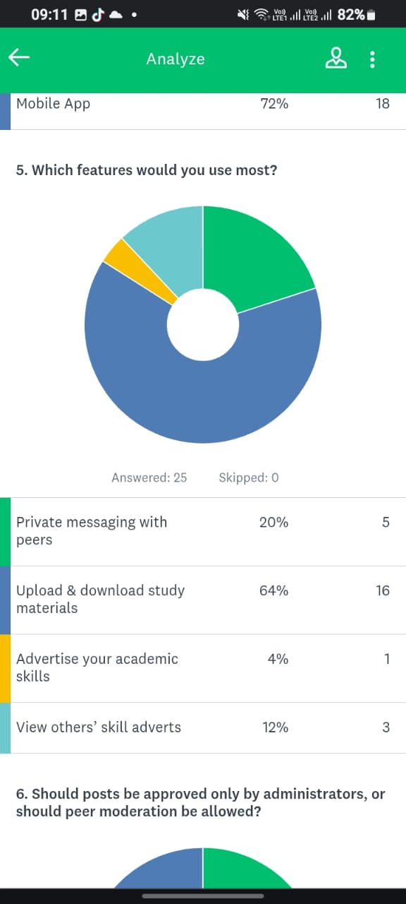
Figure 9-Question 5

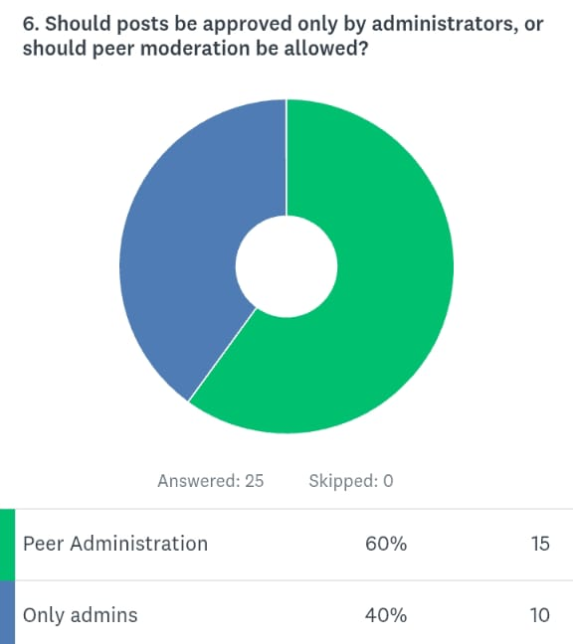
Figure 10-Question 6

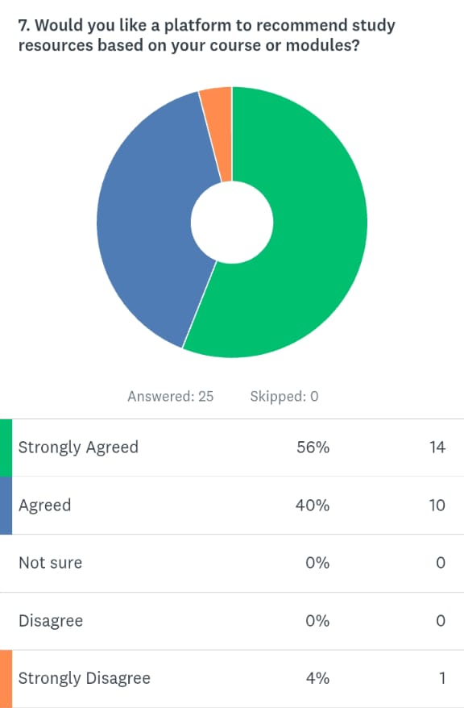
Figure 11-Question 7

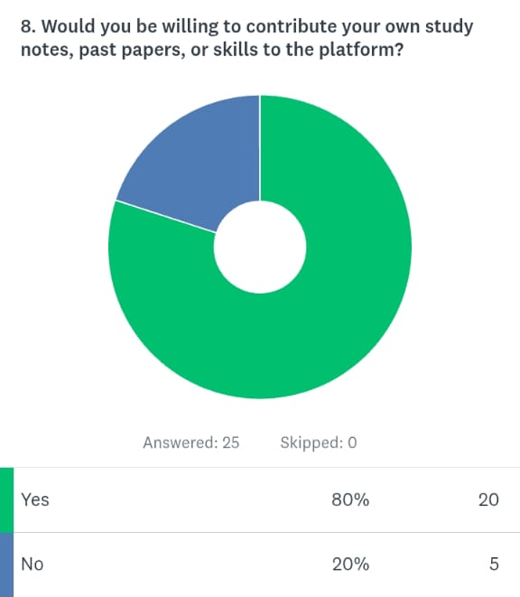
Figure 12-Question 8

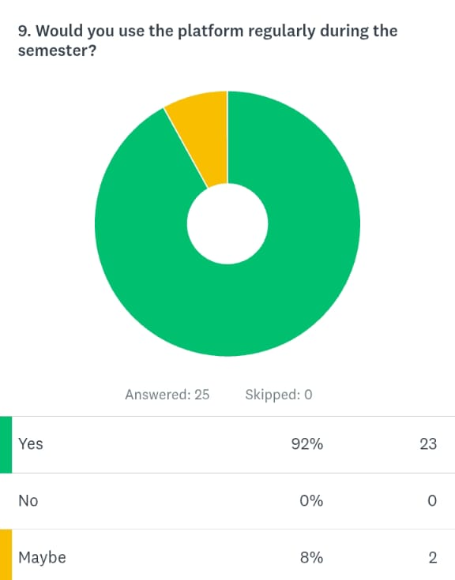
Figure 13-Question 9

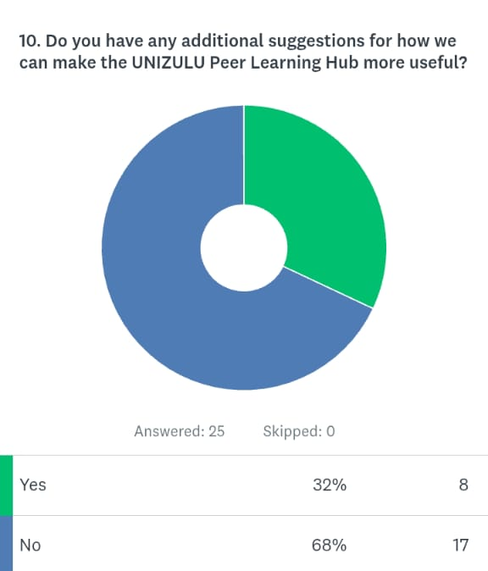
Figure 14-Question 10

