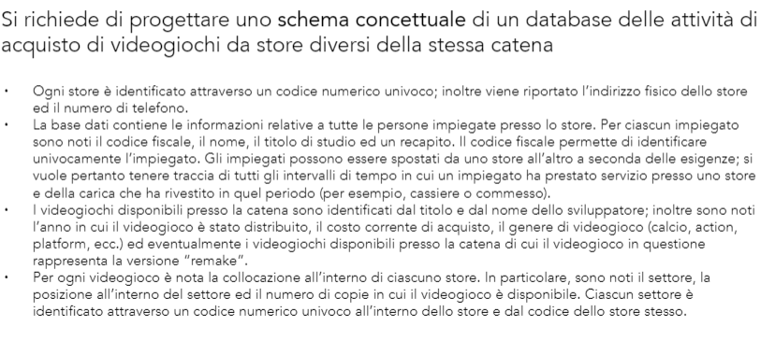

CONTACTS: **IdContacts**, Telephone1, Telephone2, Mail, Fax

ADDRESS: **IdAddres**, Street, City, PostalCode

STORE: **IDStore**, StoreName, *IDAddress*, *IDContacts*, OpeningDate, ClosingDate, Open/Close (BOOL)

EMPLOYEE: **IDEmployee**, FiscalCode, *IDRollList*, FirstName, LastName, BirthDate, Gender, *IDAddress*, *IDContacts*, Degree

RollLIST: **IDRollList**, IDEmployee

EMPLOYEEAWAY: **IDAway***, IDEmployee, IDStore, IDRole*, StartDate, FinishDate, Current(BOOL)

WORKCONTRACT: **IDWorkContract**, *IDEmployee*, EmployeeData(Start), FinishDate, Level, Salary,

ROLE: **IDRole**, Task, Description

SALESQUALITY: ***IDRollList, IDStore***, *IDDate,* TotalNetSales, TotalGrossSales, Profit, Average Receipt, PiecesReceipt,

CUSTOMER: **IDCustomer**, *IDFidelity*, FirstName, LastName, Gender, IDAddress, IDContacts, BirthDate

PRODUCT: **IDProduct**, Title, DeveloperName, ReleaseYear, SellingPrice, ListPrice, TypeGame, Remake (BOOL)

PRODUCTPOSITION: ***IDProduct, IDLocator***

LOCATOR: **IDLocator**, *IDStore*, Sector, Position

INVENTORY: **IDProduct, IDLocator**, Quantity, MinStock, SaeftyStock, QtyReorder, LastReorder, OutOfProduction

FIDELITYCARD**: IDFidelity**, *IDCustomer,* SubscriveDate, Expire, Level

SALESORDERHEADER: I**DOrderHeader**, *IDStore*, *IDRollList*, *IDCustomer*, OrderDate, PayamentMethod, SalesAmount, BaseAmount

SALESORDERSDETAILS: **IDSalesOrderDetails**, ***IDOrderHeader***, *IDProduct,* LineItemNO, Description, Quantity, UnitCost, Discount

CALENDAR: **IDDate**, Year, Month, MonthNO, Day