

MSc in Computer Engineering

Performance Evaluation of Computer Networks and Systems

Aeronautical Communications (2)

Project Documentation

Riccardo Fiorini

Federica Perrone

A.Y. 2023-2024

**Summary**

1. Introduction 2

1.1. Problem description 2

1.2. Objectives 2

1.3. Performance indexes 2

2. Modeling 3

2.1. General assumptions 3

2.2. Model description 4

2.3. Factors 4

2.4. Parameters 4

3. Implementation 5

3.1. Modules 5

4. Calibration 7

4.1. Calibration of warm-up time 7

4.2. Calibration of simulation time 8

4.3. Factors calibration 9

5. Simulation experiments 12

5.1. k uniform 12

5.2. k exponential 14

6. Conclusion 16

7. Appendix A: Verification 17

7.1. Degeneracy test 18

7.2. Consistency test 18

7.3. Continuity test 20

7.4. Monotonicity test 21

7.5. Verification against theoretical model 23

7.5.1. Maximum distance considerations 23

7.5.2. Single-BS distance distribution computation 24

7.5.3. M/G/1 26

8. Appendix B: Failed attempt of 2kr Factorial Analysis 28

# Introduction

## Problem description

Consider a communication system between aircrafts (A/Cs) and a control tower (CT). A/Cs generate one packet of fixed size every *k seconds*, where the latter is a random variable to be described later. The connection between A/Cs and the CT is provided by ground base stations (BS), which are placed on the ground according to a grid deployment, at a distance M between neighbors. Each A/C can select only one serving BS at a time. The service time s of each transmission is a function of the distance d between A/C and BS and is defined as 𝑠 = 𝑇 ∗ 𝑑 2, where T is a constant value. Each A/C can transmit only one packet at a time. A/Cs move randomly at a constant speed and can execute periodically a handover operation, i.e. change their serving BS, every *t seconds*.

The handover operation works as follows:

* The A/C enqueues a handover packet for transmission toward the CT;
* As soon as the handover packet is received, the A/C is associated to the closest BS.

Model the system described above and study the end-to-end delay and the queue length for various values of *k* and *t*.

More in detail, at least the following scenarios must be evaluated:

* Uniform inter-arrival times.
* Exponential inter-arrival times.

In all cases, it is up to the team to calibrate the scenarios so that meaningful results are obtained.

## Objectives

The objectives of the project are:

* Study the end-to-end delay for various values of k and t.
* Study the queue length for various values of k and t.

## Performance indexes

To evaluate the performance of the system, we observe:

* **Mean Response Time E[R]**: the mean time between the arrival of a packet and its departure, both in a single service center (A/Cs) and in the whole System. In the latter case, it coincides with the End-to-End delay and represent the time between the creation of a packet and its arrival at the CT. We will see that the mean response time of the A/Cs and the end-to-end delay are the same, since the BSs and the CT have no service time.
* **Mean Number of Packets in Queue E[Nq]**: the mean number of packets in the queue of the A/Cs.

# Modeling

## General assumptions

These are the general assumptions that have been made:

* The BSs are arranged in grid with equal number of rows and columns. This is implemented with the StaticGridMobility module inside each BS**Errore. L'origine riferimento non è stata trovata.**.
* The A/Cs move randomly at a constant speed, and this is implemented with the LinearMobility module inside each A/Cs. It is assumed that the A/Cs cannot exit the BS grid.
* In the handover operation, the distances between the A/C and the BSs are calculated from the coordinates of A/C and BSs.
* Communication channel between an A/C and the associated BS, and between the BS and the CT can be considered ideal, i.e. no delay and no BER. Therefore, there is no packet loss and no packet corruption.
* The communication between A/Cs and CT is a one-way communication.
* The handover operation is executed locally on the A/C.
* The packets’ queues of A/Cs have unlimited size.

Figure 1: Grid deployment schema

* 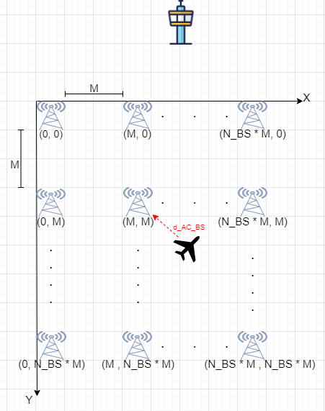The communication between the BSs and the CT is assumed to be instantaneous

## Model description

* 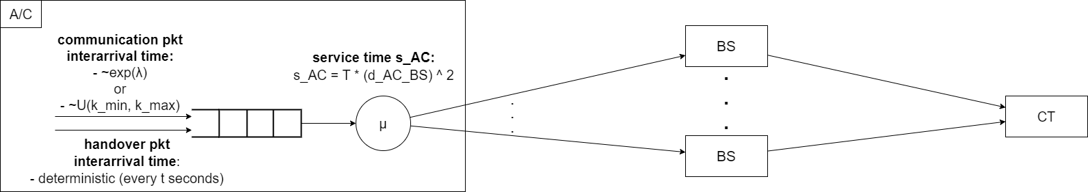d_AC_BS: this is a random variable, since it depends on the distance between the A/C and its serving BS (the A/C movement is random).

Figure 2: Aeronautical Communications - Network design

## Factors

The following factors may affect the performance of the system:

* **k_mean**, mean of the inter-arrival time distribution of communication packets (in the case where the inter-arrival time is exponentially distributed).
* **k_max**, upper extreme of the inter-arrival time distribution of communication packets (in the case where the inter-arrival time is uniformly distributed).
* **t**, seconds that elapse between one handover packet and the next.

## Parameters

Parameters of simulator have been chosen in order to comply with reality as much as possible.

* **N_A/C**, number of A/Cs in the system. Since we are interested in the study of the A/Cs internal performances, we decided to set the number of A/Cs equal to 1. In fact, increasing the number of the A/Cs, we will observe the same system behavior. This is because the other two modules have no queuing, therefore they do not make changes to the computation of the mean end-to-end delay.
* **N_BS**, number of BSs in the system. Since one of the general assumptions is that the A/C can never exit the BS grid, also the number of BSs is a parameter that does not affect the A/C performance. We deiced to set N_BS to 16.
* **M**, it represents the distance between two consecutive BS on the same row, or column, and it is fixed at 25 km.
* **T,** it is a constant used to keep the service time in a reasonable range, and has been chosen to be 10-9.
* **v,** it represents the speed of an AC, and is fixed at 275 m/s (average speed of a real A/C).

# Implementation

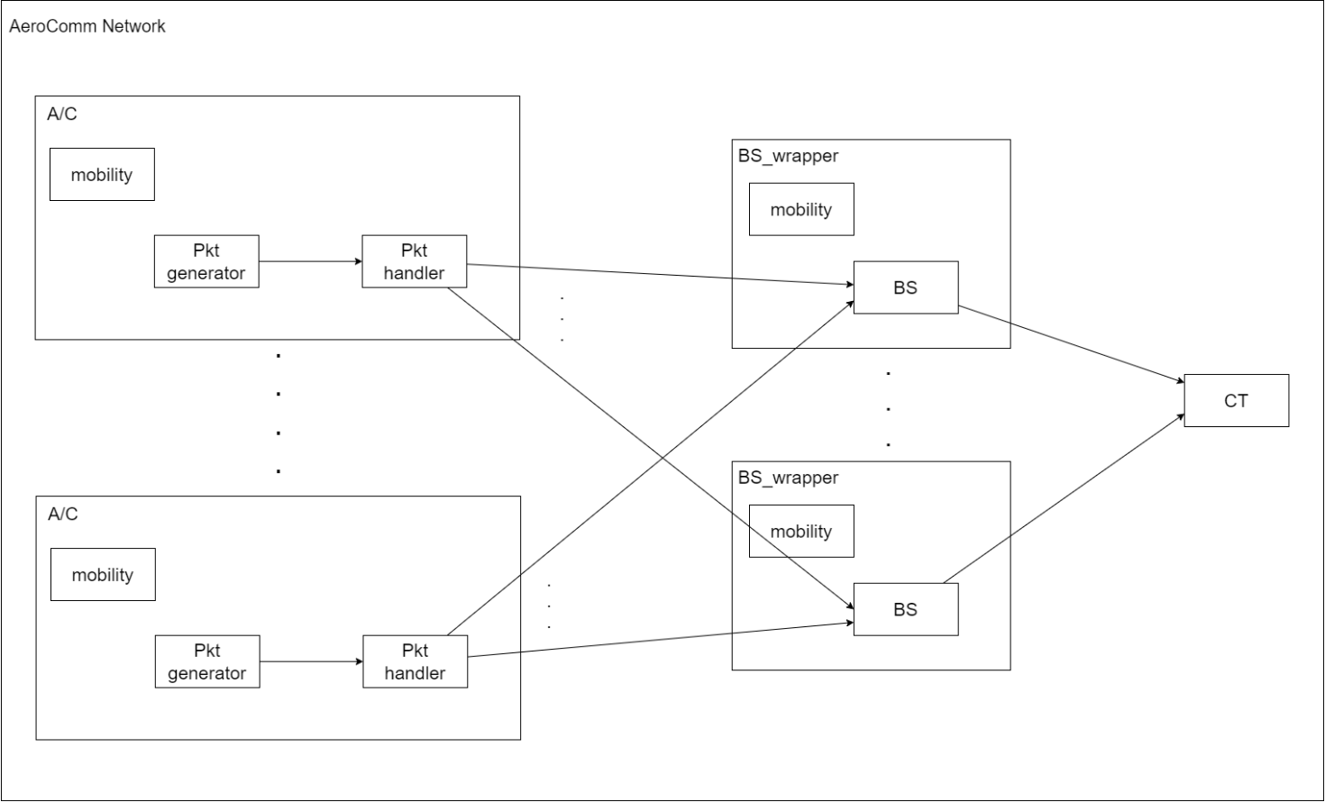To implement that system some modules have been defined.

Figure 3: Aeronautical communications - Network implementation

## Modules

The following modules have been defined:

* **AC**: compound module that represents the aircraft. It is composed by:
  + **pktGenerator**: simple module that deals with randomly generating communication packets, by means of different given distributions (uniform or exponential). It also generate handover packets every t seconds. The packets generated are transmitted to the pktHandler module.
  + **pktHandler**: simple module which represents the service center receiving the packets from the pktGenerator module. It queues and processes both communication and handover packets according to a FCFS policy. The communication packets are then forwarded to the serving BS module. Instead, the handover packets trigger an handover operation that is handled internally.
  + **mobility,** LinearMoblityINET module that simulate the A/C movement.
* **BS_wrapper:** compound module that represents the BS. It is composed by:
  + **BS**: simple module that receives the communication packets from the pktHandler module, and forwards them to the CT module.
  + **mobility,** StaticGridMobility INET module that simulate the BSs position in grid arrangement.
* **CT**: simple module representing the destination of the communication packets, for collecting the end-to-end delay statistics

# Calibration

The calibration phase is necessary to set all the simulation's parameters, both the global parameter and the factors that affect the performance of the system. We run 30 independent simulations.

## Calibration of warm-up time

To assess a reasonable warm-up time, we simulated and examined the evolution of the performance indexes of our model in the first part of its advancement, trying to observe from what point onwards they start to stabilize. We run 25 independent simulations.

As a performance index, we chose E[R] of the whole system, i.e. the mean end-to-end delay of the packets, because it reliably summarizes the entire system.

We evaluated various scenarios (both k uniform and exponential) to obtain a warm-up time that was suitable for all the different configurations we intended to simulate.

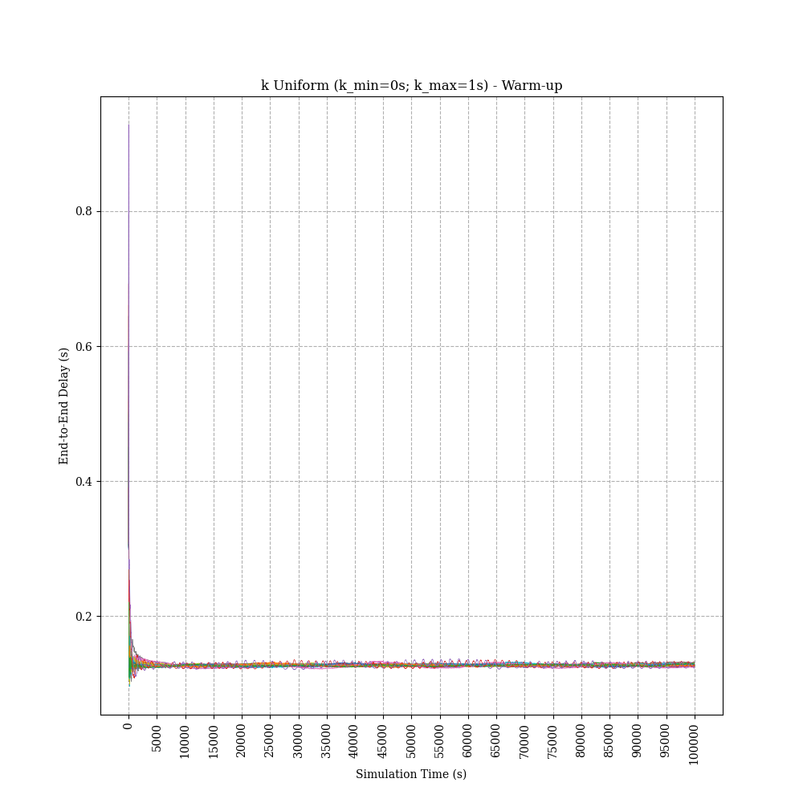From the results that can be seen in Figure 19 and Figure 18, we decided to set the **warm-up time** at **5000s**.

Figure 4: Warm-up time calibration - k uniform

## Calibration of simulation time

Figure 5: Warm-up time calibration - k exponential

To select a convenient simulation time, we chose to observe the variance of the end-to-end delay, with both k uniformly and exponentially distributed. We run 25 independent simulations.

Specifically for the k exponentially distributed case, we never observe a very stable variance, but we can also notice that the order of magnitude of the outcomes are very small and they stand in a well-defined range.

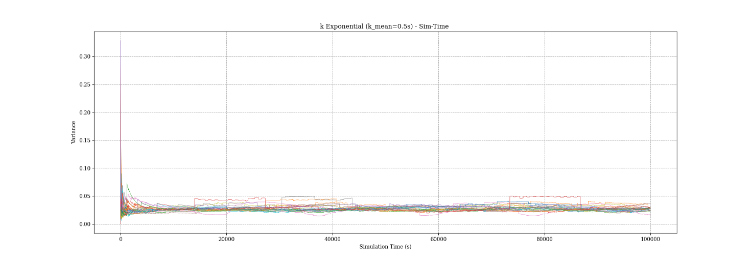For all these considerations and observing the results in Figure 20 and Figure 21, we chose to set the **simulation time** at **20000s**.

Figure 6: Simulation time calibration - k exponential

## Factors calibration

Figure 7: Simulation time calibration - k uniform

For factors calibration, we run 30 independent simulations.

The following parameter ranges were selected:

|  |  |
| --- | --- |
| **Parameter** | **Interval** |
| t | [5s, 25s] |
| k_max | [0.2s, 4.2s] |
| k_mean | [0.1s, 2.1s] |

More in detail:

* **k**: we analyzed a lower bound of 0.1s because, at that edge, the system started to become instable due to very high utilization; besides, we chose an upper limit of 2s for air traffic control necessities.
* **t**: regarding the handover period, we would like the handover operation to also involve a change of the A/C serving BS, so as to avoid having to process a packet unnecessarily. To achieve this, we should perform the handover operation whenever the A/C exceeds the limit of its serving BS. Thus, it would be necessary to have fairly high handover periods, since the BSs are 25km apart and since the A/C moves at a constant speed of 275mps.

To better understand how to size the t range, we performed some tests varying the mean inter-arrival rate of communication packets, both for k uniform and exponential, extracting both the mean end-to-end delay and the average number of queued packets. Since, we observed the same results, we decided to report only the results for k exponential and for the mean end-to-end delay.

The results obtained are shown in Figure 22, Figure 23, Figure 24 and Figure 25.

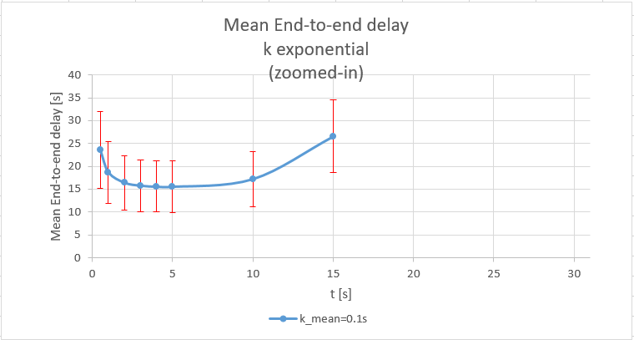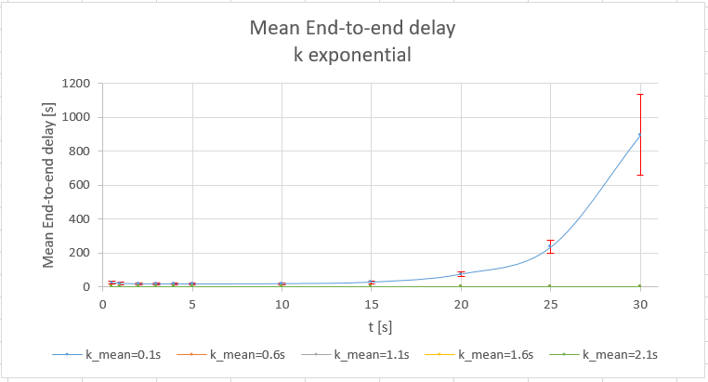

Figure 8: Mean end-to-end delay varying the handover period (t) when k_mean=0.1s - zoomed-in - k exponential

Figure 9: Mean end-to-end delay varying the handover period (t) and the inter-arrival period (k_mean) - k exponential

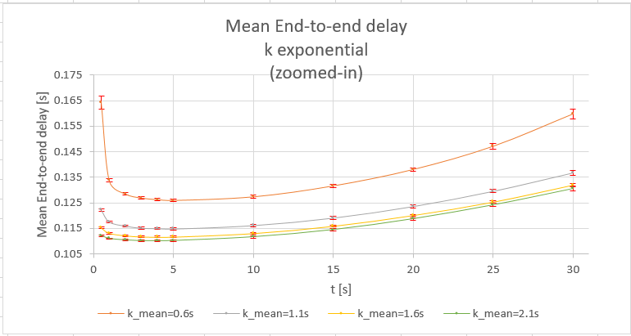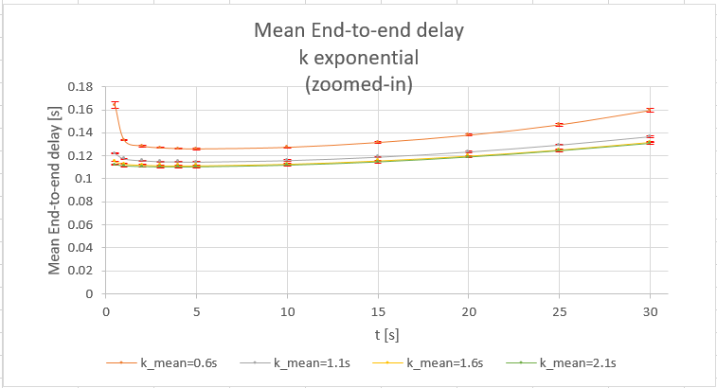When k_mean is equal to 0.1s, we can’t draw any conclusions, because the confidence intervals overlap.

Figure 10: Mean end-to-end delay varying the handover period (t) and the inter-arrival period (k_mean) - Zoomed-in - k exponential

Figure 11: Mean end-to-end delay varying the handover period (t) and the inter-arrival period (k_mean) - Zoomed-in - k exponential

In general, we can state that t negatively affects the performance in two cases:

1. If t is small, unnecessary handover operations are performed, i.e. handover operations do not lead to an actual change in serving BS.
2. If t is large, the handover is done infrequently, so the A/C is always too far away from its serving BS.

For all these considerations, we decided to set t between 5s and 25s and observe the overall behavior of the system.

# Simulation experiments

We will now proceed to conduct experiments on the validated model

We will analysis both the k distribution (uniform and exponential).

We run 30 independent simulations.

Lastly, we computed the 99% of confidence interval for each experiment.

## k uniform

During the experiments, we studied the trend of the mean end-to-end delay and the mean number of packets in queue. The following graphs show the trend of the two metrics varying the inter-arrival time (k) and the handover period (t).

In Figure 26 and Figure 27, we can see that both the mean end-to-end delay and the mean number of packets in queue highly depend on the mean inter-arrival time (k): lower mean inter-arrival times (k) lead to higher delays and longer queues, while higher mean inter-arrival times lead to lower delays and shorter queues.

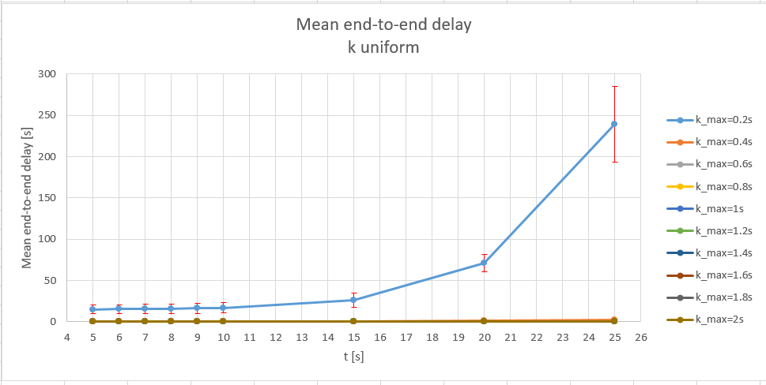Regarding the performances trend varying t, we can observe that for t around 7-8s we obtain the best performances.

Figure 12: Mean end-to-end delay for different inter-arrival times (k) and handover periods (t) - k uniform

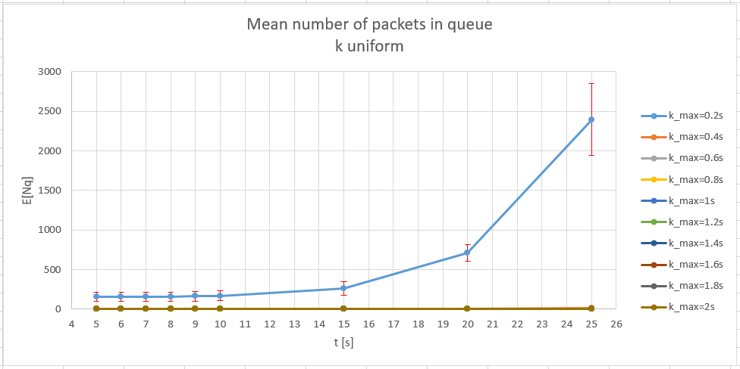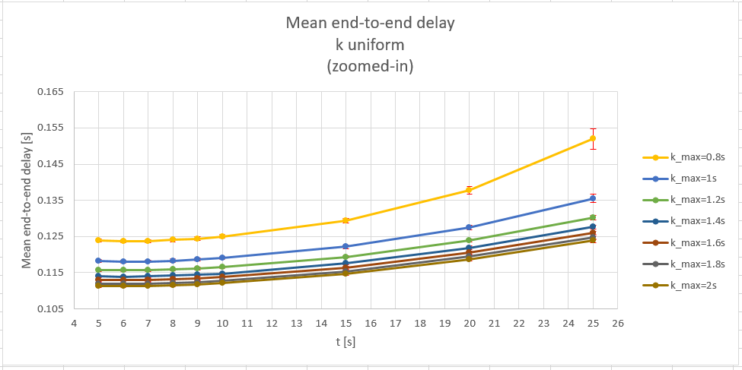

Figure 13: Mean number of packets in queue for different inter-arrival times (k) and handover periods (t) - k uniform

Figure 14: Mean end-to-end delay for different inter-arrival times (k) and handover periods (t) - k uniform - zoomed-in

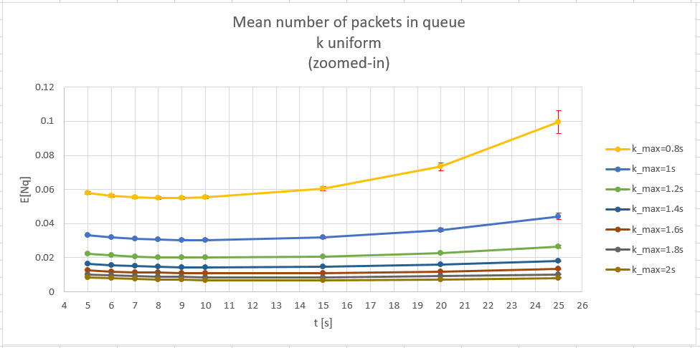In Figure 29, it seems that increasing t, for large value of k, the mean number of packets in queue stabilizes. In reality it is not so, but this effect is due to the grouping of several curves having different scales in the same graph.

Figure 15: Mean number of packets in queue for different inter-arrival times (k) and handover periods (t) - k uniform - zoomed-in

## k exponential

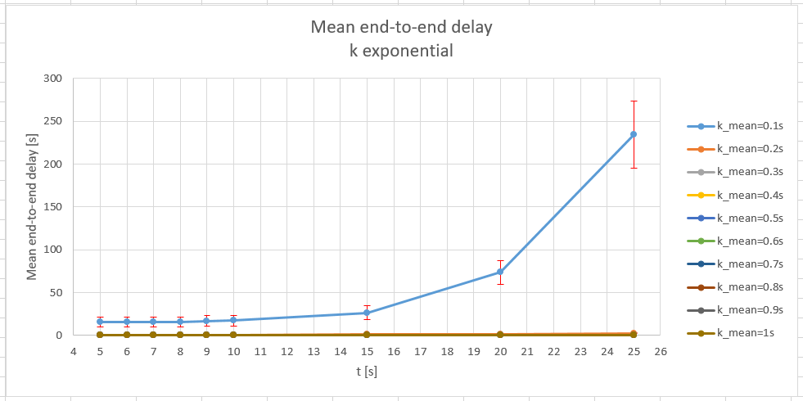With k distributed exponentially, the same considerations of the uniform distribution apply.

Figure 16: Mean end-to-end delay for different inter-arrival times (k) and handover periods (t) - k exponential

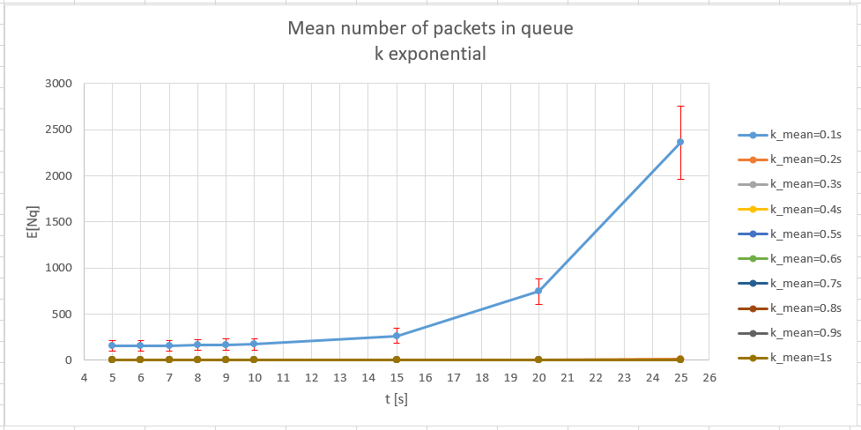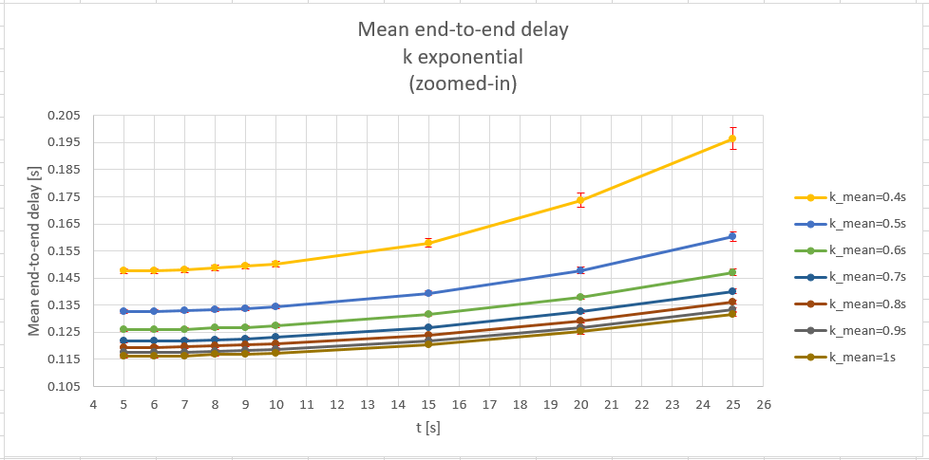

Figure 17: Mean number of packets in queue for different inter-arrival times (k) and handover periods (t) - k exponential

Figure 18: Mean end-to-end delay for different inter-arrival times (k) and handover periods (t) - k exponential - zoomed-in

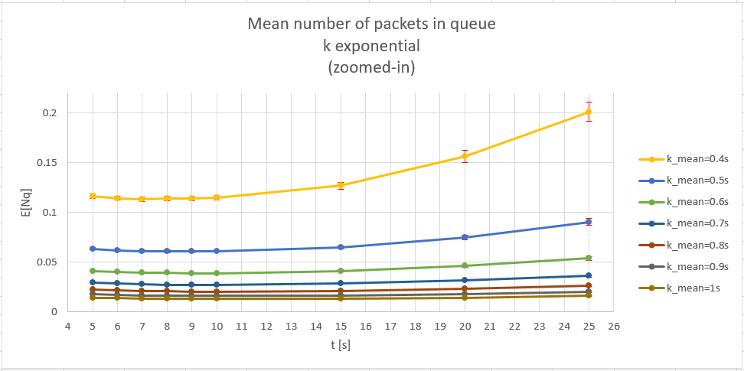

Figure 19: Mean number of packets in queue for different inter-arrival times (k) and handover periods (t) - k exponential - zoomed-in

# Conclusion

From this analysis, we can conclude that both the uniform and exponential distributions of inter-arrival time (k) give us the same results.

Regarding the handover period (t), we observed that the values that allow us to obtain the best results are between 5 and 10s. More in detail, the best performances are obtained with t around 7-8s.

For what concerns the inter-arrival time (k), suggested values are above 0.5s because, for lower values, end-to-end delay and queue length begin to be relevant. A better trade-off has to be found by a flight expert, who should choose between having a fresher piece of information, but less frequently, or a less frequent piece of information but fresher.

# Appendix A: Verification

Before to execute the experiment and the calibration phase, we verified the model, to check its coherence also with respect to the theoretical model.

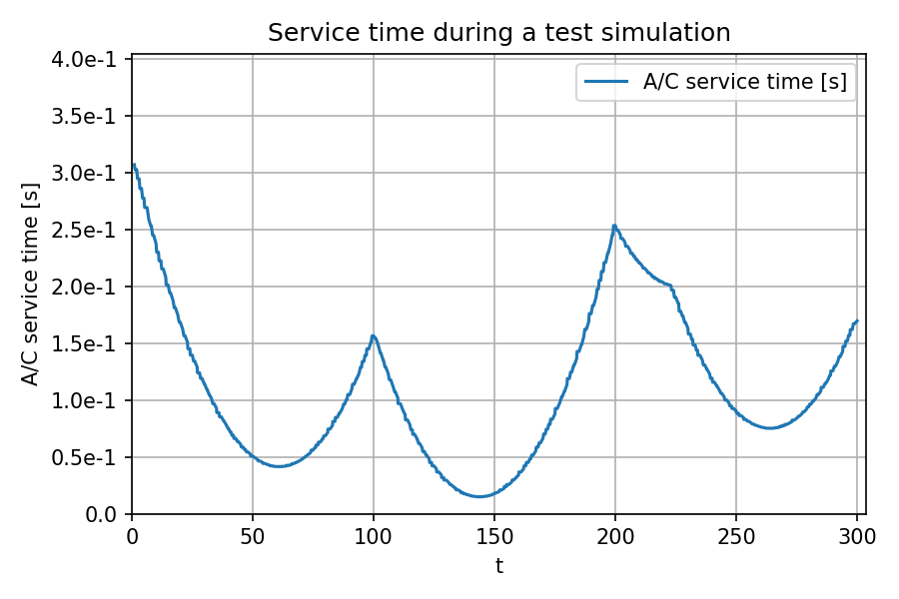First, we recorded the service time for a simulation and looked at a minor interval in order to spot obviously wrong situations.

Figure 20: Service time during a test simulation

In Figure 4, we can see that:

* service time has a paraboloid shape, which is expected since it is proportional with d^2 , which d increases linearly during time, because A/C travel at constant speed;
* graph non derivability represent the moment when A/C performs an handover operation and changes its serving BS.

Then, we performed four kinds of verification:

* Degeneracy;
* Continuity;
* Monotonicity,
* Consistency.

And then, we tested the theoretical model also with analytical computation.

All the verification experiments have been run using 10 repetition. Lastly, we compute the 90% of confidence interval for each experiment.

## Degeneracy test

The degeneracy test was used to analyze the behavior of the system under specific extreme conditions, by degenerating some parameters to see if, even in those cases, it behaves as expected.

For this aim, we observed the following cases:

* **TEST 1**: N_AC = 1; N_BS = 1; null A/C speed, so that the A/C service time (s_AC) is constant and deterministic; deterministic k. In this case, the mean end-to-end delay will be constant and equal to the A/C mean response time. There will be packet queuing on the A/C (since it has to handle also the handover packets).
* **TEST 2**: N_AC = 1; N_BS = 1; null A/C speed, so that the A/C service time (s_AC) is constant and deterministic; k uniformly distributed. In this case, the mean end-to-end delay will depend on the A/C mean response time, but also on the mean inter-arrival time k.
* **TEST 3**: N_AC = 1; N_BS = 1; null A/C speed, so that the A/C service time (s_AC) is constant and deterministic; k exponentially distributed. In this case, the system will behave as in TEST 2.

## Consistency test

The consistency test verifies that the system and the output react consistently. In detail, we performed two sub-tests (case A and case B) for each distribution of k (uniform and exponential). For the CASE A, we have only one A/C that sends communication packets to the BS, at a given rate. In CASE B, instead, we have two A/Cs that send communication packets to the BS, with a rate halved compared to CASE A. The purpose of these tests was to observe whether the end-to-end delay remained almost the same for both cases.

* **TEST 1**: k uniformly distributed

|  |  |  |
| --- | --- | --- |
| **Parameter** | **CASE A** | **CASE B** |
| **N_AC** | 1 | 2 |
| **N_BS** | 1 | 1 |
| **k_min** | 0 | 0 |
| **k_max** | 2 | 4 |
| **t** | 1 | 2 |
| **v** | 0 | 0 |

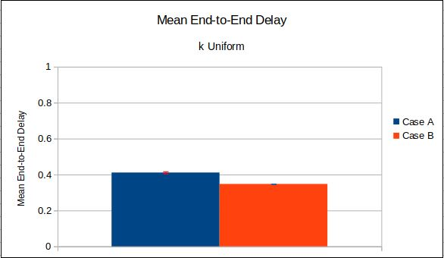In Figure 5**Errore. L'origine riferimento non è stata trovata.**, we can notice that the end-to-end delay will be quite similar in the two cases, as expected.

Figure 21: Consistency test - k uniform

* *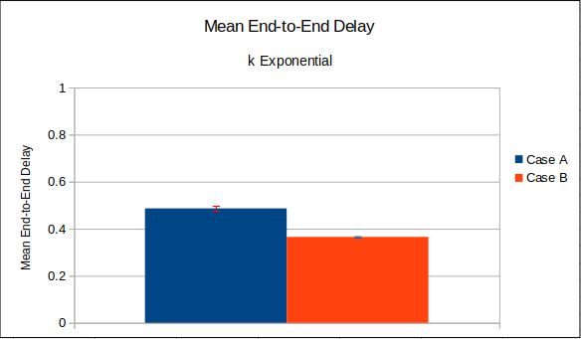***TEST 2**: k exponentially distributed

Figure 22: Consistency test - k exponential

|  |  |  |
| --- | --- | --- |
| **Parameter** | **CASE A** | **CASE B** |
| **N_AC** | 1 | 2 |
| **N_BS** | 1 | 1 |
| **k_mean** | 1 | 2 |
| **t** | 1 | 2 |
| **v** | 0 | 0 |

In Figure 6, we can notice that the end-to-end delay will quite similar in the two cases, as expected.

## Continuity test

To assess the correctness of the system we must carry out an experiment to verify if changing slightly the input affects slightly the output. For this test, we decided to vary k slightly, and observe how the end-to-end delay changed. This was done for both uniformly distributed k and exponentially distributed k. In both cases, we obtained the results expected.

* **k uniform**

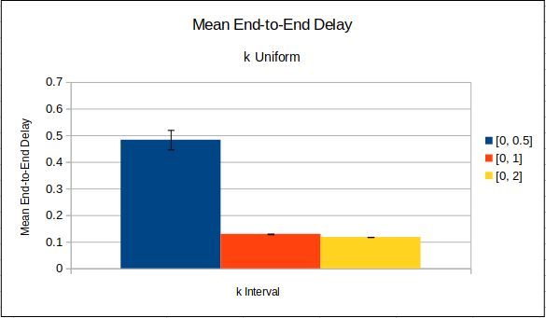In the case where k is uniformly distributed, the test was done with the parameter configuration reported in the following table.

Figure 23: Continuity test - k uniform

|  |  |  |  |  |
| --- | --- | --- | --- | --- |
| **Parameter** | **N_AC** | **N_BS** | **v** | **k_max** |
| **Value** | 1 | 4 | 275mps | ${0.5s, 1s, 2s} |

In Figure 7, we can notice that by increasing k_max (i.e. decreasing the rate with which the A/C transmits communication packets towards the BS), the end-to-end delay decreases in a similar way

* **k exponential**

In the case where k is exponentially distributed, the test was done with the parameter configuration reported in the following table.

|  |  |  |  |  |
| --- | --- | --- | --- | --- |
| **Parameter** | **N_AC** | **N_BS** | **v** | **k_mean** |
| **Value** | 1 | 4 | 275mps | ${0.25s, 0.5s, 1s} |

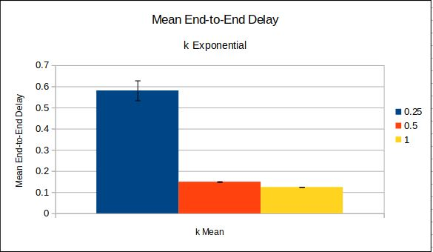In Figure 8, we can notice that by increasing k_mean (i.e. decreasing the rate with which the A/C transmits communication packets towards the BS), the end-to-end delay decreases in a similar way.

Figure 24: Continuity test - k exponential

## Monotonicity test

The monotonicity test consists in assessing the monotonicity of some performance indexes using different combinations of factors. We performed this test for both uniformly distributed k and exponentially distributed k.

* **k uniform**

In the case where k is uniformly distributed, we tested several values for k_max, as shown in the following table.

|  |  |  |  |  |
| --- | --- | --- | --- | --- |
| **Parameter** | **N_AC** | **N_BS** | **v** | **k_max** |
| **Value** | 1 | 4 | 275mps | ${0.6s, 0.9s, 1.2s, 1.5s, 1.8s, 2.1s, 2.4s} |

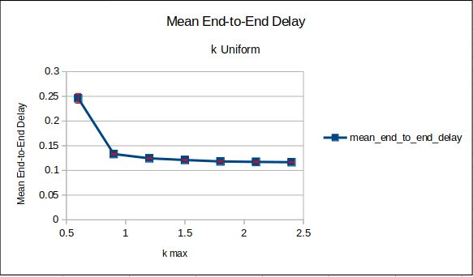As we can observe in Figure 9, the end-to-end delay monotonically decreases increasing the k_max, i.e. decreasing the rate with which the A/C transmits communication packets towards the BS. Therefore, we can say that the system behaves as expected

Figure 25: Monotonicity test - k uniform

* **k exponential**

In the case where k is exponentially distributed, we tested several values for the k_mean, as shown in the following table.

|  |  |  |  |  |
| --- | --- | --- | --- | --- |
| **Parameter** | **N_AC** | **N_BS** | **v** | **k_mean** |
| **Value** | 1 | 4 | 275mps | ${0.3s, 0.45s, 0.6s, 0.75s, 0.9s, 1.05s, 1.2s} |

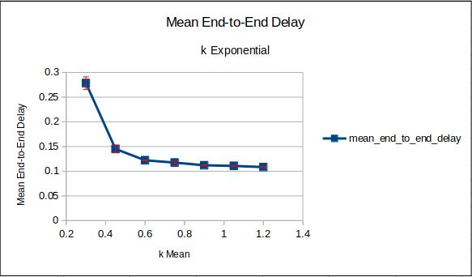As we can observe in Figure 10, the end-to-end delay monotonically decreases increasing the k_mean, i.e. decreasing the rate with which the A/C transmits communication packets towards the BS. Therefore, we can say that the system behaves as expected.

Figure 26: Monotonicity test - k exponential

## Verification against theoretical model

Theoretical model verification was performed to see if the results we obtain from theimplementation of our system are the same as we obtain analytically from that model.

In order to perform this validation, we needed to make some initial consideration because the distribution of the A/C service time is not known.

### Maximum distance considerations

The A/C service time depends on the distance between the A/C and its serving BS. This distance belongs to interval [0, dmax[, where dmax can be computed as:

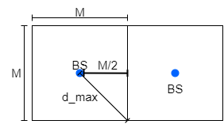

Figure 27: Computation of maximum distance between A/C and its serving BS

### Single-BS distance distribution computation

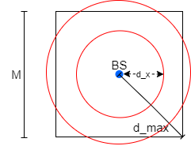In order to compute the distribution of the A/C service time, and to validate our model against a theoretical model, we had to make some simplifications for the computation of distance: we considered a grid with a single BS.

Figure 28: Computation of distance between A/C and it serving BS distribution

We want to compute the probability that picked a random position for A/C inside the cell, the distance between the A/C and the BS is equal to dx, i.e. the PDF of the random variable D.

As shown in Figure 12, the greater the circumference (centered in BS), the greater the probability that D is equal to dx, as the grater the points that satisfy this equality. Thus, the probability that D equals dx is proportional to the circumference (2πdx). However, this is only true if dx ≤ M/2. In this case, only the portions of that circumference which lay inside the square cell have to be taken in account in this computation.

Given the above considerations, a reasonable PDF for D is the following:

* The first interval represents the probability of A/C laying over a circumference fully inside the square cell;
* The second interval represents the probability of A/C laying over the arcs given by the intersection of a circumference partially outside the square cell.

The constant c can be calculated using normalization condition, and it is equal to c = 1.6*10-9.

The CDF of the distance is the following:

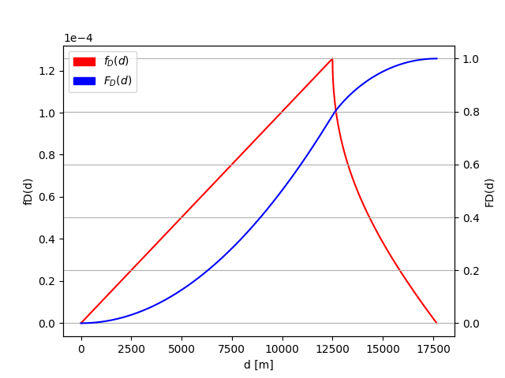Once we know the distribution for distance D, we can compute the distribution for the A/C service time S. However, to simplify validation, we decided to change the dependency between the distance and the service time, so that this is linear and not quadratic:

Figure 29: Theoretical PDF and CDF of distance

Given the above consideration, the PDF of the A/C serving time is the following:

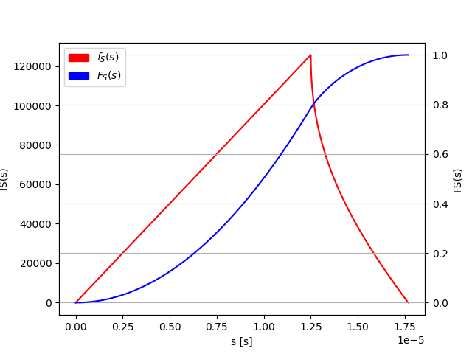The CDF of the service time is the following:

Figure 30: Theoretical PDF and CDF of service time

### M/G/1

We ran 25 independent simulations, and sampled distance and the service time.

We decided to validate the model considering only the case in which k is distributed exponentially, since the uniform distribution can be approximated to the exponential one.

During the validation phase, we decided not to consider handover messages, in this way we have an inter-arrival time distributed exponentially with rate equals to k.

Using results from section **Errore. L'origine riferimento non è stata trovata.**, we compared the samples of distance and service time with our theoretical distributions using QQ plots.

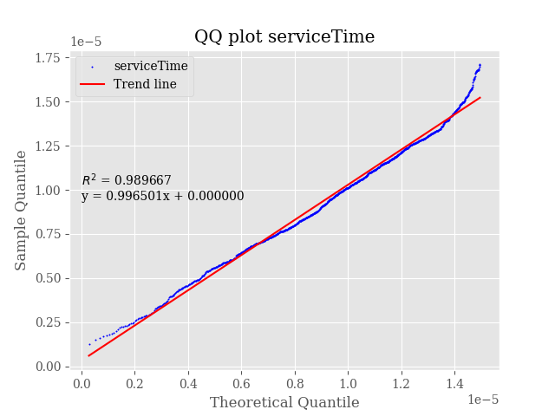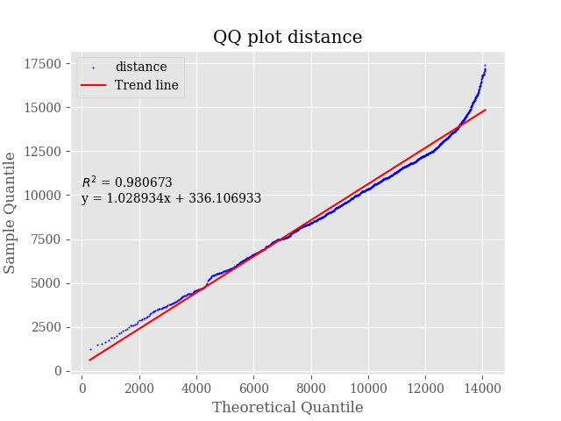Given the complexity of the CDFs, we decided to make simplifications, using the theoretical distribution of the first branch even if the distance is between M/2 and M√2/2.

Figure 31: QQ plots for fitting distance and service time distributions

We can see from Figure 15 that the tail at the end of the plot is due to the simplification discussed previously: when the distance is between M/2 and M√2/2 the sample quantiles continue to grow because they follow a different distribution with respect to the theoretical one.

To overcome this problem, during the validation phase, we decided not to generate packets when the distance exceeds M/2.

Once asserted the validity of the distributions, we compared the measured performance indexes with those computed using Pollaczek and Khinchin’s formula.

Figure 16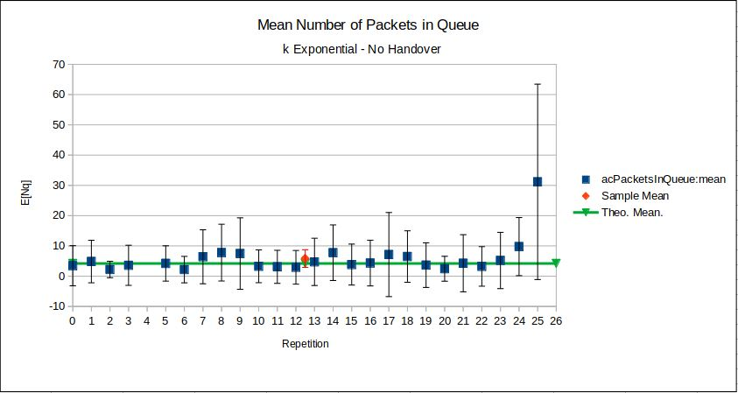 shows the mean number of packets in queue, where the green line is the value obtained from the theoretical model, the blue dots are the values obtained from each repetition of the simulation and the red dot is the mean value of all repetitions calculated with the 99% of confidence interval.

Figure 32: Validation model results against theoretical results (Mean number of packets in queue E[Nq])

Figure 17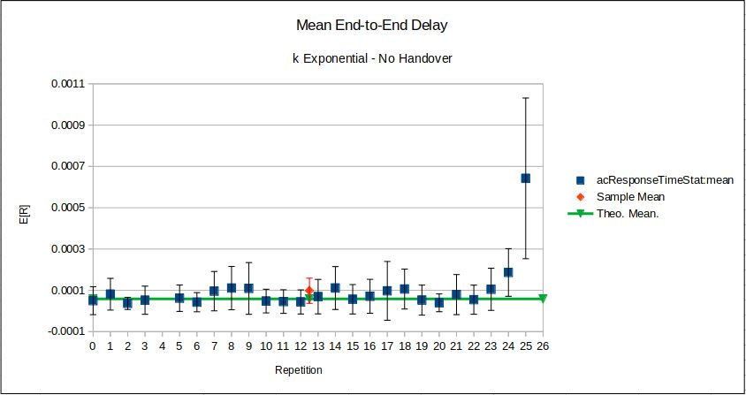 shows the mean end-to-end delay, where the green line is the value obtained from the theoretical model, the blue dots are the values obtained from each repetition of the simulation and the red dot is the mean value of all repetitions calculated with the 99% of confidence interval.

Figure 33: Validation model results against theoretical results (Mean end-to-end delay)

# Appendix B: Failed attempt of 2kr Factorial Analysis

Before proceeding with the experiments, we tried to carry out a 2kr factorial analysis to get some insights and a deeper understanding of the system under analysis. We aimed to understand the contribution of factors on the number of packets in queue and end-to-end delay.

We considered the following parameters and ranges:

* Number of replicas: 5
* k_max (Uniform): [0.2s, 4s] (**A**)
* k_mean (Exponential): [0.1s, 2s] (**B**)
* t: [5s, 25s] (**C**)

We analyzed two configurations:

1. k uniformly distributed (A)
2. k exponentially distributed (B)

By running the simulation, we realized we had results with different orders of magnitude. For this reason, we decided to perform a logarithmic transformation of the results.

The results of the 2kr factorial analysis showed that in both configurations. The factor that most influences the performances is A, instead the other factors have a negligible impact.

It’s good to notice that the contribution of errors was also negligible.

|  |  |  |  |  |  |  |  |  |
| --- | --- | --- | --- | --- | --- | --- | --- | --- |
| CONFIGURATION 1 (k uniform) | | | | | CONFIGURATION 2 (k exponential) | | | |
| End-to-end delay | | **Number of packets in queue** | | **End-to-end delay** | | | **Number of packets in queue** | |
| FACTOR | **CONTRIBUTION** | **FACTOR** | **CONTRIBUTION** | **FACTOR** | | **CONTRIBUTION** | **FACTOR** | **CONTRIBUTION** |
| A | 89.84% | **A** | 97.30% | **B** | | 89.88% | **B** | 97.12% |
| C | 5.36% | **C** | 1.06% | **C** | | 5.33% | **C** | 1.38% |
| AC | 4.66% | **AC** | 1.60% | **BC** | | 4.57% | **BC** | 1.43% |
| errors | 0.14% | **errors** | 0.04% | **errors** | | 0.21% | **errors** | 0.07% |

Unfortunately, our factorial analysis was a failure, because the hypothesis (residuals are IID normally distributed with null mean and constant standard deviation) were NOT met. Thus, we cannot consider these results in our project.

We decided to report only the graphs for the configuration1, since the assumptions are not verified in both configurations.

For what concerns the normal hypothesis, the QQ plot of the residuals vs normal (Figure 34 and Figure 35) shows doesn’t show a linear tendency.

For the homoskedasticity (i.e. constant standard deviation), the scatterplot of residuals vs predicted response (Figure 36) shows that there is a clear and not negligible trend, indicating that standard deviation is not constant.

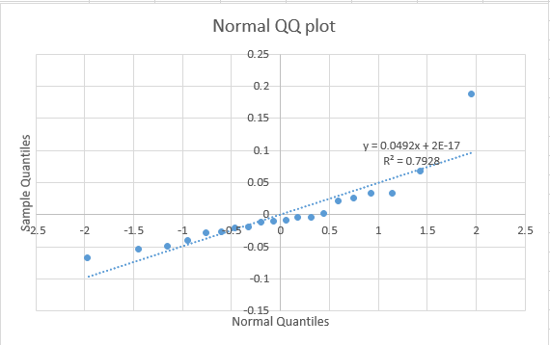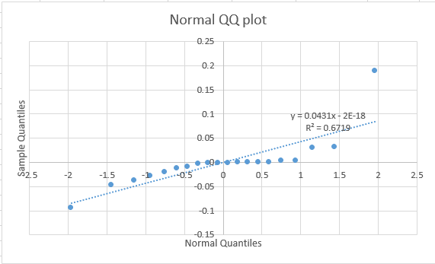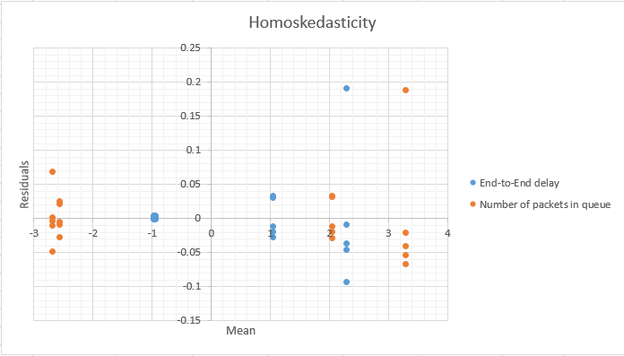

Figure 34: Normal QQ plot - Number of packets in queue - k uniform

Figure 35: Normal QQ plot - End-to-end delay - k uniform

Figure 36: Scatterplot for homoskedasticity - End-to-end delay and Number of packets in queue - k uniform