
Preliminary learning
  - TIMERA — Training Initiative for Modelling Epidemic Response in Africa
Federica Giardina
2026-11-06
Table of contents

Welcome
Also available in: Français · Português
This book contains the preliminary learning material of TIMERA, the Training Initiative for Modelling Epidemic Response in Africa. It summarises the background knowledge assumed in the course and is intended for self-study before the first face-to-face module, and as a reference during the programme.
Chapter | Content | Estimated study time
P1 | Basic R and RStudio: objects, data types, functions, data frames, data manipulation, graphs, conditional statements and loops | 15–25 hours for participants new to R; 2–4 hours otherwise
P2 | Measures of disease frequency, surveillance data, probability distributions, estimation, likelihood and regression for counts | 6–10 hours
P3 | Rates and probabilities, exponential growth, derivatives and differential equations, equilibria, matrices and numerical methods | 6–10 hours
Each chapter contains a concise presentation of the material, exercises with solutions, a self-assessment checklist and references to additional sources.

Preparation before the first module
- Install R, RStudio and the packages used in the course (Appendix A).
- Study the three chapters of this book. Participants without previous experience in R should begin with the interactive tutorials referred to in P1, as the exercises in the other two chapters also use R.
- Use the self-assessment checklist at the end of each chapter to decide whether further study is required.
- Identify a public health question from your own professional context that could be addressed with a model. This question forms the basis of the course project.

Conventions
Code is displayed in grey boxes; the output appears underneath, preceded by ##. Typing the code, rather than copying it, is recommended, as it encourages careful reading of each line. Exercises are presented in green boxes; solutions are collapsed and can be expanded.
References in italics to chapters of the TIMERA course book indicate where a topic is developed further during the course. The course book is available at https://github.com/Federica-Giardina/TIMERA.

Licence
This book is licensed under the Creative Commons Attribution-NonCommercial-ShareAlike 4.0 International License.

P1 Introduction to R
Preliminary learning — R and RStudio basics
Learning objectives
By the end of this chapter, participants should be able to:
- Use the RStudio interface, create and save scripts, and work within an RStudio Project.
- Create objects of the principal data types, and select elements of vectors and data frames.
- Use built-in functions and packages, consult help pages and write simple functions.
- Import a dataset and manipulate it with the principal tidyverse functions.
- Produce basic graphs with ggplot2.
- Use conditional statements and for loops.

This chapter introduces the basic elements of the R language. It does not assume previous programming experience. The application of R to the analysis of outbreak data and to modelling is the subject of course book: Own data and programming models in R in Module 1, and R is used in the practical sessions of every chapter of the book. Installation instructions are given in Appendix A.

P1.1 Interactive tutorials
Participants without previous experience in R are expected to complete the Applied Epi interactive R tutorials (sessions 1–6), which are available free of charge in English, French, Portuguese and Spanish at https://www.appliedepi.org/resources/tutorials.html. Each session requires approximately 2–4 hours:
Session | Topic
1 | Installation of R and RStudio
2 | Data preparation
3 | R syntax
4 | Data cleaning
5 | Summary tables
6 | Data visualisation with ggplot2
7 (optional) | Obtaining help and using AI tools
The remainder of this chapter summarises the same material in a compact form, for reference.

P1.2 RStudio and projects
RStudio has four panels: the script editor (top left), in which code is written and saved; the console (bottom left), in which code is executed; the environment (top right), which lists the objects in memory; and the files, plots and help panel (bottom right). A line of code in a script is executed with Ctrl + Enter (Cmd + Enter on macOS); text after # is a comment and is not executed.
Work should be organised in an RStudio Project (File → New Project). All file paths are then relative to the project folder, so that the analysis can be moved to another computer without modification.

P1.3 R as a calculator
3 + 4 * 2 # multiplication before addition
## [1] 11
(3 + 4) * 2
## [1] 14
10 / 4
## [1] 2.5
2^10 # power
## [1] 1024
sqrt(16)
## [1] 4
exp(1) # the number e
## [1] 2.718282
log(100) # natural logarithm
## [1] 4.60517
log10(100) # logarithm with base 10
## [1] 2
round(3.14159, 2)
## [1] 3.14

P1.4 Objects and assignment
Values are stored in objects with the assignment operator <-. Object names are case-sensitive, cannot start with a number, and should be informative.
population <- 250000
cases <- 375
incidence <- cases / population * 100000
incidence
## [1] 150

P1.5 Data types and vectors
A vector is an ordered collection of values of the same type, created with c(). The principal types are numeric, character (text), logical (TRUE/FALSE), factor (categorical variable with defined levels) and date.
age <- c(4, 12, 35, 67, 23) # numeric
sex <- c("female", "male", "male", "female", "female") # character
vaccinated <- c(TRUE, FALSE, TRUE, TRUE, FALSE) # logical
age_group <- factor(c("0-14", "0-14", "15-64", "65+", "15-64"),
levels = c("0-14", "15-64", "65+")) # factor
visit <- as.Date(c("2026-03-01", "2026-03-04", "2026-03-04", "2026-03-09", "2026-03-12"))
class(age); class(sex); class(vaccinated); class(age_group); class(visit)
## [1] "numeric"
## [1] "character"
## [1] "logical"
## [1] "factor"
## [1] "Date"
length(age)
## [1] 5
Arithmetic and comparisons are vectorised: they are applied to each element.
age * 12 # age in months
## [1] 48 144 420 804 276
age >= 15 # logical vector
## [1] FALSE FALSE TRUE TRUE TRUE
sum(vaccinated) # TRUE counts as 1
## [1] 3
mean(vaccinated) # proportion vaccinated
## [1] 0.6
table(age_group)
## age_group
## 0-14 15-64 65+
## 2 2 1

P1.5.1 Selecting elements
age[2] # second element
## [1] 12
age[c(1, 3)] # first and third elements
## [1] 4 35
age[-1] # all except the first
## [1] 12 35 67 23
age[age >= 15] # elements meeting a condition
## [1] 35 67 23
sex[vaccinated] # sex of vaccinated persons
## [1] "female" "male" "female"

P1.5.2 Missing values
Missing values are represented by NA. Most summary functions return NA if any value is missing, unless na.rm = TRUE is specified.
weight <- c(12.5, NA, 70.2, 64.0, 58.3)
mean(weight)
## [1] NA
mean(weight, na.rm = TRUE)
## [1] 51.25
is.na(weight)
## [1] FALSE TRUE FALSE FALSE FALSE
sum(is.na(weight))
## [1] 1

P1.5.3 Operators
Operator | Meaning
<- | assignment
+ - * / ^ | arithmetic
== != < > <= >= | comparison
& | ! | logical and, or, not
%in% | membership, e.g. sex %in% c("female")
$ | extraction of a column from a data frame
|> | pipe: passes the result on the left to the function on the right

P1.6 Functions and packages
A function takes inputs (arguments) and returns an output. Arguments can be given by position or by name; arguments with default values can be omitted.
round(123.456, digits = 1)
## [1] 123.5
seq(from = 0, to = 20, by = 5)
## [1] 0 5 10 15 20
rep("A", times = 3)
## [1] "A" "A" "A"
paste("District", 1:3)
## [1] "District 1" "District 2" "District 3"
Additional functions are provided by packages. A package is installed once with install.packages("name") and loaded in each session with library(name). The help page of a function is displayed with ?function_name, e.g. ?seq.

P1.6.1 Writing functions
User-defined functions avoid repeating code:
incidence_per_100k <- function(cases, population) {
cases / population * 100000
}
incidence_per_100k(cases = 375, population = 250000)
## [1] 150
incidence_per_100k(cases = c(10, 50, 120), population = c(20000, 80000, 150000))
## [1] 50.0 62.5 80.0

P1.7 Conditional statements and loops
if executes code only when a condition is true; ifelse() applies a condition to every element of a vector.
coverage <- 0.82
if (coverage >= 0.95) {
message("Coverage target reached")
} else {
message("Coverage below target")
}
ifelse(age >= 15, "adult", "child")
## [1] "child" "child" "adult" "adult" "adult"
A for loop repeats a block of code for each value of a sequence:
savings <- numeric(5) # empty vector of length 5
savings[1] <- 100
for (year in 2:5) {
savings[year] <- savings[year - 1] * 1.10 # 10% interest per year
}
savings
## [1] 100.00 110.00 121.00 133.10 146.41

P1.8 Lists
A list can contain objects of different types and lengths, and is often used to store parameters or the results of an analysis.
parameters <- list(country = "Mozambique", year = 2026, rates = c(0.1, 0.25))
parameters$country
## [1] "Mozambique"
parameters[["rates"]]
## [1] 0.10 0.25

P1.9 Data frames
A data frame is a table in which each column is a vector and each row an observation. A tibble is the tidyverse version of a data frame.
library(tidyverse)
patients <- tibble(
id = 1:5,
age = age,
sex = sex,
vaccinated = vaccinated,
visit = visit
)
patients
## # A tibble: 5 × 5
## id age sex vaccinated visit
## <int> <dbl> <chr> <lgl> <date>
## 1 1 4 female TRUE 2026-03-01
## 2 2 12 male FALSE 2026-03-04
## 3 3 35 male TRUE 2026-03-04
## 4 4 67 female TRUE 2026-03-09
## 5 5 23 female FALSE 2026-03-12
patients$age # one column
## [1] 4 12 35 67 23
nrow(patients); ncol(patients)
## [1] 5
## [1] 5
summary(patients$age)
## Min. 1st Qu. Median Mean 3rd Qu. Max.
## 4.0 12.0 23.0 28.2 35.0 67.0

P1.9.1 Data manipulation with dplyr
The principal functions of the dplyr package each perform one operation and are combined with the pipe |>:
Function | Operation
filter() | select rows
select() | select columns
mutate() | create or modify columns
arrange() | sort rows
group_by() and summarise() | summarise by group
count() | count rows by group
left_join() | combine two tables by a common column
patients |>
filter(age >= 15) |>
mutate(age_months = age * 12) |>
select(id, sex, age, age_months) |>
arrange(desc(age))
## # A tibble: 3 × 4
## id sex age age_months
## <int> <chr> <dbl> <dbl>
## 1 4 female 67 804
## 2 3 male 35 420
## 3 5 female 23 276
patients |>
group_by(sex) |>
summarise(n = n(), mean_age = mean(age), prop_vaccinated = mean(vaccinated))
## # A tibble: 2 × 4
## sex n mean_age prop_vaccinated
## <chr> <int> <dbl> <dbl>
## 1 female 3 31.3 0.667
## 2 male 2 23.5 0.5

P1.9.2 Long and wide formats
Data in wide format have one column per variable or time point; data in long format have one row per observation and a column identifying the variable. Long format is required by ggplot2.
wide <- tibble(district = c("A", "B"), `2024` = c(120, 85), `2025` = c(140, 60))
long <- wide |> pivot_longer(-district, names_to = "year", values_to = "cases")
long
## # A tibble: 4 × 3
## district year cases
## <chr> <chr> <dbl>
## 1 A 2024 120
## 2 A 2025 140
## 3 B 2024 85
## 4 B 2025 60
long |> pivot_wider(names_from = year, values_from = cases)
## # A tibble: 2 × 3
## district `2024` `2025`
## <chr> <dbl> <dbl>
## 1 A 120 140
## 2 B 85 60

P1.10 Importing and exporting data
The code below illustrates the import and export of files. The names my_data.csv, my_data.xlsx and my_data_clean.csv are hypothetical examples, to be replaced by the names of actual data files stored in the data/ folder of the project.
# "my_data" is a placeholder: replace it with the name of your own file
library(readr)
data <- read_csv("data/my_data.csv") # text files with comma-separated values
library(readxl)
data <- read_excel("data/my_data.xlsx") # Excel files
write_csv(data, "output/my_data_clean.csv") # export
After importing a dataset, it should be inspected with head(), glimpse(), summary() and View().

P1.11 Graphs with ggplot2
A ggplot2 graph is constructed from three components: a data frame, an aesthetic mapping of variables to visual properties with aes(), and one or more geometries (geom_point(), geom_line(), geom_col(), geom_histogram(), etc.). Labels are added with labs() and panels with facet_wrap().
ggplot(long, aes(x = year, y = cases, fill = district)) +
geom_col(position = "dodge") +
labs(x = "Year", y = "Number of cases", fill = "District")
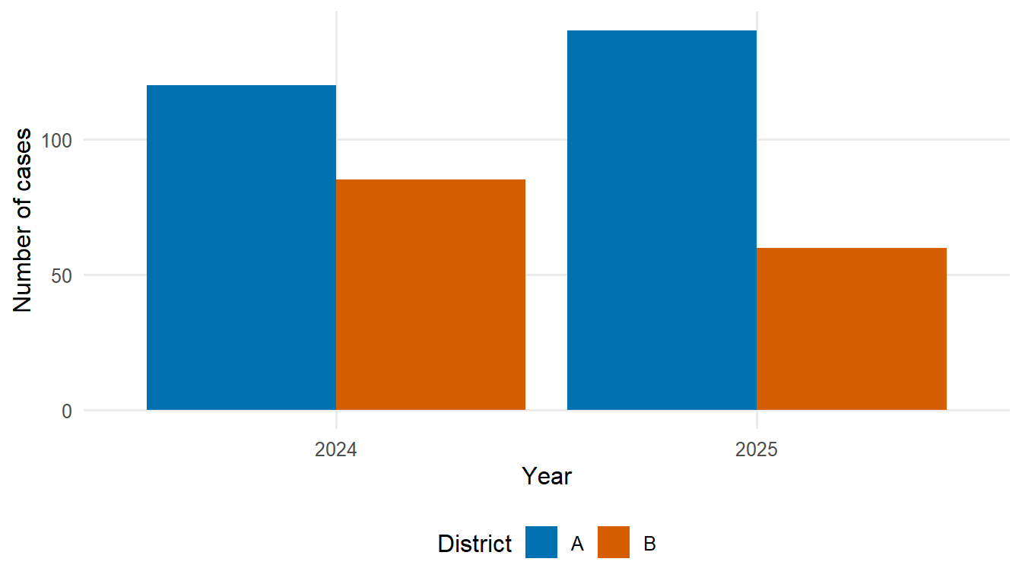
growth <- tibble(day = 0:30, children = 50 * 1.08^(0:30), adults = 30 * 1.05^(0:30)) |>
pivot_longer(-day, names_to = "group", values_to = "cases")
ggplot(growth, aes(day, cases, colour = group)) +
geom_line(linewidth = 1) +
labs(x = "Day", y = "Cases", colour = "Age group")
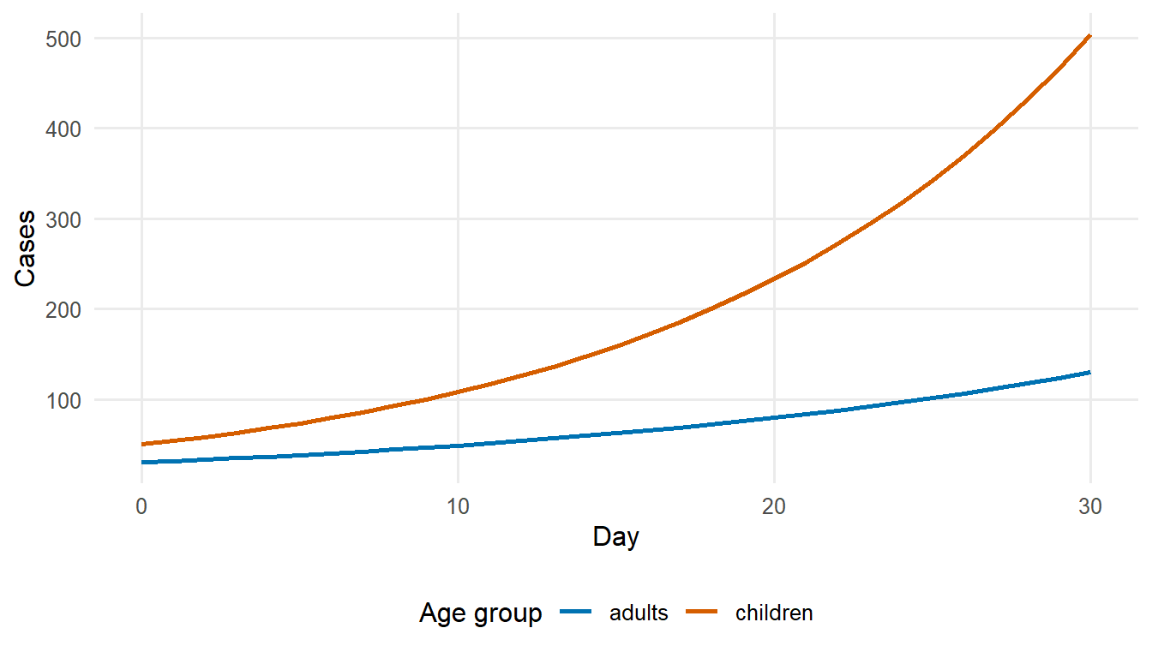

P1.12 Random numbers
R generates random numbers from many probability distributions, for example runif() (uniform), rnorm() (normal), rbinom() (binomial) and rpois() (Poisson). set.seed() makes the results reproducible.
set.seed(2027)
rnorm(3, mean = 0, sd = 1)
## [1] -0.9348780 -0.6938629 -0.5479451
rbinom(5, size = 10, prob = 0.3)
## [1] 4 2 6 5 4
sample(1:6, size = 4, replace = TRUE) # four throws of a die
## [1] 4 1 6 4

P1.13 Errors and help
Error messages indicate where execution failed. Common causes include misspelled object names (object 'x' not found), packages that have not been loaded (could not find function), unmatched brackets or quotes, and code executed in the wrong order. Further help is available from the help pages (?function), the package documentation (reference manuals and vignettes on CRAN, https://cran.r-project.org/web/packages/), the Epidemiologist R Handbook and online forums such as Stack Overflow and Posit Community. AI assistants can explain error messages and suggest code, but their suggestions must be checked and understood before use.
Exercise
- Create a vector with the weekly numbers of cases 3, 7, 12, 25, 31 and 28. Calculate the total, the mean and the week with the highest number of cases.
- Write a function percent_change(old, new) that returns the percentage change between two values, and apply it to consecutive weeks of the vector above (hint: x[-1] and x[-length(x)]).
- Using the patients data frame, calculate the proportion vaccinated among children and adults.
- Create a data frame with two columns, week (1–6) and cases (the vector of question 1), and plot the cases as a bar chart.

 Solution
x <- c(3, 7, 12, 25, 31, 28)
c(total = sum(x), mean = mean(x), peak_week = which.max(x))
## total mean peak_week
## 106.00000 17.66667 5.00000
percent_change <- function(old, new) (new - old) / old * 100
round(percent_change(x[-length(x)], x[-1]), 1)
## [1] 133.3 71.4 108.3 24.0 -9.7
patients |>
mutate(group = ifelse(age >= 15, "adult", "child")) |>
group_by(group) |>
summarise(prop_vaccinated = mean(vaccinated))
## # A tibble: 2 × 2
## group prop_vaccinated
## <chr> <dbl>
## 1 adult 0.667
## 2 child 0.5
tibble(week = 1:6, cases = x) |>
ggplot(aes(week, cases)) +
geom_col(fill = "steelblue") +
labs(x = "Week", y = "Cases")
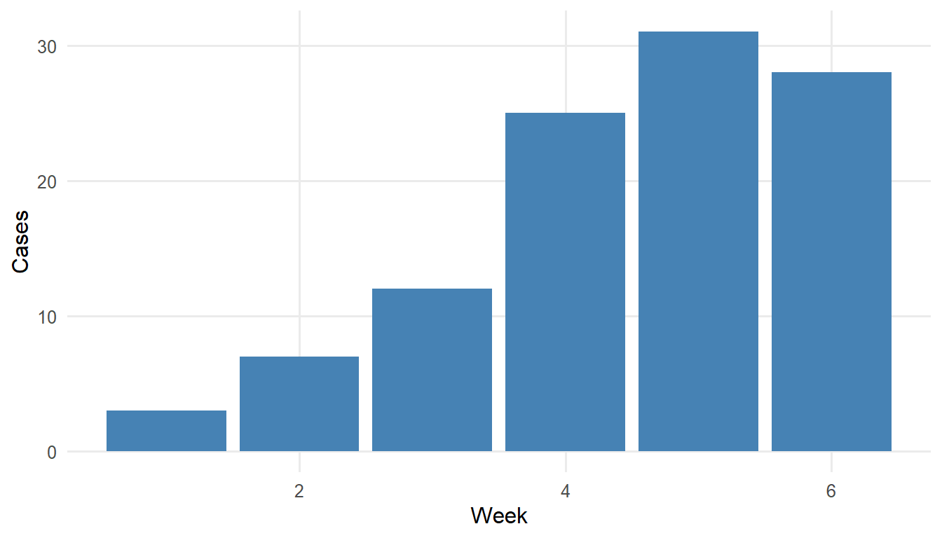

P1.14 Self-assessment
Participants should be able to perform the following tasks without assistance before the first module:
- Create an RStudio Project, open a script and execute it line by line.
- Install and load a package, and consult the help page of a function.
- Create vectors of different types, select elements and handle missing values.
- Write a function with two arguments.
- Import a CSV file and inspect it with head(), glimpse() and summary().
- Use filter(), select(), mutate(), group_by() and summarise().
- Convert a table between wide and long formats.
- Produce a bar chart and a line graph with ggplot2.
- Write an if statement and a for loop.

P1.15 Additional resources
- Applied Epi interactive R tutorials (English, French, Portuguese, Spanish): https://www.appliedepi.org/resources/tutorials.html.
- The Epidemiologist R Handbook (available in several languages): https://www.epirhandbook.com — in particular the chapters on R basics, data cleaning, dates, grouping and ggplot2.
- R for Data Science, 2nd edition (Wickham H., Çetinkaya-Rundel M., Grolemund G.): https://r4ds.hadley.nz.
- Hands-On Programming with R (Grolemund G.): https://rstudio-education.github.io/hopr/ — objects, functions and loops.
- PATH/MACEPA Data Fellowship materials, developed for public health staff in Africa and based on routine (DHIS2-type) malaria data; overview at https://path-global-health.github.io/macepa-tech-training/:
  - Foundational R Skills (https://path-global-health.github.io/df_foundational_r/): R and RStudio, dplyr/tidyr, ggplot2, messy data and joins;
  - Secondary Topics for Data Analysis in R (https://path-global-health.github.io/df_secondary-r/): functions, loops, error messages, maps, data completeness and time series plots;
  - Foundational Data Skills (https://path-global-health.github.io/df_data-skills/): organisation of project folders, version control with Git and GitHub.
- AMMnet Hackathon live sessions (Applied Malaria Modeling Network), with recordings, code and data: https://ammnet.github.io/ammnet-hackathon/ — data visualisation, data wrangling and mapping in R, some sessions in French and Portuguese.

P2 Statistical and epidemiological concepts
Preliminary learning — statistics and epidemiology
Learning objectives
By the end of this chapter, participants should be able to:
- Define and calculate the principal measures of disease frequency and severity: risk, attack rate, incidence rate, prevalence and case fatality ratio.
- Describe the characteristics of surveillance data that affect their analysis: case definitions, under-ascertainment, reporting delays and the type of date.
- Identify the probability distributions most frequently used in infectious disease modelling, and evaluate them in R.
- Calculate and interpret confidence intervals for proportions and rates.
- Explain the concept of likelihood and of the maximum likelihood estimate.
- Fit and interpret a Poisson regression model for count data.

library(tidyverse)

P2.1 Measures of disease frequency
Measure | Definition | Example
Risk (cumulative incidence) | number of new cases during a period ÷ population at risk at the start of the period | proportion of children infected during a measles outbreak
Attack rate | risk during an outbreak (a proportion, despite its name) | 512 of 763 boys confined to bed: 67%
Secondary attack rate | new cases among contacts of a case ÷ number of contacts | proportion of household contacts infected
Incidence rate | number of new cases ÷ person-time at risk | 150 tuberculosis cases per 100,000 person-years
Prevalence | number of existing cases ÷ population at a given time | proportion of children with malaria parasitaemia in a survey
Case fatality ratio (CFR) | deaths among cases ÷ number of cases | proportion of confirmed Ebola cases who die
Infection fatality ratio (IFR) | deaths ÷ number of infections (including undetected infections) | proportion of all SARS-CoV-2 infections, estimated from a serological survey, that resulted in death
Mortality rate | deaths ÷ person-time in the whole population | 45 malaria deaths per 100,000 person-years among children under five years
Prevalence, incidence and duration are related: in a stable situation, and when prevalence is low,
$$\text{prevalence}≈\text{incidence rate}×\text{mean duration of disease}.$$
This relationship reappears in compartmental models, where the number of individuals in a compartment equals the inflow multiplied by the mean time spent in it.
# Attack rate in the 1978 boarding school influenza outbreak
attack_rate <- 512 / 763
attack_rate
## [1] 0.6710354
# Prevalence from incidence and duration: 150 cases per 100,000 per year,
# mean duration of untreated tuberculosis about 2 years
150 / 1e5 * 2 * 1e5 # prevalent cases per 100,000
## [1] 300
The CFR is a property of detected cases and depends on the case definition and on the intensity of testing: if mild cases are not detected, the CFR overestimates the risk of death per infection. During an outbreak, the CFR calculated from reported cases is also biased by the delay between onset and death (course book: Severity: the case fatality ratio).

P2.2 Characteristics of surveillance data
Models are frequently fitted to routine surveillance data, which have several characteristics that must be taken into account (Centers for Disease Control and Prevention 2012):
- Case definitions distinguish suspected, probable and confirmed cases; changes in the case definition change the reported numbers.
- Under-ascertainment: only a proportion of infections results in symptoms, care seeking, testing and notification. This proportion may change over time, for instance when testing capacity increases.
- Reporting delays: cases are reported days or weeks after symptom onset, so that the most recent counts are incomplete (course book: Reporting delays and nowcasting).
- Type of date: date of infection, symptom onset, consultation, sampling, laboratory confirmation or report. Each date implies a different delay with respect to infection.
- Aggregation: Integrated Disease Surveillance and Response (IDSR) systems and DHIS2 typically report weekly counts by district; line lists contain one row per case.
The epidemic curve — the number of cases by date of onset — is the basic description of an outbreak and the principal input for transmission models. Descriptive epidemiology by time, place and person is treated in detail by Centers for Disease Control and Prevention (2012), lessons 1 and 4–6.

P2.3 Probability distributions
Probability distributions describe the variability of counts and durations. The following are used repeatedly in this book:
Distribution | Type | Mean | Variance | Typical use in modelling
Binomial($n$, $p$) | counts from 0 to $n$ | $np$​ | $np(1−p)$​ | number infected among $n$ contacts; number seropositive in a survey
Poisson($λ$) | counts ≥ 0 | $λ$​ | $λ$​ | number of cases per day or week
Negative binomial($μ$, $k$) | counts ≥ 0 | $μ$​ | $μ+μ^{2}/k$​ | overdispersed counts; number of secondary cases (superspreading)
Exponential(rate $r$) | durations > 0 | $1/r$​ | $1/r^{2}$​ | time spent in a compartment of an ODE model
Gamma(shape $a$, rate $b$) | durations > 0 | $a/b$​ | $a/b^{2}$​ | incubation period, serial and generation intervals, reporting delays
Lognormal($μ$, $σ$) | durations > 0 | $e^{μ+σ^{2}/2}$​ | $(e^{σ^{2}}−1) e^{2μ+σ^{2}}$​ | incubation period
Normal($μ$, $σ$) | continuous | $μ$​ | $σ^{2}$​ | approximations; prior distributions
Beta($a$, $b$) | proportions in (0, 1) | $\frac{a}{a+b}$​ | $\frac{ab}{(a+b)^{2}(a+b+1)}$​ | prior distributions for proportions
In R, each distribution has four functions: d... (probability or density), p... (cumulative distribution function), q... (quantile function) and r... (random draws), e.g. dpois(), ppois(), qpois(), rpois().
dbinom(3, size = 20, prob = 0.1) # P(3 of 20 contacts infected)
## [1] 0.1901199
ppois(10, lambda = 6) # P(at most 10 cases in a week with mean 6)
## [1] 0.9573791
qgamma(0.95, shape = 4, rate = 0.4) # 95th percentile of a gamma delay with mean 10 days
## [1] 19.38414
pexp(5, rate = 1 / 5) # P(leaving a compartment within its mean duration)
## [1] 0.6321206
The last result shows an important property of compartmental models based on ordinary differential equations: the time spent in a compartment follows an exponential distribution, so that 63% of individuals leave the compartment before its mean duration and a substantial proportion remains much longer. Real delay distributions are usually less dispersed and are better described by a gamma or lognormal distribution (Figure 1).
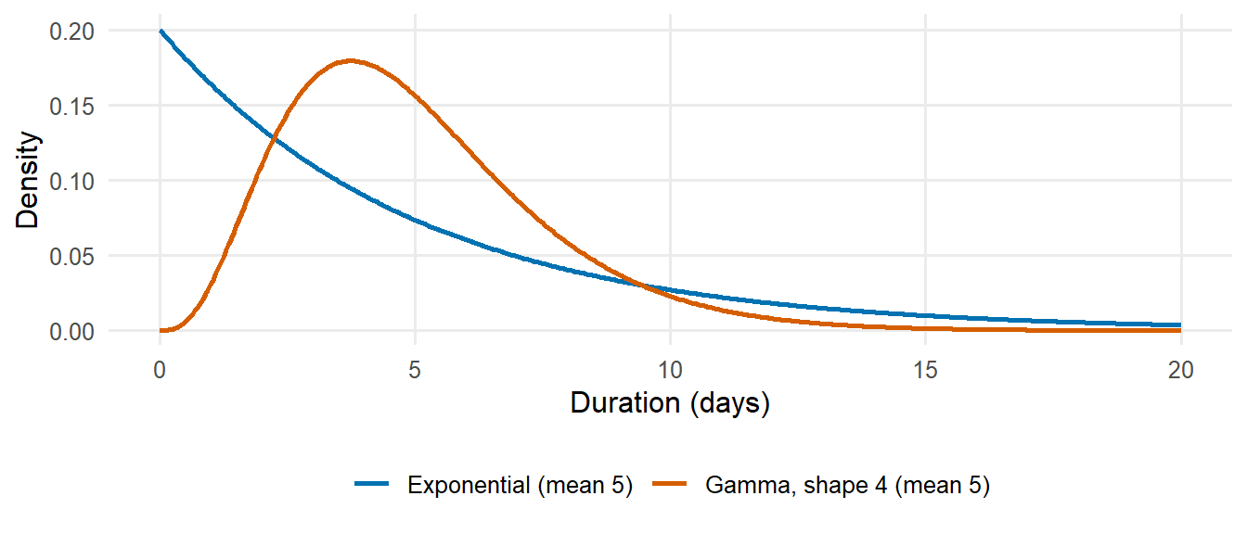
Figure 1: Exponential and gamma distributions with the same mean duration of 5 days. The exponential distribution, implied by a single compartment in an ODE model, assigns high probability to very short and very long durations.
The negative binomial distribution includes a dispersion parameter $k$; as $k$ increases, it approaches the Poisson distribution. Small values of $k$ correspond to counts that are more variable than expected under a Poisson model (overdispersion), which is common in surveillance data and in the number of secondary cases per case (course book: Stochastic models).

P2.4 Estimation and confidence intervals
A sample statistic, such as a proportion, estimates an unknown population value with sampling error. A 95% confidence interval is constructed such that, in repeated samples, 95% of such intervals would include the true value.
# Seroprevalence: 34 positive of 120 tested (exact binomial confidence interval)
binom.test(34, 120)$conf.int
## [1] 0.2048557 0.3728205
## attr(,"conf.level")
## [1] 0.95
# Incidence rate: 45 cases in 30,000 person-years (exact Poisson confidence interval)
poisson.test(45, T = 30000)$conf.int * 1e5 # per 100,000 person-years
## [1] 109.4110 200.7118
## attr(,"conf.level")
## [1] 0.95
Confidence intervals reflect random sampling error only; they do not account for systematic errors such as selection bias, misclassification or under-ascertainment.

P2.5 Likelihood
The likelihood expresses how probable the observed data are for a given value of a parameter. For 34 positives among 120 tested, the likelihood of a seroprevalence $p$ is the binomial probability $L(p)=\left({120 \atop 34}\right)p^{34}(1−p)^{86}$. The maximum likelihood estimate (MLE) is the value of $p$ that maximises $L(p)$; here it equals the observed proportion $34/120$. In practice the logarithm of the likelihood is used, as it is numerically more convenient.
log_lik <- function(p) dbinom(34, size = 120, prob = p, log = TRUE)
mle <- optimize(log_lik, interval = c(0.001, 0.999), maximum = TRUE)$maximum
c(mle = mle, observed = 34 / 120)
## mle observed
## 0.2833345 0.2833333
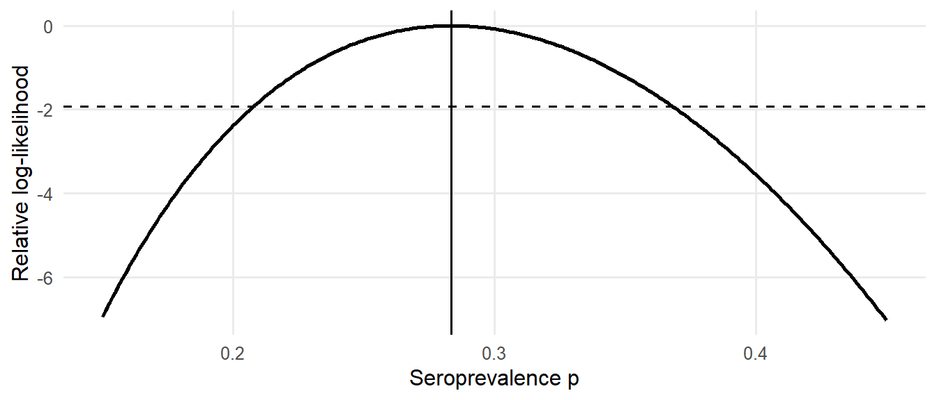
Figure 2: Log-likelihood of the seroprevalence $p$ given 34 positives among 120 tested, relative to its maximum. The maximum likelihood estimate is indicated by the vertical line; values above the dashed line form an approximate 95% confidence interval.
The same principle is used to estimate the parameters of transmission models: the model predicts the expected number of cases, and the parameters that maximise the likelihood of the observed counts are selected (course book: Linking models to data). Values of the parameter for which the log-likelihood is within 1.92 units of its maximum form an approximate 95% confidence interval (Figure 2). In Bayesian inference, the likelihood is combined with a prior distribution (course book: Bayesian model fitting).

P2.6 Regression models for count data
Poisson regression models the logarithm of the expected count as a linear function of explanatory variables. An offset equal to the logarithm of the population (or person-time) converts counts into rates; exponentiated coefficients are rate ratios.
set.seed(1)
districts <- tibble(
district = paste("District", 1:12),
population = round(runif(12, 50000, 300000)),
coverage = round(runif(12, 0.5, 0.95), 2) # vaccination coverage
) |>
mutate(cases = rpois(12, lambda = population * 2e-4 * exp(-3 * (coverage - 0.7))))
fit <- glm(cases ~ coverage + offset(log(population)), family = poisson, data = districts)
summary(fit)$coefficients
## Estimate Std. Error z value Pr(>|z|)
## (Intercept) -6.566844 0.3575204 -18.367747 2.380913e-75
## coverage -2.773596 0.4703854 -5.896434 3.714418e-09
exp(coef(fit)[["coverage"]] * 0.1) # rate ratio per 10-percentage-point increase in coverage
## [1] 0.7577819
Poisson regression on time is also used to estimate the growth rate of an epidemic from early case counts (course book: Estimation of the reproduction number from the growth rate). When counts are overdispersed, the standard errors of a Poisson model are too small; a quasi-Poisson (family = quasipoisson) or negative binomial model (MASS::glm.nb()) should then be used.
Exercise
- In a district of 80,000 inhabitants, 240 cholera cases and 6 deaths are reported during an outbreak lasting 10 weeks. Calculate the attack rate per 1,000 inhabitants and the CFR, with 95% confidence intervals.
- Using rnbinom(), simulate 1,000 weekly counts with mean 10 and dispersion $k$ = 2, and compare their variance with that of 1,000 Poisson counts with mean 10.
- A gamma distribution has mean 9 days and standard deviation 5 days. Calculate its shape and rate parameters, and the proportion of delays longer than 21 days. (Hint: shape = mean²/SD², rate = mean/SD².)

Solution
binom.test(240, 80000)$conf.int * 1000 # attack rate per 1,000
## [1] 2.632897 3.403844
## attr(,"conf.level")
## [1] 0.95
binom.test(6, 240)$conf.int # CFR
## [1] 0.009228601 0.053617475
## attr(,"conf.level")
## [1] 0.95
c(negbin = var(rnbinom(1000, mu = 10, size = 2)), poisson = var(rpois(1000, 10)))
## negbin poisson
## 61.016792 9.199243
shape <- 9^2 / 5^2; rate <- 9 / 5^2
c(shape = shape, rate = rate, p_over_21 = 1 - pgamma(21, shape, rate))
## shape rate p_over_21
## 3.24000000 0.36000000 0.02580851

P2.7 Self-assessment
- Distinguish risk, incidence rate and prevalence, and calculate each from data.
- Explain why the case fatality ratio depends on case ascertainment.
- Describe at least three characteristics of surveillance data that may bias analyses.
- Choose an appropriate distribution for a count or a delay, and evaluate it in R.
- Interpret a 95% confidence interval.
- Explain what a likelihood and a maximum likelihood estimate are.
- Interpret the coefficient of a Poisson regression model as a rate ratio.

P2.8 Additional resources
- Centers for Disease Control and Prevention (2012): Principles of Epidemiology in Public Health Practice, a free self-study course of the US Centers for Disease Control and Prevention (lessons 1–3 and 5 are particularly relevant).
- Giesecke (2017): Modern Infectious Disease Epidemiology — an introduction to the epidemiology of infectious diseases, including outbreak investigation and basic transmission concepts.
- Rothman (2012): Epidemiology: An Introduction — measures of disease frequency and effect.
- Kirkwood and Sterne (2003): Essential Medical Statistics — confidence intervals, rates, Poisson regression and likelihood (chapters on rates and on likelihood).
- Diez et al. (2019): OpenIntro Statistics — a free introductory statistics textbook (https://www.openintro.org/book/os/).
- Pawitan (2001): In All Likelihood — an advanced treatment of likelihood-based inference.
- PATH/MACEPA Foundational Epidemiology Knowledge (https://path-global-health.github.io/df-foundational-epi-skills/) — a short refresher on measures of disease frequency and association, study designs, measures of disease detection, standardisation and confounding, with a quiz and problem sets.

P3 Mathematical background
Preliminary learning — mathematics for infectious disease modelling
Learning objectives
By the end of this chapter, participants should be able to:
- Convert between rates, probabilities and mean durations, and calculate the probabilities of competing events.
- Describe exponential growth and decay, and calculate doubling times using logarithms.
- Interpret a derivative as a rate of change, and explain what a differential equation and its numerical solution are.
- Find the equilibria of a simple model and assess their stability.
- Multiply a matrix by a vector and interpret the dominant eigenvalue of a matrix.
- Solve equations and minimise functions numerically in R.

No mathematics beyond secondary-school level is assumed. The emphasis is on interpretation rather than on derivation: in this book, all equations are solved numerically in R.
library(tidyverse)

P3.1 Notation, exponentials and logarithms
Notation | Meaning
$\sum_{i=1}^{n}{x_{i}}$​ | the sum $x_{1}+x_{2}+…+x_{n}$
$e^{x}$, exp(x) | the exponential function, with $e≈2.718$
$lnx$, log(x) | the natural logarithm, the inverse of the exponential: $ln(e^{x})=x$
$\frac{dx}{dt}$​ | the derivative of $x$ with respect to time: the rate of change of $x$
$\int_{0}^{T}{f}(t) dt$​ | the integral of $f$ from 0 to $T$: the area under the curve
$λ$, $β$, $γ$, $σ$, $μ$ | Greek letters commonly used for rates (lambda, beta, gamma, sigma, mu)
Useful properties of logarithms are $ln(ab)=lna+lnb$, $ln(a^{b})=blna$ and $ln2≈0.693$. In R, log() is the natural logarithm and log10() the logarithm with base 10.

P3.2 Rates, probabilities and durations
A rate is the number of events per unit of time per individual at risk (e.g. recoveries per infectious person per day). A probability is dimensionless and refers to a specified period. If events occur at a constant rate $r$, then:
- the probability that the event occurs within a period $t$ is $p=1−e^{−rt}$;
- the mean time until the event is $1/r$;
- conversely, a probability $p$ over a period $t$ corresponds to the rate $r=−ln(1−p)/t$.
For small values of $rt$, $p≈rt$.
gamma <- 1 / 7 # recovery rate: mean infectious period of 7 days
1 - exp(-gamma * 1) # probability of recovery within one day
## [1] 0.1331221
1 - exp(-gamma * 7) # probability of recovery within 7 days (not 1!)
## [1] 0.6321206
p_annual <- 0.05 # 5% annual probability of an event
-log(1 - p_annual) # corresponding annual rate
## [1] 0.05129329
When an individual can leave a state through several routes with rates $r_{1},r_{2},…$ (competing events), the total exit rate is $r_{1}+r_{2}+…$, the mean time in the state is $1/(r_{1}+r_{2}+…)$, and the probability of leaving through route $i$ is $r_{i}/(r_{1}+r_{2}+…)$. For instance, if patients with active tuberculosis self-cure at rate 0.2 per year, die at rate 0.2 per year and are diagnosed and treated at rate 0.6 per year:
rates <- c(selfcure = 0.2, death = 0.2, diagnosis = 0.6)
1 / sum(rates) # mean duration of disease (years)
## [1] 1
rates / sum(rates) # probability of each outcome
## selfcure death diagnosis
## 0.2 0.2 0.6

P3.3 Exponential growth and decay
If each individual generates new individuals at a constant per capita rate $r$, the number grows exponentially:
$$N(t)=N_{0} e^{rt}.$$
With $r<0$ the number declines (exponential decay). Taking logarithms gives $lnN(t)=lnN_{0}+rt$, a straight line with slope $r$. This is why epidemic curves are often displayed on a logarithmic scale, and why the growth rate is estimated by regression of the logarithm of the counts on time (course book: Estimation of the reproduction number from the growth rate). The doubling time follows from $e^{rT_{d}}=2$:
$$T_{d}=\frac{ln2}{r}.$$
r <- 0.1 # growth rate per day
log(2) / r # doubling time (days)
## [1] 6.931472
exp(r * 30) # multiplication factor after 30 days
## [1] 20.08554
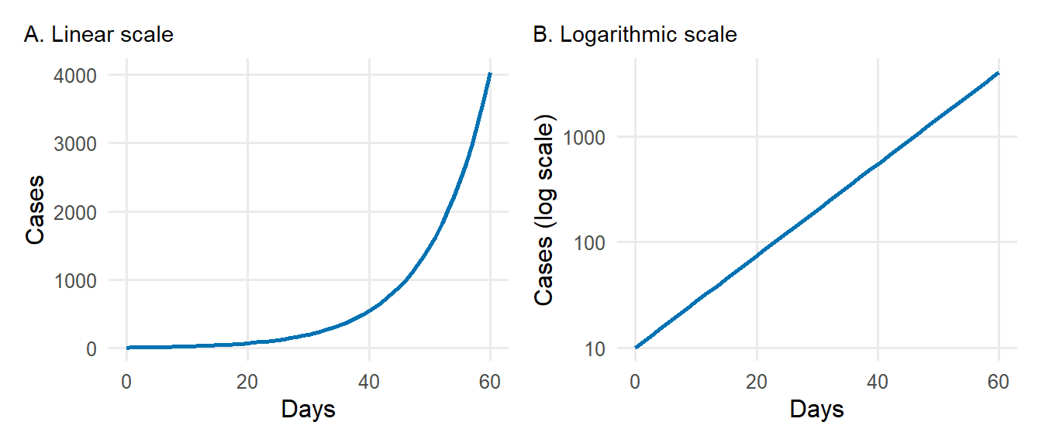
Figure 3: Exponential growth with $r$ = 0.1 per day on a linear scale (A) and a logarithmic scale (B). On the logarithmic scale, exponential growth appears as a straight line with slope $r$.

P3.4 Derivatives: rates of change
The derivative $\frac{dx}{dt}$ is the instantaneous rate of change of a quantity $x$ with respect to time: the slope of the curve $x(t)$ at time $t$. It can be approximated by the change over a short interval $h$:
$$\frac{dx}{dt}≈\frac{x(t+h)−x(t)}{h}.$$
Two results are sufficient for this book:
- the derivative of a constant is zero;
- the derivative of $N_{0}e^{rt}$ is $rN_{0}e^{rt}$, i.e. $r$ times the function itself. Exponential growth is therefore the solution of $\frac{dN}{dt}=rN$.
N_fun <- function(t) 10 * exp(0.1 * t)
h <- 1e-4
(N_fun(20 + h) - N_fun(20)) / h # numerical derivative at t = 20
## [1] 7.389093
0.1 * N_fun(20) # exact derivative: r * N(20)
## [1] 7.389056

P3.5 Differential equations and their numerical solution
A differential equation specifies the rate of change of a quantity as a function of the quantity itself and of time, for instance $\frac{dI}{dt}=βSI/N−γI$. Its solution is the function $I(t)$ that satisfies the equation for given initial values. Compartmental models consist of a system of such equations, one for each compartment (course book: The SIR model).
Most systems of differential equations cannot be solved analytically and are solved numerically. The simplest method, Euler’s method, advances the solution in small time steps $h$, using the derivative to approximate the change during each step:
$$x(t+h)≈x(t)+h \frac{dx}{dt}(t).$$
The following code applies Euler’s method to $\frac{dN}{dt}=0.1N$, for which the exact solution $N(t)=10e^{0.1t}$ is known:
euler <- function(h, t_end = 30, N0 = 10, r = 0.1) {
times <- seq(0, t_end, by = h)
N <- numeric(length(times)); N[1] <- N0
for (k in 2:length(times)) {
N[k] <- N[k - 1] + h * r * N[k - 1] # x(t + h) = x(t) + h * dx/dt
}
tibble(time = times, N = N, step = paste("h =", h))
}
c(euler_h5 = last(euler(5)$N), euler_h1 = last(euler(1)$N),
euler_h0.1 = last(euler(0.1)$N), exact = 10 * exp(0.1 * 30))
## euler_h5 euler_h1 euler_h0.1 exact
## 113.9062 174.4940 197.8847 200.8554
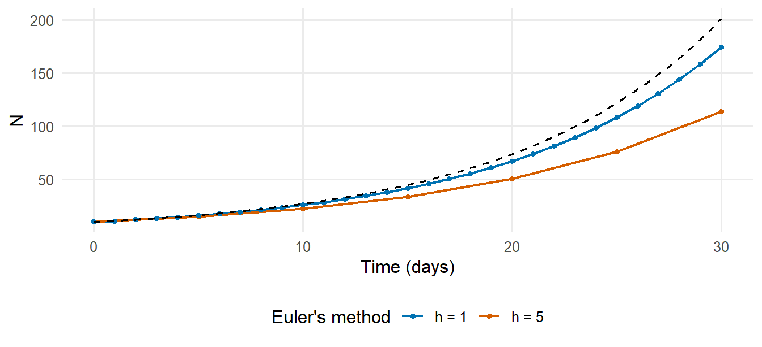
Figure 4: Numerical solution of $dN/dt=0.1N$ by Euler’s method with step sizes of 5 and 1 days, compared with the exact solution. Smaller steps give more accurate solutions.
The error of Euler’s method decreases as the step size decreases. The function ode() of the deSolve package, used throughout this book, applies more accurate methods that adapt the step size automatically (course book: Solving the SIR model in R). The discrete-time SIR model of course book: From model equations to code is equivalent to Euler’s method with a step of one day.

P3.6 Equilibria and stability
An equilibrium is a state in which all derivatives are zero, so that the system no longer changes. Consider the SIS model, in which infected individuals return to the susceptible state on recovery:
$$\frac{dI}{dt}=βI\frac{N−I}{N}−γI.$$
Setting $\frac{dI}{dt}=0$ gives two equilibria: $I^{*}=0$ (no infection) and $I^{*}=N(1−γ/β)=N(1−1/R_{0})$, with $R_{0}=β/γ$. The second equilibrium exists (is positive) only if $R_{0}>1$.
An equilibrium is stable if the system returns to it after a small perturbation. This can be assessed from the sign of the derivative near the equilibrium: in Figure 5, $dI/dt$ is positive below the endemic equilibrium and negative above it, so that $I$ moves towards the endemic equilibrium from either side, which is therefore stable; the disease-free equilibrium is unstable when $R_{0}>1$.
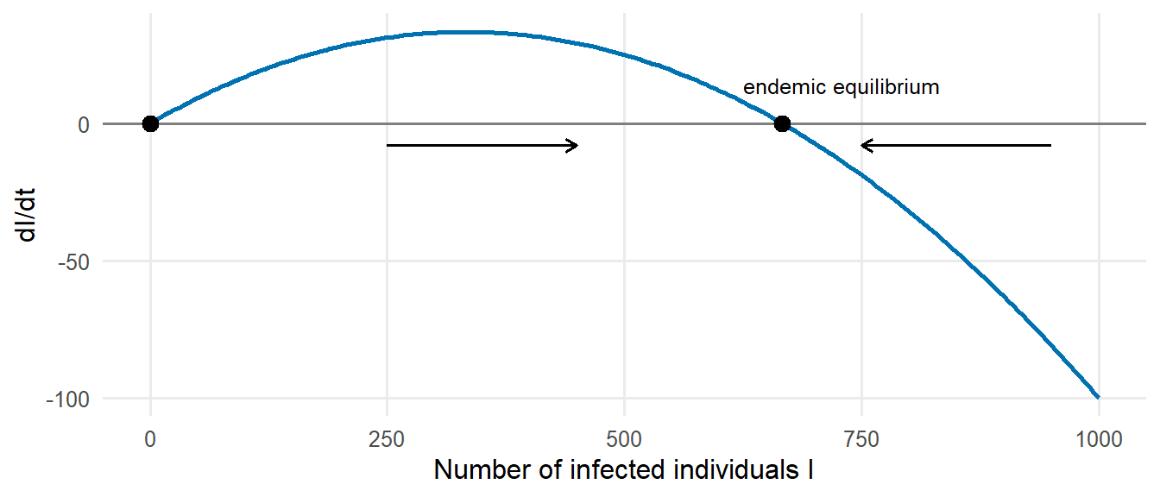
Figure 5: Rate of change $dI/dt$ as a function of the number of infected individuals $I$ in the SIS model ($β$ = 0.3, $γ$ = 0.1 per day, $N$ = 1,000; $R_{0}$ = 3). Equilibria (points) occur where $dI/dt=0$; arrows indicate the direction of change.

P3.7 Integrals: from rates to totals
The integral of a rate over time gives a total. For example, the cumulative number of infections between times 0 and $T$ is the integral of the incidence, i.e. the area under the incidence curve. When a function is available at regular time points, the integral is approximated by the sum of the values multiplied by the time step:
dt <- 0.25
t <- seq(0, 10, by = dt)
incidence <- 100 * exp(-0.3 * t) # new cases per day
sum(incidence) * dt # approximate cumulative cases
## [1] 330.0084
100 / 0.3 * (1 - exp(-0.3 * 10)) # exact integral
## [1] 316.7376

P3.8 Vectors and matrices
Models with several population groups (age groups, districts, risk groups) use vectors and matrices. A matrix–vector product combines each row of the matrix with the vector: if $C$ is a contact matrix and $y$ a vector of the proportions infectious in each group, then the product $Cy$ gives the number of infectious contacts made by an individual in each group.
C <- matrix(c(12, 4, # contacts of children with children, adults
3, 8), # contacts of adults with children, adults
nrow = 2, byrow = TRUE,
dimnames = list(c("children", "adults"), c("children", "adults")))
prop_infectious <- c(children = 0.02, adults = 0.005)
C %*% prop_infectious # infectious contacts per day, by group
## [,1]
## children 0.26
## adults 0.10
For a square matrix $K$, an eigenvalue $ρ$ and eigenvector $v$ satisfy $Kv=ρv$: multiplication by $K$ only rescales $v$. If $K$ is the next-generation matrix, whose element $K_{ij}$ is the number of infections in group $i$ caused by one infectious individual in group $j$, then repeated multiplication describes successive generations of infection. After a few generations, the number of cases is multiplied in each generation by the dominant eigenvalue of $K$, which is therefore the basic reproduction number $R_{0}$ (course book: Adding realism to models).
K <- matrix(c(2.0, 0.5,
0.6, 0.8), nrow = 2, byrow = TRUE)
eigen(K)$values # the dominant (largest) eigenvalue is R0
## [1] 2.2124038 0.5875962
cases <- c(1, 0) # one infected child
for (g in 1:6) {
new_cases <- K %*% cases
cat("generation", g, ": ratio =", round(sum(new_cases) / sum(cases), 3), "\n")
cases <- new_cases
}
## generation 1 : ratio = 2.6
## generation 2 : ratio = 2.3
## generation 3 : ratio = 2.235
## generation 4 : ratio = 2.218
## generation 5 : ratio = 2.214
## generation 6 : ratio = 2.213

P3.9 Solving equations and optimisation numerically
Two numerical tasks occur repeatedly in this book:
- finding the root of an equation, i.e. the value at which a function equals zero, with uniroot() — for instance the final size equation $z=1−e^{−R_{0}z}$ (course book: The SIR model);
- minimising or maximising a function, with optimize() (one parameter) or optim() (several parameters) — for instance to estimate model parameters by maximum likelihood (course book: Linking models to data).
# Root: final size for R0 = 2
uniroot(function(z) z - (1 - exp(-2 * z)), interval = c(0.01, 1))$root
## [1] 0.7968216
# Minimisation: the value of a that minimises (a - 3)^2 + 1
optimize(function(a) (a - 3)^2 + 1, interval = c(0, 10))$minimum
## [1] 3
Exercise
- The mean duration of infectiousness of measles is 8 days. Calculate the daily recovery rate and the probability that an infectious person is still infectious after 14 days.
- During the early phase of an outbreak, cases double every 4 days. Calculate the growth rate $r$, and the number of cases after 3 weeks if there are 20 cases today.
- Apply Euler’s method with a step of one day to the equation $\frac{dI}{dt}=−0.2I$ with $I(0)=100$, over 20 days, and compare with the exact solution $100e^{−0.2t}$.
- Calculate the endemic equilibrium of the SIS model for $β=0.25$, $γ=0.2$ and $N=10,000$.
- Calculate $R_{0}$ for the next-generation matrix $K=\left(\begin{matrix}1.5 & 0.3 \\ 0.4 & 0.6\end{matrix}\right)$.

Solution
# 1
rate <- 1 / 8; c(rate = rate, p_still_infectious = exp(-rate * 14))
## rate p_still_infectious
## 0.1250000 0.1737739
# 2
r <- log(2) / 4; c(r = r, cases_after_21_days = 20 * exp(r * 21))
## r cases_after_21_days
## 0.1732868 761.0925536
# 3
I <- numeric(21); I[1] <- 100
for (k in 2:21) I[k] <- I[k - 1] + 1 * (-0.2 * I[k - 1])
c(euler = I[21], exact = 100 * exp(-0.2 * 20))
## euler exact
## 1.152922 1.831564
# 4
10000 * (1 - 0.2 / 0.25)
## [1] 2000
# 5
max(eigen(matrix(c(1.5, 0.3, 0.4, 0.6), 2, byrow = TRUE))$values)
## [1] 1.617891

P3.10 Self-assessment
- Convert a mean duration into a rate, and a rate into a probability over a given period.
- Calculate the probabilities of competing events.
- Calculate a doubling time from a growth rate, and vice versa.
- Explain in words what $\frac{dS}{dt}=−βSI/N$ means.
- Explain how a differential equation is solved numerically, and why the step size matters.
- Find the equilibria of a one-dimensional model by setting the derivative to zero.
- Compute a matrix–vector product and the eigenvalues of a matrix in R.

P3.11 Additional resources
- Vynnycky and White (2010), chapters 2–3 and their online model files — an introduction to the mathematics of infectious disease models, written for epidemiologists.
- Otto and Day (2007): A Biologist’s Guide to Mathematical Modeling in Ecology and Evolution — a thorough introduction to differential equations, equilibria, stability and matrices for life scientists (chapters 1–5 and the primers on calculus and linear algebra).
- Bodine et al. (2014): Mathematics for the Life Sciences — calculus and linear algebra with biological applications.
- Strogatz (2015): Nonlinear Dynamics and Chaos — an accessible treatment of equilibria and stability (chapters 1–2) for participants who wish to study further.
- OpenStax, Precalculus 2e, chapter 6 (Exponential and logarithmic functions) — a free introductory textbook (https://openstax.org/details/books/precalculus-2e).
- Imperial College London, Infectious Disease Modelling specialisation (Coursera; free to audit), in particular the first course, which introduces differential equations through the SIR model (https://www.coursera.org/specializations/infectious-disease-modelling).
- Khan Academy, courses on exponential functions, logarithms, differential calculus and matrices (https://www.khanacademy.org/math).

Appendix A — Installation of R and RStudio

A.1 R and RStudio
- Install R (version 4.4 or later) from https://cran.r-project.org, selecting the appropriate operating system (for Windows: Download R for Windows → base).
- Install RStudio Desktop (free of charge) from https://posit.co/download/rstudio-desktop/.
- Open RStudio. R runs within RStudio and does not need to be opened separately.
Where software cannot be installed locally, Posit Cloud (https://posit.cloud) can be used in a web browser.

A.2 Packages
The following code installs all packages used in the course. Installation requires an internet connection and takes approximately 5–15 minutes.
packages <- c(
"tidyverse", # data management and visualisation
"deSolve", # differential equations (compartmental models)
"outbreaks", # historical outbreak datasets
"fitdistrplus", # fitting of delay distributions
"EpiEstim", # time-varying reproduction number
"epichains", # branching processes
"finalsize", # final size in age-structured populations
"socialmixr", # social contact matrices
"coda", # MCMC diagnostics
"patchwork", # combination of figures
"knitr", "rmarkdown"
)
install.packages(setdiff(packages, rownames(installed.packages())))
The installation can be verified with a small SIR model:
library(deSolve)
out <- ode(y = c(S = 999, I = 1, R = 0), times = 0:50,
func = function(t, y, p) with(as.list(c(y, p)), {
list(c(-b * S * I / 1000, b * S * I / 1000 - g * I, g * I))
}),
parms = c(b = 0.5, g = 0.25))
plot(out)
The installation is successful if three plots (S, I and R against time) are displayed.

A.3 Course materials
The materials of the course itself are available at https://github.com/Federica-Giardina/TIMERA (Code → Download ZIP). After unzipping, the folder should be opened as an RStudio Project (File → New Project → Existing Directory).

A.4 Datasets
All datasets used in Module 1 can be downloaded as CSV files in a single archive, TIMERA-datasets.zip, which also contains a description of each dataset and its source. The CSV files can be opened in R, Excel or any statistical software.

References
Bodine, Erin N., Suzanne Lenhart, and Louis J. Gross. 2014. Mathematics for the Life Sciences. Princeton University Press.
Centers for Disease Control and Prevention. 2012. Principles of Epidemiology in Public Health Practice: An Introduction to Applied Epidemiology and Biostatistics. 3rd ed. U.S. Department of Health; Human Services, CDC.
Diez, David, Mine Çetinkaya-Rundel, and Christopher D. Barr. 2019. OpenIntro Statistics. 4th ed. OpenIntro. https://www.openintro.org/book/os/.
Giesecke, Johan. 2017. Modern Infectious Disease Epidemiology. 3rd ed. CRC Press.
Kirkwood, Betty R., and Jonathan A. C. Sterne. 2003. Essential Medical Statistics. 2nd ed. Blackwell Science.
Otto, Sarah P., and Troy Day. 2007. A Biologist’s Guide to Mathematical Modeling in Ecology and Evolution. Princeton University Press.
Pawitan, Yudi. 2001. In All Likelihood: Statistical Modelling and Inference Using Likelihood. Oxford University Press.
Rothman, Kenneth J. 2012. Epidemiology: An Introduction. 2nd ed. Oxford University Press.
Strogatz, Steven H. 2015. Nonlinear Dynamics and Chaos: With Applications to Physics, Biology, Chemistry, and Engineering. 2nd ed. CRC Press.
Vynnycky, Emilia, and Richard G. White. 2010. An Introduction to Infectious Disease Modelling. Oxford University Press.

