**Login Test Page Task**

**Frameworks and Libraries**

This project has been developed in TypeScript with a ReactJS code base.

<https://reactjs.org/docs/getting-started.html>

<https://www.typescriptlang.org/docs/handbook/react.html>

The Login Form itself has been developed by using Material UI, one of the most useful and powerful UI frameworks for React, and Formik which allows to easily create completely working and Forms.

<https://material-ui.com/>

<https://formik.org/docs/overview>

Project handling has been rendered simpler and very intuitive thanks to Yarn Package Manager.

<https://yarnpkg.com>/

ReactJS provides easy and intuitive templates thanks to

*"*y*arn create-react-app"*   
Or

*“yarn create react-app my-app --template typescript*”

that has been used in this case to take profit of the powerful and intuitive combination of ReactJS itself and Typescript.

**UI building**

Material UI is probably one of the most used and useful UI libraries for React and web development.

Several already built components, easily customizable can meet every developer’s need.

In this project was used to create the most of UI’s element such as :

Which is our content surface and hosts our form.

Which is a native UI element from Material UI.

Once Ui’s components were created the need to develop a fast and easy way to manage our Form Fields where to enter data and in this case Formik provided a light way to create the form fields.

Formik provides help, also in managing spaces for the fields themselves.

MyField.tsx is the component created to have the UI appear like this: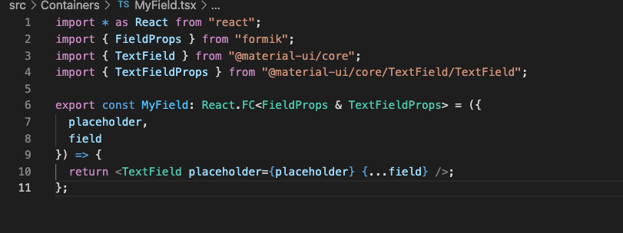



The workflow to create the Card and the Form component is easy to recognize inside MyForm.tsx file.

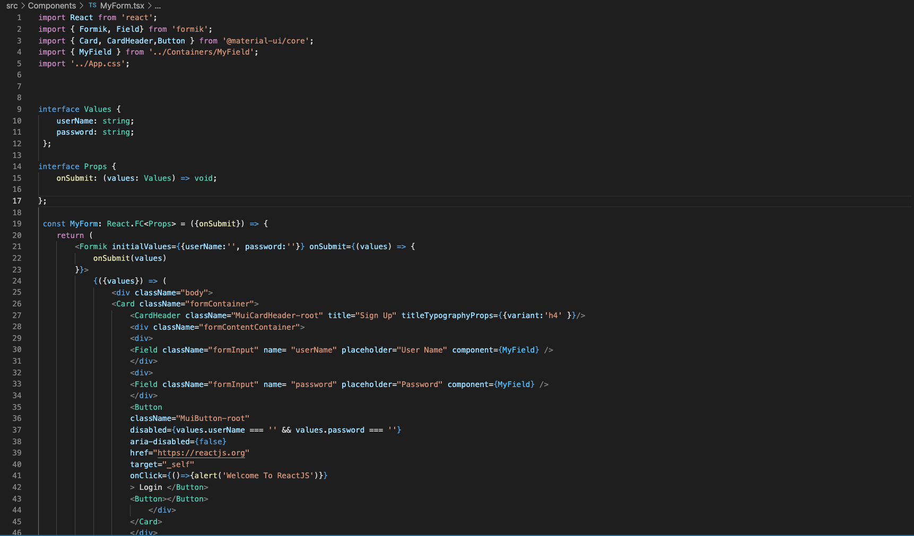Thanks to the <Formik> component is even possibile to manage the initialState of the form which is empty at the very beginning, but once we click in the fields it becomes possible to write inside our data to log-in to pur personal page.