Homework 6 – Federico Capaldo

The following screenshots are of the output my main.cpp, in which I created 8 Shapes as required by the homework, drew them and in the end printed the total area.

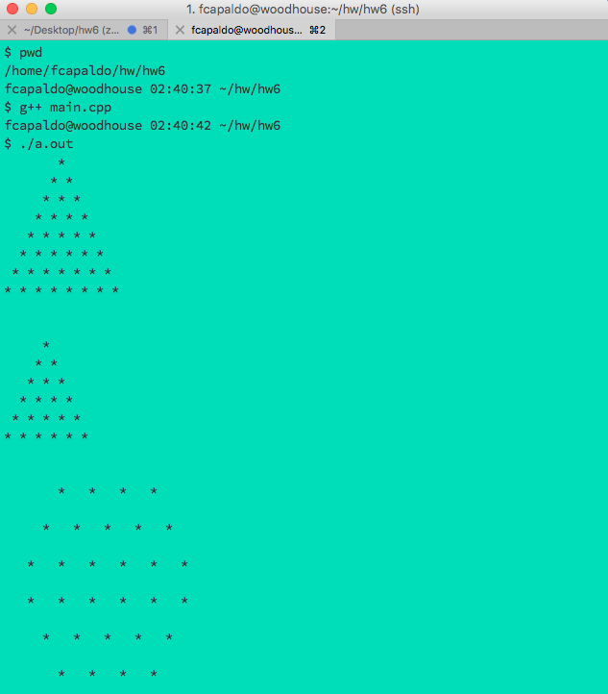





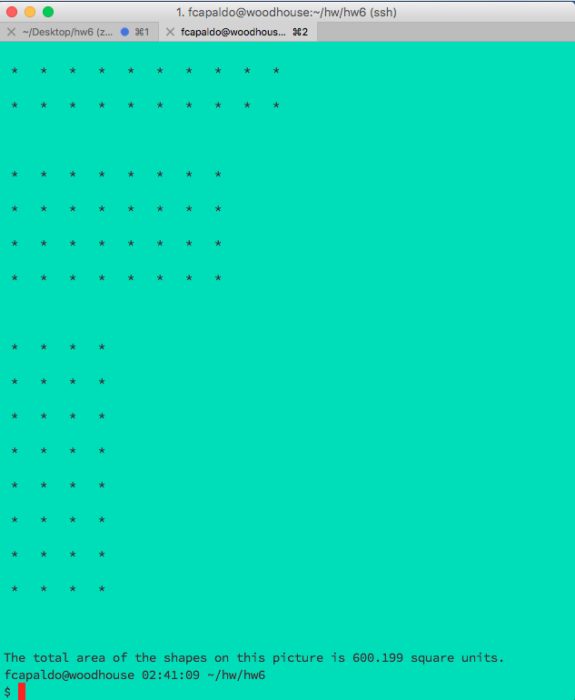

Note the last line which contains the message of the total area, where the actual area is calculated dynamically based on the shapes added to the Picture object.

Valgrind Report: Destructor was successfully implemented and there are no memory leaks.

