**FEDERICO LUGLI**

**Case Objective**

Nick Thomas, CEO of Auto Concepts, a new division focused on innovative automobile models aligned with the US Department of Energy's clean fuels initiative and IoT technology, is seeking direction for design decisions. To gauge consumer attitudes towards fuel prices, global warming, and design preferences, he's engaged CMG Research, led by Cory Rodgers, to conduct a survey using an online panel. The survey aims to understand if consumers prefer standard, hybrid, or radically different models promising higher fuel economy. With the survey data now collected, Cory assigns data analyst Celeste Brown to conduct descriptive analysis to identify patterns and variability. The dataset represents a cross-section of American households, including vehicle owners and non-owners, for market insights relevant for the next 3-5 years.

|  |  |  |
| --- | --- | --- |
| **Question Description** | **Codes** | **Value Labels** |
| Size of Hometown or city | 1,2,3,4,5 | Under 10k, 10k to 100k, 100k to 500k, 500k to 1 million, 1 million and more |
| Gender | 0,1 | Male, Female |
| Marital Status | 0, 1 | Unmarried, married |
| No. of people in family | Actual Number | No labels |
| Age Category | 1, 2, 3, 4, 5 | 18 to 24, 25 to 34, 35 to 44, 45 to 54, 55 to 64, 65  and older |
| Education Category | 1, 2,3 ,4, 5 | Less than high school, high school diploma, some college, college degree, postgraduate degree |
| Income Category | 1, 2, 3, 4, 5 | Under $25k, $25k to 49k, $50k to $74k, $75k to $125k, $125k and more |
| Dwelling type | 1, 2, 3, 4 | Single family, Multiple family, Condominium/ townhouse, Mobile home |
| I am worried about global warming  Gasoline emission contributes to global warming  We need to do something to slow global warming  We should be looking for gasoline substitutes | 1, 2, 3, 4, 5, 6, 7 | Very strongly disagree, strongly disagree, Disagree, Neither disagree nor agree, Agree, Strongly agree, Very strongly agree |
| Desirability: 1-seat motorcycle electric  Desirability: 2-seat runabout sport electric  Desirability: 2-seat runabout hatchback gasoline hybrid  Desirability: 4-seat economy diesel hybrid  Desirability: 5-seat economy gasoline | 1, 2, 3, 4, 5, 6, 7 | Very undesirable, Undesirable, Somewhat desirable, Neutral, Somewhat desirable, Desirable, Very desirable |
| Lifestyle: Novelist  Lifestyle: Innovator  Lifestyle: Trendsetter  Lifestyle: Forerunner  Lifestyle: Mainstreamer  Lifestyle: Classic | 1,........,7 | Doesn’t describe me at all……. Describes me perfectly |
| Favourite television  show type | 1, 2, 3, 4, 5, 6, 7 | Comedy, Drama, Movies/mini-series, News/ documentary, Reality, Science fiction, Sports |
| Favorite radio genre | 1, 2, 3, 4, 5, 6 | Classic pop & rock, Country, Easy listening, Jazz & Blues, Pop & chart, Talk |
| Favorite magazine type | 1, 2, 3, 4, 5, 6, 7, 8 | Business & MOney, Music and Entertainment, Family and Parenting, Sports & Outdoors, Home & Garden,  Cooking-Food & Wine, Trucks-cars & Motorcycle, News -Politics & Current Events |
| Favourite local Newspaper section | 1, 2, 3, 4, 5, 6, 7 | Editorial, Business, Local News, National News, Sports, Entertainment, Do not read |
| Use of online blogs  Use of content communities  Use of social network sites  Use online games  Use of virtual worlds | 0, 1, 2, 3 | Never, 1- 2 time per day, 3- 4 times per day, 5+ times per day |

*CMG Market Research hires a new intern*

On your first day as a marketing intern at CMG Research, having impressed with your Excel skills and data analysis knowledge, you're tasked with a pressing project for Auto Concepts. Cory Rodgers, alongside Celeste Brown, needs further analysis for a survey in its final stages, focusing on model definitions for potential multi-million dollar developments. Despite it being your first day, expectations are high for you to deliver additional insights. With Cory and Celeste away for three days, they're available via call, text, or email for any queries. A meeting is set for Thursday at 9 AM to review your findings.

1. **Comment if segmenting the market based on “Marital Status” is important for Nick Thomas.**

To ascertain the significance of "marital status" in influencing car choices, I opted to conduct a T-test. The selected alpha level for this analysis was 0.01. The null hypothesis posited that "marital status has no impact on the preference for the chosen car type."

*Cartype: supercycle1seat*

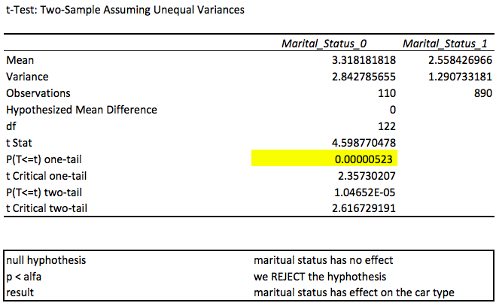

*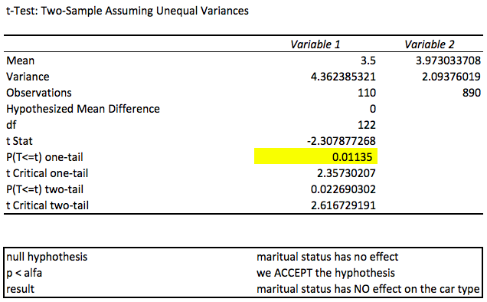Cartype: runaboutsport2seat*

*Cartype: runaboutstowage2seat*

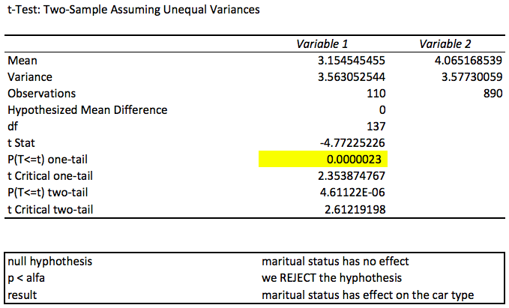

**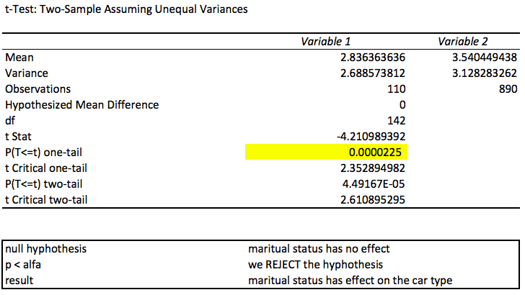***Cartype: economyhybrid4seat*

*Cartype: economygas4seat*

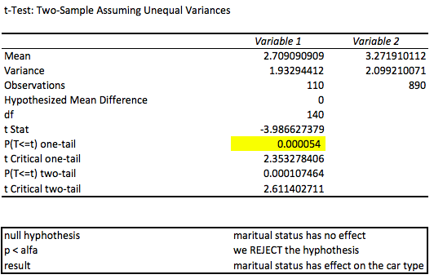

1. **Comment if “car type” has an influence on the desirability of each car model.**

To assess the desirability of each car model, I conducted an Analysis of Variance (ANOVA) test. I set the alpha value at 0.01, and our chosen null hypothesis posited that "the type of car has no significant effect on the desirability of the car model."

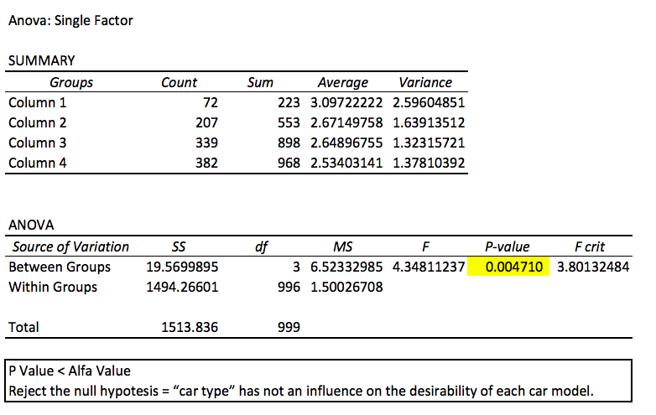*Cartype: supercycle1seat*

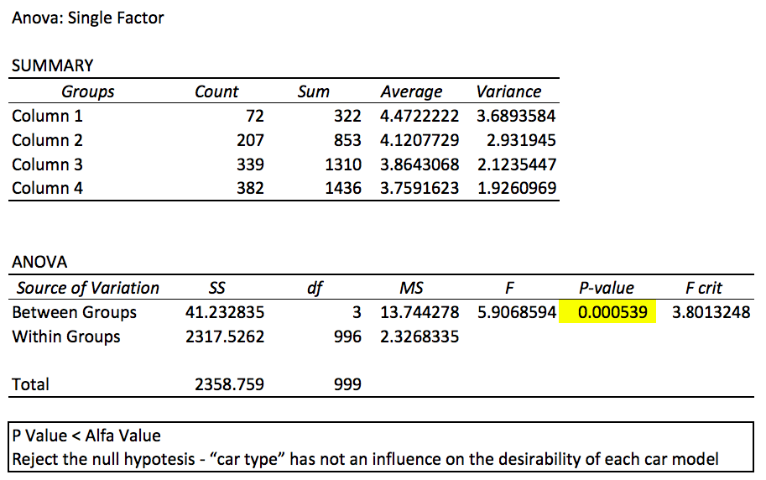*Cartype: runaboutsport2seat*

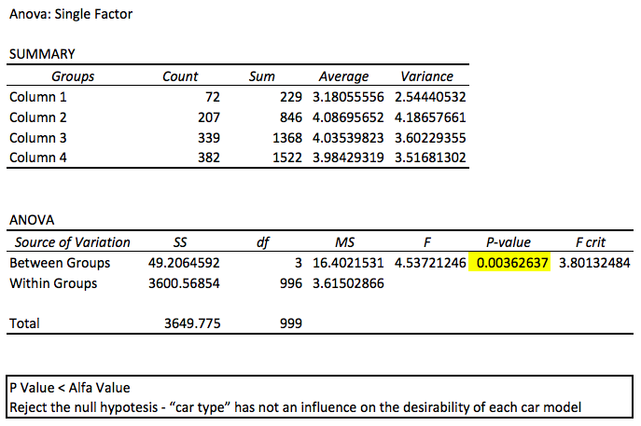*Cartype: runaboutstowage2seat*

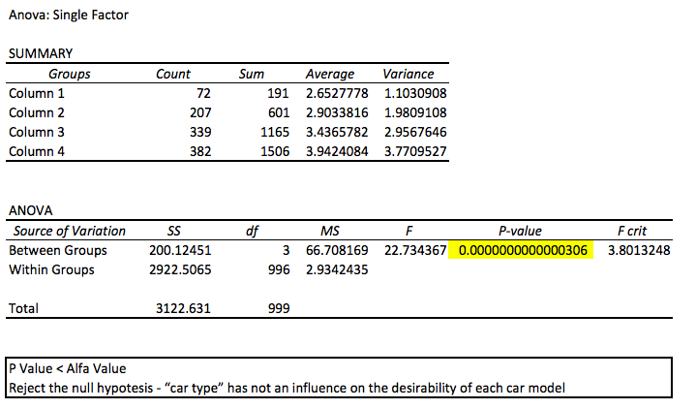*Cartype: economyhybrid4seat*

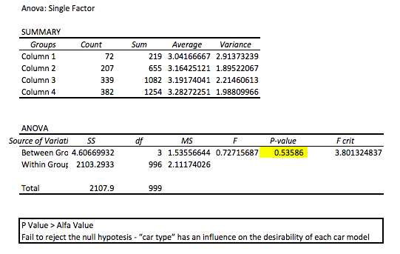*Cartype:* *economygas4seat*

1. **List the statistically significant independent variables (use 95% level of confidence).**

To understand the statistically significant independent variables, I have been doing a regression analysis.

***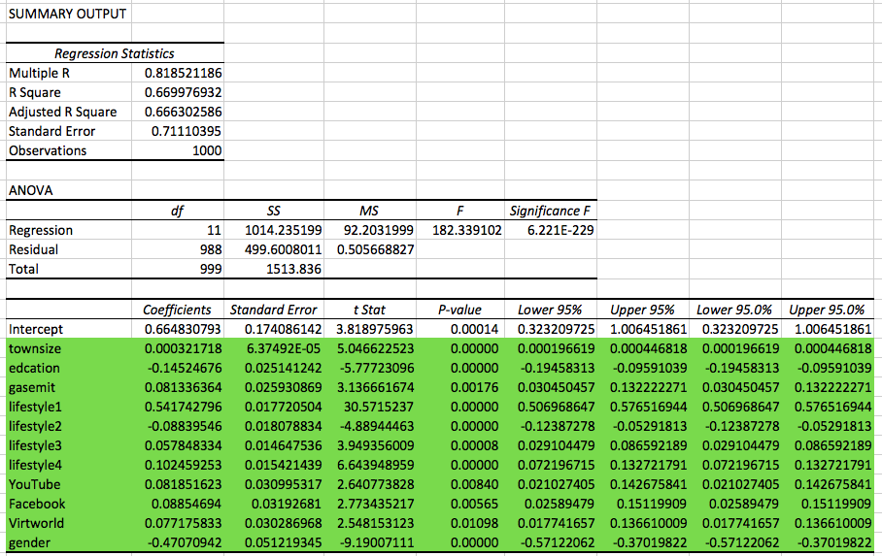****Cartype: supercycle1seat*

*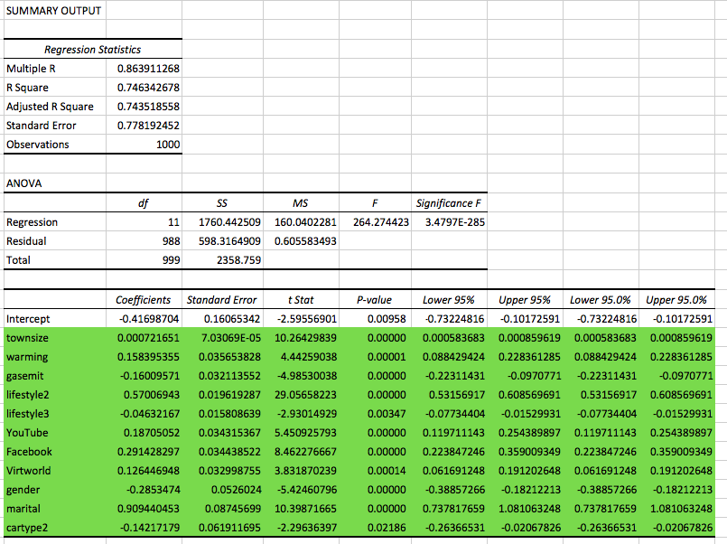Cartype: runaboutsport2seat*

*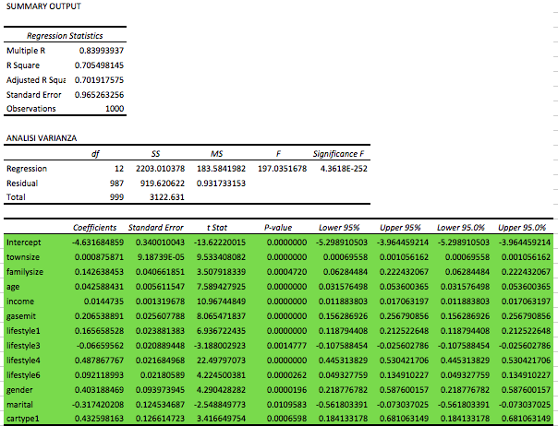Cartype: runaboutstowage2seat*

*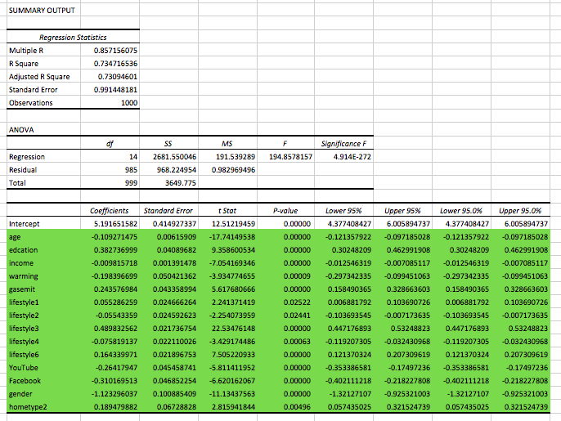Cartype: economyhybrid4seat*

*Cartype: economygas4seat*

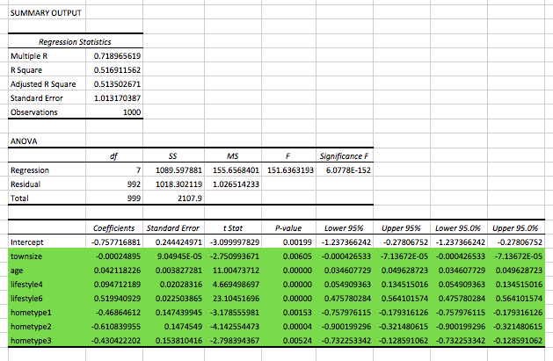

1. **Interprets the directional of the relationship of each statistically significant independent variable with respect to the preference for the hybrid model concerned.**

The below chart show the final significant independent variables for the hybrid model. By examining the Beta values or Coefficient values presented in the table, a distinct pattern emerges. Notably, variables such as "Lifestyle3" and "Marital," highlighted in red, exhibit a negative impact on preference. Conversely, the variables highlighted in green showcase a positive influence on preference.

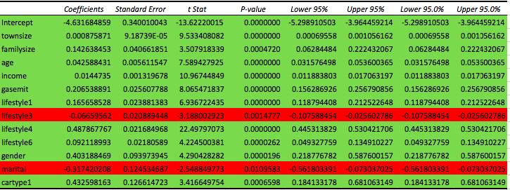

1. **Identifies or distinguishes the relative importance of each of the statistically significant independent variables.**

*Cartype: Supercycle1seat*

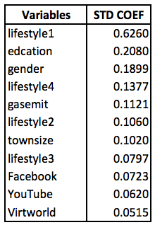

*Cartype: Runaboutsport2seat*

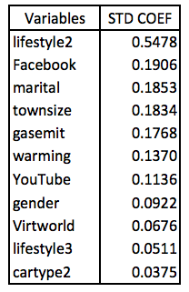

*Cartype: Runaboutstowage2seat*

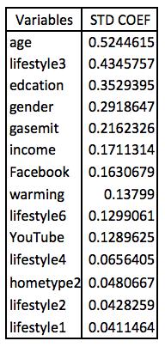

*Cartype: Economyhybrid4seat*

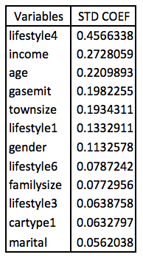

*Cartype: Economygas4seat*

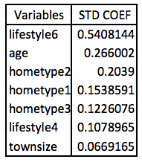

1. **Assesses the strength of the statistically significant independent variables as they join to predict the preferences for the hybrid model concerned.**

Desirability=−4.6317+0.00088×townsize+0.1426×familysize+0.0426×age+0.0145×income+0.2065×gasemit+0.1657×lifestyle1−0.0666×lifestyle3+0.4879×lifestyle4+0.0921×lifestyle6+0.4032×gender−0.3174×marital+0.4326×cartype1

*Town Size (townsize):*

Assessment: There is a statistically significant positive relationship between town size and desirability. However, the effect is very small.

Family Size (familysize):

Assessment: There is a statistically significant positive relationship between family size and desirability. A larger family size is associated with higher desirability.

*Age:*

Assessment: There is a statistically significant positive relationship between age and desirability. As age increases, desirability tends to increase.

*Income:*

Assessment: There is a statistically significant positive relationship between income and desirability. Higher income is associated with higher desirability.

*Gas Emission (gasemit):*

Assessment: There is a statistically significant positive relationship between gas emission and desirability. Higher gas emission is associated with higher desirability.

*Lifestyle Factors (lifestyle1, lifestyle3, lifestyle4, lifestyle6):*

Assessment: These lifestyle factors show statistically significant relationships with desirability. The specific impact depends on the factor, and coefficients indicate the direction and magnitude of the effect.

*Gender:*

Assessment: There is a statistically significant positive relationship between gender and desirability. Being of a certain gender is associated with higher desirability.

*Marital Status (marital):*

Assessment: There is a statistically significant negative relationship between marital status and desirability. Being married is associated with lower desirability.

*Car Type 1 (cartype1):*

Assessment: There is a statistically significant positive relationship between having car type 1 and desirability.

1. **Comment on the target audience for each car model.**

