IBM – Machine Learning with Python - Coursera
Apuntes
Week 1
Machine Learning is the subfield of computer science that gives “computers the ability to learn without being explicitly programmed".
Machine Learning is the branch of AI that covers the statistical part of artificial intelligence, it teaches the computer to solve problems by looking at data, learning from them and then using that experience to solve that same problem in different situations.
Deep Learning is a very special field of Machine Learning, where computers can learn and make intelligent decisions on their own. It involves a deeper level of automation in comparison with most Machine Learning algorithms.
Python is a powerful general purpose programming language that recently emerged as the preferred language of data scientists.
Python libraries for Machine Learning: Numpy (math library to work with n dimensional arrays in Python), SciPy (collection of numerical algorithms and domain specific toolboxes), matplotlib (plotting package), Pandas (provides high performance, easy to use data structures; importing, manipulating numerical tables and time series), Skicit Learn (collection of algorithms and tools for Machine Learning; data preprocessing, train/test split, algorithm setup, model fitting, prediction, evaluation, model export)
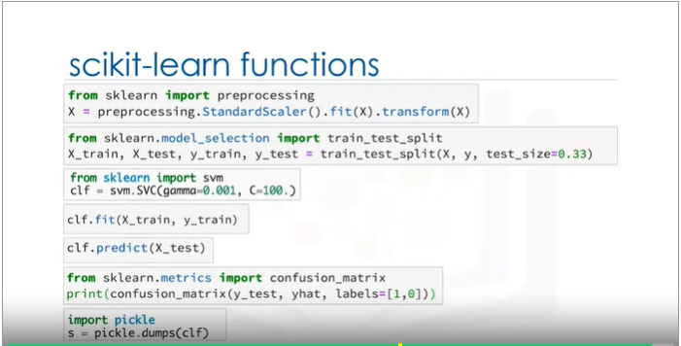

Supervised v. Unsupervised.
Week 2
Linear Regression
Dependent variable vs independent variables.
Continuous vs discrete values.
Simple regression vs multiple regression.
Linear vs non-linear models.
Estimated parameters.
Minimize mean squared error.
Model evaluation: train_test_split. Metrics: accuracy (error – observed vs predicted), mean absolute error, mean squared error, root mean squared error, relative absolute error, relative squared error, R-squared.
Training accuracy: Not necessarily a good thing. You can be overfitting the model to the training set, which may capture noise and produce a non-generalized model.
Out of sample accuracy: On data that the model has not been trained on (test data).
K-fold-cross-validation
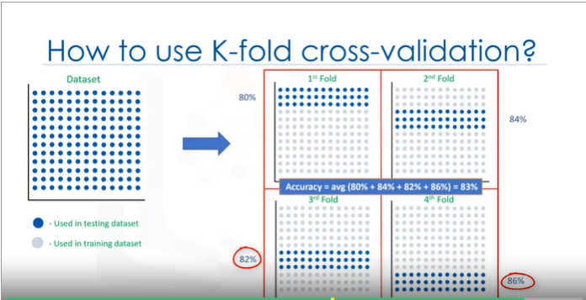

Multiple Linear Regression
Interpretacion de los efectos parciales.
Prediccion puntual, prediccion por intervalos.
Forma matricial.
Metodos de estimacion: minimos cuadrados ordinarios. Cuando n < 10.000 funciona bien, pero sino la capacidad computacional requerida es demasiado. Gradient descent n > 10.000.
Principio de parsimonia.
Dummies.
Non-linear regression – Polynomial Regression
Complex relation between y and X’s.
Linealidad en los parametros vs linealidad en las variables. ( en los parametros).
We cannot use ordinary least squares.
Plot the dependent variable to each independent variable. Calculate the correlation coefficient between independent and dependent variable, if it is 0.7 or higher there is a linear tendency. Transform your data if a linear relation does not apply. Specification.

Week 3
Classification
A supervised learning approach. A means for categorizing some unknown items into a discrete set of categories or “classes”. Binary and multi-class classification.
Decision trees, Naïve Bayes, Linear discrimination analysis, k-nearest-neighbor, logistic regression, neural networks, support vector machines.
K-Nearest-Neighbors
Parameter K- number of “neighbors” around a centroid.
Takes a bunch of label points and used them to learn how to label other points. It classifies cases based on their similarity to other cases. Data points that are near each other are said to be “neighbors”. Based on the paradigm that similar cases with the same class labels are near each other. Thus, the distance between two cases is a measure of their dissimilarity.
Different ways to calculate the distance between two points: Euclidean distance,
Works as follow: 1- pick a value for K. 2- calculate the distance of unknown case from all cases. 3-select the k-observations in the training data that are “nearest” to the unknown data point. 4- Predict the response of the unknown data point using the most popular response value from the K-nearest-neighbors.
We have to normalize our feature set to get the accurate dissimilarity measure.
How to choose the right k?
Low value for k – over fitting. High value for k – overly generalized model.
Test different values for K and see which is best for your model.
KNN can also be used for regression.
Evaluation metrics for classification:
Jaccard index, F-1 Score (precision, recall), Log loss (when the predicted output is a probability)
Confusion matrix
Decision Trees
Decision trees are built by splitting the training set into distinct nodes. Each internal node corresponds to a test, each branch corresponds to a result of the test, and each leaf node corresponds to a classification.
It can be built by choosing the attributes one by one. 1- Chose an attribute from your data set. 2- Calculate the significance of attribute in splitting of data. 3- Split data based on the value of best attribute. 4- Go to step 1.
Recursive partitioning to classify the data. The algorithm choses the most predictive feature to split the data on. You look to get the more pure results in the nodes (with more proportion of one classification in one result than any other possible results you can get if you chose another feature to split the data).
More predictiveness, less impurity, lower entropy.
Calculate the entropy of a node: use the frequency table of the attribute. Entropy formula.
Information gain.
Attributes that return the highest information gain (certainty) and the lowest entropy (uncertainty).

Logistic Regression
Good situations to use logistic regression vs any other classification algorithm: if your data is binary (specifically, Bernoulli), probabilistic prediction, if your data in linearly separable (decision boundary), if you need to understand the impact of a variable (efectos parciales).
Sigmoid function, another name for the logistic function. The output is a value [0, 1]. Probability.
Cost function output is the error between observed and predicted values. Gradient descent estimates the parameters that minimize the cost function.
Support Vector Machine
A supervised learning algorithm that classifies cases by finding a separator. Mapping data to a high dimensional feature space, finding a separator. You have a non-linear separable data and transform it to a higher dimension and separate it with a hyperplane (linearly separable).
Functions used for mapping data into a higher dimensional space: linear kernel, polynomial kernel, RBF, sigmoid kernel. In practice, chose different functions and compare the results, there is no easy way of knowing first hand which one will perform better.
Maximize the margin, using gradient descent.
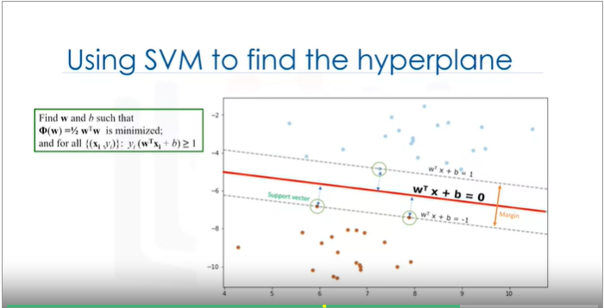

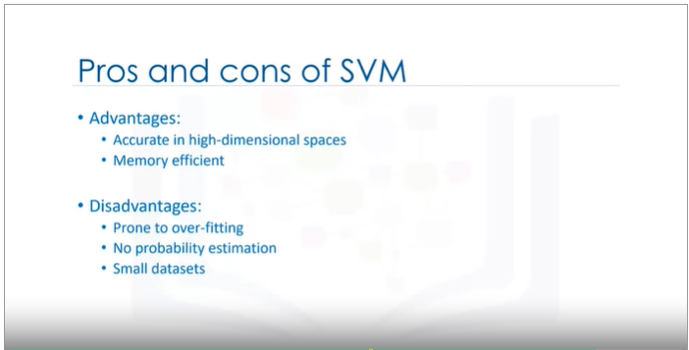

Week 4
Clustering
Cluster: A group of objects that are similar to other objects in the cluster, and dissimilar to data points in other clusters.
Clustering vs classification.
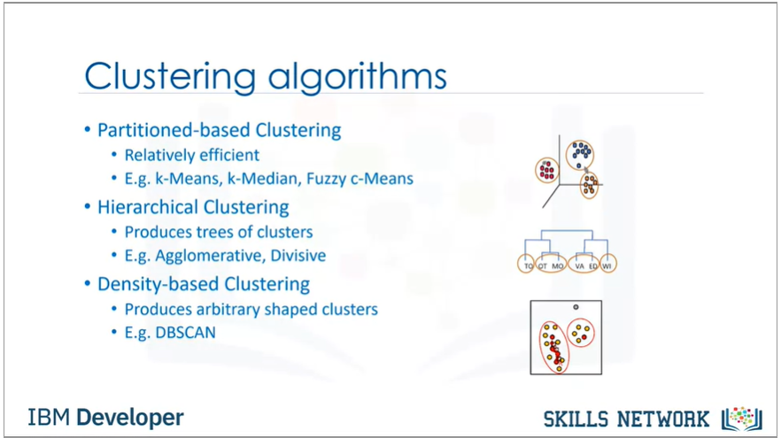
K-Means-Clustering
Customer segmentation: The practice of partitioning a customer base into groups of individuals who have similar characteristics.
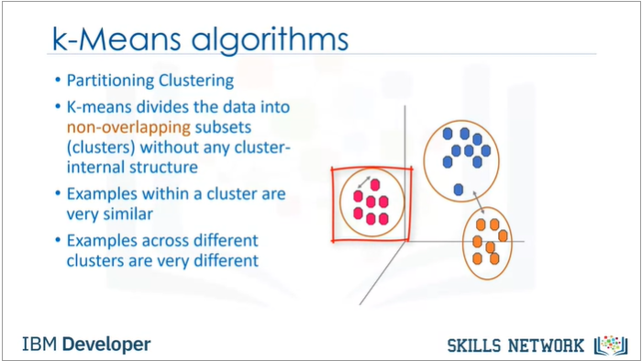
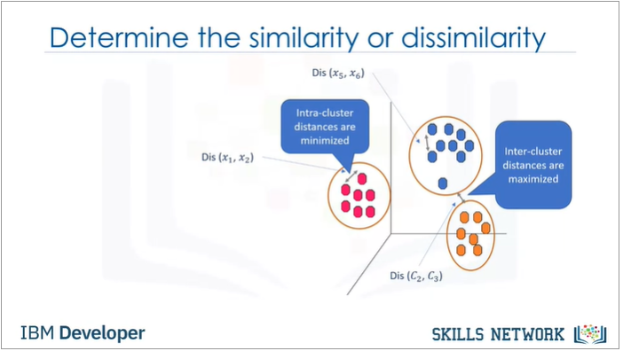
Initialize K (randomly pick centroids), distance calculation (different measures of distance may be used), assign each point to the closest centroid, compute the new centroids for each cluster (the mean of the previous determined clusters), repeat step 2-4 until the centroids do not longer move.
Iterative algorithm.
Error:
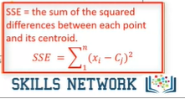
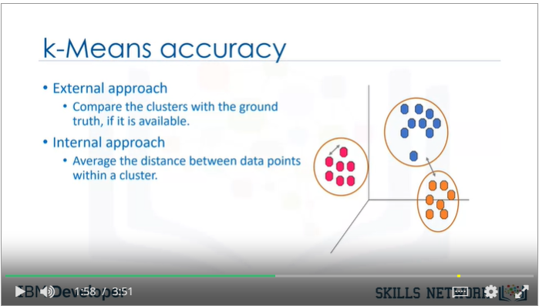
Choosing k: Run the clustering across the different values of K and looking at a metrics value for clustering, this metric can be mean distance between data points and their cluster centroid which indicate to what extent we minimize the error of our clustering, and then by looking at the change in this metric we can find the value for k. The problem is that by increasing k will always decrease the error, so the elbow point in the plotted function of k and the error is selected (elbow method).
Hierarchical clustering
Builds a hierarchy of clusters where each node is a cluster consisting of the clusters of its daughter nodes.
Divisive vs Agglomerative.
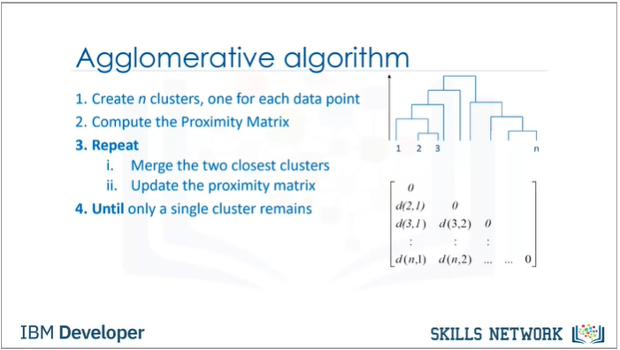
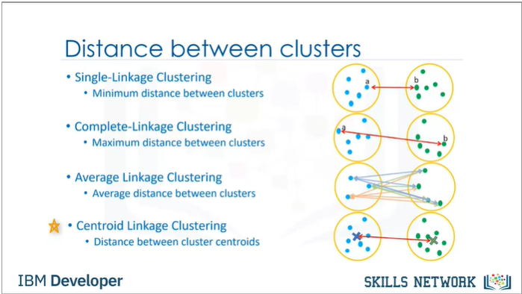

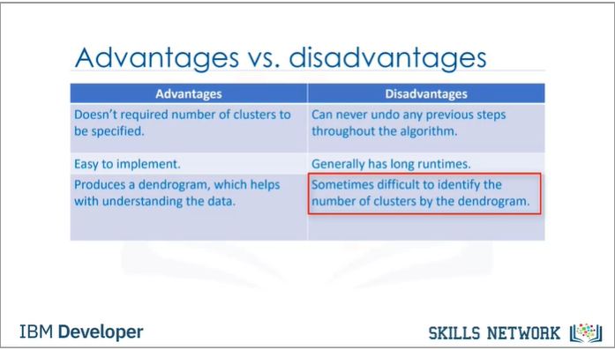

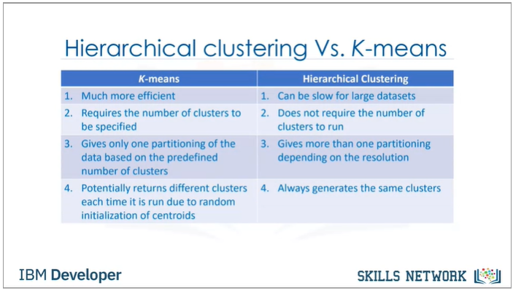

DBSCAN – Density Based Clustering
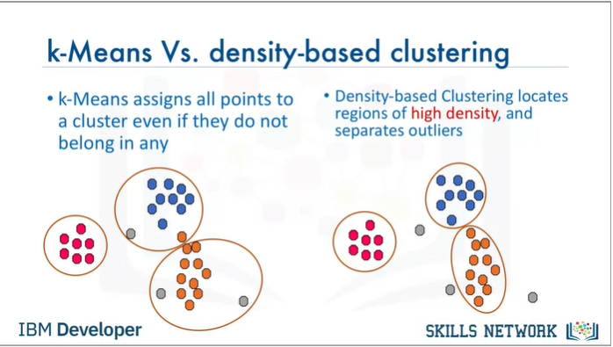

Week 5
Recommender systems
Recommender systems capture the pattern of people´s behavior and use It to predict what else they might want or like.
Applications: suggesting items to buy (Netflix, amazon, LinkedIn, Facebook, twitter), where to eat? which job to apply to? Personalize your experience in the web.
Advantages: Broader exposure, possibility of continual usage or purchase of products, provides better experience.

Two types: Content based, Collaborative filtering.
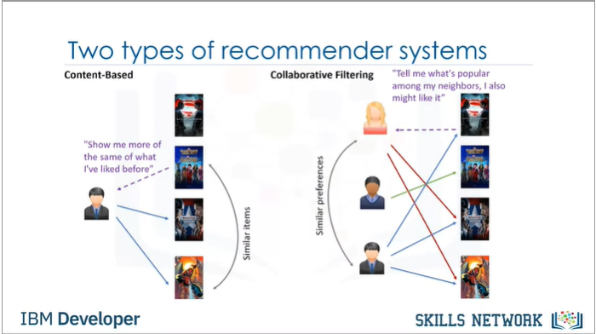

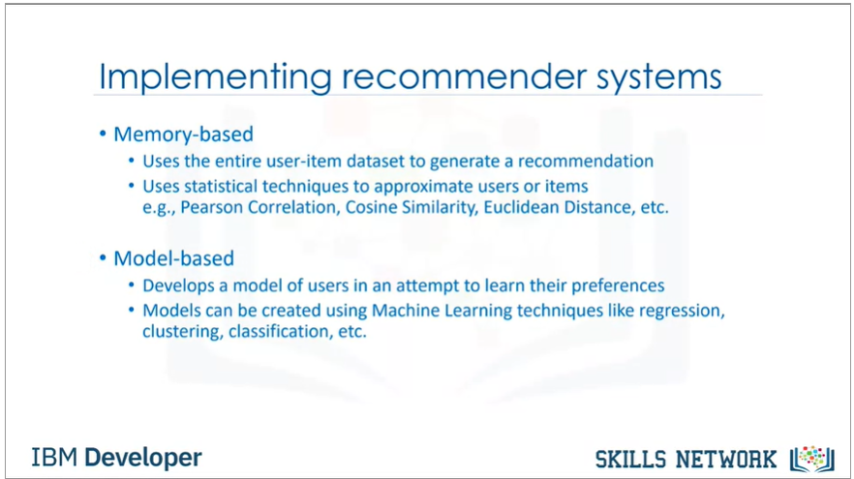

Content based:
Recommends items to users based on their profile. User profile is defined by his preferences. Shaped based on user ratings. The process is based on the similarity of those items, the similarity is measured based on the content of those items.
Collaborative filtering:
Based on the facts that relationships exit between products and people interest.
Two approaches: user based, item based.
User based: We have an active user to whom the recommendation is aimed. The collaborative filtering engine first looks for users who are similar (users who share the active user´s ratings patterns) (bases this similarity on history, preference and choices that users made when buying , watching or enjoying sth), then it uses the ratings from the similar users to predict the possible ratings for the active users for an item he has not yet bought, watched, etc.
- Determine how similar the active user is to the other users. (distance, similarity measures) (We use items that both users have rated in the past)
- Create a weighted ratings matrix. Calculate the possible rating of our active user about our two target movies/items. It incorporates the ratings of other users, and gives more weight to the users that are more similar to the active user.
- Generate the recommendation matrix by adding all of the weighted ratings. We have to normalize the weighted values. Result: potential ratings the active user will give to the items based on the ratings of other similar users.

Item based: It is not based on similar users (with common preferences) to the active user. It is based on similar items to the items that the active user has already rated highly.
