**BACKGROUND**

The *episcan* implementation here discussed is based on the (T et al., 2011), (Kam-Thong et al., 2010) papers. The implementation is largely based on the <https://cran.r-project.org/web/packages/episcan/index.html> package. The first step is totally based on the *epiblaster1geno* function in that library.

As stated in the outline of the library, *epiblaster1geno* can handle both **continuous** and **binary phenotype**, with the adequate flag in the methods.

A preliminar check was done to be sure about the results of the method and the markdown in a doc form can be retrieved in ../ Report_episcan.docx

**CODE**

The code is based on two main bash files that iterates on every file in the data folder and launch the corresponding R implementations of the 1st and 2nd step case/control or with a continuous phenotype.

Those files name are

* iterator_on_files.sh
  + The file that parse the parameters and create an iteration loop with all the .txt files in the data folder
* script_with_parameter.sh
  + For each data input, launch the 2 *R scripts* with the corresponding flag for continuous/binary /case_control, hence performs the prioritization and return the final file.

The implementations are in the R files. For the *case_control* the files are

* [Episcan_experiment_case_control.R](https://github.com/FedericoMelograna/Epiblaster_implementation/blob/main/Code/Episcan_experiment_case_control.R)
* [Episcan_experiment_2nd_step_case_control.R](https://github.com/FedericoMelograna/Epiblaster_implementation/blob/main/Code/Episcan_experiment_2nd_step_case_control.R) 2nd step

While the respective for the *continuous* case are

* [Episcan_experiment_continuous.R](https://github.com/FedericoMelograna/Epiblaster_implementation/blob/main/Code/Episcan_experiment_continuous.R) //1st step
* [Episcan_experiment_2nd_step_continuous.R](https://github.com/FedericoMelograna/Epiblaster_implementation/blob/main/Code/Episcan_experiment_2nd_step_continuous.R) //2nd step

Focal functions in the scripts are

*1st step* for a quantitative outcome

For the binary case the function is

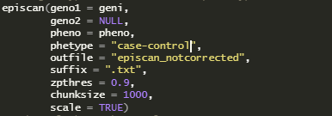

.

While for the *2nd step* the core function implementations are

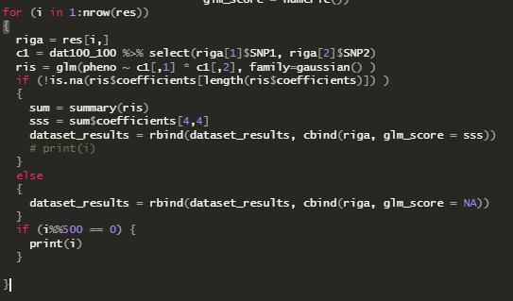

Taking into account the coefficients of an interaction *[ the beta value*] in a LM regression for the continuous case

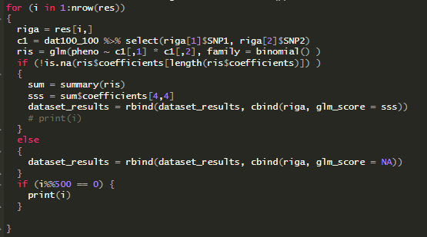

A GLM with binomial family for the binary case.

While



And 

Are the core function to *truncate* and *order* the results in the bash iterator.

For the truncating an adaptive behaviour is used in which a ***low threshold*** of 2.5 is applied if the interaction passing the first selection are not too many and ( > 500 kb ), otherwise a *stricter* threshold is used, with 3.5 and if the dimension is still > 500 kb, the top threshold of 4.5 is used.

N.b. the data should be in a “ “ *space separed* file in which the outcome is in a column named “Class” and each other column is a SNP with the column name the SNP name

**RESULTS**

The results will be stored into a created folder with the same name as the input dataset [e.g. IBD_DATA/]

And all preliminary and final results will be stored there.

The main output is:

episcan_GLM_second_SORTED



Difference from *episcan_GLM_second_SORTED* and *GLM_second_step_NA_elim* are only vestigial and are to be consider as interchangeable.

The first columns *SNP1* and *SNP2* are the name of the SNPs involved, while the *Z_score* is the statistic, *ZP* is the p-value found in the 1st step, that is based on an approximation of the real likelihood function, while the *glm_score* is the real p-value of the beta when adding the interaction of the predictors in the 2nd step.

Those p-values are ***not*** corrected for multiple testing.

**IMPLEMENTATION EXAMPLE**

**cd** /mnt/c/Users/fmelo/Desktop/Backup_Federico/Work/Epistasis/Episcan_epiblaster/Pipeline_iterative/Code_v2_enhanced

**./iterator_on_files.sh** /mnt/c/Users/fmelo/Documents/GitHub/epistasis-simulation/Gametes/Data_li_1_EDM-2/ /mnt/c/Users/fmelo/Desktop/Backup_Federico/Work/Epistasis/Episcan_epiblaster/Pipeline_iterative/Gametes_results/ /mnt/c/Users/fmelo/Desktop/Backup_Federico/Work/Epistasis/Episcan_epiblaster/Pipeline_iterative/Code_v2_enhanced/ quantitative

Or, in a more generalizable way

**cd** Documents/GitHub/epiblaster/

**filepath**=`pwd`

**# mkdir** -p Example_result # can also automatically create the repo!

**Code/iterator_on_files.sh** $filepath/Example_data/ $filepath/Example_result/ $filepath/Code case-control

We refer to the README to further information on how to set a successful one-liner implementation

**PACKAGE NEEDED**

The only needed packages are

library(episcan)

library(dplyr)

That can be easily installed from the CRAN.

The implementation is based on a UNIX system, so it naturally adapts to the server, but need **git bash** or similar to run on a WINDOWS machine. It has been tested on both a windows machine with wsl.exe ( Ubuntu 20.04 LTS (GNU/Linux 4.4.0-19041-Microsoft x86_64) ) and the server.

Kam-Thong, T., Czamara, D., Tsuda, K., Borgwardt, K., Lewis, C. M., Erhardt-Lehmann, A., Hemmer, B., Rieckmann, P., Daake, M., Weber, F., Wolf, C., Ziegler, A., Pütz, B., Holsboer, F., Schölkopf, B., & Müller-Myhsok, B. (2010). EPIBLASTER-fast exhaustive two-locus epistasis detection strategy using graphical processing units. *European Journal of Human Genetics 2011 19:4*, *19*(4), 465–471. https://doi.org/10.1038/ejhg.2010.196

T, K.-T., D, C., K, T., K, B., CM, L., A, E.-L., B, H., P, R., M, D., F, W., C, W., A, Z., B, P., F, H., B, S., & B, M.-M. (2011). EPIBLASTER-fast exhaustive two-locus epistasis detection strategy using graphical processing units. *European Journal of Human Genetics : EJHG*, *19*(4), 465–471. https://doi.org/10.1038/EJHG.2010.196