**Man who designed Architecture Building to stand trial**

**Written by Joshua Cohen-Collier on September 14, 2015**

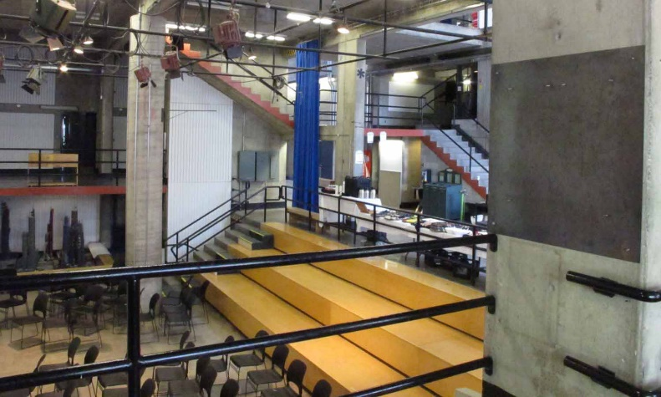

**After more than 25 years on the run, Badat Desseini has been captured and charged**. Desseini was charged in absentia in 1989 after a man died while trying to find the 5th floor.

Carleton’s Architecture building has claimed 3 lives

After police raided his house, they discovered his diary, describing how he wished to design “the most devious, evil, confusing, and mazelike building in the history of ever.” He later released a jihadi-style video detailing his desire to destroy all those who made fun of him when he was a child for his logical lego design, which they said was too sensible for a toddler.

Although many have taken sympathy with the terrorist, there is no doubt that his creation has wreaked havoc on the population of Carleton. His first victim was Mark Cedenbland, who was found unconscious after jumping from a balcony, screaming, “There is no 5th floor, it’s a lie, get out while you can!”

His second and third victim died in the same incident. Hillary Smith was trying to get from the 2nd floor to the 4th floor. Her parents called the police after she called her mother saying, “Mom, I don’t think I can get out of here. I love you”. Officer Sampson Kilpatrick was first on the scene, and herself got lost in the building, after which the search was stopped. Their bodies were never found.

The parents of Smith and Cedenbland, and the wife of Kilpatrick, expressed their thanks towards local law enforcement, and hope that the jury would find the man who destroyed their families guilty. Mary Kilpatrick was quoted as saying, “That building is ridiculous. Seriously, why are their two elevators for different levels of floors? It doesn’t make any sense.”

Desseini has been charged with 3 counts of manslaughter, public mischief, and construction of a demonic building.