**Engineer killed after dividing by 0**

**Written by Joshua Cohen-Collier on April 2, 2016**

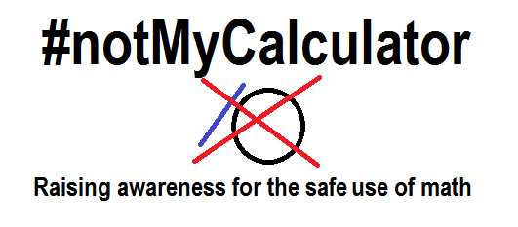

**Carleton University engineering student found dead Friday morning.**

Jordan Matmik had heard all the warnings. He’d listened to his professor’s plea with their students to never do the unthinkable. But he just couldn’t help himself.

Each year more than 1000 engineers are killed while dividing by 0, some accidental, some suicidal, some jokingly, and the numbers are rising.

It’s an epidemic, says Professor Johan Hathman. “Each year I look at the new engineering students, all the young, curious faces, and I wonder which ones will be alive by the end of the year. In my opinion, this is the greatest threat to our existence since the invention of emotions.”

In response to the tragedy, Matmiks parents have started the #notMyCalculator initiative, which aims to increase awareness of proper calculator use. “We just don’t want anyone to have to go what we’re going through. No one should have to lose a loved one like this.”

In addition, Carleton University has pledged 1 million dollars to the cause, and has vowed to take preventative measures as well. “Carleton University mourns the loss of Jordan Matmik. Although his death was not predictable, Carleton is commited to the health and safety of our students. As such, informational math pamphlets will be distributed in each frosh kit, which will replace condoms and STI preventation material. Carleton believes this is the best method to protect the well-being of our-students.”