**Anti-life death cult, Pro-life protestors clash at rally**

**Written by Joshua Cohen-Collier on November 16, 2015**

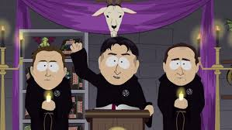**Cult members, protestors get violent at local rally.**

Things got heated at Barrhaven Centre on Monday, as a rally held by Pro-Life Ottawa was interrupted by members of the cult of Cthulu, a dark god from another dimension. The cult members began ritualistic chanting in the background, until violence erupted. The ralliers maintain that they were attacked first, while the cult members, however, say that all life is irrelevant and that saying otherwise is blasphemy.

A statement by cult leader Darthstroyer(real name Percy Goldberg) on their website reads, “This is an issue that is really important to us. People seem to think that its only pro-life vs pro-choice, and we really wanted people to see a different side of the argument that is equally important but not given as much attention because of media bias. We believe that all life is irrelevant, regardless of whether the baby has achieved consciousness. We’d like to introduce a new policy where all babies are aborted as soon as pregnancy is detected, and then immediately afterwards the carrying body, or ‘mother’ as well. This ensures the most fair and equitable policy, as no one receives special treatment”.

While the pro-life party was not available for comment, the Greater Ottawa Union of Choice released a televised message, stating, “While we certainly don’t agree with the policies of the anti-life party, they seem to make much more sense than the pro-lifers”.