**FIFA Looking to Punish Divers**

**Written by Joshua Cohen-Collier on February 23, 2016**

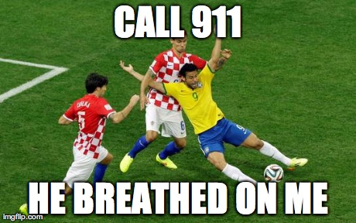**Proposed changes include inflicting injury that player fakes.**

Soccer’s highest international governing body has launched a task force to deal with the problem of diving, also known as “simulation”.

The Fédération Internationale de Football Association (FIFA) announced the task force on its website: “For too long, we have tolerated the problem of players faking injuries to gain an unfair advantage. We wish to solve this problem in order for people who play other sports to stop looking at us like we’re giant pussies.”

A soccer player falls during a play. The two opposing players were both given red cards, and suspended indefinitely for attempted murder.

The task force has proposed several changes to the way that punishments are handed out to offenders. These include actually inflicting the injury that the player is faking on them, letting the fans of the opposing team onto the field at each dive, and forcing them to go to a pool and use the diving board. Another upcoming proposal includes starting a charity fundraiser after each game where money is raised by allowing fans to kick the offending players in the groin.

Retired Argentinean legend Diego Maradona had perhaps the most interesting idea. “Every player that dives has to wear a bandana. The referees are given weapons and allowed to attack the players with bandanas.” he proposed. “Each time the player gets a penalty, instead of a free kick, the ref receives a weapon upgrade.”