**NHL to market in South America, will now use soccer nets, injury time**

**Written by Joshua Cohen-Collier on March 23, 2016**

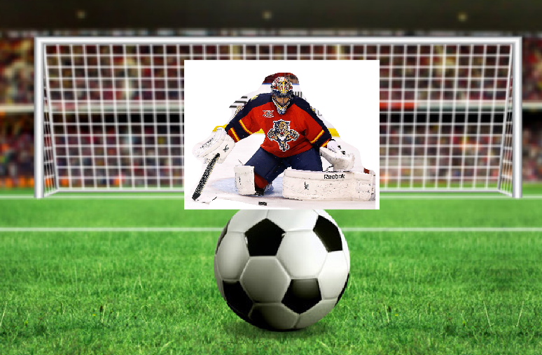**NHLPA, NHL agree on new rules.**

Artists concept art of new changes

On Saturday, the NHL announced that they would implement radical new changes in an effort to increase scoring, and introduce hockey to a new audience.

NHL Commissioner Gary Bettman was quick to hail this as a victory for fans, “For too long, South America has been uninterested in the most exciting sport in the world. We’ve spent millions building outdoor rinks in Brazil, Argentina, Brazil, and Colombia, but for some reason the locals only use them for a few hours then never again. After extensive research, we have concluded that this is because of the lack of familiarity with the nets, and the lack of ridiculous, over-the-top faking of injuries.”

The new changes include using standard FIFA goalposts, making shot blocking with hands a game misconduct, changing overtime to injury time, and allowing players to roll around in fake agony.