**Hallowed Hog: Guide to being an Advicer 2015-2016**

**Becoming an Advicer:**

Before you start writing advice columns, you’ll need to get your webmaster to create an account for your made up persona on the website. Try and be something funny, and unique with at least one gimmick. You’ll need to give them the following information;

* Persona Name
* Email(your actual email, not for the persona)
* Areas of Expertise for the persona
* Anything else that might be funny
* Picture of persona

An example is given below;

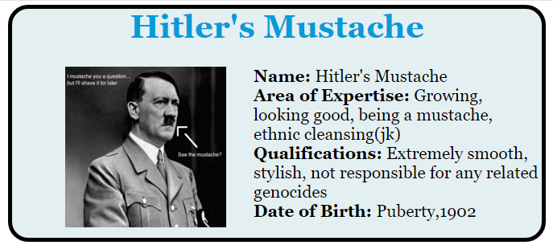

The webmaster will create your advice column, and as you send your articles to the editor, they will be uploaded and sorted by date on the website. When someone asks a question on the website, you will receive an email from **HallowedHogAdvice@terribleAdvice.ca**, and it will be marked with a ! to signify importance. Once you’re setup on the website, the webmaster will send you an email. Check your junk mailbox to make sure that you add that address to your contacts, otherwise it will always be in the junk folder.

**Writing the Advice Columns**

Unlike the article, advice columns only require one file, which is written entirely in .txt documents, not Microsoft Word.

**Article text**:

* Must follow CUSA discrimination policy, and Hallowed Hog constitution.
* Must be submitted as .txt document.
* Should be more than 20 words and less than 300(this is a guideline, not a rule).
* Can be of any topic of the authors choosing, as long as the above guidelines are met.

It should be noted that in text documents, only regular characters can be used, and that if you put a space in the middle of a line to make it easier to read for you, on the website there will be a space between those words even if it’s in an awkward spot. Basically, only put a space where there needs to be a new paragraph or heading.

To change text in these documents like you would in word, use the following tags as shown below. You won’t be able to see what this would look like until it’s actually on the website unfortunately. Everything between the tags has the effect applied. Tags need to be closed as well. Multiple Tags can be combined.

|  |  |  |  |
| --- | --- | --- | --- |
| **Effect** | **Tag, Closing** | **Example in .txt** | **What it looks like on website** |
| Bold | <b> </b> | My name is <b>Josh</b>ua | My name is **Josh**ua |
| Italic | <i> </i> | My name is <i>Josh</i>ua | My name is *Josh*ua |
| Underline | <u> </u> | My name is <i>Josh</i>ua | My name is Joshua |
| Small | <small> </small> | My name is <small>Josh</small>ua | My name is Joshua |
| Highlighted | <mark> </mark> | My name is <mark>Josh</mark>ua | My name is Joshua |
| Strikethrough | <del> </del> | My name is <del>Josh</del>ua | My name is ~~Josh~~ua |
| Subscript | <sub> </sub> | My name is <sub>Josh</sub>ua | My name is Joshua |
| Superscript | <sup>  </sup> | My name is <sup>Josh</sup>ua | My name is Joshua |
| Bold and Italic | <b><i> </b></i> | My name is <b><i>Josh</i>ua</b> | My name is ***Josh*ua** |

**Naming, Sending the Advice Column**

Once you have your column, name it as shown below and send it to the editor. Files must be named exactly like the following;

For instance, if a column named “Friend won’t wear gold star” is written on February 15, 2016, the file must be named as follows;

2016-02-14+Friend+won't+wear+gold+star

Any spaces in the article name must be replaced with “+”

The article can be formatted however you want, but the following is a good example (the parts in bold below are taken from the name of the article, and shouldn’t actually be inside the txt document) :

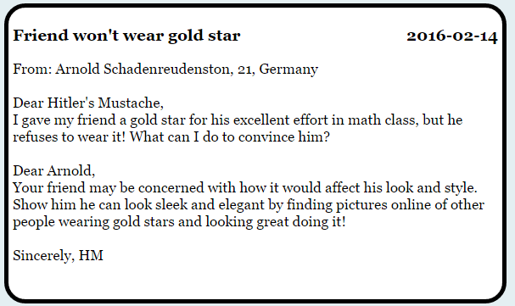

AFTER THE COLUMN IS DONE, EMAIL IT(with subject being Hallowed Hog) TO [hallowed_headitor@hotmail.com](mailto:hallowed_headitor@hotmail.com)

**Edits**: Unlike the printed articles, advice columns can be edited at any time by contacting the head editor.

**Editing the Advice Columns**

Advice columns should be edited the same way as articles, including grammar and formatting.

Once the article is done, it should be put in the archives folder under the appropriate author, then the webmaster should be contacted.