

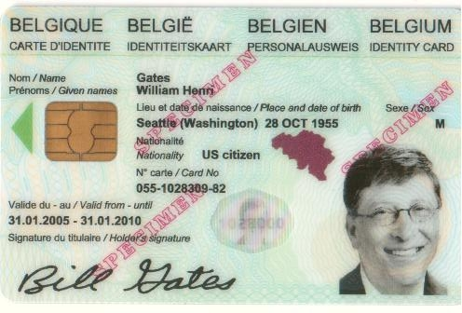 | Requirements analysis and Logical View  Infrastructure for eID test cards  Ref : FEDICT/2008/GB/eID/11  November – 2008

ORIGINAL - ORIGINEEL
Authors :  Stef HOEBEN  Development Engineer  Chris VERACHTERT  SW Architect | 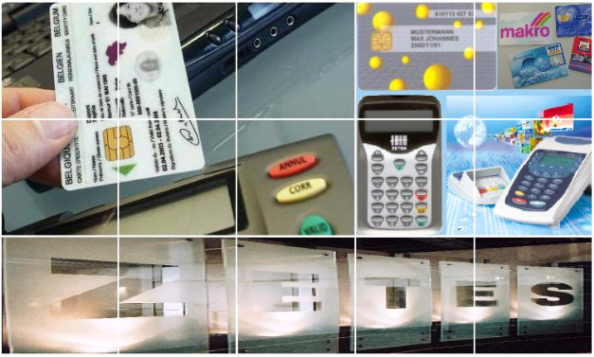

Date | Author | Comments
1.0 | Stef H. | Initial version
1.1 | Stef H. | Removed TBD’s, link to Arena’s doc, added info about a predefined set of virtual cards
1.2 | Stef H. | Further details, removed “can”, “foresee”, “a.o”, ..

Table of contents
Table of contents i
1. Introduction 2
2. Requirements analysis 3
2.1 Database 3
2.2 Web server 3
2.2.1 Creating contents for new virtual eID cards 3
2.2.3 Changing the status of the certificates 3
2.3 CRL generator 4
2.4 OCSP responder 4
2.5 PCSC proxy library 5
2.6 Control application and control library 6
2.7 Pin unblock application 7
3. Logical view 7
3.1 Database 7
3.2 Web server 7
3.3 CRL generator 7
3.3.1 Frequency of CRL and delta CRL generation. 8
3.4 OCSP responder 8
3.5 PCSC proxy library 10
SCardListReaders 11
SCardConnect 12
SCardControl 14
SCardTransmit 15
3.5.1 Using the PCSC proxy library 16
3.6 Control application and control library 16
3.6.1 Control library 16
3.6.2 Control application(s) 17
3.7 Pin unblock application 17

Introduction
This is a project for FedICT, meant to make it easier to test applications for the BE eID card. Currently, the problem is that lots of cards would be needed to test all possible cases (languages, max/min sizes of the fields, strange characters, cert status, …)
The solution we provide will make it possible for a developer/tester to use ‘virtual cards’, in ‘virtual readers’. These virtual cards can be download from a website.
The figure below displays the general architecture overview of our solution, consisting of the following main components:
- On the server side: a web server, database and OCSP responder
- A client side PCSC proxy library: virtual card and reader emulation
- A client side control library/application: control of the virtual cards and readers
- A client side PIN unblock application
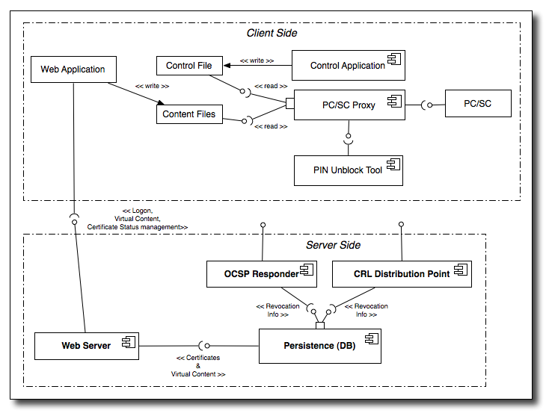

Requirements analysis

2.1 Database
The Database will contain the following data:
- The contents of the real and virtual cards
- For each certificate: the status (suspended, revoked, ..). This is needed for the CRL and OCSP generation.
- User account data
- Web shop data
For more details, see the document by Arena Solutions called “Zetes Fedict eID 2008 - Technical Analysis v3.docx” chapter 1.

2.2 Web server
The web server will contain functionality to create virtual eID cards and to modify the status of the certificates of those cards. Other functionality will be present (e.g. web shop), this is further detailled in a document by Arena Solutions called “Zetes Fedict eID 2008 - Technical Analysis v3.docx” chapters 2, 3 and 4.

2.2.1 Creating contents for new virtual eID cards
The developer will see a form containing all the ID and address values that can be specified, as well as validity period of the certificates and their initial status.
After modifying certain fields (or not), the developer can click a 'Create virtual card' button upon which a file containing the virtual card's contents will be downloaded on the developer's hard disk. This file will then be used by the client side components to emulate a virtual card.
When clicking the 'Create virtual card' button, the web server will check the inputs and then generate the eID card contents, using a unique card serial number and the public keys of the real developer card. (The authentication public key is directly derived from the certificate that was used to log in to the web server, the signature certificate is looked up in the Database, taking the authentication certificate as a key.)
Additionally, the developer will be able to download a predefined set of virtual cards without having to go through the web form.

2.2.3 Changing the status of the certificates
The developer will see the list of the Authentication and Signature certificates of his/her developer card plus those of all virtual cards he/she created. For each certificate, the current status and a drop-down box containing the possible new status-es is shown.
Only valid state transitions are allowed in order not to confuse applications with invalid (delta) CRLs. As a result, the status of a revoked certificate can't be changed anymore. However, since the developer can create new certificates on new virtual cards this is no big limitation.
The changes make are immediately propagated to the OCSP responder and will appear in the next CRL.
Overview of the valid status changes :
Nummer | Current status | New status
1 | Suspended | Active
2 | Suspended | Revoked
3 | Active | Suspended
4 | Active | Revoked

2.3 CRL generator
At regular intervals, the CRL genenerator will issue a CRL and/or delta CRL, using the info in the Database. The CRL generator can be used in 2 modes:
- “normal” mode: it should be called every time again to generate a CRL and then exit
- “deamon” mode: it should be called once and then keeps running
Use cases
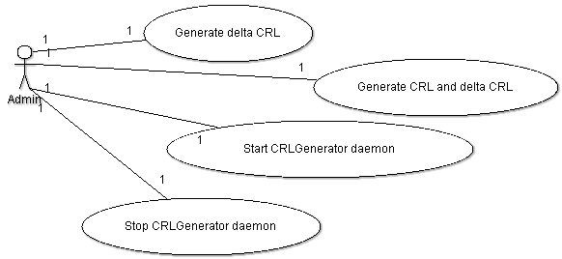

2.4 OCSP responder
This server will respond to OCSP requests, taking as input the status of the certificates as set by the developer.
Care will be taken to mimic the behavior of the real OCSP responder as close as possible. This means that for valid requests, the responses will contain the same fields; and for invalid requests, the same errors will be returned.
Use cases
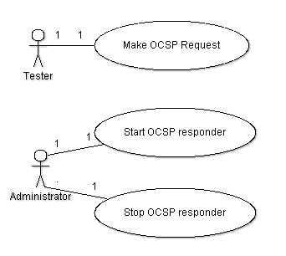

2.5 PCSC proxy library
The PCSC proxy library will have the same interface as the real PCSC library that is provided by the Operating System (e.g. winscard.dll on Windows). Developers/testers will use this library instead of the real PCSC library.
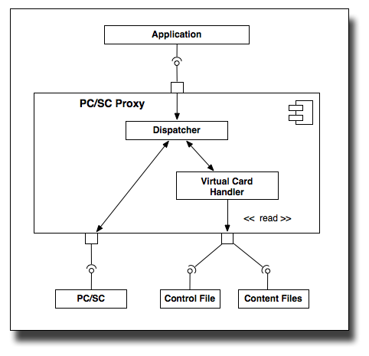
The PCSC proxy library will do the following:
- forward calls for the real readers/cards to the real PCSC library
- implement the functionality for virtual cards and virtual readers

For each real card reader, a virtual card reader will be emulated by the PCSC proxy lib. In this virtual reader, a virtual card will be present if a real card is present in the real reader. (So removing the real card means also removing the virtual card; and removing the real reader means removing the virtual reader). Which card is linked to a real card, is specified in a control file that can be manipulated by a control library (see below).
The virtual reader/card could be hidden by means of a settingin the control file
Technology used: since the PCSC API is a C API and since the PCSC proxy library will call the real PCSC library, C/C++ will be used here.

2.6 Control application and control library
A library will be made that allows the tester to control the behaviour of the PCSC proxy library. More specifially, the Control library will have functionality to:
- Set the visibility mode
- Add and remove directories containing virtual content files
- Get the list of physical chip numbers for which virtual content files are present
- Get the list of found virtual content files (for a certain physical chip number)
- Get and set the virtual cards that will be used by the PCSC proxy library
The visibility mode can be used to control wether the default (= the first) reader is the virtual or physical reader; it can have the following values:
- REAL_FIRST: first return the physical reader
- REAL_LAST: first return the virtual reader:
- HIDE_REAL: hide the physical readers
- HIDE_LAST: hide the virtual readers (as if no PCSC proxy library is being used)
Communication between the control library and the PCSC proxy library is done via a control file: changes to these control files are made by the control library and are read by the PCSC proxy library.
By using files, no complicated, platform-dependent ways of communication is required.
Additionally, a command line application on top of the command library will be implemented, allowing easy integration into scripts.
Below is an example of the control file:
<?xml version="1.0" encoding="UTF-8"?>
<control>
<show>REAL_LAST</show>
<virtualcard>
<hardchipnr>534C494E336600296CFF2623660B0826</hardchipnr>
<file>C:/Documents And Settings/Stephen/virtual1.xml</file>
</virtualcard>
<virtualcard>
<hardchipnr>534C494E336600296CFF2623669E4C22</hardchipnr>
<file>C:/Documents And Settings/Stephen/virtual2.xml</file>
</virtualcard>
</control>

Technology used: we will use Java to develop the control library and application.

2.7 Pin unblock application
The PUKs for all cards will be the same. This choice allows to make a simple PIN unblock application that contains these PUK values. This way, the developer doesn’t have to maintain PUK codes and no online connection is needed for unblocking.
Technology used: Java (Swing) and a JNI PCSC wrapper; perhaps combined with the control application into 1 single application.

Logical view

3.1 Database
See the Arena Solutions document: “Zetes Fedict eID 2008 - Technical Analysis v3.docx” chapter 1.

3.2 Web server
See the Arena Solutions document: “Zetes Fedict eID 2008 - Technical Analysis v3.docx” chapters 2, 3 and 4.

3.3 CRL generator
The CRL generator is a Java command line application that uses the Bouncy Castle library to do the actual (delta) CRL generation, using the certificate information in the Database.
The CRL generator can either be called every time again to generate a delta CRL and if needed a CRL, or otherwise be started as a “daemon” once and then keep running.
Class diagram
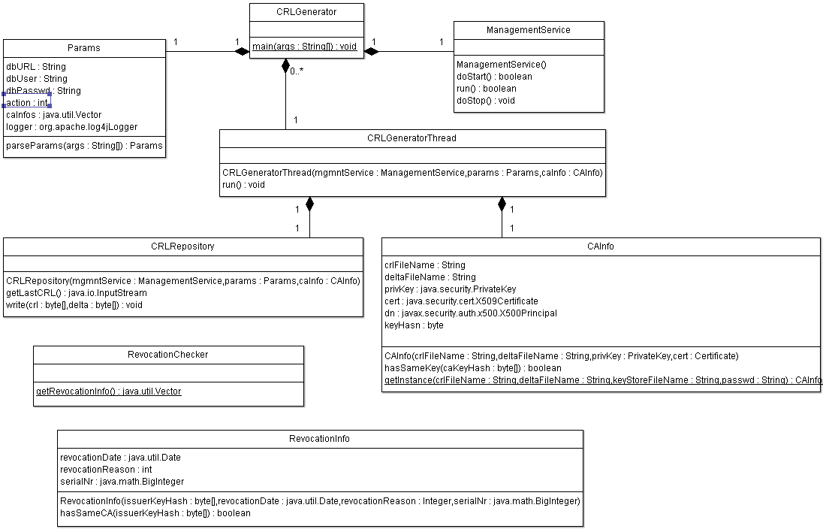
The main class (CRLGenerator) will be called to start the CRL generator. Depending on the command line parameters (parsed with by the Params class), the CRL generator will generate a delta CRL and/or CRL and exit, of start as a daemon that keeps running and will generate a (delta) CRL at regular times.
The Params class also parses a config file containing a.o. the CA files to be loaded. For each key file loaded, the CRLGenerator will start a CRLGeneratorThread that will create (a) CRL(s) for that CA. The CA info (CRL and delta CRL output files, key, …) are put in a CAInfo object. The CRLGeneratorThread will also create a CRLRepository object that will take care of writing the CRL and delta CRL(s) and for reading the previous CRL (needed to generate a delta CRL).
The RevocationChecker class will ask the Database for revocation info and will return a vector of RevocationInfo objects.
The ManagementService class takes care of checking wether a CRLgenerator daemon is already started, and for stopping the daemon.
Below is an example of a config file containing all the parameters:
#
# BE eID test CRL generator
#

# How long between 2 CRLs, in minutes
crlIntervalMins = 60

# How much delta CRLs to generate per CRL.
# 0 means that no delta CRLs will be generated; otherwise one
# delta CRL will always be generated at the same time as the CRL
deltasPerCRL = 4

# The temp dir to write CRLs and delta CRLs to before renaming
# them to the actual (delta) CRL file
tempdir = .

# The directory where the logs will be placed.
# This directory should preferably be made writeable
# only by the CRL generator
logfile = crlgenerator.log

# Log level.
# Allowed values: debug, info, warn, error
loglevel = debug

#####################################################################
# For each CA, 4 values should be specified:
# crlFileName : the path to the CRL to generate
# deltaFileName : the path to the delta CRL to generate
# keyFileName : the path to the key file for this CA (jks and pkcs12 key files are supported)
# keyFilePasswd : the password for the key file
#####################################################################

########## The info for the 1st CA (Citizen CA) ##########
crlFileName1 = crl1.crl
deltaFileName1 = crld1.crl
keyFileName1 = responder.p12
keyFilePasswd1 = ocsPass...

#####################################################################
# Database connection params
#####################################################################

# DB URL
dbUrl = "jdbc:mysql:eidtestinfra"

# DB user name
dbUser = "test"

# DB password
dbPasswd = "1234"

3.3.1 Frequency of CRL and delta CRL generation.
For what the real BE eID CRL generation is concerned, each citizen CA issues once a week a CRL and a delta CRL that contains the difference between the new and the previous CRL.
For the test CRLs, we will release a CRL each hour and a delta CRL every 15 minutes (the delta will refer to the CRL that was generated 15, 30, 45 or 60 minutes before).

3.4 OCSP responder
The OCSP responder will be a Java command line application using the OCSP classes of the Bouncy Castle library to parse OCSP requests and generate OCSP responses.
Class Diagram
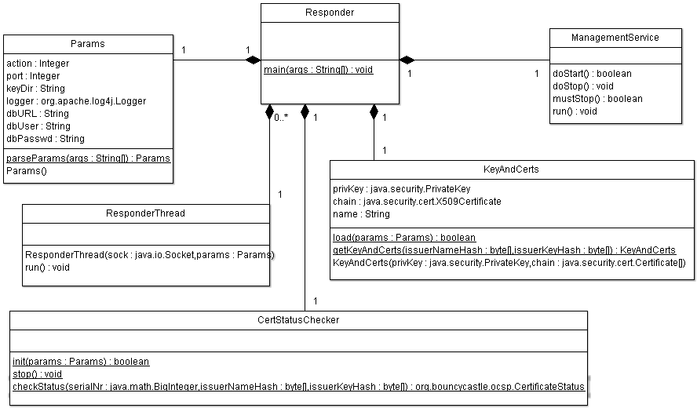
The main class (Responder) will be called to start and stop the OCSP responder. After a startup sequence (see below), it will be waiting for incoming requests. For each incoming request, a ResponderThread object is created that will handle the response. When a STOP message is sent, the Responder will wait until all threads have been finished and then finish with a shutdown sequence (see below).
In order to send a STOP message to the Responder, a ManagementService thread is started that will listen on another (local) port for management messages.
The Responder class will parse the OCSP requests, look up the certificate status in a database (abstracted by the CertStatusChecker class) and generate an OCSP responses; the key and certificate chain for signing the OCSP response is delivered by the KeyAndCerts class that is able to load pkcs12 and JKS key files from disk.
All parameters are provided in a config file that is parsed by the Params class. Below is an example of such a config file:
#
# BE eID test OCSP responder
#
# The port on which the OCSP responder must listen
port = 8888
# The directory in which the OCSP responder will search
# for key files (by looking at the file extensions, jks
# and pkcs12 key files are current supported)
# This directory should preferably be made readable only
# for the OCSP responder, and not writeable.
keydir = .
# The directory where the logs will be placed.
# This directory should preferably be made writeable
# only by the OCSP responder
logfile = ocspresponder.log
# Log level.
# Allowed values: debug, info, warn, error
loglevel = debug
# Database connection params
# DB URL
dbUrl = "jdbc:mysql:eidtestinfra"
# DB user name
dbUser = "test"
# DB password
dbPasswd = "1234"
Sequence diagram
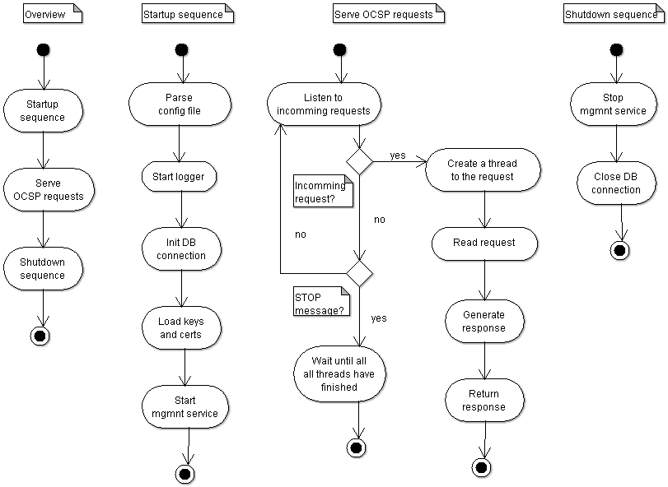

PCSC proxy library
The PCSC proxy library exports the same functions as the original PCSC library (winscard.dll on Windows, libpcsclite.so on Linux, libpcsclite.dylib on Mac OS X).
For some functions, the PCSC proxy library simply forwards the function to the original PCSC library. For other functions, parameters are modified before/after they are/were forwarded to the original PCSC library, or are not forwarded to the original PCSC library but handled only e PCSC proxy library.
The original PCSC lib is not modified, but the PCSC functions in the pcsc proxy is modified in order to obtain the following behavior:
- When asking the list of readers (SCardListReaders function), a virtual reader is added to the list of physical reader that was returned by the original PCSC library. It is possible to choose whether the physical or the virtual reader is returned first, as well to choose not to return the physical or virtual readers.
- When a smart card is inserted in a physical reader, a virtual card is inserted in the corresponding virtual reader; and idem for removal.
- The first time a command is sent to a virtual card (SCardTransmit function), the PCSC proxy library will obtain the chipnumber of the physical card in the corresponding physical reader. This chipnumber is looked up in the control file and the required virtual contents file (on the hard disk) is “read into the virtual card” and used to respond to the command sent to the virtual card.
Class diagram
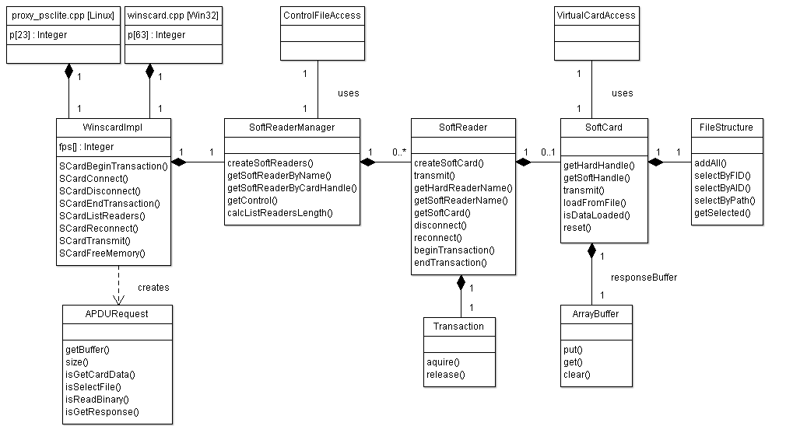
Below is a more detailed overview of the most important functions. The notation ‘hard’ relates to physical reader/card, while ‘soft’ relates to the virtual reader/card.

SCardListReaders
More than one card reader device can be attached to one PC at a time. The application discovers the available readers by calling SCardListReaders on the dll. All commands pass through the proxy. The proxy sends the SCardListReaders command to the original dll. When the proxy receives the response it will create one soft reader for each hard reader attached. The soft reader receives a name which is the name of the hard reader with a prefix.
Example:
- Name of hard reader: “Gemplus USB Smart Card Reader 0”
- Name of soft reader: “!Virtual Gemplus USB Smart Card Reader 0"

The names of soft readers are added to the string containing names of hard readers and the full string is passed in the response to the application.

[mszReaders + soft]
App
Proxy DLL
Original DLL
SCardListReaders
SCardListReaders
[mszReaders]
Soft Reader
foreach hard reader
Soft Reader Manager
createSoftReaders(mszReaders)
Control
new
getListReaderOrder
sort
[mszReaders + soft]

SCardConnect
The application sends the SCardConnect operation to receive a handle to the card. If the SCardConnect contains a hard reader name then a handle to the hard reader is returned to the client. If the SCardConnect contains a soft reader name then a handle to the soft reader is returned to the client. The proxy stores the soft handle with the hard handle, so that in any future operation in which a soft handle is passed, the corresponding hard handle can be looked up and used to access the hard card if required.
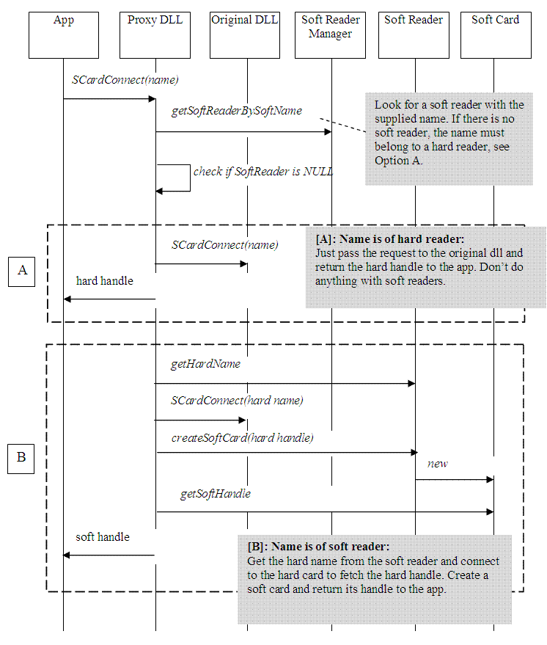

SCardControl
SCardControl functions such as those that interact with the pin pad are only forwarded to the hard reader even if a handle to a soft reader is passed.
App
Proxy DLL
Original DLL
SCardControl(hard)
SCardControl(hard)

App
Proxy DLL
Original DLL
SCardControl(soft)
Lookup hard handle by soft handle
SCardControl(hard)

SCardTransmit
An SCardTransmit call is used to send APDUs to the card. Before the SCardTransmit, the application sends a SCardConnect. At the time of connect the chip number of the physical card was unknown and because the chip number serves as the key to lookup the virtual card contents, the virtual card content could not be loaded. The SCardTransmit requires data to be loaded on the virtual card.
When the proxy receives the SCardTransmit, it looks to see if data is loaded on the soft card. If not then a GET CARD DATA apdu is send to the hard card from which response the chip number is read. With that chip number the control file is requested to return the path to the file that contains data of the soft card. The soft card data gets loaded and the original SCardTransmit is send to the soft card.
If there is no virtual chip number present for that real chip number in the control file, or if the proxy cannot find a virtual contents file for that virtual chip number, then the virtual card will respond with SW1-SW2 = 6D 00 (not supported) to indicate that is an unknown card.
if no data loaded
App
Proxy DLL
Original DLL
SCardTransmit[soft handle, command]
Soft Reader
Soft Card
getSoftCardFileLocation(chip number)
isDataLoaded

Control
SCardTransmit[GET CARD DATA]
loadFromFile
SCardTransmit[soft handle, command]
if any of:
READ BINARY
GET CARD DAT
SELECT FILE
GET RESPONSE
SCardTransmit[command], Transaction
The following APDU commands are send to the soft card:
- SELECT FILE
- READ BINARY
- GET CARD DATA
- GET RESPONSE
All other APDU commands are send to the hard card only
Remark: if an APDU is sent to the hard card, the appropriate DF (directory) on the hard card needs to be selected first.

3.5.1 Using the PCSC proxy library
In order to use the PCSC proxy instead of the original library (which resides in the system32 dir on Windows or the /usr/lib dir on Linux/Mac OS X), our PCSC proxy library will have the same name as the original PCSC library.
In order to let applications use the proxy PCSC library instead of the original one, testers will have to do the following:
On Windows, the PCSC proxy library should be placed in the same directory as where the test application is started. This way, Windows will find the PCSC proxy library first).
On Linux and MAC OS X, the LD_LIBRARAY_PATH (DYLD_LIBRARY_PATH on Mac OS X) should be modified by pre-pending it with the directory containing the PCSC proxy library.

Replacing the original PCSC library by the proxy PCSC library
On Linux and Mac OS X, it is easy (if one has root access) to rename the original PCSC library and place the proxy PCSC library in /usr/lib. Also on Windows XP and Vista, it is possible but not trivial.
We will enable our PCSC proxy library to check if the original PCSC library have been renamed and load in that case; and upon request of FedICT we will provide documentation on how to replace the original PCSC library.
However, replacing a system library can be dangerous and is not considered good practice, therefore we will only document this feature and warn for it, but not provide any tools or scripts to facilitate it.

Control application and control library

3.6.1 Control library
The PCSC proxy library will use a system-wide control file for knowing which virtual file should be present in the virtual readers and the visibility mode for returning readers. The Control library allows easy manipulation of this control file.
Class diagram
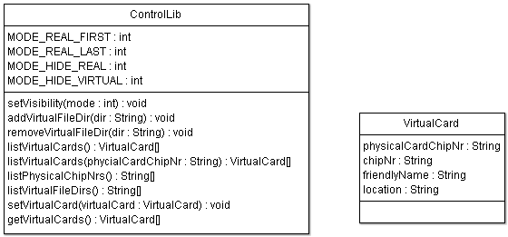
The control library will be written in Java.

3.6.2 Control application(s)
A GUI (Java, Swing) will be made on top of this library.
For integration into test scripts, we will provide a command line tool as well. This will be a Java application on top of the Control library that can be used to specify which virtual card to use for a specific physical card.

3.7 Pin unblock application
The Pin unblock application is a Java GUI that will display the list of smart card readers containing a card. The user can select a reader and click “Unblock”. In order to protect against blocking the PUK of real eID cards, only if the card inside the selected reader is a test card, the unblock will be done.
Class diagram
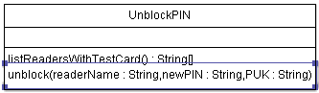
The listReadersWithTestCard() method returns the list of all readers in which a test card is present. The unblock() method unblocks the card in the specified reader.
This functionality will be integrated into the Control application GUI.

