**Sprint Report Document**

NICTA

Ted Friedman

Eric Krenz

Sean Luthjohn

Jordan Steffan

**1. Sprint Planning Meeting -** <Date Conducted>

**1.1 Sprint Backlog**

Our project backlog can be found on Github by following the link below, then entering the Documentation folder and viewing the most recent Microsoft Project planning document. At the time of this report, the most recent project plan is dated March 10.

Github → [Link](https://github.com/Fedoraman42/NICTA-NDSU-National-Map/tree/dev)

**2. Sprint Review Meeting –** 3/10/15

**2.1 Customer Demo**

**QGIS:**

Sean- images

**Population → Average_household_size**

**Legend**

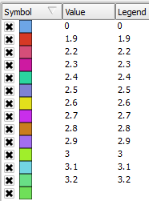

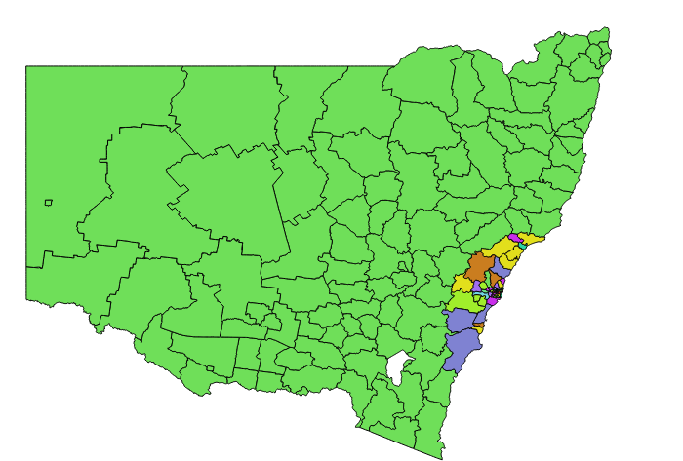

**Purpose of travel (trips %) → Shopping

**Legend**

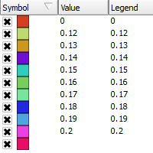

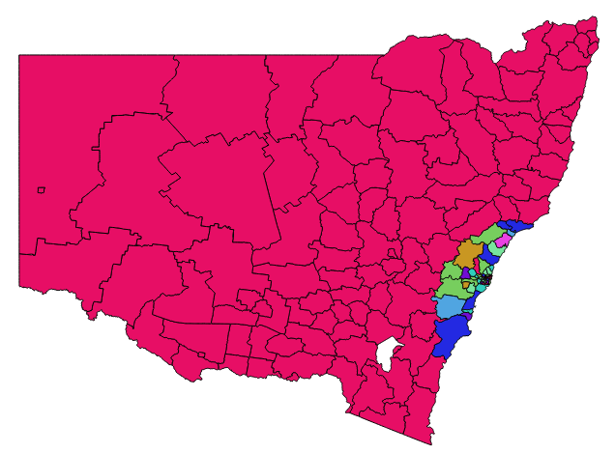

**Geoserver:**

**Columns names are something we need to work on. Upon joining the tables the columns names are wiped and given new names. We are working on getting that fixed.**

[Average Household Size NSW](http://melt.ndacm.org:8080/geoserver/NSW/wms?service=WMS&version=1.1.0&request=GetMap&layers=NSW:NSW&styles=&bbox=140.99927904,-37.50507657,159.28163794,-28.15702055&width=645&height=330&srs=EPSG:4326&format=application/openlayers)

[Purpose of travel (trips) --> Social Recreation NSW](http://melt.ndacm.org:8080/geoserver/NSW/wms?service=WMS&version=1.1.0&request=GetMap&layers=NSW:NSW2&styles=&bbox=140.99927904,-37.50507657,159.28163794,-28.15702055&width=645&height=330&srs=EPSG:4326&format=application/openlayers)

**2.2 Stakeholder Involvement Review**

Involvement from our sponsor and mentor was useful but it would have been beneficial if they had suggested some of the software tools we need to use to us from the start. Dr. Avazpour’s ability to get us into contact with a NICTA engineer was very helpful, but unfortunately it took a larger amount of time to schedule this than we would have liked.

**2.3 Data Management Review**

As a whole, we have taken good steps in ensuring that our security and safety restraints regarding our data management have been followed correctly. Early on in our analysis with our mentor, we realized that there would be certain sensitive data that would need to be passed between our team and the company. This has been fulfilled by means of a private repository on github, and by maintaining a secure uniform location to share files between team members.

**2.4 Requirements Review**

Our requirements have remained solid, but our stretch goals are getting pushed back to account for the lower-than-expected amount of progress we have made over the course of the sprint. We still aim to have two working datasets as requested by the end of the project. As an analysis of our velocity, our team and mentor are in agreement that we are on the right track and will pick up speed as the semester progresses.

**2.5 Progress Review**

Over the course of the sprint we worked on documentation as well as getting set up to work on the project. Because of lack of information, we overestimated our velocity for this sprint and as such will continue with the user stories from Sprint 2 in Sprint 3. These user stories include activities for formatting and displaying the first set of data to work with the National Map, as well as display options for once the data is applied to the National Map.

**3. Sprint Retrospective Meeting -** 3/10/15

**3.1 Top Highlights**

* Team chemistry - we get along whether working or team bonding elsewhere
* Meetings with mentor and sponsor - always productive
* Having a more solid understanding of the project through learning of QGIS
* Got to meet with a NICTA engineer

**3.2 Top Lowlights**

* Sometimes we lose focus and waste time
* Learned about QGIS and other necessary technologies too late
* Way behind on user stories - underestimated depth of the project

**3.3 Reflection on Improvements**

* Make sure to ask the engineer when we have technical questions
* Continue to divide up tasks between group members so be efficient with our time