**Sprint Report Document**

NICTA

Ted Friedman

Eric Krenz

Sean Luthjohn

Jordan Steffan

**1. Sprint Planning Meeting - <Date Conducted>**

**1.1 Sprint Backlog**

Our project backlog can be found on Github by following the link below, then entering the Documentation folder and viewing the most recent Microsoft Project planning document. At the time of this report, the most recent project plan is dated April 8.

Github → [Link](https://github.com/Fedoraman42/NICTA-NDSU-National-Map/tree/dev)

**2. Sprint Review Meeting – 4/9/15**

**2.1 Customer Demo**

We are able to get some of the New South Wales data to drag and drop correctly into National Map and display correctly, as shown below: 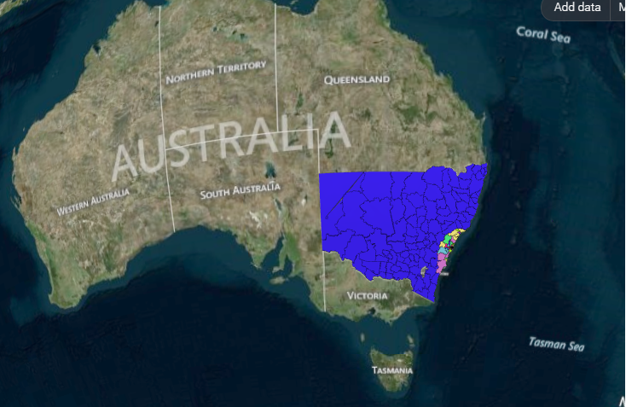

National Map Demo:

**Travel → Trips per person on a weekday**

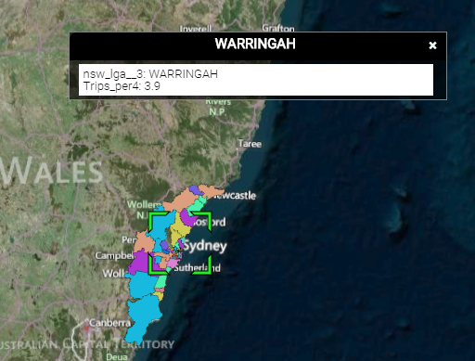

**Population → Person**

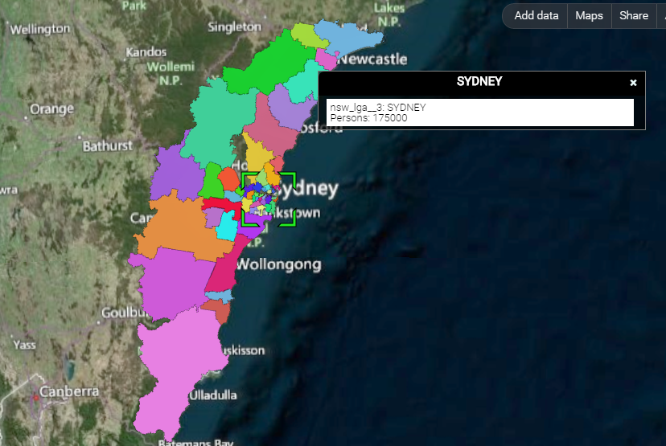

**Distance(kms) → Average trip length**

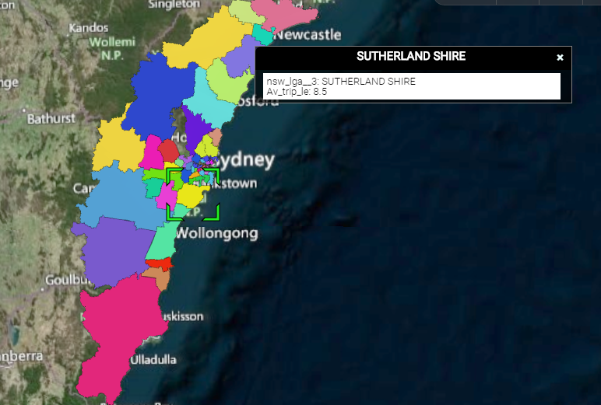

**2.2 Stakeholder Involvement Review**

Between Spring Break and Easter break, we lost a couple meetings with our sponsor and mentor, but we were able to give our midterm presentation to Dr. Avazpour and Dr. Grundy, and they both seemed happy with the progress we have made. Mike, the NICTA engineer we’ve been in contact with, has been helpful. However, he hasn’t always understood our inquiries, which has led to progress delays while waiting for responses.

**2.3 Data Management Review**

As of this moment, we have continued to adhere to proper data management policies. Our data is securely stored either in our own personal Google Drive, or on our private repository. A risk was acknowledged earlier on in the project stating that it might be possible that we would not be able to receive data fast enough from the company, however we have since discovered that this would not be an issue. Our team will continue to keep any sensitive data secure, and we are hopefully at a point in our project where we will be able to get more out of the data we have to work with.

**2.4 Requirements Review**

As of our last meeting with our mentor, they are happy with the direction we are taking for the project. Our requirements for the near future consist of converting the rest of the data to a proper format, and learning the most efficient method for translating the data to a visualizable format.

**2.5 Progress Review**

This sprint, a variety of work was completed across many fronts

* **Infrastructure**
  + Geoserver was set up
  + A new virtual machine was spawned for the databases
  + PostgreSQL was installed
  + PostGIS was enabled
  + Geoserver was configured
  + Utilities were installed to convert shapefiles into PostGIS tables (shp2pgsql)
  + QGIS
  + Geoserver
  + Shp2pgsql
    - Converts shapefiles to PostGIS tables
* **Code tracing**
  + Finished mapping the ausglobe.js file to defined code files
  + Failed to do a complete debugging of entire code process
  + Traced National Map code for adding data
    - Found the JavaScript module for the drag-and-drop feature
    - Attempted to find the module that loads data into the map
      * Found that if National Map cannot load data, it just returns an error
    - Determined generally where our modules will connect to National Map
    - Determined how National Map stores map data
      * Determined list of data formats National Map can/will be able to read

**3. Sprint Retrospective Meeting - 4/7/15**

**3.1 Top Highlights**

* We were able to finally get our data to visualize on the National Map.

**3.2 Top Lowlights**

* Most of the work put into geoserver is not going to be useful, we believe that National Map is blocking requests from outside of their domain. We have found a workaround, by exporting KML files directly from QGIS.
* The process of debugging through every code file used when running the National Map led to browsers consistently crashing. Reevaluation of how useful the debugging will be needs to be determined, and if it is important a new method will have to be used.

**3.3 Reflection on Improvements**

The team will coalesce on the use of KML files for feeding data into the map. This is the most important objective for the project as of this moment. This progress gives us hope to get the data for New South Wales to show correctly on the map, and potentially the data for Victoria as well now that we have a process developed.