|  |  |
| --- | --- |
| **Project Case** |  |
| COMP6114  Pattern Software Design |
| **Computer Science** | **E212-COMP6114-DY01-00** |
| ***Valid on*** *Even Semester Year 2020/2021* | **Revision 00** |

1. Seluruh kelompok tidak diperkenankan untuk:

*The whole group is not allowed to:*

* + 1. Melihat sebagian atau seluruh proyek kelompok lain,

*Seeing a part or the whole project from another groups*

* + 1. Menyadur sebagian maupun seluruh proyek dari buku,

*Adapted a part or the whole project from the book*

* + 1. Mendownload sebagian maupun seluruh proyek dari internet,

*Downloading a part or the whole project from the internet,*

* + 1. Mengerjakan soal yang tidak sesuai dengan tema yang ada di soal proyek,

*Working with another theme which is not in accordance with the existing theme in the matter of the project,*

* + 1. Melakukan tindakan kecurangan lainnya,

*Committing other dishonest actions,*

* + 1. Secara sengaja maupun tidak sengaja melakukan segala tindakan kelalaian yang menyebabkan hasil karyanya berhasil dicontek oleh orang lain / kelompok lain.

*Accidentally or intentionally conduct any failure action that cause the results of the project was copied by someone else / other groups.*

1. Jika kelompok terbukti melakukan tindakan seperti yang dijelaskan butir 1 di atas, maka **nilai kelompok** yang melakukan kecurangan (menyontek maupun dicontek) akan di – **NOL** – kan.

*If the group is proved to the actions described in point 1 above, the score of the group which committed dishonest acts (cheating or being cheated) will be “Zero”*

1. Perhatikan jadwal pengumpulan proyek, segala jenis pengumpulan proyek di luar jadwal tidak dilayani.

*Pay attention to the submission schedule for the project, all kinds of submission outside the project schedule will not be accepted*

1. Bila Anda tidak membaca peraturan ini, maka Anda dianggap telah membaca dan menyetujuinya

*If you have missed to read these regulations, so you are considered to have read and agreed on it*

1. Persentase penilaiaan untuk matakuliah ini adalah sebagai berikut:

*Marking percentage for this subject is described as follows:*

|  |  |  |
| --- | --- | --- |
| **Tugas Mandiri**  *Assignment* | **Proyek**  *Project* | **UAP**  *Final Exam* |
| 40% | 60% | - |

1. Software yang digunakan pada matakuliah ini adalah sebagai berikut:

*Software will be used in this subject are described as follows:*

|  |
| --- |
| **Software**  *Software* |
| Visual Studio 2019 (ASP.NET)  Visual Studio 2019 - SAP Crystal Reports  Chrome / Firefox / Microsoft Edge |

## Ekstensi file yang harus disertakan dalam pengumpulan tugas mandiri, dan proyek untuk matakuliah ini adalah sebagai berikut:

*File extensions should be included in assignment and project collection for this subject are described as follows:*

|  |  |
| --- | --- |
| **Tugas Mandiri**  *Assignment* | **Proyek**  *Project* |
| Folder Project (SLN, CS, ASPX, ASPX.CS, CONFIG, XML, DLL, PDB, RPT, XSS, XSD, SQL, MDF, LDF, EDMX, Image Files (JPG / PNG)) | Folder Project (SLN, CS, ASPX, ASPX.CS, CONFIG, XML, DLL, PDB, RPT, XSS, XSD, SQL, MDF, LDF, EDMX, Image Files (JPG / PNG)) |

## Soal

*Case*

**CentuDY**

**CentuDY** is a newly established medicine shop in Bluejack Land. To start its business, itneeds to create a website for their shop. In that website, people can find information about the medicines which **CentuDY** sells and buy it. This website also allows admin to manage its users, medicines and all transactions made by users.

As a web developer, you are asked to create a website using **ASP.NET** for this online shop. You are also **required** to use **Domain Driven Design** method to develop the website. Please note that using web service is **optional** in this project. The **required** layers are:

* **View**

View layer, or Presentation Layer, is responsible for showing information to the user and interpreting the user's commands. This layer is the home for all user interfaces in the project.

* **Controller**

This layer is responsible to **validate** all input from the view layer. It also responsible for **delegating request**s from the user to the lower layer for further processing.

* **Handler**

This layer is responsible to handle all **business logic** required in the application. It will delegates the task to query from the database, including select, insert, update and delete, to the repository layer. Please notes that there can be a single handler that accesses multiple repository.

* **Repository**

Repository layer responsible for **giving access** to the database and model layer via its public interfaces to acquiring references to preexisting domain objects. It provides methods to manipulate the object, such as add and delete, which will **encapsulate the actual manipulation operation** of data in the data store (or database). Repository also provides methods that select objects based on some criteria and return fully **instantiated** objects or collection of objects whose attribute meets those criteria.

* **Factory**

You need to encapsulate all **complex object creation** in this layer. For example, when the client needs to create an aggregate object (an object that holds a reference to another object), the object factory must provide an interface for creating these objects. It is important to notes that an object returned by the factory must in **a consistent** state.

* **Model**

The model layer is responsible for **representing concepts** in the business or information about the business situation.

The following is the **Entity Relationship Diagram** for **CentuDY’s Database:**

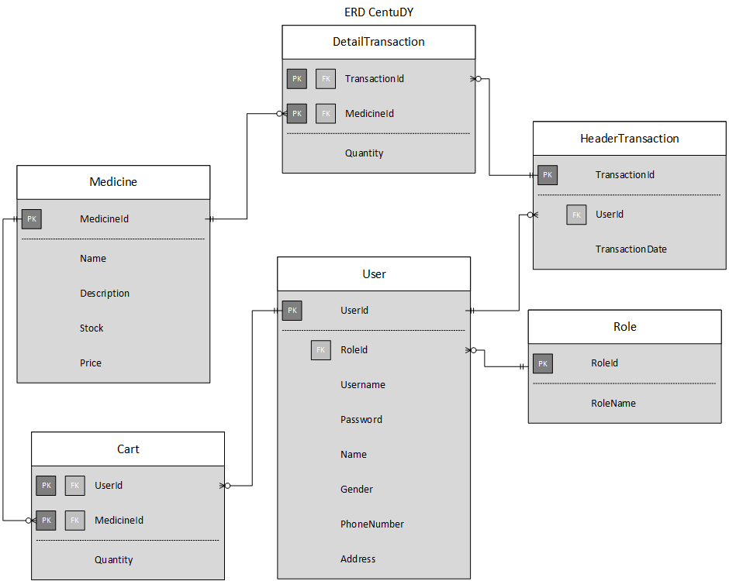

**Figure 1. Entity Relationship Diagram of CentuDY’s Database**

There are three types of user's roles in this website: **Administrator**, **Member**, and **Guest** (**non-logged-in user**). Below are the minimum pages you need to create for each role:

* + - **Administrator**
* View Medicines
* Insert Medicine
* Update Medicine
* View Users
* Profile
* Update Profile
* Change Password
* View Transactions Report
  + - **Member**
* View Medicines
* View Cart
* Add to Cart
* Profile
* Update Profile
* Change Password
* View Transactions History
  + - **Guest**
* Login
* Register

The descriptions for each page are as follows

* + - 1. **Login**

This page is the **landing page** of the website where the user will attempt to log in to the website. This page is only accessible to **guests** and willprovide a hyperlink to **Register Page** at the bottomof the login form.

The following table shows the existing fields in the login form and validations for each field:

|  |  |
| --- | --- |
| **Field** | **Information** |
| **Email** | Must be filled and appropriate with the data in the database |
| **Password** | Must be filled and appropriate with the data in the database |

If the user entered an **incorrect** username or password, then an error message will be shown corresponding to the validation triggering it.

The login page will also have a **remember me** checkbox. The remember mecheckbox will save your login information by implementing a **cookie** which also has an **expired time** if a user had checked it so that the next time the user attempts another login, the **email** and **password** field will be **auto-filled** with the user’s previous login information, **fetched from the cookie**.

1. **Register**

This page allows guests to **register** themselves as CentuDY’s members. Validate this page is only accessible to **guests**. The user will be redirected to this page when they clickedthe Register hyperlinkprovided at the Login Page.Display an error messageif the user inputs invalidpersonal data. The following table shows the existing fields on this page and the validation for each field:

|  |  |
| --- | --- |
| **Field** | **Information** |
| **Username** | Minimal length is 3 characters, must be unique, and Cannot be empty |
| **Password** | Minimal length is 8 characters and Cannot be empty |
| **Confirm Password** | Must be the same as the inputted password and Cannot be empty |
| **Name** | Cannot be empty |
| **Gender** | Must be chosen |
| **Phone Number** | Must be numeric and Cannot be empty |
| **Address** | Must contain the word "Street" and Cannot be empty |

1. **Home**

After success logged in, the user will be redirected to the home page and this page is only accessible by **logged-in users**.There will be a welcome message containing the user’s username which will be **fetched using session**,displayed at the top of the homepage.

This page will show some buttons to redirect the user to another page in the website. Every **logged-in** userwill have the following buttons available:

* **View Medicines**:Redirects the user to View Medicines Page
* **View Profile**: Redirects the user to Profile Page
* **Logout**:Logs out the user from the website and **destroys all cookie variables**

If the user is a **member**, the following buttons will become visible:

* + **View Cart**:Redirects the user to View Cart Page
  + **View Transaction History**: Redirects the user to View Transaction History

User that has member role will also be shown 5 **randomly** picked medicines from the databaserecommended to them, which will also have an Add to Cart button at each table row**.** The Add to Cart Button will redirect the user to Add to Cart Page and the selected medicine’s ID will be passed using the URL’s query string parameter.

If the user is an **administrator,** the following buttons will become visible:

* **Insert Medicine**: Redirects the user to Insert Medicine Page
* **View Users**: Redirects the user to View Users Page
* **View Transactions Report**: Redirects the user to View Transactions Report Page

1. **View Medicines**

This page allows users to see all of CentuDY’s medicines information, fetched from the database. This page is accessible for all **logged-in users**. The user will be redirected to this page when they clickedthe View Medicines Buttonprovided at the Home Page.The medicine's information that must be shown **is Medicine Name**, **Description**, **Stock,** and **Price**. There will be a **search box** at the top of the page to filter medicines based on its **name.** The filtering process **must** be implemented by using **the database filtering logic**.

For **member** users, the **Add to Cart** button will become visible for each medicine item. If users click Add to Cartbutton, the user will be redirected to **Add to Cart Page** and the selected medicine’s ID will be passedusingtheURL’s query string parameter.

For **administrator**, the following buttons will become visible:

* + **Insert Medicine**: Redirects the user to Insert Medicine Page
  + **Update Medicine**: Redirects the user to Update Medicine Page and the selected medicine’s ID will be passed using the URL’s query string parameter
  + **Delete Medicine**:Deletes the selected medicine from the database and **refreshes** the data table. Validate the to-be-deleted medicine **cannot** be referenced in another table in the database

1. **Insert Medicine**

This page is only accessible for **administrator.** This page allows an administrator to insert **a** new medicine into the database. The user will be redirected to this page when they clicked the Insert Medicine Buttonprovided at the Home Page or View Medicines Page**.** Display error message if the administrator inputted invaliddata. When the user has inputted all of the fields correctly and pressedthe Insert Button, the inputted medicine information will be **added** and **saved** into the database. The following table shows existing fields on this page and the validation for each field:

|  |  |
| --- | --- |
| **Field** | **Information** |
| **Name** | Cannot be empty |
| **Description** | Must be longer than 10 characters and Cannot be empty |
| **Stock** | Must be numeric, more than 0 and Cannot be empty |
| **Price** | Must be numeric and more than 0 and Cannot be empty |

1. **Update Medicine**

This page is only accessible for **administrator.** This page allows an administrator to **update** **an existing** medicine in the database. The administrator will be redirected to this page when they clicked the Update Medicine Button provided at the View MedicinesPage. All of the to-be-updated medicine submitting it again by pressing the Update Button. The medicine’s data will be fetched from the database by using the medicine’s ID provided from the URL’s query string parameter. When the user has inputted all of the fields correctly and pressed the Update Button, the medicine’s information in the database will be **updated**. Display error message if the administrator inputted invaliddata.

The following table shows existing fields in the page and the validation for each field:

|  |  |
| --- | --- |
| **Field** | **Information** |
| **Name** | Cannot be empty |
| **Description** | Must be longer than 10 characters and Cannot be empty |
| **Stock** | Must be numeric, more than 0, and Cannot be empty |
| **Price** | Must be numeric, more than 0, and Cannot be empty |

1. **View Users**

This page is accessible only for **administrator**. The administrator will be redirected to this page when they clicked the View Users Button provided at the Home Page. This page allows administrators to see all of the members’ information registered in CentuDY. The information of the member that must be shown is **Username**, **Name**, **Role**, **Gender**, **Phone Number**,and **Address.** The following buttons will also be available for the administrator’s use and are located at each row of the table row:

* **Delete User**: Deletes the selected user from the database and **refreshes** the data table. Validate the to-be-deleted user cannot be referenced in another table in the database

1. **Profile**

This page allows **member** and **administrator** to view their data. The user will be redirected to this page when they clicked the View Profile Button provided at the Home Page. This page is only accessible to **logged-in users.** The personal data that must be shown are **Username**, **Name**, **Gender**, **Phone Number** and **Address**. The following buttons will also be provided on this page:

* + **Update Profile**: Redirectsthe user to Update Profile page
  + **Change Password**: Redirects the user to Change Password Page

1. **Update Profile**

This page allows the user to **change** their profile information. The user will be redirected to this page when they clicked the Update Profile Button provided at Profile Page. Display error message if the user inputted invalid data. All of the to-be-updated profile's current data will be shown on this page and the user can change those data before submitting it again by pressing the Update Button. When the user has inputted all of the fields correctly and pressed the Update Button, the user’s information in the database will be **updated**. The following table shows existing fields in the page and the validation for each field:

|  |  |
| --- | --- |
| **Field** | **Information** |
| **Name** | Cannot be empty |
| **Gender** | Must be chosen |
| **Phone Number** | Must be numeric and Cannot be empty |
| **Address** | Must contain the word "Street" and Cannot be empty |

1. **Change Password**

This page allows user to change their password. This page is accessible by **logged-in** users only. The user will be redirected to this page when they clicked the Change Password Button provided at the Profile Page. Display error message if the user inputted invalid data. The user will be requested to insert **Old Password**, **New Password** and **Confirm New Password** field. When the user has inputted all of the fields correctly and pressed the Update Button, the user’s information in the database will be **updated**. The following table shows the conditions for each field:

|  |  |
| --- | --- |
| **Field** | **Information** |
| **Old Password** | Must match with the password in database and Cannot be empty |
| **New Password** | Must be longer than 5 characters and Cannot be empty |
| **Confirm Password** | Must match new password and Cannot be empty |

1. **View Transactions Report**

This page is accessible only for the **administrator**. The administrator will be redirected to this page when they clicked the View Transactions Report Button provided at the Home Page. This page will display the report of all member's transactions in CentuDY using **Crystal Report**. The report will have to show each transaction’s **entire information** and its **Sub Total** and **Grand Total** value.

1. **View Cart**

This page is only accessible for **member user**s. The user will be redirected to this page when they clicked the View Cart Button provided at the Home Page or when they had added a new cart. This page displays **all medicines** that have been added into the current **logged-in user**’**s** shopping cart. Display cart information such as **Medicine Name**, **Price**, **Quantity**, **SubTotal,** and **Grand Total**. Users can **remove** **medicine** from the user’s cart by using the Delete Cart Buttonwhich is provided at each table row. There is will also be a Checkout Buttonwhich will **empty** the user’s cart in the database and move those data into **transactions table**.

1. **Add to Cart**

This page is only accessible for **member**.This page allows a member to insert the **number** of medicines that he/she wants to add to the cart. This page alsoshowsall informationabout the selected medicine,such as **Name**, **Description**, **Stock,** and **Price**. The medicine’s information will be fetched from the database by using the medicine’s ID provided from the URL’s query string parameter. Display an errormessage if the member inputted invalid quantity.Required inputted **quantity validations** are as the following:

- Cannot be empty

* + Must be numeric
  + Must be more than 0
  + Must be less than or equals to current stock
  + The inputted quantity and the reserved quantity in other carts combined altogether must not exceed the selected medicine’s current stock.

Note that if the medicine is **already listed** in the shopping cart, its cart quantity will be **added** with the new quantity.When the user has inputted the quantity correctly and pressed the Add to Cart Button, the newly inputted cart information will be **added** and **saved** into the database, then the user will be redirected to View Cart Page.

1. **View Transactions History**

This page is accessible only for **member**. The user will be redirected to this page when they clicked the View Transactions History Button at the Home Page. This page will display **all transactions** that have been made by the currently **logged-in member**. The information of transactions that must be shown is **Medicine Name**, **Quantity**, **Date, Sub Total and Grand Total**.

**If you do not understand, please ask your assistant!**