Miniscope DAQ PCB Assembly Information

**Assembly:**

* 1 BGA (.8mm pitch)
* Through Hole:
  + Unique components: 5
  + Total parts: 7
  + All on top layer
* Surface Mount:
  + Unique components: 56
  + Smallest footprint: 0402
  + Total parts: 189
  + All on top layer
  + C67, C68, C72, C83 are unpolarized ceramic capacitors. Ignore polarization marks on board for these components.
  + U11, U12, U14 LED orientation is shown below:

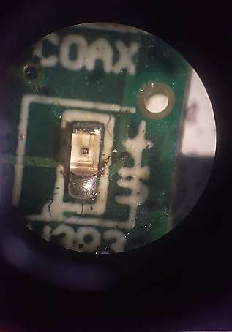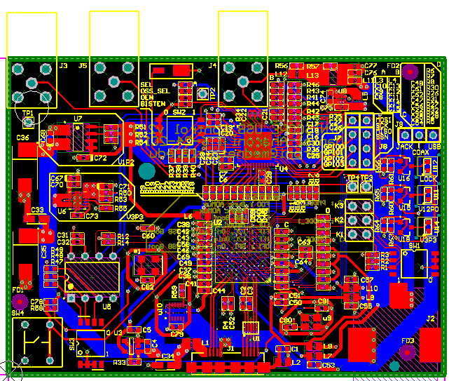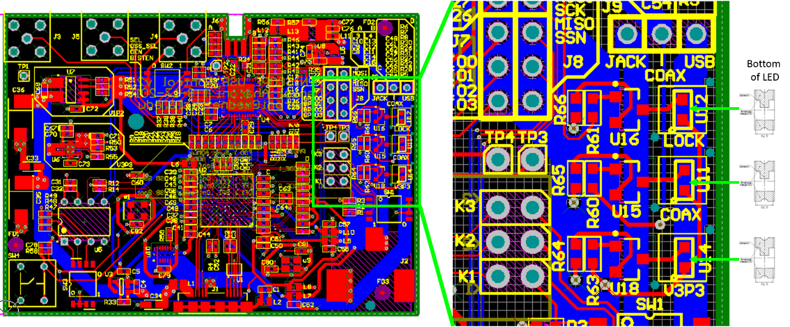

**Top of LED**