# **INFO6020 – Graphics 2 - Mid-term Exam – Winter 2020**

Instructor: Michael Feeney

## The exam format:

* You may use any resources you feel are necessary to complete the exam, but you are to answer the questions **on your own**. I will be looking for plagiarism (i.e. copying) very carefully. There is *no possible way* that the specific code to answer these questions, or the output to the screen, would be very similar to the look of another student’s code. Remember, this is a test and there are very clear policies about cheating on tests.   
  + <http://www.fanshawec.ca/admissions/registrars-office/policies/cheating-policy>
  + <http://www.fanshawec.ca/sites/default/files/assets/Ombuds/cheating_flowchart.pdf>
* The questions are ***NOT*** of equal weight. There are four (4) pages with five (5) questions
* The answers may be one or a combination of the following:
  + Short answer (in your own words)
  + Snippets of code
  + Complete running solutions
* CLEARLY indicate which answer goes to which question. My suggestion is that you place each answer in its own folder, named “Question_01”, “Question_02” and so on (or something equally clear). Another option is to create a Visual Studio solution and add a number of projects – one per question – to it. If I can’t make heads or tails of what question is what, I probably won’t even mark it.
* Place any written answers into a Word, RTF, or text file. Again, *clearly* indicate which question you are answering.
* If you are combining answers (which is likely), please indicate this with a “readme” file or some note (*not* buried in the source code somewhere).
* For applications: if it doesn’t build and run, *it’s like you didn’t answer it*. I’ll correct trivial, obvious problems (like you clearly missed a semicolon, etc.), but you need to be sure that it compiles and/or runs.
* You have until **2:30 AM** on **Thursday, February 27th** to submit all your files to the appropriate drop box on Fanshawe Online.
* Also be **SURE** that you are actually submitting the correct files)
* You can reach me through e-mail ([mfeeney@fanshawec.ca](mailto:mfeeney@fanshawec.ca)) or by calling the school.
* There is also a **PlyFiles.7z** file you will need. It’s available on FOL with the mid-term.

## Questions:

You will be using a number of models from the “Simple Space Interiors” models.

There are three textures that are in the collection, and the “comment TextureFile” inside the plyfile.

1. (20 marks) Recreate the “control room” shot, using the appropriate models and textures.   
     
   Do ***not***create the “starfield” outside the windows.

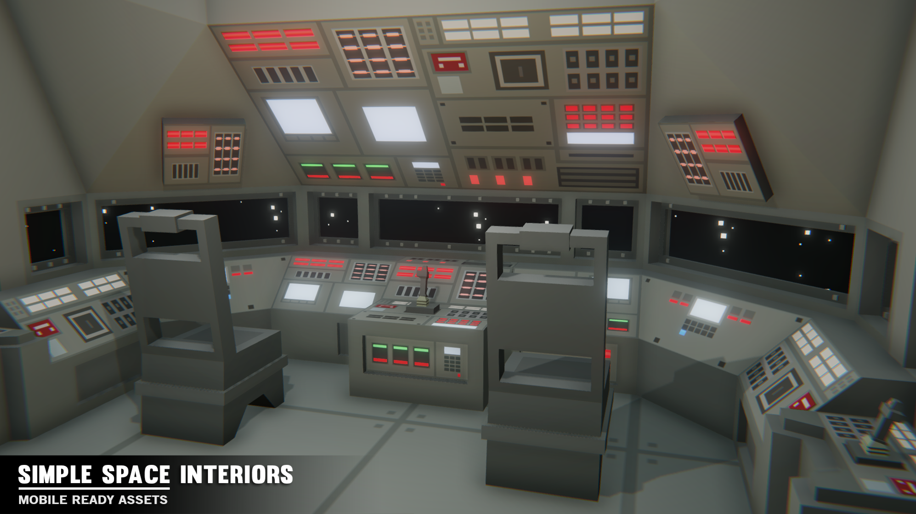

1. (10) Place some space image just outside the “console” windows.   
     
   Use a quad, or cube, or something else, with the star texture.
2. (50) Replace this scene and make a “star field” effect. The “star field effect” can be seen here: <https://www.youtube.com/watch?v=axo6YpDt9f0>  
     
   Do this in the following way:   
   * Create a new scene, which is completely black
   * Place solid coloured spheres on the screen as “stars”:
     1. Add a sphere to the centre of the screen. This is where the star will “start”.
     2. Choose another location on the screen at random. This is where the star will “end”.
     3. The star will “move” from the start location to the end location.
     4. Choose a velocity of this by calculating the difference between the end and start location, divided by a few seconds.  
          
        How this works is that all the stars move over the same length of time (a few seconds). Starts that have farther to go will move more quickly.
3. (50 marks) Replace the space scene from question 2, with the moving star field effect from question 2.   
     
   To do this, render the star field to an off-screen FBO, then update the texture outside the window.
4. (40 marks) Add a “hyperspace” effect to this star field effect like this: <https://geoawesomeness.com/star-wars-hyperspace-google-maps/>   
   (*just after 20 seconds, when the planet appears and zooms into place)*  
     
   Do this in the following manner:

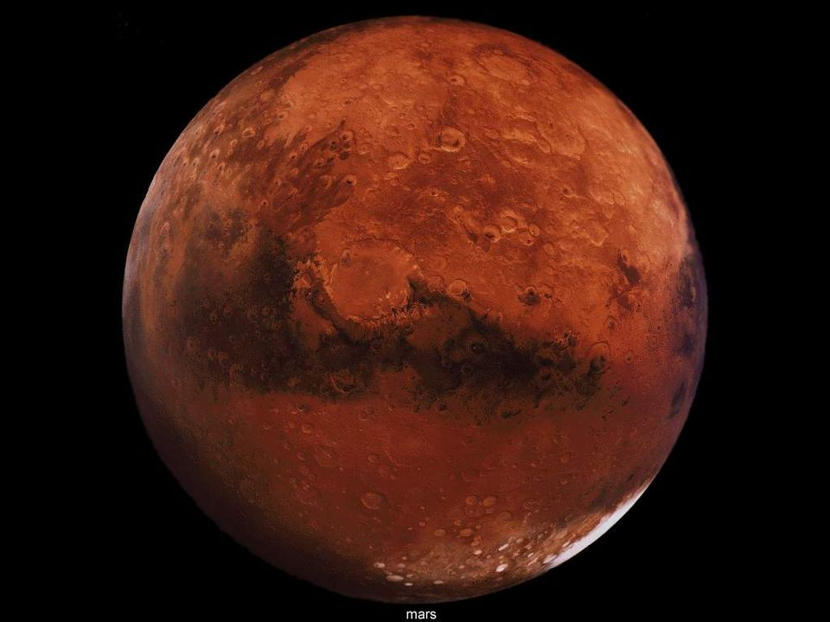

* + Find an appropriate image of a planet by googling “planet from space”
  + You are looking for an image of a planet surrounded by black, like the image on the right.
  + Make this image very small, while the star field is running, then gradually make the planet larger (looking like you are approaching), while the star field effect “slows down” (the starts move more slowly) and starts to fade.
  + By the time the planet is “large enough”, the stars should be completely invisible.
  + Use the “discard” in the shader to eliminate the “black” in the planet texture.

That’s it.