# **INFO6020 – Graphics 2 - Mid-term Exam – Winter 2022**

Instructor: Michael Feeney

## The exam format:

* You may use any resources you feel are necessary to complete the exam, but you are to answer the questions **on your own**. I will be looking for plagiarism (i.e. copying) very carefully. There is *no possible way* that the specific code to answer these questions, or the output to the screen, would be very similar to the look of another student’s code. Remember, this is a test and there are very clear policies about cheating on tests.   
  + <http://www.fanshawec.ca/admissions/registrars-office/policies/cheating-policy>
  + <http://www.fanshawec.ca/sites/default/files/assets/Ombuds/cheating_flowchart.pdf>
* The questions are ***NOT*** of equal weight. There are five (5) pages with four (4) questions
* The answers may be one or a combination of the following:
  + Short answer (in your own words)
  + Snippets of code
  + Complete running solutions
* CLEARLY indicate which answer goes to which question. My suggestion is that you place each answer in its own folder, named “Question_01”, “Question_02” and so on (or something equally clear). Another option is to create a Visual Studio solution and add a number of projects – one per question – to it. If I can’t make heads or tails of what question is what, I probably won’t even mark it.
* Place any written answers into a Word, RTF, or text file. Again, *clearly* indicate which question you are answering.
* If you are combining answers (which is likely), please indicate this with a “readme” file or some note (*not* buried in the source code somewhere).
* For applications: if it doesn’t build and run, *it’s like you didn’t answer it*. I’ll correct trivial, obvious problems (like you clearly missed a semicolon, etc.), but you need to be sure that it compiles and/or runs.
* You have until **2:30 AM** on **Thursday, February 27th** to submit all your files to the appropriate drop box on Fanshawe Online.
* Also be **SURE** that you are actually submitting the correct files)
* You can reach me through e-mail ([mfeeney@fanshawec.ca](mailto:mfeeney@fanshawec.ca)) or by calling the school.
* There is also a **PlyFiles.7z** file you will need. It’s available on FOL with the mid-term.

## Questions:

You will be using a number of models from the “Simple Space Interiors” models.

There are three textures that are in the collection, and the “comment TextureFile” inside the plyfile.

There’s also a “Babbage space station.7z” file which contains the space station files.

The other Babbage space station is the original files that were downloaded, if you want them, but you don’t need them for the mid-term.

1. (20 marks) Recreate the “control room” shot, using the appropriate models and textures.   
     
   The consoles in this image are made of two models:  
   * SM_Env_Consoles_01_xyz_n_rgba_uv.ply
   * SM_Env_Consoles_Corner_01_xyz_n_rgba_uv.ply

There’s two corner consoles (one reversed, which you can do by scaling by -1 on one of the axis, or reverse it in MeshLap, or some other way).

There are screen models, called “screen_X”, where X is 1, 2, or 3.

The centre console has three screens, one rectangular and two square.

The corner consoles has two screens, one rectangular and one square.

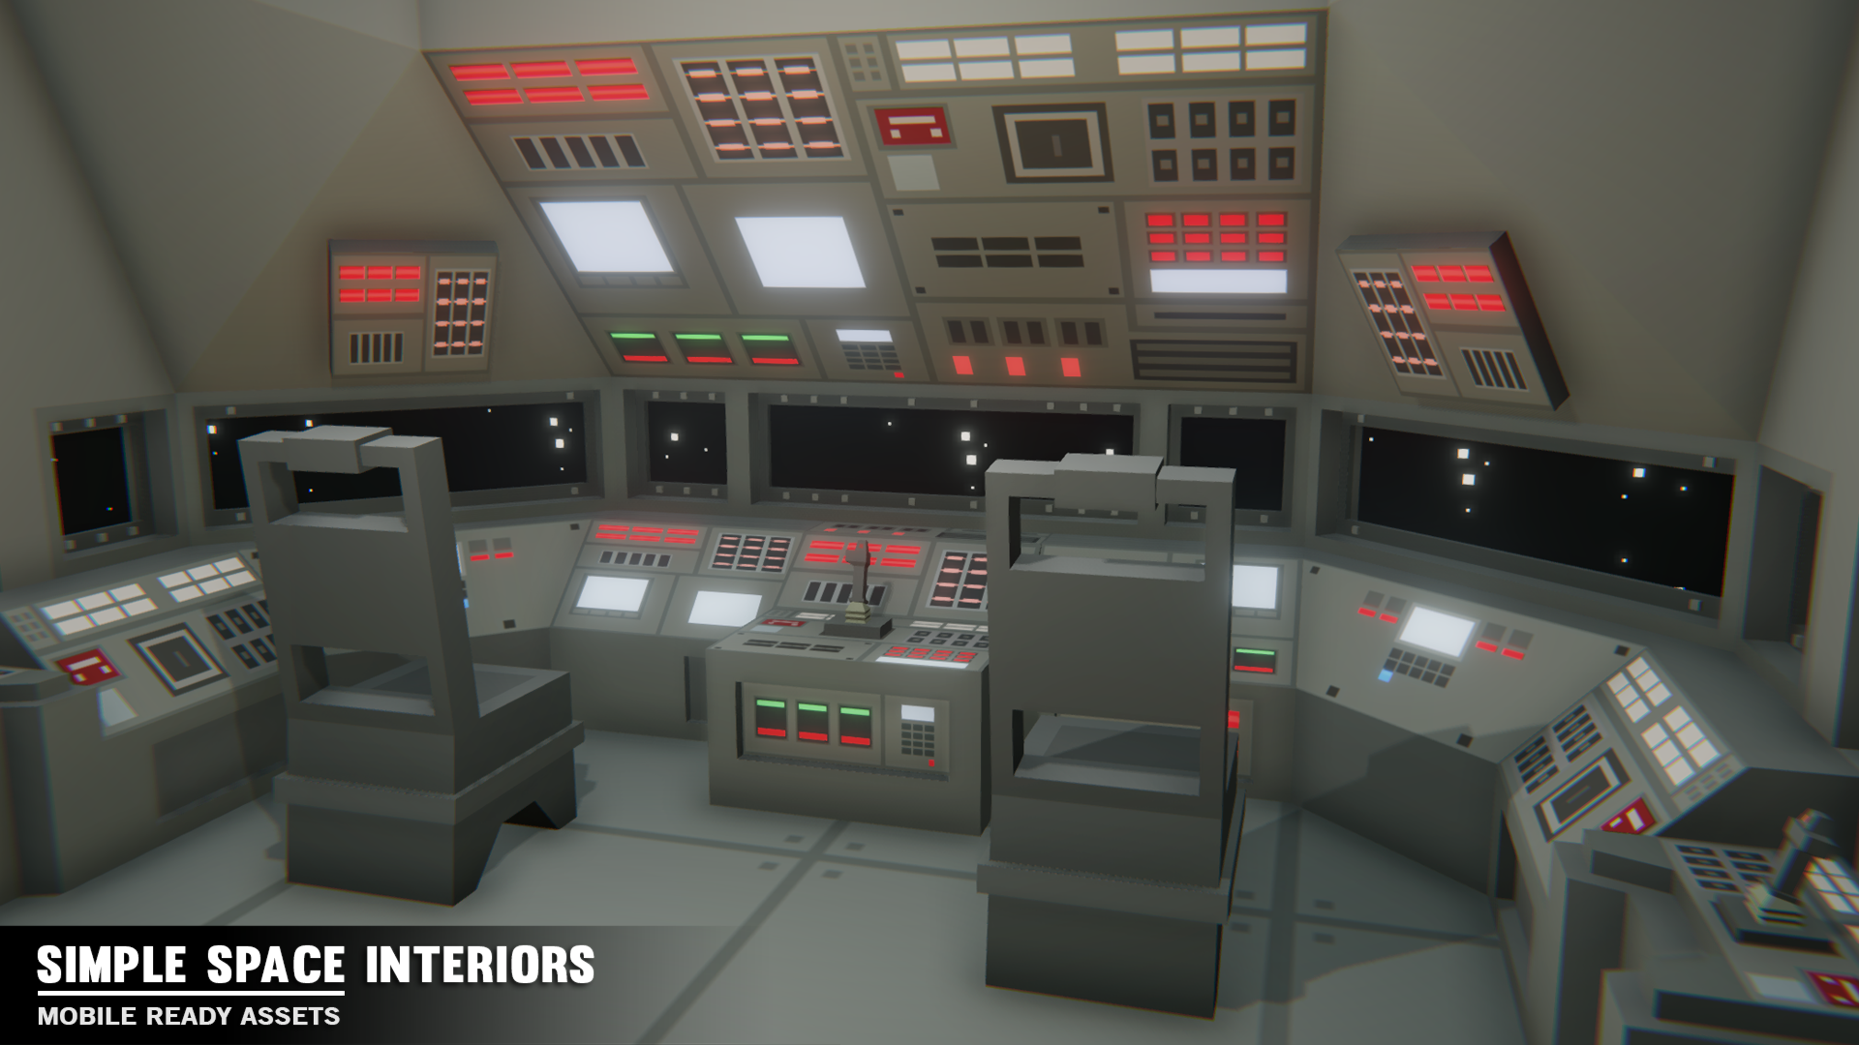

1. (10) Place some space image just outside the “console” windows using a skybox, a quad, cube or something else.   
     
   The star field should be being displayed on the rectangular windows, which you can do by *not* including the rectangular screen models.
2. (150) This control room is inside this larger “Babbage Space Station” model (below).

Note that you are *not* placing the console inside this larger model (although that would be neat...) – instead, you are going to simulate this by showing the station on the console “screens”, which are the *rectangular* screens in the upper image.

There’s four screens in total, two on either side of the central rectangular screen, and two more on the extreme left and right of the windows.

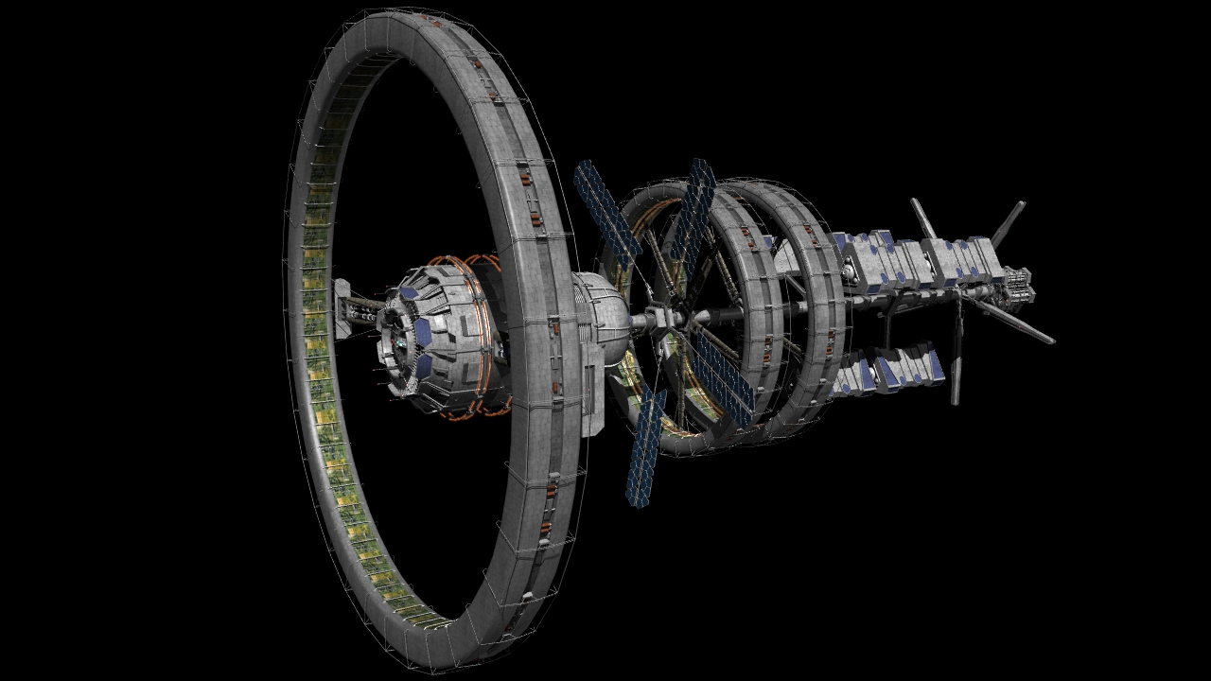

Place the Babbage Space Station somewhere in your scene but NOT visible through the front windows of the control panel or in view when the camera is looking at the consoles.

We can assume there are cameras all around the station, so that the crew can get a look at various parts, sort of like security cameras in a building, but here we are seeing the outside of the ship. If you look through this video, you see a number of *external* views of various Space X launches. That’s the idea.

Like you’d never see the entire space station because: well how would you do that if you are on the space station, right? You’d have to be far away from the station which is just too scary.

The two left and right side screens (the ones in the “corner” models) should cycle through five (5) different views of the space station. I’m not too concerned what these are, but they should show a “reasonable” variety of angles. Seriously, it’s a pretty interesting model, so imagine you had to place cameras on the surface of it, looking at other parts.

Maybe the solar panels, from some part on the ring? Maybe from the central “hub” part, looking at the inside of the ring? You get the idea.

These images should change to randomly show one of the five (5) views in some random interval from 3-4 seconds per screen. So the screens should be showing different views most of the time *and* they should “switch” at slightly different intervals.

1. (100 marks) Show some interesting “space” text on the other screens:

On the remaining two screens, on either side of the main window, show some sci fi nonsense text, sort of like something from the movie “Aliens” or “2001: A Space Odyssey” or even Star Wars.

* From Alien: <https://youtu.be/f95xBXq8MR0?t=125>
* From 2001: <https://youtu.be/bQP6EetXs88?t=3160>

To get this, type “computer code texture” or “sci fi screen texture” into google and take a few textures from there.

Like the side screens, these two screens should show different information and change at random intervals.

However, these should periodically add flickering and static.

Why is it that future space ships have displays that flicker? Seriously?   
It’s like why all future holograms look like garbage, too? Why?   
*This* is the technology they didn’t figure out?

Faster than light travel – no problem.

Clear, stable screens – an impossible technology.

Moving on...

**The “flicker” effect** can happen by periodically adding some random value from, say 0.3 to 0.7 to the vertical value of the texture, then slowly moving it down or up to 0.0.

This will cause the image to “jump” to some new location, then gradually “drift” down the where it’s supposed to be. Even if you add to this value (to get it back to effectively zero), the image will still wrap around.

Then a few seconds later, it happens again.

**The “static” effect** can happen by periodically adding and/or fading in a static texture (google “static texture”) and applying random U and V offsets to the texture *each frame* and *combining it with* the “sci fi” texture that’s being displayed as well.

Note: these are only suggestions for how to do this effect. If you have a different technique that accomplishes the same “look” feel free to use that. I’m only looking for the final look, not specifically how you did it.

That’s it.