# **INFO6020 – Graphics 2 - Mid-term Exam – Winter 2023**

Instructor: Michael Feeney

## The exam format:

* The questions are NOT of equal weight. There are five (5) pages with five (5) questions.
* Since the questions “build on” one another, I’d suggest that you combine the questions into one solution & project, rather than separating them into separate projects. It should be clear what question(s) you’ve answered based on the output and functionality of the question, but if you feel it would be helpful to add more clarification, feel free to add a readme file and/or a narrated video explanation..
* For applications: if it doesn’t build and run, it’s like you didn’t answer it. I’ll correct trivial, obvious problems (like you clearly missed a semicolon, etc.), but you need to be sure that it compiles and/or runs.
* You have until **the last week of class (Friday, April 14th, 2023 is the last day of class)** to submit all your files to the appropriate drop box on Fanshawe Online.
* There is also a Retro TV.7z file you will need. It’s available on github (with this exam).

## Questions:

You are going to mimic something like the image below, with a few CRT (Cathode Ray Tube) televisions showing a number of “channels”.

We will imagine that this happened decades ago, and a lot of people are watching live pictures from the landing site, but through a store window, something like this:

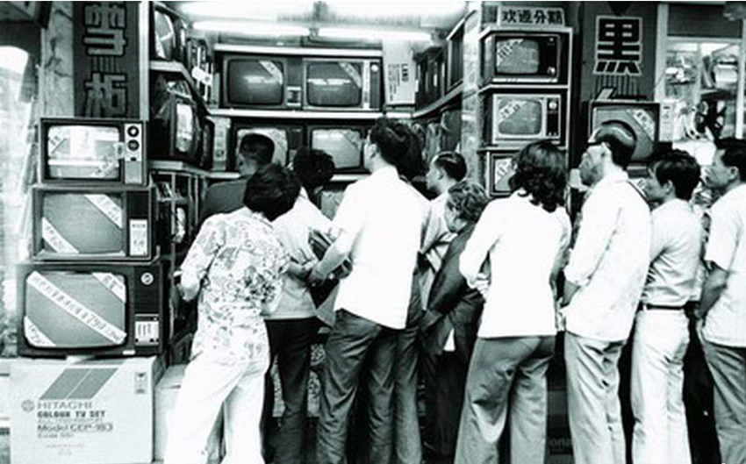

(<https://kaneparker93.files.wordpress.com/2013/09/people-watching-tv-in-window.jpg>)

However, you are to make the image look more like this (with just the old TVs present):

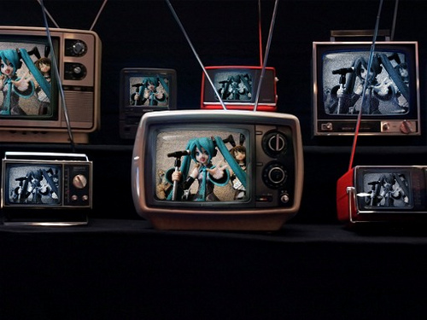

(<https://c1.staticflickr.com/5/4030/4293572142_b6bf9a394f.jpg>)

1. (20 marks) Using the “Retro TV” models, place **three (3)** televisions in your scene.   
   They can be part of another scene (i.e. there can be other objects there, like a room or whatever) or they can be the only things present (so they are just “appearing” there in a void of blackness). You should be able to see the screens of all the TVs at the same time – i.e. you can place them side by side, on top of each other, whatever. See the picture on page 2 where all the TVs screens are visible to the people watching.   
   * Choose three different colours for the “body” of the screen.
   * The screen should also be black (the TVs are “off”), but they should be highly specular (i.e. shiny) like glass (CRTs were made of glass, right?)

In North America, there were originally thirteen (13) channels. Yes, that’s it. **Actually, it was worse than that as there wasn’t a “channel 1”, so you only had twelve (12) channels from 2 to 12.** And not every “channel” had something on it. If there was nothing on that channel, then you say static. It literally looked (and sounded!) like this: <https://www.youtube.com/watch?v=t0I4mTEdAf8&ab_channel=NemArt>   
  
Your TVs will have three (3) different “channels” to watch, and the rest show “static”.   
  
Attributes of “static” and channel changing:

* It’s black and white (or almost black and almost white).
* It’s completely random.
* It changes every screen update, which is 30 frames per second with NTSC and 25 frames per second with PAL. This means the static would change that often.
* Sometimes parts of, or the entire, screen would “roll” since the TV couldn’t find the “vertical blanking” interval. The white band in this video illustrates this: <https://www.youtube.com/watch?v=8cxh54Tfs28&ab_channel=cineguac>
* When a channel was “switched”, the image would quickly fade to black, while the new image quickly faded in. Often there was a “glitch” sort of thing as well as a frame or two of “roll” when the new channel first appeared. This is someone mimicking this quite well (queued up to the 13:04 time): https://youtu.be/vk17iqXUr9I?t=784

1. (100) Make a single “channel” that shows any *other* scene you’d like.   
   In other words, you are *not* showing the TVs, but something else completely.   
   You can choose any scene you’d like, even from another project/test.  
     
   Add a keypress (or equivalent, like imGUI/whatever) to “turn on” one of the TVs.   
     
   This would mimic the CRT “warming up” (it literally did need to warm up the electron gun in the back) which looked like the screen being completely black screen, with the image slowly getting brighter over a few seconds.   
     
   Add another keypress (or equivalent) to “turn off” the TV. The image would very quickly “fade” to black over about a second.
2. (100) Change how the TV turns on once it’s “warmed up”.  
     
   While a cold TV took a few seconds to start showing the bright image, once the TV was “warmed up”, you could turn it on, then turn it back on within a few minutes and the image would almost instantly appear. This was because the electron gun was literally still “hot” and didn’t need to warm up.   
     
   Mimic this by adding some kind of timer so that:  
   * It takes about 2 minutes for the TV to fully “cool down”.
   * If you turn the TV back on *after* this 2 minutes, it should show that “warm up” effect.
   * If you turn the TV back on *before* this 2 minutes, then it takes proportionally less time. i.e. if it takes your TV four (4) seconds to “warm up” (i.e. fade the image from black to the fully bright image), then if you turned it back on after one (1) minute it should take around two (2) seconds (1/2 the time) to fade up from black.
3. (200-300 marks) Make two more “channels” on the other two   
     
   Repeat questions 2 and 3 for two more channels, so:
   * 75 marks for each of the new channels
   * 50 marks for the turn off/turn on hot/cold start up time effect (question 3)

One of these channels has to be something completely different (or look completely different, like unrecognizable from the 1st channel – i.e. you can place your camera in some place that makes it *seem* like it’s not a different angle of the same scene).

The other channel can just be a different placement of the camera. i.e. can be the same scene but it’s a very different camera angle.

1. (100 marks) Mimic changing the channels.   
     
   Add keystrokes (or equivalent) to change the channels on the TVs. You only need to change the channel up and down – i.e. you don’t have to be able to randomly choose any of the thirteen (13) channels.   
     
   Show the channel changing by showing the “channel change” effect from page 3.  
     
   Only three (3) of the channels “work” and the rest show static. You can choose any channels you want, but they can’t be consecutive. Like you can’t do channels 1, 2 & 3, but you can do 1, 3 & 5. In other words, there has to be at least one “static” channel in between the “real” channels.   
     
   You have to be able to change the channels on the TVs independently.   
     
   Indicate the channel you are on (channel 2 – 13). Remember there isn’t a channel 1, so you go from channel 13 🡪 2 and 2 🡪 13 when you go down/up respectively.   
     
   (100 mark **bonus**): Indicate the channel number on screen. Some “fancier” TVs were like modern flatscreens in that they would briefly show the channel number. To get this bonus, the channel number has to shown as part of the static & channel change effects.

(That’s it for the exam).