INFO6020 – Graphics 2 – Mid-term
Thursday, February 20th, 2013, 9:00 AM to 9:00 PM
Instructor: Michael Feeney

The exam format:
- The questions are not of equal weight. There are four (4) pages with four (4) questions.

- The answers may be one or a combination of the following:

  - Short answer (in your own words)
  - Snippets of code
  - Complete running solutions
- CLEARLY indicate which answer goes to which question. My suggestion is that you place each answer in its own folder, named “Question_01”, “Question_02” and so on (or something equally clear). Another option is to create a Visual Studio solution and add a number of projects – one per question – to it.
- Place any written answers into a Word, RTF, or text file. Again, clearly indicate which question you are answering.
- If you are combining answers (which is possible), please indicate this with a “readme” file or some note (not buried in the source code somewhere) indicating this.
- For applications: If it doesn’t build and run; it’s like you didn’t answer it. I’ll correct trivial, obvious problems, but you need to be sure that it compiles and/or runs.
- This is an “open computer” style exam (like "open book" with the additional resources of what's on your computer, too) but keep in mind that you are supposed to be doing this exam completely on your own (with absolutely no communication or collaboration):
  - It is almost impossible that the basic structure of your code and/or the approach you take would be virtually identical to another student taking this test. This would indicate collaboration, in other words “plagiarism” or “cheating.”
  - I will be aggressively looking out for this kind of thing, as it is a clear violation of the college plagiarism policy.
  - Please refer to Policy 2-G-04 on Fanshawe Online or in the Student Handbook for more information.
- Keeping in mind the plagiarism policy, you *can* use the code that was provided for you in class, you may not simply submit unchanged, or virtually unchanged, code we've done in class, even if it fully or partially answers the question.

- (25 marks) You are on the hunt for bunnies, specifically Stanford bunnies.
Create a scene that has:
  - a number (at least 20) of Stanford bunnies, of various sizes. These would be lit by at least two lights, and no textures.
  - “ground” (for the bunnies to sit on), that can be anything you’d like: a single ply file or multiple ply files, arranged together. The ground is lit by two lights, but also has a single texture (something grass and/or dirt like).
  - Some fences (to contain the bunnies). These can be lit if you’d like, but they have to use some sort of “discard transparency.” Note: You can NOT use the textures that we used in class for this; you must use another set of textures.
- (50 marks) Like real bunnies, Stanford bunnies are easily frightened, so you can’t get too close. Alter your scene in question 1 so that you can “zoom in” on the bunnies.
Specifically:
  - You need to turn the camera up, down, left, and right. You can use the mouse of the keyboard. The camera does not have to actually move in the scene.
  - Press the “z” key to “zoom in”.
  - Press the “x” key to “zoom out” (i.e. go back to the regular view)
  - When zoomed in (most of the marks are for this part):
    - You need to move the camera “closer” to the bunnies. Note that the camera has to be looking in the same direction. You can do this in a number of ways (including actually repositioning the camera), but the effect has to be that the objects you are seeing are “closer” than they are when “zoomed out”.
    - There has to be a full-screen “reticle” effect that look like a typical TV/movie “binocular” or “telescope” sort of effect. Something like these:
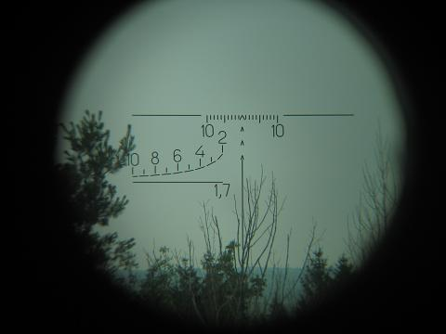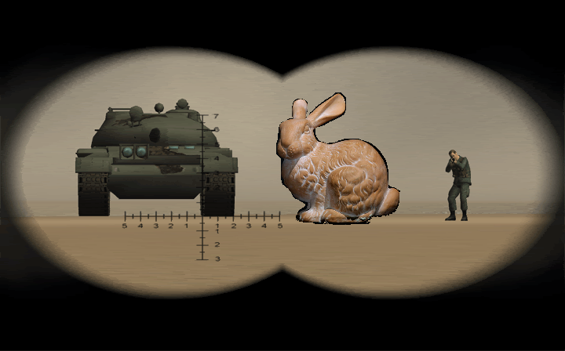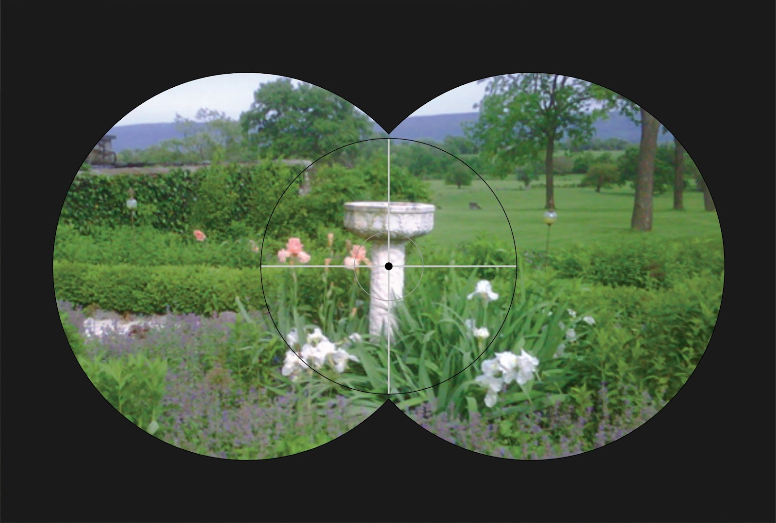

- (30 marks) Add one of the following particle effects to the bunny scene:

- A cosy fire that the bunnies can sit around, or
- Rocket exhaust, which makes the plain bunnies Super Rocket Robot Bunnies!
Regarding marking here: Although it is up to you to decide how you want to implement the effect (point particles, different colours, imposters, 3D particles, etc.) the effect has to look “convincing,” in the sense that a “typical” person would look at it and immediately determine what you are showing.

So, if you do something like a red coloured point fountain in the centre of the screen, it won’t look nearly as good (aka “convincing”) as a system based on flame texture based 3D/imposters.

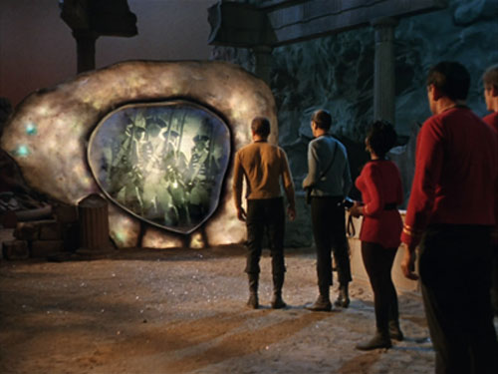
- (50 marks) In game and science fiction, there is a concept of a “portal” which is like a door or window into another, alternative world. The idea is that this world “overlaps” our world, but you can’t see it. The game “portal”, the “Stargate” move and TV shows, and the book “The Subtle Knife” and others make this one of the central themes.

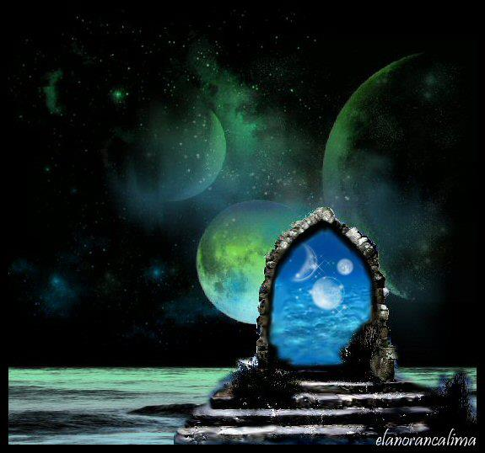

The image on the left is like a “Stargate” portal, where you walk through and go to another part of the galaxy. The one on the right is from the original Star Trek, where the portal allows you to go to a different time.
Note that you can look through the portal to see what’s going on.
You are to create two scenes of bunnies, one in the “daytime” and one in the “night time”.
You can use the same scene you used in previous questions, or you can create a new scene.
Details:
- Like question 1, you need 20 bunnies, and a “ground” object of some sort
- You need to have TWO different scenes, one with a number of bright lights (the “daytime” one), and one with either very dim lights or only one, dim light (the “night time” one).
- The bunnies in the “daytime” scene have to be in different places from the “night time” scene.
- Place five quads or blocks (cubes) in random locations and angles (rotations around the Y or up-down axis) in the scene. These will be the “portals”.
- Using the stencil buffer, show the “night time” scene, but display the “day time” scene through the “portals”.
- You should be able to move around the scene with the mouse or keyboard.
The image below attempts to show this:
- Note that the portals are facing random directions.
- You would be able to see the “other” scene through these portals
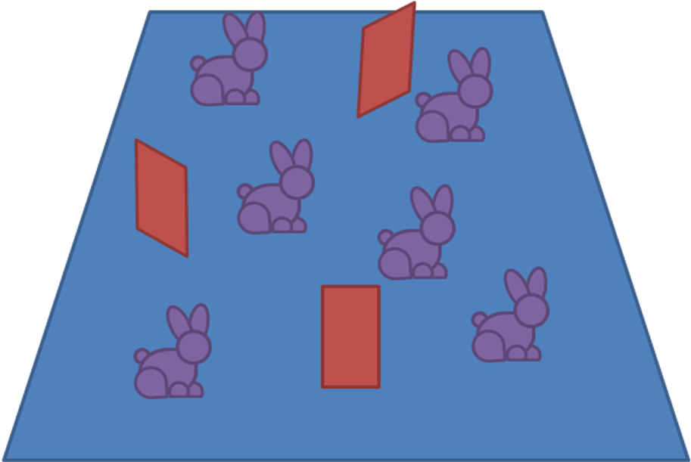

That’s it.

