INFO6011 – Physics & Simulation 2
Mid-term Exam – Winter 2011
Instructor: Michael Feeney

The exam format:
- You may use any resources you feel are necessary to complete the exam, but you are to answer the questions on your own.

- The questions are all of equal weight. There are two (2) pages with five (5) questions.
- The answers may be one or a combination of the following:

  - Short answer (in your own words)
  - Snippets of code
  - Complete running solutions
- CLEARLY indicate which answer goes to which question. My suggestion is that you place each answer in its own folder, named “Question_01”, “Question_02” and so on (or something equally clear). Another option is to create a Visual Studio solution and add a number of projects – one per question – to it.
- Place any written answers into a Word, RTF, or text file. Again, clearly indicate which question you are answering.
- If you are combining answers (which is likely), please indicate this with a “readme” file or some note (not buried in the source code somewhere) indicating this.
- For applications: If it doesn’t build and run; it’s like you didn’t answer it. I’ll correct trivial, obvious problems, but you need to be sure that it compiles and/or runs.
- You have until Saturday, February 26th at 11:59 pm to submit all your files to the appropriate drop box on Fanshawe Online.
- You can reach me (in order of preference/chance of actually getting me):
  - By e-mail (mfeeney@fanshawec.ca)
  - My cell 519-494-7569
  - Or at home 519-438-3300
  - My office phone: (519) 452-4430 x4798

Questions:

- Demonstrate dynamic intersection. You may use spherical, axis-aligned bounding boxes (AABB) or some other primitive. Your program should be able to show a collision that is taking place between the update time steps.
- Explain how Verlet integration techniques (which were used for cloth in Physics and Simulation 1) can also be used to simulate soft bodies.
- Explain a specific draw back/potential “gotcha” with using this technique and a possible work around.
- Explain why most wheeled vehicle simulations simplify the wheels to a point, rather than doing a complete simulation of the entire structure of the wheel?

- When used strictly for animation, forward kinematics often ignores the actual position of an articulated body. In this case, the animation will ‘tweak’ the animation until it ‘looks good.’ In physical simulation, we are concerned with the interaction between objects. Explain how you would go about determining the 2D end location of a 2D, three linked arm, with three joints each with one degree of rotational freedom.
To help clarify, the 2D arm would look something like this:

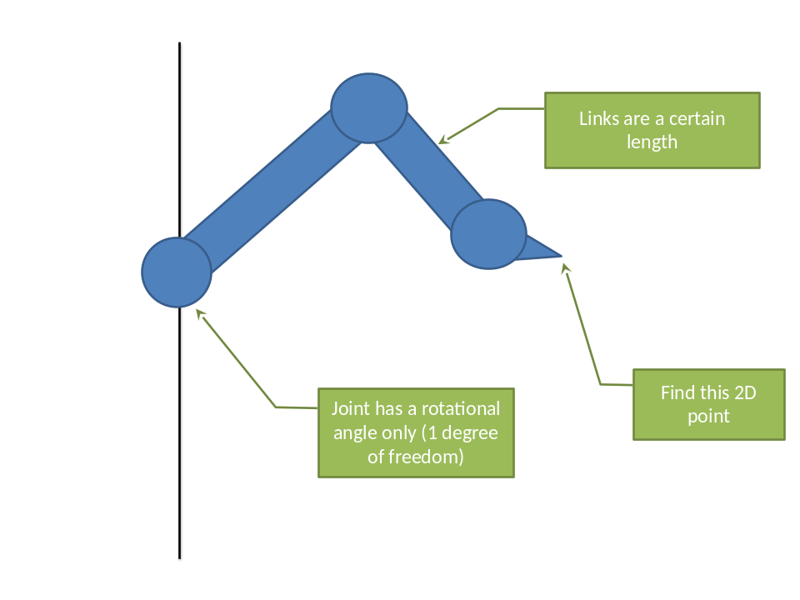

That’s it.

