INFO6022 – Physics 2 – Mid-term
Friday, February 22nd, 2013, 10:00 AM to 10:00 PM
Instructor: Michael Feeney

The exam format:
- The questions are not of equal weight. There are four (4) pages with four (4) questions.

- The answers may be one or a combination of the following:

  - Short answer (in your own words)
  - Snippets of code
  - Complete running solutions
- CLEARLY indicate which answer goes to which question. My suggestion is that you place each answer in its own folder, named “Question_01”, “Question_02” and so on (or something equally clear). Another option is to create a Visual Studio solution and add a number of projects – one per question – to it.
- Place any written answers into a Word, RTF, or text file. Again, clearly indicate which question you are answering.
- If you are combining answers (which is possible), please indicate this with a “readme” file or some note (not buried in the source code somewhere) indicating this.
- For applications: If it doesn’t build and run; it’s like you didn’t answer it. I’ll correct trivial, obvious problems, but you need to be sure that it compiles and/or runs.
- This is an “open computer” style exam (like "open book" with the additional resources of what's on your computer, too) but keep in mind that you are supposed to be doing this exam completely on your own (with absolutely no communication or collaboration):
  - It is almost impossible that the basic structure of your code and/or the approach you take would be virtually identical to another student taking this test. This would indicate collaboration, in other words “plagiarism” or “cheating.”
  - I will be aggressively looking out for this kind of thing, as it is a clear violation of the college plagiarism policy.
  - Please refer to Policy 2-G-04 on Fanshawe Online or in the Student Handbook for more information.
- There may be a number of versions of the exam.

For all questions:

- Keeping in mind the plagiarism policy, you *can* use the code that was provided for you in class, you may not simply submit unchanged, or virtually unchanged, code we've done in class, even if it fully or partially answers the question.
- The idea of an “open book” (or “open computer”) test is not to simply find code that does what I’ve asked; the “open book” nature is so that you don’t have to memorize tedious details, like the parameter list of functions, etc.
- In other words: you should be able to do this test CLOSED BOOK. What I’m looking for is that you are capable of answering questions with no references whatsoever – but I also don’t think it’s fair (or sensible) to have to remember every single detail.

If you are unclear about what I’m saying, please read this analogy:
Let’s say you were taking baking, instead of programming.
In your practical exam, you would be asked to bake something.
If it were a “closed book” exam, then you wouldn’t have access to a cook book; you would have to MEMORIZE all the recipes, along with the exact amount of each ingredient.
I would think that students who could memorize a cook book don’t necessarily make the best cooks. They might, but just because you are good at memorizing doesn’t mean that you are good at baking.
So, you are given an “open book” test. This allows you to bake something WITHOUT THE NEED TO LOOK AT THE COOK BOOK unless, perhaps, there was some trivial thing you had to look up (“was that ¼ teaspoon of salt or a ½ teaspoon? I’ll look that up.”
- Submitting code from class would be like freezing a cake that I made earlier, then presenting it as your own during the exam.
- Submitting code that’s taken from someone else would be like having another student bake two cakes during the test, give it to you, then you submit it as your own.
- Having two (or more) of you work together is like having a group bake many cakes, then claim that you each baked your own, individual cake. You didn’t.
You should be baking (aka “programming”) completely on your own, and ideally without any resources whatsoever.

Any of the questions, below, that refer to ropes, cloth, or soft objects, can utilize the Verlet integration and constraint code from class, provided it is not the OpenGL code that was provided to you.

- (30 marks) To divide up a room - particularly if you have any teen girls in your house - you may use a 'bead curtain'. This is a bunch of strings, strung with beads, that hand in parallel row, like this:

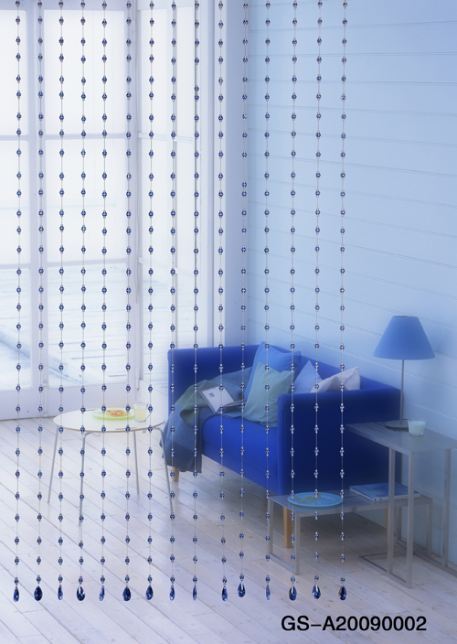
Create an application that simulates a beaded curtain, using spheres for the beads. It should have at least 20 strings of beads, that are at least 25 beads in length. You do not have to show the "strings" between the beads.

- (20 - 40 marks) Add some sort of functionality to show that the bead curtain is actually made up of individual strings of beads, and that these strings are not connected in any way.

You have two options here:

- (20 marks) By pressing a key or clicking the mouse, "sway" one string of the beads. In other words, move the bottom most bead so that the entire string sways. You can apply a temporary force to the bottom bead or temporarily position it so that, when released, it will start to sway.
- (40 marks) Simulate something that looks like wind going through the strings. You can do this by randomly applying forces (or slightly adjusting the current position) of the bottom most bead. You need to be able to "turn on" and "turn off" the "wind" and the wind needs to be somewhat random: i.e. when the "wind" is on, the beads should all move in the same direction, but with slightly random perturbations.
- (20 marks) Alter your application so that you can change the amount of "springy-ness" in the strings. By pressing a set of keys, you should be able to make the strings that connect the beads very stretchy (the beads can move away from each other) to very stiff (they beads don't move away from each other). Note: I'm referring to the beads that are on the same string, not beads in adjacent strings - they aren't supposed to be connected to each other at all.
- (30 marks) Alter your application so that you can move a sphere or box through the bead curtain, just like the pretty girl in the photo is doing, except she's a person, not a sphere/box.
You will have to implement some sort of spherical collision detection (I would suggest spherical if you're using a sphere and AABB if you are using a box) so that the beads move out of the way, and drape over the sphere/box.
If you choose a box, you do not have to rotate it; in other words, the box can be axis-aligned as it passes through the beads.

That’s it

