INFO3111 – C++ Computer Graphics (v1)
Final Exam – Summer 2026
Instructor: Michael Feeney

The exam format:
Your exam will be “open computer” and “open book.” This means that you will have to answer questions on your computer that are mainly “project” based; you will be give a problem – potentially with some code to start with – and you will have to “solve” the problem.

- You have 2 hours and 50 minutes. You will likely be pressed for time, so use it wisely:
  - If you get ‘stuck’ on a problem, move on and come back to it.
  - At the ½ way mark, you should have at least ½ of the questions done.
  - The value of each question is indicated beside the question. Don’t spend all your time on questions worth very little.
  - Be aware that some questions build on previous answers.
  - It is possible to get “part marks” (but not if it won’t build, explained later)

- You are not to be in communication with anyone during the test – so if you are on the internet (other than to submit at the end), I have to assume you are in communication, so you will get zero (0), be asked to leave, and be written up for an academic offence. This includes FOL, MSDN, OpenGL.org, etc
- Your solution may not contain any third party libraries (like boost) or any "C++11/14" features. If it has either of these things, the question(s) will not be marked (because it won't build). There has been some stress about this, so here’s a “meeting you ½ way”: if it builds in Visual Studio 2012, then you’re likely OK (I wasn't “super picky” for the mid-term, but will be ruthless for this final.)
- If the solution does not build (and run), I will not mark it (so you will receive zero on questions that can't be built and/or won't run). When I say "run", I'm not speaking about some, random, unforeseen bug that crashes your application, but rather something that you should have obviously dealt with, like memory exceptions, missing files, etc.
- You can not use any third party game engines (Unity, Unreal, etc.), scene-graph systems (SDL, etc.), etc.; this must be code that is clearly “your own” and was produced during this term, using the resources introduced/provided from the class (i.e. you may use any of the code posted on the FOL INFO-3111 page, as well as anything you’ve used to complete checkpoints, etc., provided it doesn't violate any the "third party" code rules.). One exception to this is the use of third-part 3D model and texture loading libraries, like Assimp and SOLID; you may use those, provided the rest of the code is "yours" and produced this term (so replacing just the ply loader we've used with Assimp, would be allowed, for example).
- There are four (4) questions on this test and it is eight (8) pages long.

Your Questions and Submitting:
Simple, short-ish version:

- It takes me a while to download, organize, extract, open, and build your submissions, so PLEASE, for all that is good in the world, make it simple (and quick) for me.
- There's really no reason I can't just press F5/click-on-the-green-triangle and go.
- No "can't find the directories", or other nonsense.

(Long version) However, I also would rather not have:
- A 750 Mbyte submission that's only that big because all the temporary files are still in there. It's not a "show stopper" if you do this, but it's pretty freaking annoying.
- But, I also don't want just the bare "cpp" and "h" files, either. And yes, as amazing as it sounds, I am well aware that you "only need those files" to be able to build. Duh. My "issue" is that it's a giant pain in the neck: I have to get a solution+project file, set up the directories, linker settings, etc. Do you really want me to mark your thing when you're (unnecessarily) forced me to do all that nonsense? Hint: think of the mood I'll be in after all that. Not good.
- A 100+ line "love note/directions/FAQ/choose-your-own-adventure-style" document explaining all the picky, tedious details of how I can switch from one question to another: "You just comment lines X and Y, uncomment these five lines, comment this, change the text 'batha fodder' to 'blue alien woman' and then re-compile! Simple!" Nope, it's just freaking annoying.
- "Clever" things like "oooh, it's only one solution, but multiple projects! See what I did there?!".... except that 95% of the time, the student forgets to submit a key file, hard-codes the location of the libraries and assets, project settings, etc., completely defeating this, leaving it the same state as option "b)".

Remember, I've got almost 60 students to mark... 15 - 30 (45 if it's a mess) minutes a student... you do the math. And unless an instructor is some kind of psychopath /sociopath (is there a difference, really?) or being sarcastic, no instructor actually likes marking... you prolong this nightmare at your own peril: if your submission involved enough time that I could answer the question myself in less time, then I may not mark it at all... ("no build, no mark" is the rule, after all). What I want is: Download, Extract, F5, and #mindblown_itssobeautifulIstartcryingwithjoy_givethem100percent.

Sensible suggestions:

- If the answers obviously build on each other, you can submit them as one solution+project
- If they don't build on each other, then PLEASE place them in a separate folder. Yes, this means copying the entire solution+project folder. If there are any changes to the project/code are required to "switch" from one answer to another, then put them into separate folders.
- If you notice giant, temporary files (i.e. the ones Visual Studio regenerates anyway), then please delete them before compressing and submitting. If you can't see these (possibly) hidden files, then... seriously? You don't have your folder options showing "hidden" and "system" files as well as showing extensions? Really? Maybe you should do that.... just sayin'

Signing Out:
Exception: during the last 15-20 minutes, just go ahead and submit.
- Upload your compressed file(s) to the drop box. You can submit multiple times - if there are duplicates, I'll take the latest one, unless you tell me otherwise.

Unless otherwise indicated, all these solutions assume that you are creating/using a C++ project using Visual Studio 2008, 2010, 2012, 2013, or 2015 using the OpenGL 4.x API (with freeGLUT, GLEW, and GLM). I’ll be compiling them in VS2015, and using the 2008 “toolset” (or the 2012 if it won’t compile with 2008, to test for C++11 stuff), then re-compiling with 2015. In other words, I’ll be using the VS2015 compiler, but without any C++11 features. Like I mentioned earlier, if it doesn't build with the 2008 toolset, I'll try 2012 - partially C++11 compliant - but if it won't build with 2012, then it "doesn't build" - there is no reason why your OpenGL application can't compile with the 2008 toolset.

NOTE: Unless otherwise indicated, you should be displaying the ply files and textures that were included with the exam (assets.7zip/assets.zip) and/or files that were used in class and/or the mid-term exam. In other words, you can use stuff already on your computer, but can't go on-line to get more assets. Some of the larger models have multi-resolutions - I will be marking with the HIGHEST resolution models.

Password is: "OpenGLIsTheGreatestThingEver"
(no quotes)

The Questions:

Never tell me the odds!
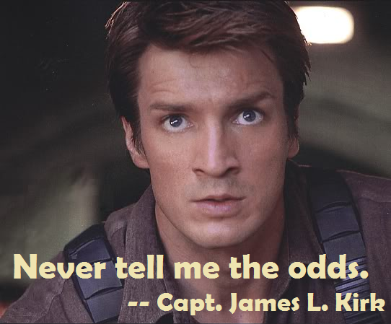

You are to recreate a few scenes from the “asteroid field” sequence of “Star Wars: The Empire Strikes Back”. The entire sequence is here: https://youtu.be/KvJDItC6tE0 and in a high resolution clip on FOL: "Star Wars Episode V The Empire Strikes Back, asteroid scene.mkv"

Note that the scenes are "static" (i.e. things aren't moving or changing) unless specifically indicated.

- (30 marks) Millennium Falcon in space, surrounded by rocks (about 2:01 into the clip):

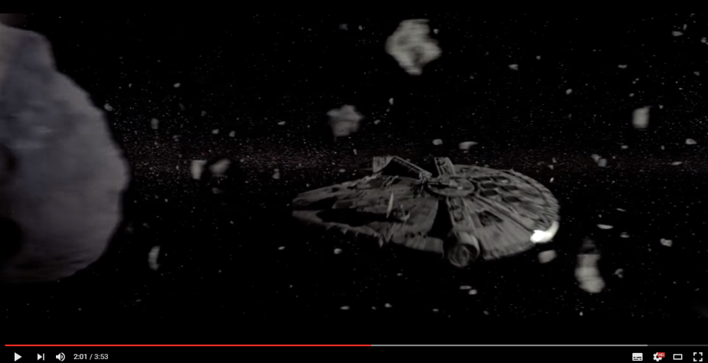

  - Place at least three (3) point/spot lights on the "engine" at the back, around the entire curve (more or less)
    - This must include an "emissive" looking component to the "engine light", using the separate "engine" model available (Falcon_Engine_Only.ply).
    - The lights should only light up areas around the engine, not bleed all over the place (or at least not much)
  - At least five (5) asteroids, of at least three (3) types (models), with at least three (3) different "rock" textures; note that you have to "mix" up the textures and the models; in other words, you can't always have the same texture on the same ply model, every time: so no "rock1.ply" ALWAYS having "rock1.bmp" - there has to be at least one "rock1.ply" with a different texture, too.
- (20-30 marks) A TIE Fighter shooting at the Millennium Falcon (around 3:04 into the clip, but you can ignore the giant asteroid, and simply add your TIE Fighters to the scene in question 1):
(you can put a giant asteroid in there, if you really want)

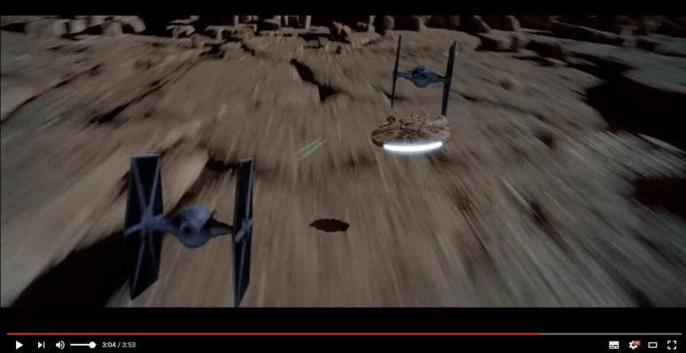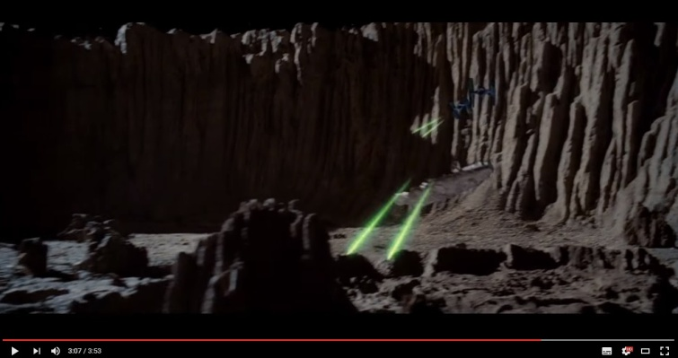

  - (5 - 10 marks): Two "bullet/blaster" objects "shooting" from the TIE Fighter to the Falcon, like in the video.
    - (5 marks): Object is spherically/ball shaped
    - (10 marks) Object is "bullet" (elongated) in shape, and is facing in the correct orientation - the TIE Fighter and Millennium Falcon can not be on the same axis in this case - i.e. the bullet can't be simply "aimed" linearly along a single axis (like just along the x-avis, for example). In other words, the Falcon and the "shooting" TIE Fighter must have (significantly) different x, y, and z positions.
  - (10 marks) Each "bullet/blaster" object must have an accompanying light object that only lights a limited area near the object.
  - (2.5 marks - 10 marks) Ensure the "bullet/blaster" objects have an "emissive" light component.
    - (2.5 marks) Use a sphere
    - (5 marks) Use the "TearDropBullet.ply" object (correctly aligned along the path)
    - (10 marks) Use a textured & transparent "1x1_6_Star_2" "imposter" object (correctly aligned along the path)

- (40 marks) Place the camera so that it is looking out of the cockpit of the Falcon, like at 2:30 in the clip, clearly showing the asteroids and a star field in the background.
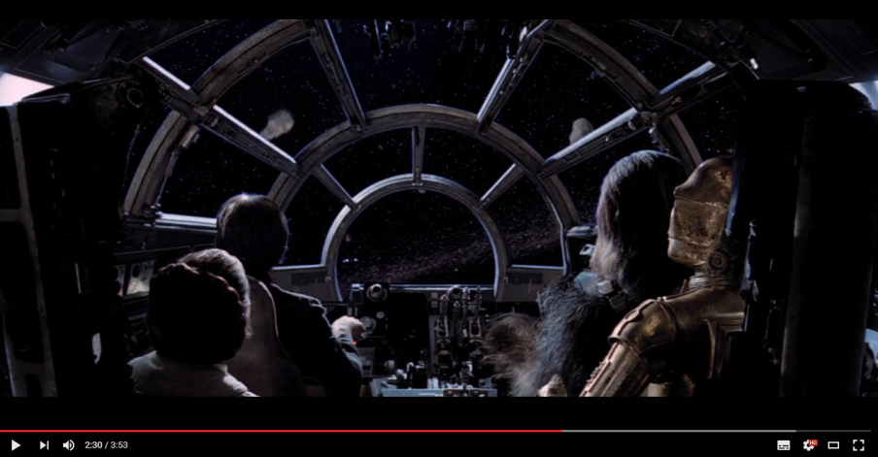

- (10 marks) You have to have a semi-transparent “dirty glass” texture present. If I move the camera (a little bit, like side to side, or up and down) I should see that there’s a texture there.
  - Note: There are three "windscreen" models - i.e. the "glass" part - one with the normals facing "into" the Falcon, one facing "out", and one a combination of both (two sided): "Falcon_Windscreen_inner.ply", "Falcon_Windscreen_outer.ply", and "Falcon_Windscreen_inner_and_outer.ply".
Of course, you could also disable back face culling, too, if you want.
- (5 marks) There should be at least six (6) asteroids of three (3) types (i.e. sizes, shapes), with four (4) different “asteroid”-ish textures (rock, sand, etc.)
- (10 marks) Place a star field texture on a flat object, in the distance (or the inside of a large sphere), showing the stars. Note that while I'll be moving the camera a little, I won't be looking "all around", so a large, flat object with stars, appropriately placed in the scene is good enough.
- (15 marks) Around 3:40 into the video, you learn that the Millennium Falcon has headlights (high-beams? But it goes faster than light... hmmm). Place two (2) appropriately sized and placed spotlights on the Falcon (see video), and place an asteroid near enough that these can be clearly seen (don't worry, Han's such a good pilot, he'll get out of the way "just in time!"). NOTE: This is still from the view from the cockpit, so you can't see the emissive part of the headlights (like you can in the video), so you only need to see that the light is shining "forward" (you can have the emissive part, if you like, though).
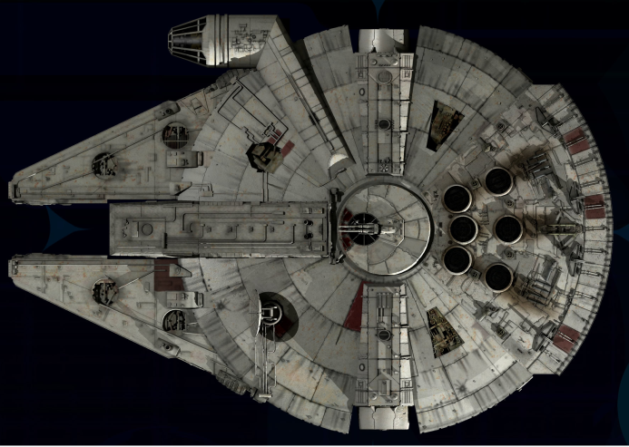
"cockpit"
"headlights"
- (20 marks) One of the TIE Fighters crashing, something like point 2:26 into the video (That poor storm trooper! Maybe they just got really hurt, but got rescued, and are feeling much better now?): https://youtu.be/KvJDItC6tE0?t=146)

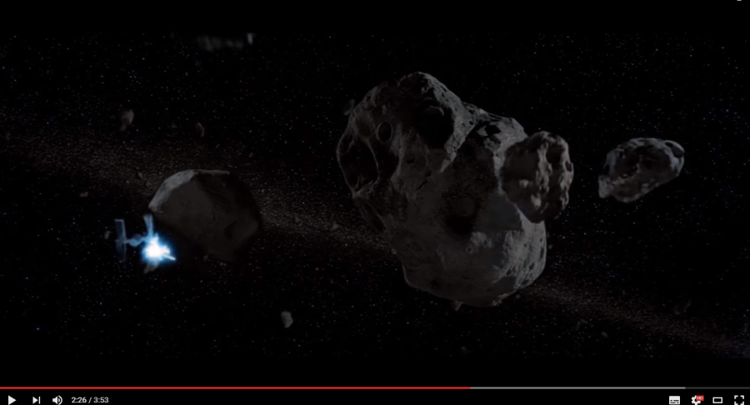
Using (an) "imposter" object(s), (an) "explosion" texture(s) (either red/orange or "blue-ish"), as well as a "mask" texture(s) to show this explosion (note: since we are using the average of the red+green+blue for the mask, you can use coloured "masking" textures - like the explosion texture itself). You require the following:
- The complete or "broken up" models of the TIE Fighter ("Body_Only", "Port_Panel_Only", and "Starboard_Panel_Only" are the "broken up" versions)
- One (or more) of the "imposter" models
- One (or more) "explosion" texture + mask texture

Place the TIE Fighter parts artistically near an asteroid, with the "parts" looking like they've blown apart, as we as a single "explosion" (using alpha-based or discard transparency). Keep in mind that this is a static (still/non-moving) scene (unless you do the bonus...).
- 10 marks: placing the models, appropriately lit (by both the starlight and the explosion)
- 10 marks: placing the explosion imposter

Bonuses:
- (20 marks) Add at least two more explosions of at least two "types" (i.e. there should be two (2) different "explosion" textures, but you can use the same "imposter" for all three (3) explosions, so long as they are different scales, positions and orientations - so they look appropriately different).
- (15 marks) Add another "explosion", but showing the dust/dirt that would have been thrown up when the TIE Fighter hit the asteroid (note this isn't shown in the clip, but we'll assume it would happen at the same moment it hit the asteroid). This can use the same "imposter" model, but needs a "dirt/dust" looking texture+mask
- (20 marks) Add a skybox to the scene, giving it the full surrounding effect vs a flat texture

That’s it

Be sure to sign out.

May the Force be with you.

