**My Name is Bello Afeez**

I am testing

**If this is working**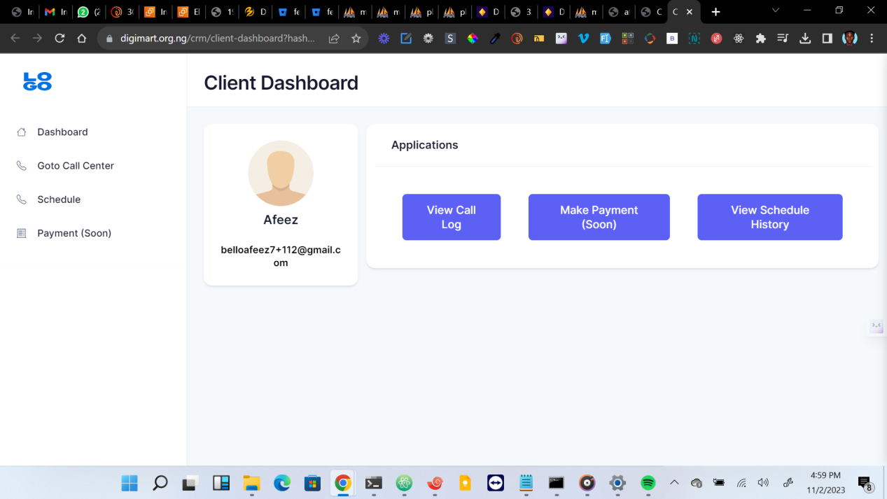

I am in good terms

This is a chart

|  |  |  |  |  |
| --- | --- | --- | --- | --- |
|  |  |  |  |  |
|  |  |  |  |  |
|  |  |  |  |  |
|  |  |  |  |  |