**AOL Nap Pod Usage Report**

*Eccella ERM Augmented Reality Demo*

July 21st, 2017



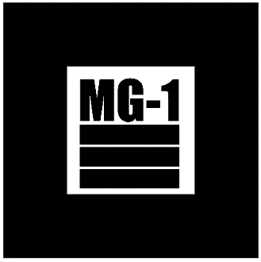After the initial excitement of successfully finishing AOL Advertising Analytics Minimal Viable Product project has subdued, Eccella received a report regarding alarming level of nap pod usage by an employee over two weeks. Nap pod usage history data has been pulled and thoroughly investigated to find out who has developed excessive bond to AOL’s nap pod.

**Week 1 Data**

|  |  |  |  |  |  |  |  |
| --- | --- | --- | --- | --- | --- | --- | --- |
| Employee | A | B | C | D | E | F | G |
| Hours | 2 | 3 | 6.5 | 1 | 2.5 | 1 | 3.5 |

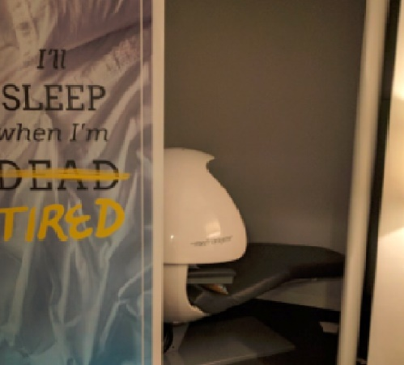

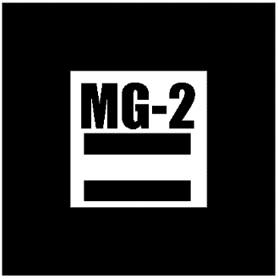**Week 2 Data**

|  |  |  |  |  |  |  |  |
| --- | --- | --- | --- | --- | --- | --- | --- |
| Employee | A | B | C | D | E | F | G |
| Hours | 5.5 | 4 | 10 | 1 | 3 | 3 | 3.5 |



Based on the usage data, personnel ‘C’ seems to be the one who took advantage of nap pod a little too much. However, this report is supposed to be confidential and anonymous. Therefore the identity of personnel ‘C’ will not be shown to readers unless…