**The Story Line Tool**

**D20 2nd Semester Final Project**

EASV Sønderborg

Computer Science

Hand in: 17th June 2021

Authors: Andrej Simionenko, Raheela Tasneem, Fei Gu, Ibraheem Swaidan

Supervisors: Karsten Skov, Tommy Haugaard, Frank Østergaard Hansen

# Preface

preface

# Resource

* GitHub Link: <https://github.com/Fei-D20/D20_2nd_Semester_Final_Project.git>
* The project report: [https://github.com/Fei-D20/D20_2nd_Semester_Final_Project/blob/0a6c3eb512f8fc81127eb344f31c905944d0b893/Document/ProjectReport/Report.docx](https://github.com/Fei-D20/D20_2nd_Semester_Final_Project/blob/main/Document/ProjectReport/Report.docx)

Table of Contents

PROJECT TITLE 1

D20_2nd_Semester_Final_Project 1

Preface 2

Resource 2

Introduction 6

Case study 7

Requirement study 8

Delimitations 9

Technology and Business 10

The Business Model Canvas 10

Competitor Examples 11

Values for the user 12

System development 13

Unify process 13

Inception phase 13

Elaboration phase 13

Construction 13

Transition 13

Domain analyses 14

Vision 14

Data dictionary 14

Domain model 14

UP 15

Process flow 15

Use Cases 15

Time estimation 17

Throw away prototyping 17

Usability 17

Class diagram 17

SSDs 17

Inspection 17

Reflections 17

Recommendation of improvements 17

Programming 18

Architecture(diagram) 18

Patten analyses 19

Database analyses 20

Database Model (ERD) 20

Database relationship 20

Database creation (scripts ) 20

JDBC 20

Stored procedures 20

GUI design 21

GUI structure 21

GUI controller 21

Unit-test 21

Design Class Diagram 22

Sequence diagram 23

Conclusion 24

Bibliography 25

Appendices 26

Error! Hyperlink reference not valid.Error! Hyperlink reference not valid.Error! Hyperlink reference not valid.Error! Hyperlink reference not valid.Error! Hyperlink reference not valid.Error! Hyperlink reference not valid.Error! Hyperlink reference not valid.Error! Hyperlink reference not valid.Error! Hyperlink reference not valid.Error! Hyperlink reference not valid.Error! Hyperlink reference not valid.Error! Hyperlink reference not valid.Error! Hyperlink reference not valid.Error! Hyperlink reference not valid.Error! Hyperlink reference not valid.Error! Hyperlink reference not valid.Error! Hyperlink reference not valid.Error! Hyperlink reference not valid.Error! Hyperlink reference not valid.Error! Hyperlink reference not valid.Error! Hyperlink reference not valid.Error! Hyperlink reference not valid.Error! Hyperlink reference not valid.Error! Hyperlink reference not valid.Error! Hyperlink reference not valid.Error! Hyperlink reference not valid.Error! Hyperlink reference not valid.Error! Hyperlink reference not valid.Error! Hyperlink reference not valid.Error! Hyperlink reference not valid.Error! Hyperlink reference not valid.Error! Hyperlink reference not valid.

## The tabels reference

Table 1: Development case 13

Table 2: The use case 15

## The Figures reference

Figure 1 : Domain model 15

# Introduction

//

# Case study

Our team has been tasked with creating a tool, that would help writers composing a new book or a story. Currently, many authors begin their new work by collecting many notes about the story and its proceedings, often written on post-it notes or event cards. This is where the problems arise: when there are a lot of cards its quite hard to manage and keep track of all of them, they can be easily misplaced or lost, moreover it is hard for multiple authors to work with them, it takes a long time to sort them and find a needed one to create a flowing storyline. This is where the Story Line Tool comes in, it will prevent all the issues mentioned above and simplify the work of an author. The tool will allow a single or multiple authors to easily work on a project by allowing them to take and save notes, rearrange them in desired order, print the events in chronological order and export everything in a text file.

Our team believes that such tool would be very useful for authors, to ease their process of creation, and that it has a place in the market.

# Delimitations

Delimitations

# Technology and Business

## The Business Model Canvas

## Competitor Examples

Similar software

## Values for the user

An answer to what value the product creates for the user

# System development

## Development case

Table 1: Development case (s – start, r - refine)

|  |  |  |  |  |  |
| --- | --- | --- | --- | --- | --- |
| Discipline | Artifact | Inception phase | Elaboration phase | Construction | transition |
| Business Modeling | Business Domain analysis | S |  |  |  |
| System development | Development case | S | R |  |  |
| Domain analyses | Vision | S | R |  |  |
|  | Data dictionary | S | R |  |  |
|  |  |  |  |  |  |
|  |  |  |  |  |  |
|  |  |  |  |  |  |

## Domain analyses

### Vision

This application is working for the author who need to have a platform to store, organize, manage the ideas, and also cooperation with some other authors. They can share the idea between multiple cooperators and leave some opinions as well. And also, they can use this application create chronicle of events, and check the view of the story timeline. Make the decision about the different choice which is the actor made. And check how is going on.

This application can also export the events as the text file with formatter.

### Data dictionary

***The author:*** the final user for this application who want to get help for to make event card and easier cooperation work.

***Event card:*** the small note (like sticky note or tile) on the working board with single words. And the user can create, delete, edit, search and sort it.

***Story:*** the author will write after creating all event and timeline. Which is the novel author will write.

***Timeline:*** the story event flow following the time.

***Role:*** the character who are in the story.

***Event:*** the situation or action the role play in the story.

***Event time:*** the time which event happen in the story.

***Note:*** the event detail.

***Sub-note:*** the more of event add under the note.

***Direction:*** what will happen in the story.

***Levels:*** some event card under another event.

***Relationship:*** the connected between different events.

***Events chronologically:*** the event happen following the time.

***Chapters:*** the categories or sections of story which is the event lay on.

***Comments:*** the author leave some description about event (or make a note for the event detail) and also for multiple authors leave notes to each other.

### Domain model

The domain model descripts about what kind of entity in this domain area, and which attribute they have. Also include about the relationship between the entity.

In this case, an author or multiple authors who have own name can write some events.

A lot of events can constitute one story. And a different direction of story creates different timeline in the story.

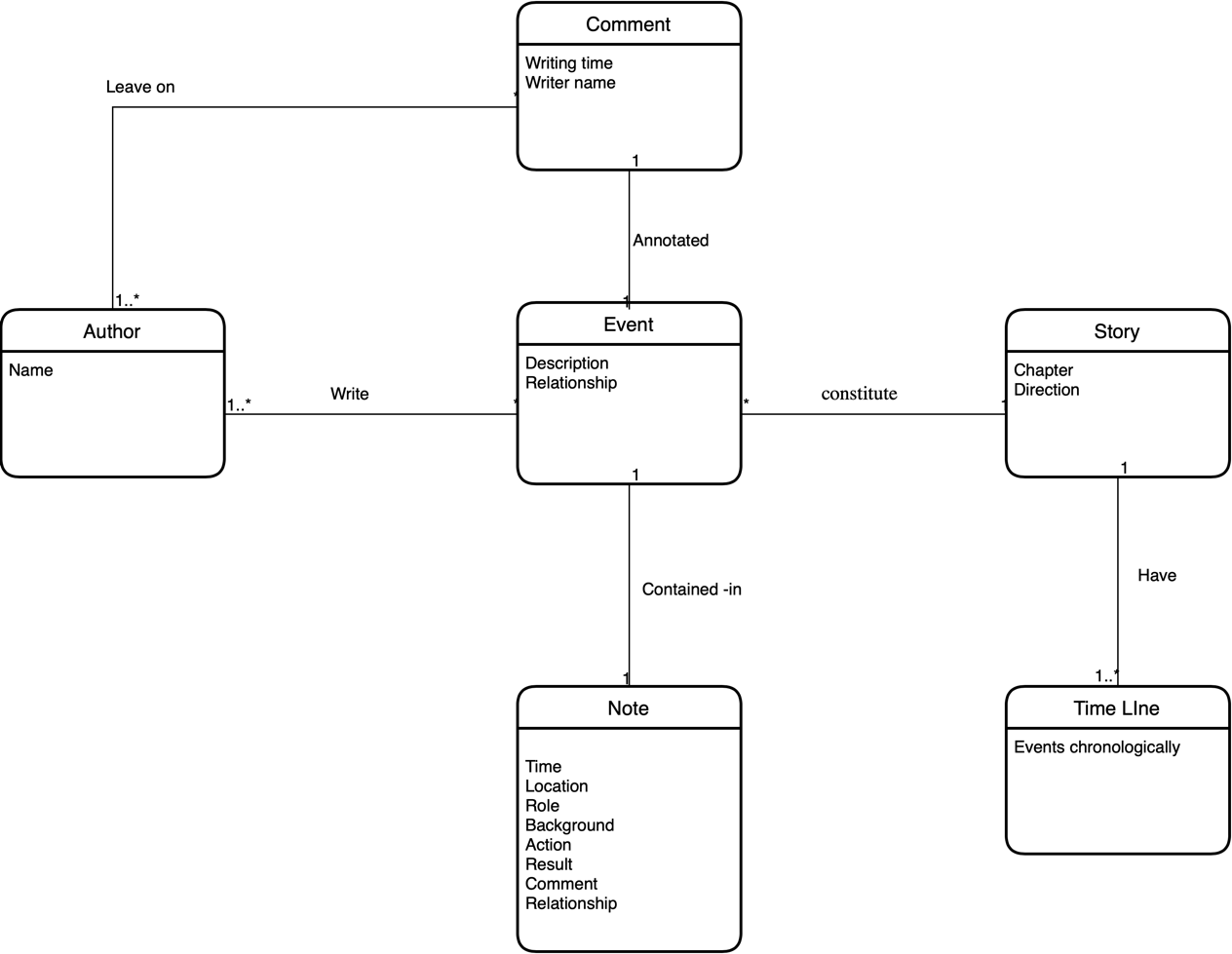

Figure 1 : Domain model

## UP

### Process flow

### Use Cases

Table 2: The use case

Brief use cases:

|  |  |  |  |  |
| --- | --- | --- | --- | --- |
| Use case number | Actor | Use case | Version | Time Estimation |
| UC 1 | User | Create a new note box | 1 | hours |
| UC 2 | User | Create Delete note option | 1 | hours |
| UC 3 | User | Make event box (to Write) | 1 | hours |
| UC 4 | User | Create a Timeline | 1 | hours |
| UC 5 | User | Create Store events | 1 | hours |
| UC 6 | User | Create Categories option (like chapters) | 1 | hours |
| UC 7 | User | Create Drag and drop sticky notes option | 1 | hours |
| UC 8 | User | Mention Time | 1 | hours |
| UC 9 | User | Make Store notes | 1 | hours |
| UC 10 | User | Make undo button | 1 | hours |
| UC 11 | User | Make Store button | 1 | hours |
| UC 12 | User | Create a redo option | 1 | hours |
| UC 13 | User | Create change color option | 1 | hours |
|  |  |  |  |  |
| UC 14 | User | Make connection between events | 1 | hours |
| UC 15 | User | Set the priority about events (or level as well) | 1 | Hours |
| UC 16 | User | Create a story line | 1 | Hours |
| UC 16.1 | User | Create a new story line |  |  |
| UC 16.2 | User | Modify the story line |  |  |
| UC 16.3 | User |  |  |  |
| UC 17 | User | Set a comment about event card | 1 | Hours |
|  |  |  |  |  |
|  |  |  |  |  |
| UC18 | User | Register as new user | 1 | Hours |
| UC19 | User | Create user login | 1 | hours |
| UC 20 | User | Create Password field | 1 | hours |
| UC 21 | User | Forgot Password | 1 | hours |
|  |  |  |  |  |
|  |  |  |  |  |
| UC 22 | User | Create a project (novel) |  |  |
| UC 23 | User | Share a project to another author  (Or choose/add another user as cooperator) |  |  |
| UC 24 | User | Save project |  |  |
| UC 25 | User | Export a project as text (like .TXT file or .md file) |  |  |
| UC 26 | User | Import a project as text |  |  |
| UC 27 | User | Insert some event (from .TXT or .md file) into a project |  |  |
| UC 28 | User | Create date-based reminders |  |  |
|  |  |  |  |  |
| UC 29 | User | Edit a note option |  |  |
| UC 29.1 | User | Add a sub-note |  |  |
| UC 30 | User | Change project name |  |  |
| UC 31 | User | Create choose font and size option |  |  |
| UC 32 | User | Add picture |  |  |
| UC 33 | User | View option (list or gallery) |  |  |
|  |  |  |  |  |
| UC 34 | User | Search event card |  |  |
| UC 35 | User | Sort the chosen event/all event |  |  |
|  |  |  |  |  |
| Database |  |  | 1 | 30hours |
|  |  |  |  |  |
| Software to connect database and use cases |  |  |  | 30 hours |
|  |  |  |  |  |

Casual use cases:

|  |  |  |  |
| --- | --- | --- | --- |
| Use case ID | Use case name | Actor | Flow of events |
|  |  |  |  |
|  |  |  |  |
|  |  |  |  |

Fully dressed use cases:

|  |  |
| --- | --- |
| Use Case Id | UC1 |
| Trigger | The user wants to create a new note |
| Actor | User |
| Version | 1 |
| Flow of events | 1. The use case starts when the user clicks on “create” button 2. The actor writes a note 3. The actor clicks on “save” button to save 4. The actor drags and drop the note in the right order(event) |
| Date | 21/05/21 |
| Author | IS |

|  |  |
| --- | --- |
| Use Case Id | UC18 |
| Trigger | Register as new user |
| Actor | User |
| Version | 1 |
| Flow of events | 1. User select “sign up”  2. User fill the necessary information  3. User clicks on “Accept” to execute the registration |
| Date | 21/05/21 |
| Author | IS |

### Time estimation

### Throw away prototyping

### Usability

### Class diagram

### SSDs

### Inspection

### Reflections

### Recommendation of improvements

# Programming

Programming

## Architecture(diagram)

## Patten analyses

## Database analyses

### Database Model (ERD)

### Database relationship

### Database creation (scripts )

### JDBC

### Stored procedures

## GUI design

### GUI structure

### GUI controller

### Unit-test

## Design Class Diagram

Just place an excerpt

## Sequence diagram

# Conclusion

Conclusion

# Bibliography

Bibliography

# Appendices

Appendices