The auto camper rental  
 software

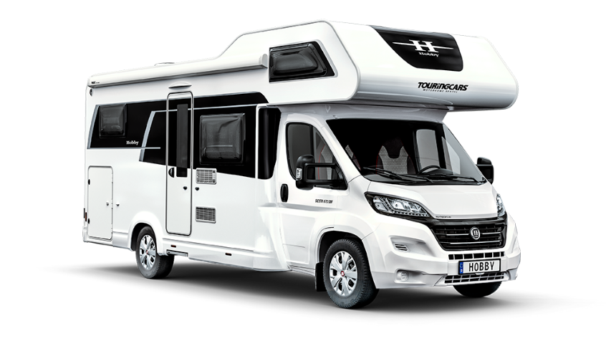

Computer Science- 2nd Semester training project

Hand in: May 7th, 2021

Supervisors: Karsten Skov, Tommy Haugaard, Frank Østergaard Hansen

**Authors: Andrej Simionenko, Raheela Tasneem, Fei Gu**

Contents

1 Inception Phase 4

1.1 Start-up phase 4

1.2 Vision 4

1.3 Domain Model 4

1.4 Data dictionary 6

2 Elaboration Phase 7

**Table of figures**

# Inception Phase

## 1.1 Start-up phase

The start-up phase begins with preparations of working environments for project and team. For the period of the project, it was early on decided to use zoom- break out rooms as well as discord server in order to hold daily meetings and communicate. There, the progress of the project as well as the next steps were discussed and shared.  
For collaboration between the team members, a Github repository was used in order to share and work together on java code and database, while draw.io program was used in order to create the diagrams. Additionally, for collection of information and report writing online google word document was utilized.

## 1.2 Vision

The team is designing and creating an administration and booking system for Wagner Families auto camper rental business. The system is created for rental of a fleet of auto campers, and it should be time-efficient and easily manageable for the Wagner family, modernizing the way they do business.

## 1.3 Domain Model

The domain model is a structured visual representation of interconnected concepts or real-world objects that incorporates vocabulary, key concepts, behavior and relationships of all its entities. In figure 1, the domain model of auto camper rental software is shown and is used in order to showcase the purpose of the software.

During the process of building a custom-made system, Domain model comes in especially useful in few different aspects. From the perspective of developers, the domain model helps to clarify and understand the real-world problems, that the customer is facing and offers an opportunity to discuss the requirements for the system. On the other hand, from the perspective of the customer, the domain model allows a more user friendly and not very technical picture of the upcoming system, as one of the draws of domain model is its visual simplicity. It must be stated that the conceptual classes in the domain model are not software objects, but more so representations of real-world conceptual classes.

For this project, a domain model using a UML class diagram notation was used. Straight lines connecting different objects showcase association. Thus…….

**Domain model here**

## 1.4 Data dictionary

The data dictionary is an agreement between the customers and developers over the concrete meaning of specific words used in the system. The dictionary is used to gain consistency and avoid confusion when specific words are used. Figure 2 shows a data dictionary for the auto camper system, where specific words are explained in further detail and their meaning in the system is set.

|  |  |  |  |  |
| --- | --- | --- | --- | --- |
| **Name** | **Description** | **Alias** | **Format** | **Range** |
|  |  |  |  |  |
|  |  |  |  |  |
|  |  |  |  |  |
|  |  |  |  |  |
|  |  |  |  |  |
|  |  |  |  |  |
|  |  |  |  |  |

# 2 Elaboration Phase

## 2.1 Use Cases

Use cases are written descriptions or event steps defining and documenting the interactions between actors and the system to achieve a goal. They are commonly used to represent a goal of a system and describe, clarify a single task of the process. Use cases can contain one or multiple scenarios, describing the order of events.  
The actors in the use cases can be humans, other users of the system, or the system itself. Description is used to explain a certain scenario, sequence of actions and interactions between the actors and the system.  
For the project two main types of use cases will be used: brief use cases and fully dressed use cases. The different types of use cases are used depending on how much detail is needed for certain scenarios.