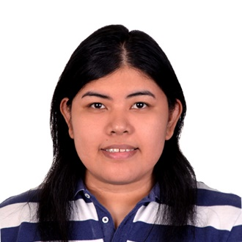**FAITH A. DECENA**

#4 Molave St. South Green Park Village, Tandang Sora, Quezon City

+63 9183432308 | 929-45-16

[decena.faith.a@gmail.com](mailto:decena.faith.a@gmail.com) | | <https://bubblyfei.wixsite.com/feiportfolio>

# CARRER OBJECTIVE:

I am a fresh graduate currently looking for a full-time job in the field of multimedia arts. My passion to create drove me in wanting to enhance my knowledge and skills. To utilize, gain experience and contribute to society.

# TECHNICAL SKILLS:

• Competent in Adobe Creative Suite (Photoshop, InDesign, Animate CC, Illustrator)

• Proficient in Microsoft Office Suite (Word, Powerpoint, Excel)

• HTML / CSS basic coding

• Photo Editing / Manipulation

• Video Editing

# EDUCATION:

**Bachelor of Arts in Multimedia Arts Specialized in Video Motion Graphics (2015-2018)**

*CIIT College of Arts and Technology*

94 Kamuning Road, Interweave Building Brgy, Quezon City, 1103 Metro Manila

**Bachelor of Science in Multimedia Arts (2009-2014)**

*Mapua Institute of Technology*

658 Muralla St., Intramuros, Manila 1002, Philippines

**Elementary (1999-2005) - Highschool (2005-2009)**

*Maria Montessori School of Quezon City (1999 - 2009)*

116 Visayas Avenue, Quezon City, Philippines

# PERSONAL DATA:

Nationality: Filipino

Civil Status: Single

Birthplace: Quezon CIty

Birthdate: March 7, 1992

# TRAINING / SEMINAR ATTENDED:

• Organized the seminar and workshop of Galawang Animasyon: Pagkilala Sa Mundo ng Animasyon

at CIIT College of Arts and Technology in 2017

• Attended How to Make an Effective Documentary Film seminar at CIIT in 2017

# On-The-Job Training:

**Rising Tide Mobile Entertainment, Inc**

Creatives - Intern (September 2017- February 2018)

104 Rada St. HRC Center, Legaspi Village, Makati City

• Created social platform advertisements used in Facebook and Instagram which includes GreenNGo, Platinum Karaoke, Cloverleaf, Haus Blend, Vertis North

• Created mock-ups which used in pitches and presentations with the available assets given.

• Edit a photo and create simple frame animation using Photoshop CS6.

• Tracked and piled up inquiries in comments section

# Previous Jobs:

**Collective Solutions – MINTED Section**

SDA (Seasonal Design Associate) - Prob (Oct 2018 - Dec 2018)

Commonwealth, Brgy. Holy Spirit, Quezon City

# References:

Please Contact the following:

**Chris Sanchez John Bonaagua**

Career and Placement Officer, CIIT Creatives Intern Supervisor, Rising Tide

Phone: +63 9479588983 Email: <johnfernando@risingtide.ph>