UI Design(Storyboard)

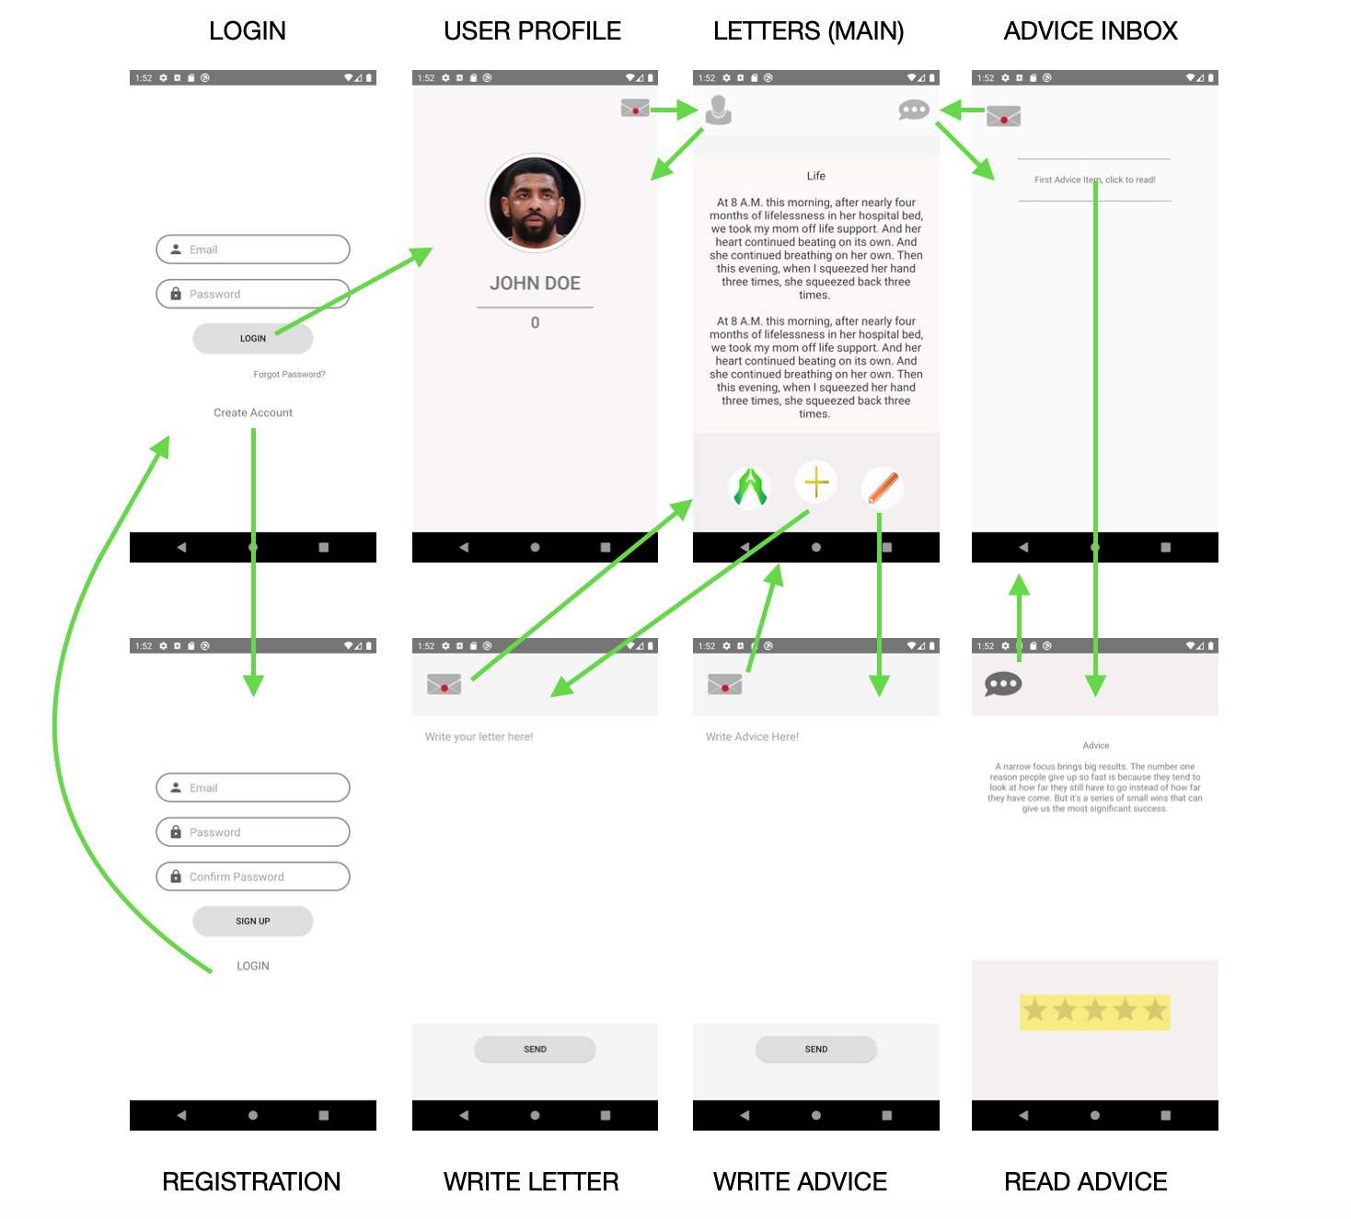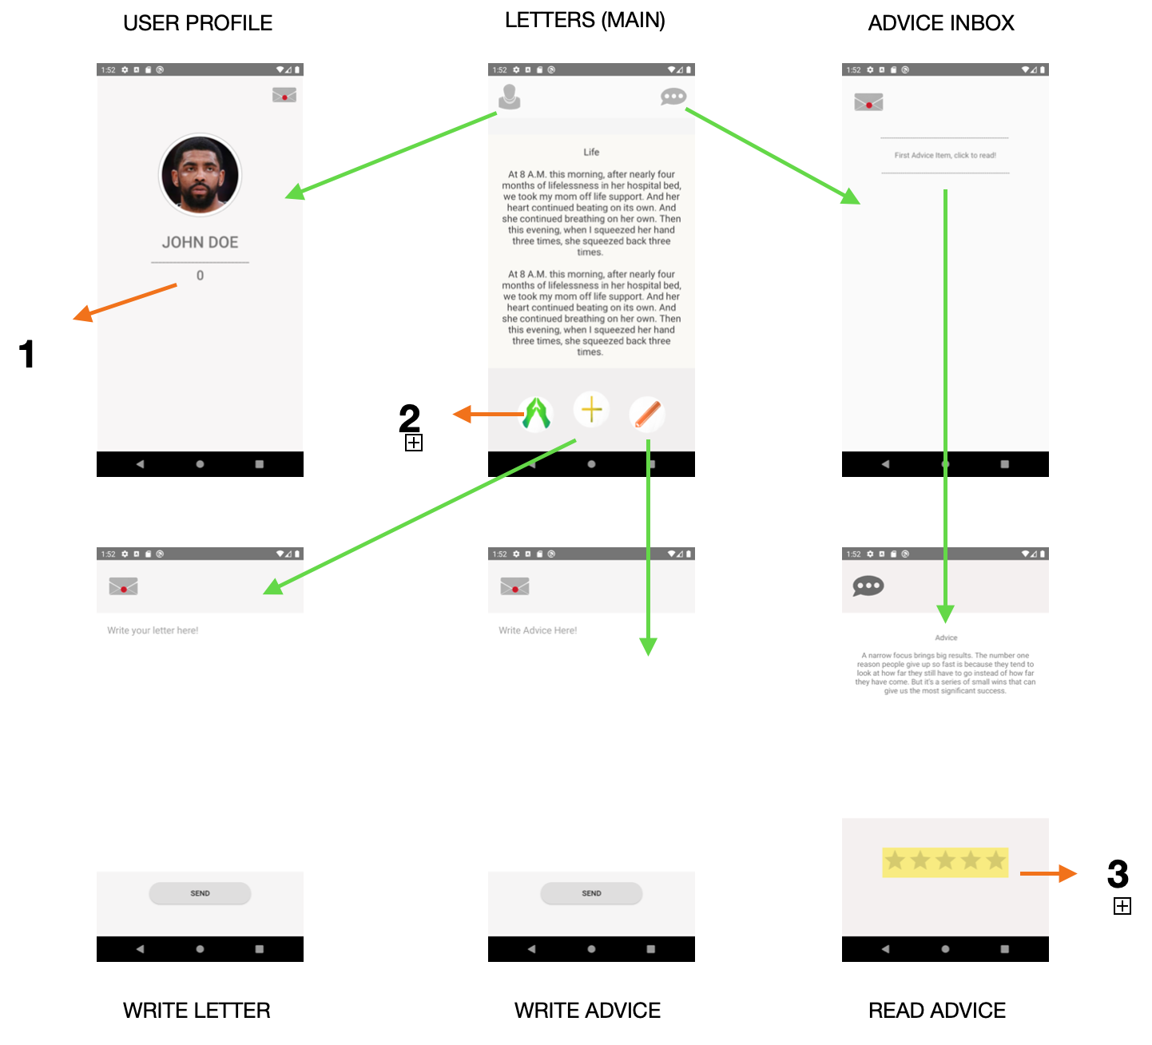

Special Features

1. Points : It is earned, and reflects how much the person helped others, based on the rating. It is a reward system that will help users stay interested in the app.
2. Pray: skips to the next letter that the person might be able to give advice to, also doubles down as a filtering system for spam or bad letters. After a particular letter is skipped (i.e 15) times, it will be removed.
3. Rating: rates the advice, and 0 rated advice are considered bringing others down, appropriate punishment will be carried out.

Semester Checkpoint Document

Application Concept:

* TLDR: Our groups take on the Kind Words app will allow for Users to share anonymous letters, available for a 24-hour period only, and interact with these letters in a Tinder-esque format. Clicking the left arrow button will ignore a letter, selecting the right arrow button will allow for replies to the letter, and swiping down will report / flag the letter.

Key Functionality:

* Publicly post anonymous letters that can be replied to by other users on the app
* Report users who post offensive content
* Cards disappear every 24 hours
* Clients are allowed to delete cards but cannot edit them
* Left/Right buttons to interact with letters

Rough Architecture:

* Register Page: allows for users to sign up for an account to use Kind Words
* Login Page: allows for registered users to login to their account on Kind Words
* Public Feeds Page: Allows for users to see the letters that have been submitted for the day. The letter cards will be displayed under an anonymized, random username. Users will be able to interact with the app in a Tinder-like format. Swiping right on the letter will allow the user to reply to a letter. Swiping left will skip or ignore the letter. Swiping down will report the letter. Again, letters will expire after 24 hours to keep the app fresh and exciting.
* User Page:
  + My Letters Section: Allows for users to see the letters they have submitted and the replies to these respective letters
  + My Replies Section: Allows for users to view cards they replied to and view subsequent replies in a thread like format
* User Settings Page: allows for users to delete their account

Android System Components Expected to be Implemented

* Firebase Log-In
* Firebase Database