# VLSI Circuits and Technology 2

**Homework - 2, Group 6**

|  |  |  |
| --- | --- | --- |
| Jiacheng Liu | - | - |
| Ji Xia | - | - |
| Yiming Liu | - | - |
| Feifan Xu | - | - |
| Yiheng Liu | - | - |

Contributions 1

Description of the Specification 1

Description of the Test Plan 3

## Contributions

●**Jiacheng Liu: Code the vending machine using Verilog**

●**Ji Xia: Code the testbench and write the report**

●**Yiming Liu: Code the testbench and write the report**

●**Feifan Xu: Code the vending machine using Verilog**

●**Yiheng Liu: Write the report**

## Description of the Specification

We design a vending machine using Verilog. Our design just has one always block to realize all functions. In the always block, we use if-else statement to separate all conditions, because the machine has a lot of inputs to be used to separate all conditions. The detailed content is as follows.

First, we set up a reset signal to initial the registers and assign values to several types of registers: (1) the number register of transaction, (2) output registers ‘out’, ‘To’, ‘Wo’, ‘Co’, ‘C’, ‘so, ‘Bo’, ‘RRo’, (3) number registers of the remaining products in the vending machine. We assume all products only have two left in the machine and the maximum transaction is three per time.

Second, we set up a rr signal which means customers want to return money or end the transaction, to determine whether customers want to continue or stop the transaction. If customers want to return money or end the transaction, the rr signal will generate a pulse signal like a real button. Then the vending machine will move onto the return money mode. The machine will subtract twenty dollars from the remaining money repeatedly until the remaining money is less than twenty dollars. Every time the machine performs the operation, after that output ‘RRo’ is assigned value 2. Similar to the whole process above, the machine will try to subtract ten dollars, five dollars, two dollars and one dollar and only when the machine do the operations successfully, ‘RRo’ will be assigned value 1, 4, 3, 5 and 0, respectively.

Third, if the rr signal is low value, meaning the customers want to continue the transaction, so we use (~M4) && (~M5) to separate two conditions, using paper bills or using credit/debit cards. We assume M4(debit card) and M5(credit card) cannot be high at same time because in reality we cannot insert credit card and debit card at same time. If M4(debit card) or M5(credit card) is high value, which means the customers want to use cards to purchase the products, the vending machine does not need to calculate the remaining money because customers do not need to return money. Therefore, we just need to determine whether the products customers want are on sale and whether the customers have done the transaction three times. If it meets the requirement, the vending machine will assign high value to ‘To’, ‘Wo’, ‘Co’, ‘[2:0]Bo’, ‘[3:0]C’.

Fourth, if the M4 or M5 is low value, it means the customer want to use paper bills or coins, so we create a variable ‘out’ to store the remaining money. If M0, M1, M2 or M3 is high value, it means the customers have inserted $10, $1, $2 or $5 respectively. So variable ‘out’ will increase $10, $1, $2 or $5, respectively. Then the customers can purchase products. Similar to the transaction using credit/debit card, the machine should check whether the products the customers want meet requirement. The requirements are whether the products are on sale, whether the maximum transactions are over three and whether the remaining money ‘out’ is more than the price of the products. When meeting all of the requirements above, the machine will assign high value to ‘To’, ‘Wo’, ‘Co’, ‘[2:0]Bo’, ‘[3:0]C’. The remaining money will return when the ‘rr’ is high value as we have mentioned before, otherwise registers ‘so’ will be assigned high value.

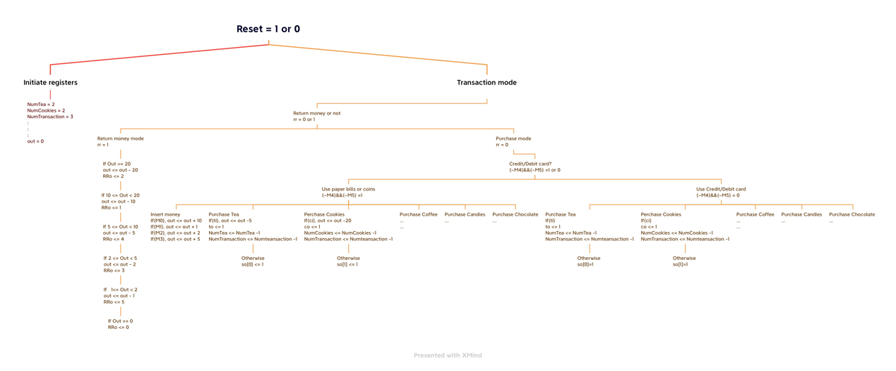Figure 1 shows almost the whole process.

Figure 1 The Logical Graph of the Vending Machine

## Description of the Test Plan

1. Test money inserting, then buy three different products, finally return money. We assume the customer inserts a $1, two $2, a $5, six $10. Then the customer buys a tea, a cookie and a coffee. The remaining money will be $38. The machine will return a $1, a $2, a $5, a $10 and a $ 20. In summary, we will input one M1, two M2, one M3 and six M0 pulse signals to represent money inserted. We also will input a ti, wi, ci and rr pulse signal to represent products the customer buys and returning money. In expect, the machine will output RRo signal whose values will be 5, 4, 3, 2, 1, 0 and To, Wo, Co signals whose values will be 1. (time = 0 to 390)
2. Test buy three same products and check whether the machine will output so(sold out) signal. We assume the customer inserts one $1, one $2, one $5, one $10. Then the customer buys three tea products. However, the tea products only have two on sale, whose total price is $10, so the machine will return one $2, one $1 and one $5. In addition, so(sole out) will be 0000000001. (time = 395 to 660)
3. Test credit/debit card. We assume the customer insert credit/debit card and the M4/M5 signal will maintain until the customer finish the transaction. We also assume the customer buy three tea Background pattern

   Description automatically generatedproducts. In expect, the output ti, so will be 1 and 0000000001. (time for debit = 665 to 760, time for credit = 765 to 840)

Figure 2 The Results of the Test