*Bioinformatics*, YYYY, 0–0

doi: 10.1093/bioinformatics/xxxxx

Advance Access Publication Date: DD Month YYYY

Application Note

|  |
| --- |
| Subject Section  The Genetic Map Comparator: a quick and easy way to visualize your genetic maps  Yan Holtz1, Jacques David1, Vincent Ranwez1*  1*1Montpellier SupAgro, UMR AGAP, 34060 Montpellier, France*  *To whom correspondence should be addressed.  Associate Editor: XXXXXXX  Received on XXXXX; revised on XXXXX; accepted on XXXXX  Abstract  **Motivation:** Genomic selection strongly relies on genetic map to accelerate breeding programs. Thanks to high throughput sequencing high density maps are now available for numerous species. Comparing several maps require dedicated tools able to summarize the key characteristics of high density maps and to pinpoint their differences and similarities.  **Results:** We developed GeneMap Comparator a web based application allowing to easily compare different maps by depicting their key statistics and the relative position of their common markers.  **Availability:** The genetic map comparator is available online: <http://www.agap-sunshine.inra.fr/holtz-apps/GenMap-Comparator/>. Source code is freely available on GitHub for non-commercial use only. (<https://github.com/holtzy/GenMap-Comparator>).  **Contact:** ranwez@supagro.fr  **Supplementary information**: Supplementary data are available at *Bioinformatics* online. |

# Introduction

Drawing and visualizing genetic maps is a common task for whoever works with genetic markers. When several populations are studied with common markers, the necessity to compare genetic positions is obvious. A graphical representation is needed, both for publication purpose and easy interpretation. This task is often repeated several times, after each map recalculation and an effective tool is thus needed.

A few tools like MapChart [1] are already available for genetic maps visualization. They are most often made to visualize one map and its related QTLs, but sometimes propose a comparison option. However, their main target is not the maps comparison and they are not adapted to the new features of nowadays-genetic maps, which are more and more dense due to current advances in bio-molecular tools. Cmap [2] and Cmap-3D [3] are dedicated to maps comparison but suffer the same problem. Scientist and breeder are now frequently facing the challenge to compare several genetic maps each carrying several hundreds of marker. With current tools it leads to a messed-up visualization that does not permit to understand data properly.

The Gene Map Comparator uses emerging interactive data visualization tools such as R shiny [4] and Plotly to represent and compare genetic maps. Using interactivity allows the user to more efficiently explore the data, while selecting chromosomes, zooming on figures, hovering on interesting markers.

Moreover, the gene map comparator allows performing inter-chromosomal analyses to detect markers with inconsistent chromosomal assignment. Correlation between genetic maps is provided. Basic statistics commonly handmade computed are calculated. The raw data are always reachable in a dedicated sheet.

This tool should allow to efficiently exploring highly dense genetic maps and significantly helps scientists and breeders to prepare their scientific publications.

# Technology and installation

The Gene Map Comparator is an R shiny [4] online application hosted in a dedicated server. The application is available on the web ([www.agap-sunshine.fr/genmapcomp](http://www.agap-sunshine.fr/genmapcomp)). Users can select and upload their data from their computer to the online application. It makes the use of the tool very simple since no installation is required. Moreover, it means that the app is available for every exploitation system and every device with no exception. The source code is available on GitHub, what allows a custom utilization by a user if needed, and what should permit to quickly improve the tool.

Two input formats are accepted, corresponding to the current genetic map building software such as OneMap, MapMaker or Carthagene. Three examples dataset taken from publication concerning durum wheat [5] and sorghum [6] are also provided. It proves the ability of the application to work on real data.

# Key functionalities

Several sheets are available. The **Home page** allows uploading a personal or an example dataset. **Basic statistics** provides general information such as number of markers, total length, number of unique positions and inter marker distances. Statistics are provided for the whole map and chromosome per chromosome. Summary tables are available to download in .csv format, ready for publication purpose. The **comparison** page displays the selected map in a desired order. A black line represents each map. Each dot represents a genetic marker and information concerning it is available hovering the dot. Purple lines link every common marker between two adjacent maps. To have a more global view and detect inter-chromosomal inconsistencies of chromosomal assignment, the **inter-chromosomal analyses** page displays a scatter plot with genetic positions of two selected maps only. The **raw map** is also made available for reading, with extended exploration tools such as ordering, filtering and searching. The last **documentation** sheet provides information needed to use the application properly.

# Case study

This tool has been developed to support a study concerning durum wheat. Two populations were genotyped. Two individual maps and a consensus map were built, with respectively xx, xx and xx SNP markers). A physical map with the putative position of markers was also available. To investigate the consistency of markers assignments and positions, an important number of comparisons were needed. Existing tools were not adapted for reasons presented above.

The genetic map comparator revealed to be really efficient to explore data quickly and in a really easy way. It permitted to pass fluently from the genetic map building to the visualization step, thus improving the genetic map building efficiency. Several of the published figures were synthetized-exporting charts from the tool.

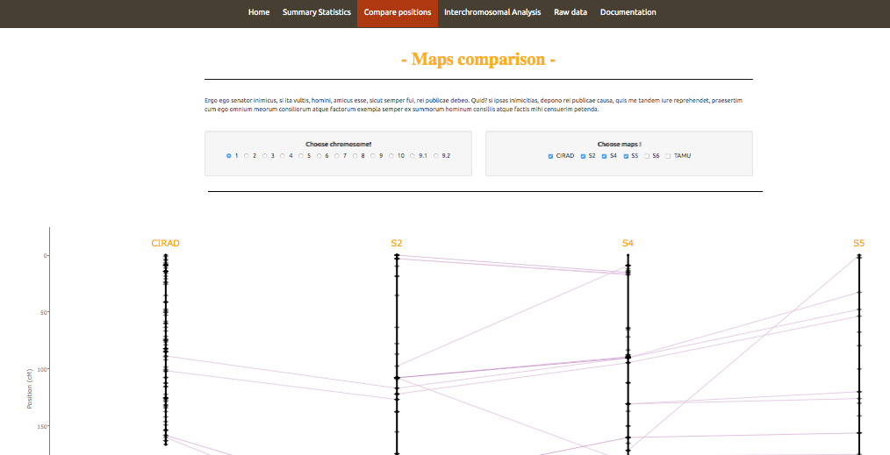

**Fig. 1**: Parallel comparison of 4 genetic maps. (Third sheet of the application). Each vertical black line illustrates the selected chromosome of the 4 populations, with a point for each marker. Numbers on the left side specifies positions in cM. Names of markers are available on hover. Purple lines represent common markers between 2 adjacent maps.

Funding

This work has been supported by the French research agency: Agence Nationale de la Recherche (ANR-10- BINF-01-02 ”Ancestrome”).

*Conflict of Interest:* none declared.

References

1. Voorrips RE. MapChart: software for the graphical presentation of linkage maps and QTLs. J Hered. 2002;93: 77–78. doi:10.1093/jhered/93.1.77

2. Fang Z, Polacco M, Chen S, Schroeder S, Hancock D, Sanchez H, et al. cMap: The comparative genetic map viewer. Bioinformatics. 2003;19: 416–417. doi:10.1093/bioinformatics/btg012

3. Duran C, Boskovic Z, Imelfort M, Batley J, Hamilton NA, Edwards D. CMap3D: A 3D visualization tool for comparative genetic maps. Bioinformatics. 2010;26: 273–274. doi:10.1093/bioinformatics/btp646

4. Chang W, Cheng J, Allaire JJ, Xie Y, McPherson J. shiny: Web Application Framework for R [Internet]. 2015. Available: http://cran.r-project.org/package=shiny

5. Maccaferri M, Ricci A, Salvi S, Milner SG, Noli E, Martelli PL, et al. A high-density, SNP-based consensus map of tetraploid wheat as a bridge to integrate durum and bread wheat genomics and breeding. Plant Biotechnol J. 2014; 1–16. doi:10.1111/pbi.12288

6. Mace ES, Rami J-F, Bouchet S, Klein PE, Klein RR, Kilian A, et al. A consensus genetic map of sorghum that integrates multiple component maps and high-throughput Diversity Array Technology (DArT) markers. BMC Plant Biol. 2009;9: 1–14. doi:10.1186/1471-2229-9-13