Create Executable using Pyinstaller
Looking to create an executable from Python script using pyinstaller?

If so, I’ll show you the full steps to accomplish this goal in Windows.

Step 1: Add Python to Windows Path
To start, you may want to add Python to Windows path.

An easy way to add Python to the path is by downloading a recent version of Python, and then checking the box to ‘Add Python to PATH’ during the installation:

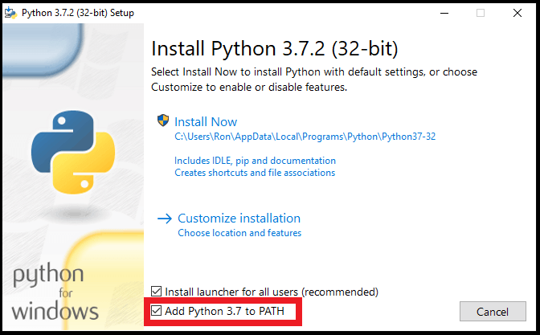

Step 2: Open the Windows Command Prompt
Next, open the Windows Command Prompt:

Step 3: Install the Pyinstaller Package
In the Windows Command Prompt, type the following command to install the pyinstaller package (and then press Enter):

pip install pyinstaller

This is how the command would look like:

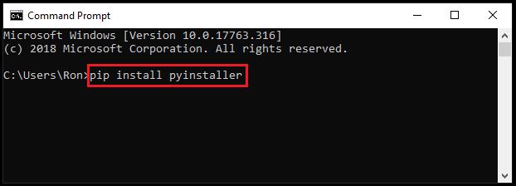

Step 4: Save your Python Script
Now you’ll need to save your Python script at your desired location.

For illustration purposes, I created a simple Python script that will display ‘Hello World!’ when clicking the button:

import tkinter as tk

root= tk.Tk()

canvas1 = tk.Canvas(root, width = 300, height = 300)
canvas1.pack()

def hello ():
label1 = tk.Label(root, text= 'Hello World!', fg='green', font=('helvetica', 12, 'bold'))
canvas1.create_window(150, 200, window=label1)

button1 = tk.Button(text='Click Me',command=hello, bg='brown',fg='white')
canvas1.create_window(150, 150, window=button1)

root.mainloop()

I then saved the Python script in the following folder:

C:\Users\<someuser>\Desktop\MyPython

Where I named the Python script as ‘hello’

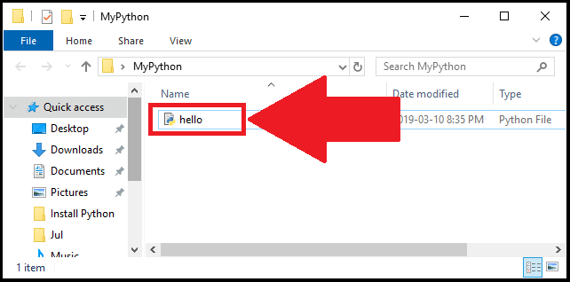

Step 5: Create the Executable using Pyinstaller
Now you’ll be able to create the executable from the Python script using pyinstaller.

Simply go to the Command Prompt, and then type:

cd followed by the location where your Python script is stored

Next, use the following template to create the executable:

pyinstaller --onefile pythonScriptName.py

Since in our example, the pythonScriptName is ‘hello‘, then the command to create the executable is:

pyinstaller --onefile hello.py

In the command prompt:

Once you’re done, press Enter for the last time.

Step 6: Run the Executable
Your executable should now get created at the location that you specified.

In my case, I went back to the location where I originally stored the ‘hello’ script. Few additional files got created at that location. To find the executable file, open the dist folder:

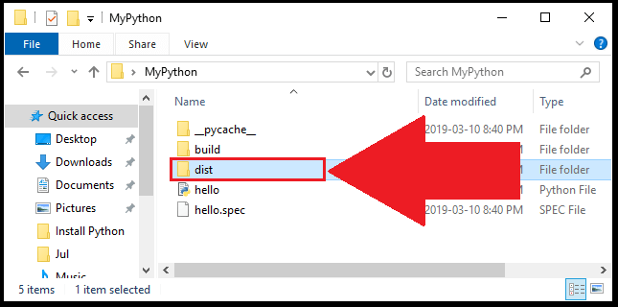
Now you’ll see the executable file:
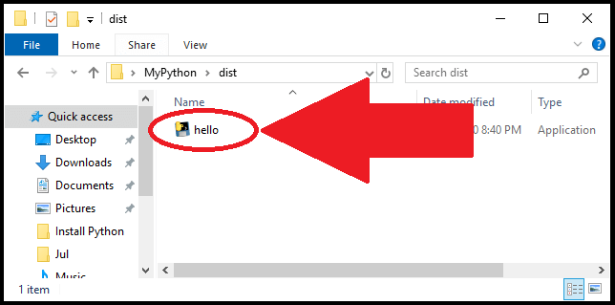
Once you click on the file, you should be able to launch your program (if you get an error message, you may need to install Visual C++ Redistributable).

For our example, once you click on the ‘hello’ executable, you’ll see the following display with a single button:

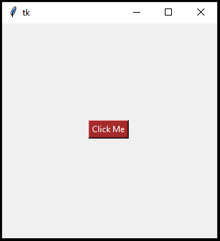
If you click on the button, you’ll see the expression of ‘Hello World!’
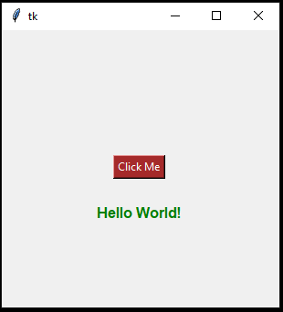
You can read more about pyinstaller by visiting the pyinstaller manual.

