1)display all airplane that are eligible to fly

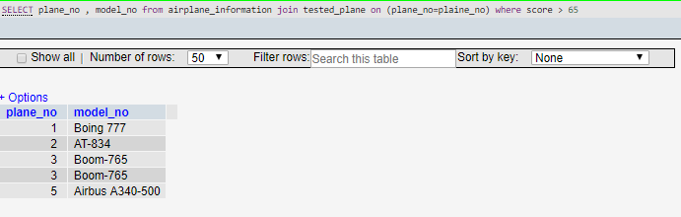

2)show all technician who are expert on Boeng777

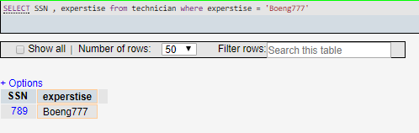

3)show all airplane that have been tested after 2018-12-07

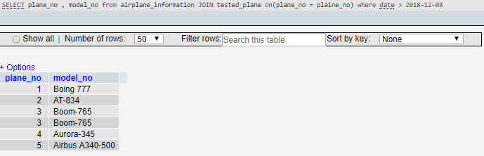

4)show all airplane that have been entered in the west hungar during the last month

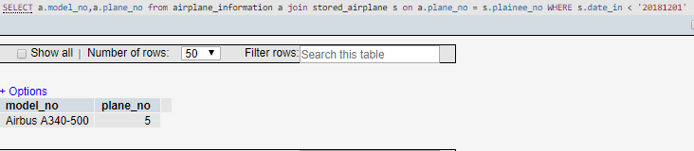

5)show all the airplane that have been tested by feliks

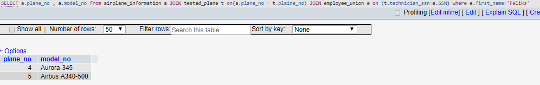

6)show all airplane that failed the cabin check

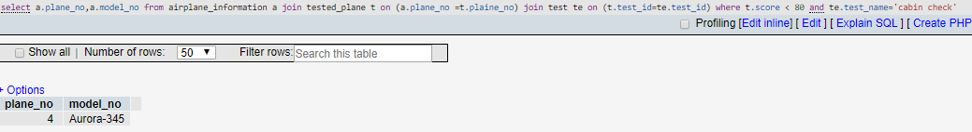

7)show all traffic controller who didn't have exams  last month

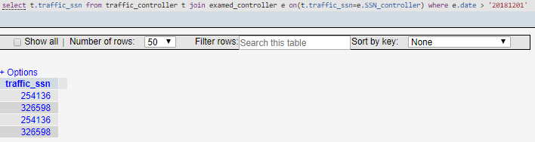

8)show all technician who have expertise on the same model

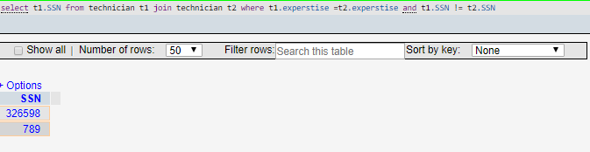

9)show all the traffic controller who had a spcific exam(exam_desc='check revising'

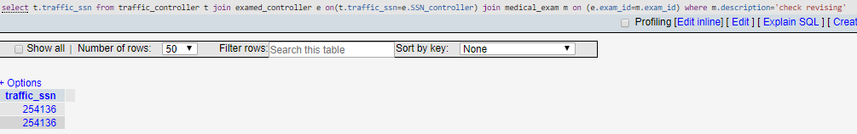

10)show all the traffic controller that had a test on a certain date (date=2018-12-15)

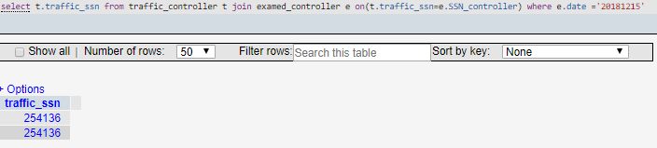

11)show all airplane that can take more than 150 people

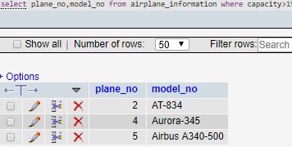

12)show all airplane that didn't have any test

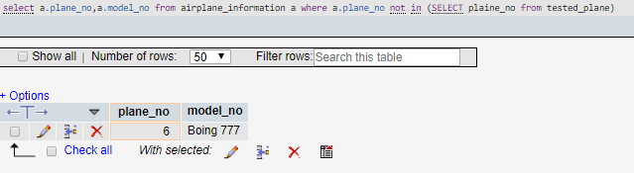

13)show all technician ssn that did more than one test and the score they gave

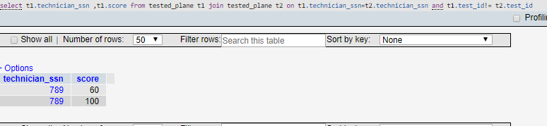

14)show membership_no of a specific traffic_controller (name='Hakan')

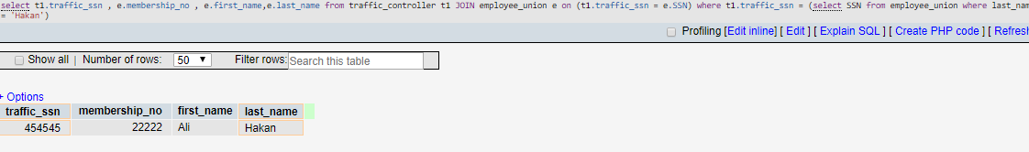

15)show all airplane whose model start with 'b'

