UsingModels1.R

Feipeng Huang

2022-11-10

catrate = read.csv("/Users/stonehuang/Documents/environmental_data/data/catrate.csv")  
head(catrate)

## pond success years cat.rate  
## 1 2 5 7 0.2857143  
## 2 3 5 7 0.2857143  
## 3 4 6 7 0.1428571  
## 4 5 4 7 0.4285714  
## 5 6 0 7 1.0000000  
## 6 7 1 4 0.7500000

summary(catrate)

## pond success years cat.rate   
## Min. : 2 Min. :0.000 Min. :1.000 Min. :0.1429   
## 1st Qu.: 5 1st Qu.:1.000 1st Qu.:3.000 1st Qu.:0.2857   
## Median : 8 Median :2.000 Median :4.000 Median :0.4286   
## Mean : 8 Mean :2.538 Mean :4.692 Mean :0.5394   
## 3rd Qu.:11 3rd Qu.:5.000 3rd Qu.:7.000 3rd Qu.:0.7500   
## Max. :14 Max. :6.000 Max. :7.000 Max. :1.0000

#Q1.  
hist(catrate$cat.rate, xlab = "Catastrophe Rate", main = "Histogram of Catastrophe Rates")

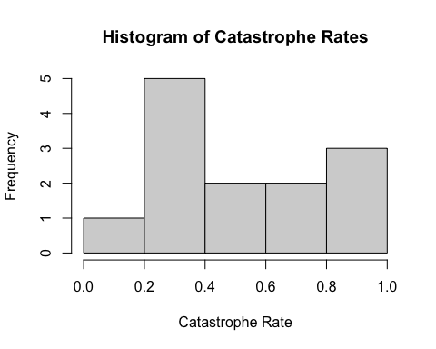

#Q2. p-value = 0.04097  
shapiro.test(catrate$cat.rate)

##   
## Shapiro-Wilk normality test  
##   
## data: catrate$cat.rate  
## W = 0.86202, p-value = 0.04097

#Q3. The null hypothesis for the Shapiro-Wilk test is that the data were sampled from a normally-distributed population.  
#Q4. There is strong evidence that the sample came from a non-normally-distributed population.  
#Q5.  
t.test(catrate$cat.rate, mu = 2/7)

##   
## One Sample t-test  
##   
## data: catrate$cat.rate  
## t = 2.9595, df = 12, p-value = 0.01193  
## alternative hypothesis: true mean is not equal to 0.2857143  
## 95 percent confidence interval:  
## 0.3526250 0.7261295  
## sample estimates:  
## mean of x   
## 0.5393773

#Q6. The catastrophic rate is equal to the pond late-filling rate.  
#Q7. This is a two-tailed test.  
#Q8. p-value = 0.01193. Even if the p-value is very small and we think there is no pattern, there is still a small chance that a pattern exists.  
#Q9. 0.3526250 0.7261295, it does not include 0  
#Q10. I conclude that there is strong evidence to reject the null hypothesis because the p-value is lower than 0.05.  
#Q11.  
wilcox.test(catrate$cat.rate, mu = 2 / 7, exact=FALSE)

##   
## Wilcoxon signed rank test with continuity correction  
##   
## data: catrate$cat.rate  
## V = 85, p-value = 0.006275  
## alternative hypothesis: true location is not equal to 0.2857143

#Q12. The p-value is 0.006275, lower than the p-value from the t-test.  
#Q13. I conclude that there is strong evidence to reject the null hypothesis because the p-value is lower than 0.05.  
#Q14. The overall conclusions I could draw from the results of the two tests are the same.  
#Q15. The Wilcoxon Rank Sum Test is more appropriate because the data are not normally-distributed.  
#Q16.  
require(palmerpenguins)

## Loading required package: palmerpenguins

penguin_dat = droplevels(subset(penguins, species != "Gentoo"))  
dat_adelie = subset(penguin_dat, species == "Adelie")  
shapiro.test(dat_adelie$flipper_length_mm)

##   
## Shapiro-Wilk normality test  
##   
## data: dat_adelie$flipper_length_mm  
## W = 0.99339, p-value = 0.72

dat_Chinstrap = subset(penguin_dat, species == "Chinstrap")  
shapiro.test(dat_Chinstrap$flipper_length_mm)

##   
## Shapiro-Wilk normality test  
##   
## data: dat_Chinstrap$flipper_length_mm  
## W = 0.98891, p-value = 0.8106

#Q17. I conclude that the flipper lengths are normally-distributed for both species because the p-values (0.72 for Adelie, 0.8106 for Chinstrap) are higher than 0.05. We fail to reject the null hypothesis.  
#Q18.  
par(mfrow = c(1, 2))  
hist(dat_adelie$flipper_length_mm, xlab = "flipper length (mm)", main = "Flipper Length \n of Adelie Penguins")  
hist(dat_Chinstrap$flipper_length_mm, xlab = "flipper length (mm)", main = "Flipper Length \n of Chinstrap Penguins")

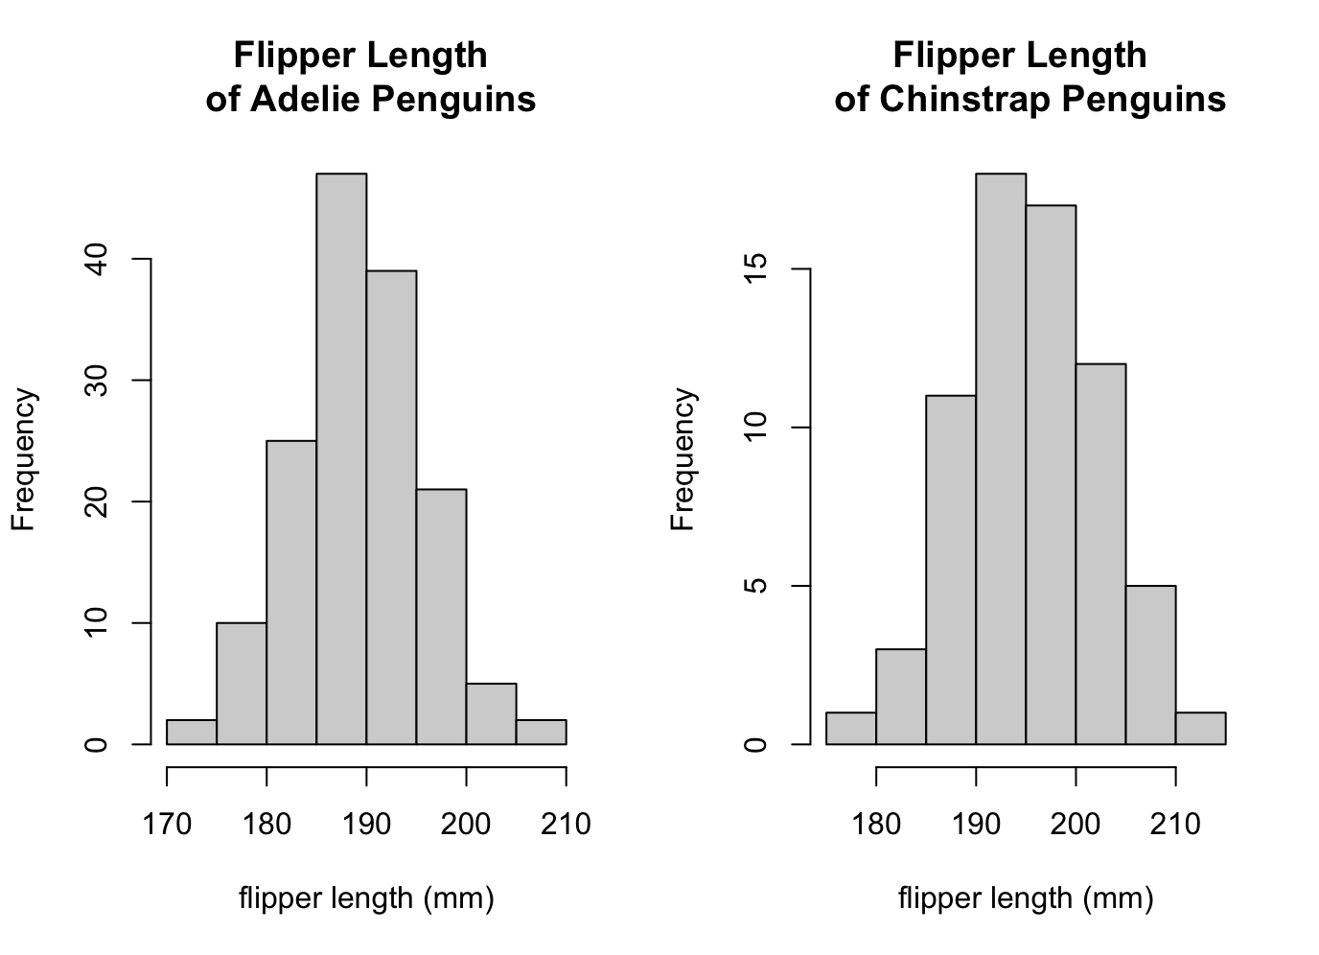

#Q19. Adelie and Chinstrap penguins have different flipper lengths. (two- tailed test)  
#Q20.  
t.test(flipper_length_mm ~ species, data = penguin_dat)

##   
## Welch Two Sample t-test  
##   
## data: flipper_length_mm by species  
## t = -5.7804, df = 119.68, p-value = 6.049e-08  
## alternative hypothesis: true difference in means is not equal to 0  
## 95 percent confidence interval:  
## -7.880530 -3.859244  
## sample estimates:  
## mean in group Adelie mean in group Chinstrap   
## 189.9536 195.8235