UsingModels2.R

Feipeng Huang

2022-12-01

require(palmerpenguins)

## Loading required package: palmerpenguins

boxplot(body_mass_g ~ sex*species, data = penguins, las = 3, names = c("female \n Adelie", "male \n Adelie", "female \n Chinstrap", "male \n Chinstrap", "female \n Gentoo", "male \n Gentoo"), ylab = "body mass (g)", xlab = "")

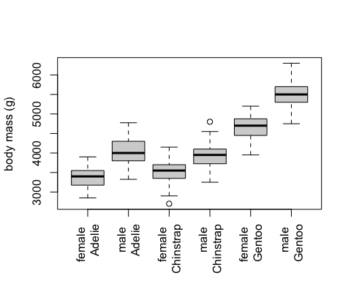

#2 Based on the boxplots, I think male penguins are significantly heavier than female penguins of the same species and the difference is significant because the box for male is higher than the box for female of the same species and the boxes do not overlap much.  
#3 I think adding sex to a model that already includes species will improve the model fit because there are significant variations in sex that we need to capture.  
#4  
fit_both = lm(body_mass_g ~ sex * species, data = penguins)  
summary(fit_both)

##   
## Call:  
## lm(formula = body_mass_g ~ sex * species, data = penguins)  
##   
## Residuals:  
## Min 1Q Median 3Q Max   
## -827.21 -213.97 11.03 206.51 861.03   
##   
## Coefficients:  
## Estimate Std. Error t value Pr(>|t|)   
## (Intercept) 3368.84 36.21 93.030 < 2e-16 ***  
## sexmale 674.66 51.21 13.174 < 2e-16 ***  
## speciesChinstrap 158.37 64.24 2.465 0.01420 *   
## speciesGentoo 1310.91 54.42 24.088 < 2e-16 ***  
## sexmale:speciesChinstrap -262.89 90.85 -2.894 0.00406 **   
## sexmale:speciesGentoo 130.44 76.44 1.706 0.08886 .   
## ---  
## Signif. codes: 0 '***' 0.001 '**' 0.01 '*' 0.05 '.' 0.1 ' ' 1  
##   
## Residual standard error: 309.4 on 327 degrees of freedom  
## (11 observations deleted due to missingness)  
## Multiple R-squared: 0.8546, Adjusted R-squared: 0.8524   
## F-statistic: 384.3 on 5 and 327 DF, p-value: < 2.2e-16

#5 female Adelie  
#6 Intercept, speciesChinstrap  
#7 3527.206  
summary(fit_both)$coefficient [1 , 1] + summary(fit_both)$coefficient [3 , 1]

## [1] 3527.206

#8 3527.206  
Chinstrap = subset(penguins, species == "Chinstrap")  
Chinstrap_female = subset(Chinstrap, sex == "female")  
mean(Chinstrap_female$body_mass_g)

## [1] 3527.206

aggregate(body_mass_g ~ species*sex, data = penguins, FUN = mean)

## species sex body_mass_g  
## 1 Adelie female 3368.836  
## 2 Chinstrap female 3527.206  
## 3 Gentoo female 4679.741  
## 4 Adelie male 4043.493  
## 5 Chinstrap male 3938.971  
## 6 Gentoo male 5484.836