final_analysis.R

Feipeng Huang

2022-12-07

library(here)

## here() starts at /Users/stonehuang/Documents/environmental_data

delomys = read.csv(here("data", "delomys.csv"))  
  
summary(delomys$body_mass)

## Min. 1st Qu. Median Mean 3rd Qu. Max.   
## 5.00 35.00 43.00 44.06 54.00 105.00

summary(delomys$body_length)

## Min. 1st Qu. Median Mean 3rd Qu. Max.   
## 49.0 106.0 116.0 114.7 124.0 265.0

shapiro.test(delomys$body_mass)

##   
## Shapiro-Wilk normality test  
##   
## data: delomys$body_mass  
## W = 0.99506, p-value = 4.33e-05

shapiro.test(delomys$body_length)

##   
## Shapiro-Wilk normality test  
##   
## data: delomys$body_length  
## W = 0.87609, p-value < 2.2e-16

plot(body_mass ~ body_length, data = delomys, xlab = "Body length", ylab = "Body mass", main = "Scatterplot of body mass and body length")

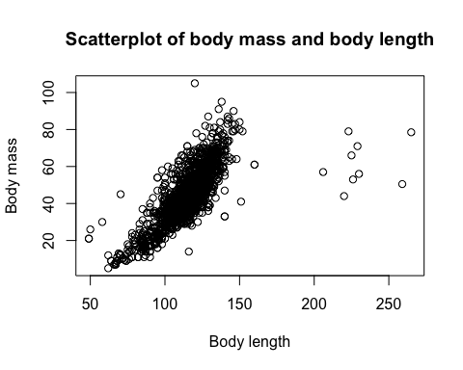

hist(delomys$body_mass, xlab = "Body mass", main = "Histogram of body mass")

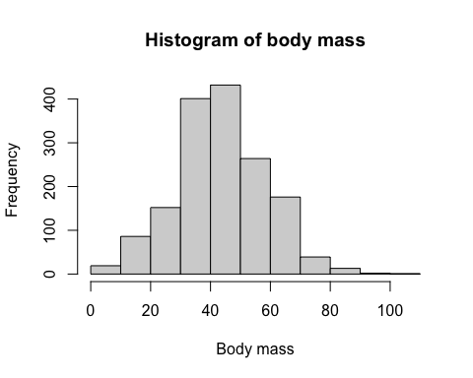

hist(delomys$body_length, xlab = "Body length", main = "Histogram of body length")

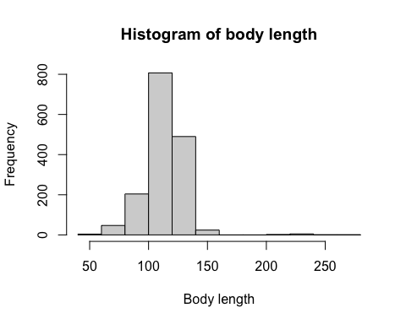

boxplot(body_mass ~ binomial, data = delomys, xlab = "Species", ylab = "Body mass", main = "Boxplot of body mass conditioned on species")

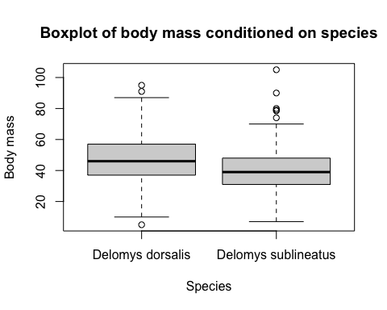

boxplot(body_mass ~ sex, data = delomys, xlab = "Sex", ylab = "Body mass", main = "Boxplot of body mass conditioned on sex")

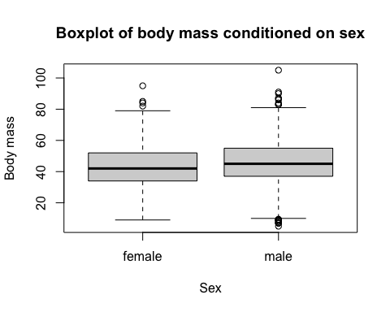

boxplot(body_mass ~ sex*binomial, data = delomys, las = 3, names = c("female \n D. dorsalis", "male \n D. dorsalis", "female \n D. sublineatus", "male \n D. sublineatus"), ylab = "Body mass", xlab = "", main = "Boxplot of mass conditioned on sex and species", cex.axis = 0.7, cex.lab = 0.7)

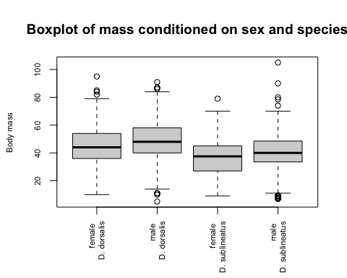

#Q1 The relationship between body mass and length seems to be linear. Mass is positive correlated with length.  
#Q2 The data, especially body length, does not appear normally-distributed because the histograms are not symmetrical.  
#Q3 I think the (unconditioned) body masses and body length are not normally-distributed (histograms are skewed, p-values < 0.05). My visual assessment of normality matched the results of the numerical normality tests.  
#Q4 D. dorsalis seems to weigh more than D. sublineatus and male seems to weigh more than female, but not by much. There is no significant difference.  
  
fit1 = lm(body_length ~ body_mass, data = delomys)  
fit2 = lm(body_mass ~ sex, data = delomys)  
fit3 = lm(body_mass ~ binomial, data = delomys)  
fit4 = lm(body_mass ~ sex + binomial, data = delomys)  
fit5 = lm(body_mass ~ sex * binomial, data = delomys)  
  
hist(residuals(fit1))

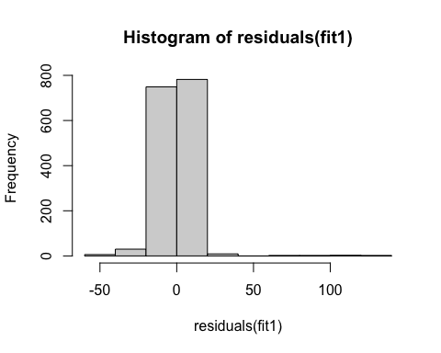

hist(residuals(fit2))

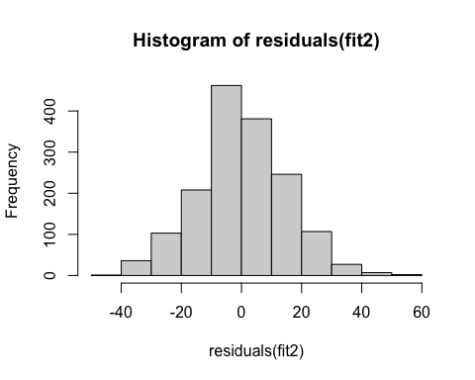

hist(residuals(fit3))

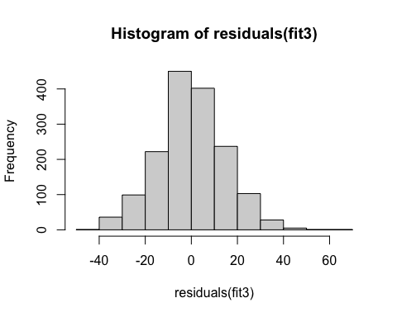

hist(residuals(fit4))

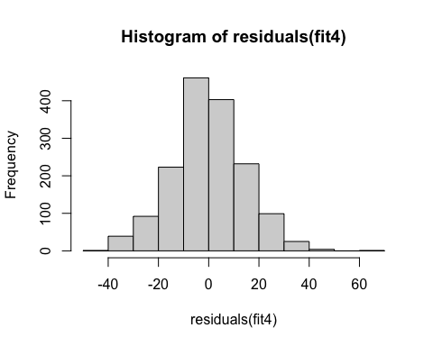

hist(residuals(fit5))

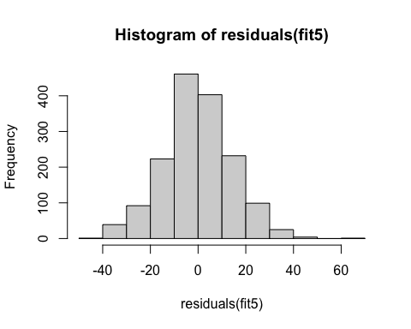

shapiro.test(residuals(fit1))

##   
## Shapiro-Wilk normality test  
##   
## data: residuals(fit1)  
## W = 0.73462, p-value < 2.2e-16

shapiro.test(residuals(fit2))

##   
## Shapiro-Wilk normality test  
##   
## data: residuals(fit2)  
## W = 0.99563, p-value = 0.0001541

shapiro.test(residuals(fit3))

##   
## Shapiro-Wilk normality test  
##   
## data: residuals(fit3)  
## W = 0.99535, p-value = 8.103e-05

shapiro.test(residuals(fit4))

##   
## Shapiro-Wilk normality test  
##   
## data: residuals(fit4)  
## W = 0.99525, p-value = 6.805e-05

shapiro.test(residuals(fit5))

##   
## Shapiro-Wilk normality test  
##   
## data: residuals(fit5)  
## W = 0.99526, p-value = 6.816e-05

#Q5 Based on the numerical and graphical diagnostics, all models fail to fulfill the assumption of normality of the residuals.  
#Q6 Violations of the normality assumption are not equally severe for all the models. The violation is much more severe in model 1.  
  
knitr::kable(coef(summary(fit1)))

|  | Estimate | Std. Error | t value | Pr(>|t|) |
| --- | --- | --- | --- | --- |
| (Intercept) | 76.1246565 | 0.9158120 | 83.12258 | 0 |
| body_mass | 0.8754988 | 0.0196905 | 44.46298 | 0 |

#Q7 0.8754988  
#Q8 163.6745  
76.1246565+(0.8754988*100)

## [1] 163.6745

#Q9 76.12466  
76.1246565+(0.8754988*0)

## [1] 76.12466

knitr::kable(coef(summary(fit2)))

|  | Estimate | Std. Error | t value | Pr(>|t|) |
| --- | --- | --- | --- | --- |
| (Intercept) | 42.711465 | 0.5288929 | 80.756355 | 0.0000000 |
| sexmale | 2.784133 | 0.7456117 | 3.734024 | 0.0001951 |

knitr::kable(coef(summary(fit3)))

|  | Estimate | Std. Error | t value | Pr(>|t|) |
| --- | --- | --- | --- | --- |
| (Intercept) | 46.752427 | 0.4499933 | 103.89582 | 0 |
| binomialDelomys sublineatus | -7.683058 | 0.7604562 | -10.10322 | 0 |

knitr::kable(coef(summary(fit4)))

|  | Estimate | Std. Error | t value | Pr(>|t|) |
| --- | --- | --- | --- | --- |
| (Intercept) | 45.070355 | 0.5556429 | 81.113891 | 0e+00 |
| sexmale | 3.795395 | 0.7259609 | 5.228099 | 2e-07 |
| binomialDelomys sublineatus | -8.193492 | 0.7609985 | -10.766764 | 0e+00 |

knitr::kable(coef(summary(fit5)))

|  | Estimate | Std. Error | t value | Pr(>|t|) |
| --- | --- | --- | --- | --- |
| (Intercept) | 45.0554562 | 0.6052973 | 74.4352459 | 0.0000000 |
| sexmale | 3.8280908 | 0.8966667 | 4.2692460 | 0.0000208 |
| binomialDelomys sublineatus | -8.1417394 | 1.1281046 | -7.2171847 | 0.0000000 |
| sexmale:binomialDelomys sublineatus | -0.0950187 | 1.5285856 | -0.0621612 | 0.9504424 |

#Q10 female  
#Q11 Delomys dorsalis  
#Q12 male  
#Q13 Delomys dorsalis  
  
knitr::kable(anova(fit2))

|  | Df | Sum Sq | Mean Sq | F value | Pr(>F) |
| --- | --- | --- | --- | --- | --- |
| sex | 1 | 3061.678 | 3061.6779 | 13.94294 | 0.0001951 |
| Residuals | 1578 | 346507.131 | 219.5863 | NA | NA |

knitr::kable(anova(fit3))

|  | Df | Sum Sq | Mean Sq | F value | Pr(>F) |
| --- | --- | --- | --- | --- | --- |
| binomial | 1 | 21289.68 | 21289.6805 | 102.0751 | 0 |
| Residuals | 1583 | 330164.45 | 208.5688 | NA | NA |

knitr::kable(anova(fit4))

|  | Df | Sum Sq | Mean Sq | F value | Pr(>F) |
| --- | --- | --- | --- | --- | --- |
| sex | 1 | 3061.678 | 3061.6779 | 14.95838 | 0.0001144 |
| binomial | 1 | 23727.134 | 23727.1342 | 115.92320 | 0.0000000 |
| Residuals | 1577 | 322779.997 | 204.6798 | NA | NA |

knitr::kable(anova(fit5))

|  | Df | Sum Sq | Mean Sq | F value | Pr(>F) |
| --- | --- | --- | --- | --- | --- |
| sex | 1 | 3.061678e+03 | 3.061678e+03 | 14.948932 | 0.0001150 |
| binomial | 1 | 2.372713e+04 | 2.372713e+04 | 115.849977 | 0.0000000 |
| sex:binomial | 1 | 7.913846e-01 | 7.913846e-01 | 0.003864 | 0.9504424 |
| Residuals | 1576 | 3.227792e+05 | 2.048091e+02 | NA | NA |

#Q14 Sex and species are significant predictors for body mass.  
#Q15 There is not a significant interaction.  
#Q16 The significance level of sex and the significance level of species do not change much among the different models. All corresponding p-values are very small.   
  
AIC(fit2)

## [1] 13006.8

AIC(fit3)

## [1] 12966.36

AIC(fit4)

## [1] 12896.73

AIC(fit5)

## [1] 12898.72

#Q17 model 4 and 5  
#Q18 I would select model 4 because it is the best fit (lowest AIC), and an additive model is easier to understand and explain than an interactive model.