Lab 11: Stimulation and Power Analysis

Q1

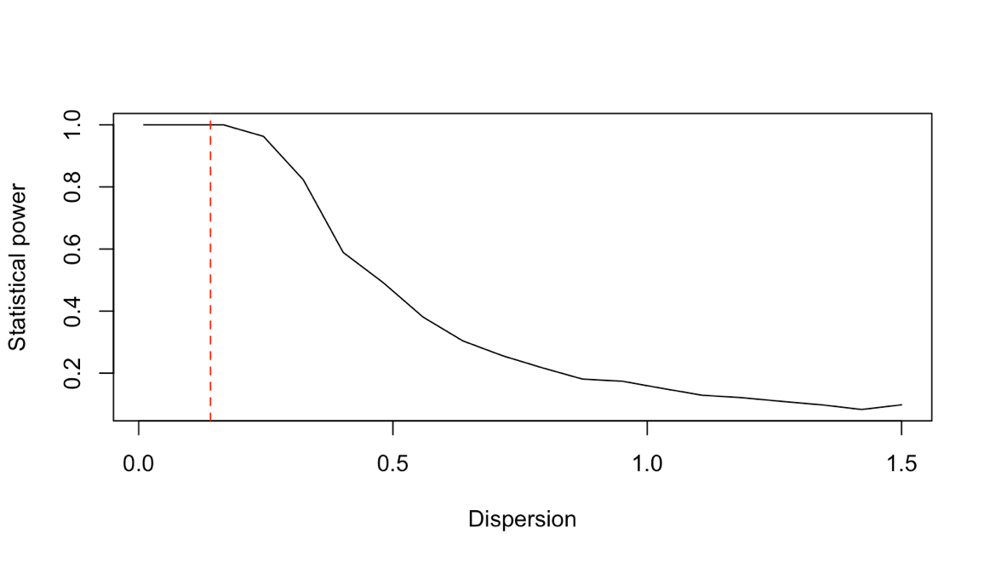

Q2 Statistical power decreases as population dispersion increases because there is more variability in the population when the population has a large dispersion, which makes us harder to detect a pattern.

Q3

Q4 Statistical power does not change much with variation in sample size alone, but it changes a lot with variation in population dispersion (small dispersion – higher statistical power), which suggests population dispersion has a much stronger effect on statistical power than the sample size.

Q6 When designing an experiment, I would have a large, representative sample size to ensure the population dispersion/standard deviation is low, so the statistical power is high.