Lab 3

Feipeng Huang

###Q1  
#Basal area is the cross-sectional areas of tree stems. We measure the circumference at breast height (1.3 meters or 4.5 feet from the ground), estimate the diameter, and calculate the area.  
#basal area of a forest = total basal area of all trees / area of a forest

###Q2

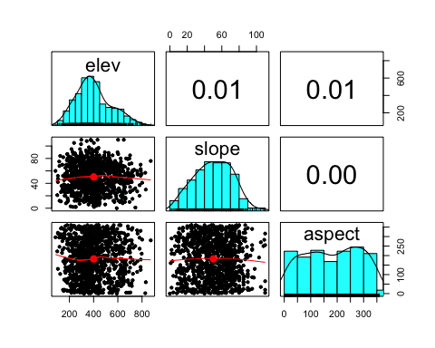

###Q3

###Q4  
#Townsend's Solitaire preferred mid to high elevations and were not found at elevations below 300 meters. The logistic model is not a good fit because TOSO was absent from many mid to high elevations. More observations of TOSO would better reflect the habitat preference.

###Q5

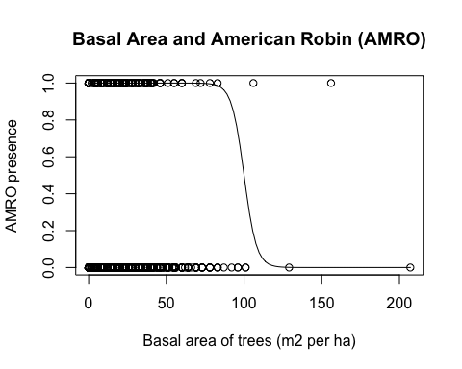

###Q6  
#American Robin preferred low tree cover (basal area < 50 m2 per ha). However, there are many low basal area sites where robins were absent. So a logistic model is not a good fit. High basal area sites are not representative in this data set.  
  
###Q7  
#181 Gray Jays were observed in all of the sampling sites.

###Q8  
GRJA = dat_all$GRJA  
sum(GRJA)

###Q9  
#There are 110 sampling sites in which Gray Jays were observed.

###Q10  
GRJA > 0

GRJA_present_absent = as.numeric(GRJA > 0)  
sum(GRJA_present_absent)