Lab 5

Feipeng Huang

#Q1  
exp_fun = function(x, a, b)   
{  
return(a * exp(-b * x))  
}  
#Q2

#Q3  
#The starting height of the curve varies as I vary parameter a. (bigger a - higher starting height)  
#Q4  
#The rate of decay varies as I vary parameter b. (bigger b - faster decay)  
#Q5

#Q6  
#The initial slope varies as I vary parameter a. (bigger a - bigger slope)  
#Q7  
#The highest point of the curve varies as I vary parameter b. (bigger b - lower highest point)

Q8

**slope = -0.0005**

**x1 = 500**

**y1 = 0.4**

I first selected a data point to be (x1, y1). There seems to be a downward trend, so I chose a negative slope.

Q9

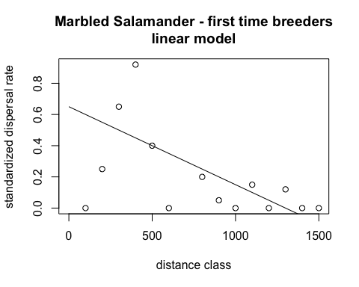

Q10

**a = 1**

**b = 0.003**

The highest dispersal rate is 0.92, so I decided a = 1 (the starting height). I set b to 0.003 to best fit the rate of decay.

Q11

Q12

**a = 0.0015**

**b = 0.0025**

The highest point occurs at x = 400. 400 = 1/b, so I set b to 0.0025. I set a to 0.0015 by choosing two nearby points on the far left of the graph and calculating the slope.

Q13

Q14

resids_linear = dat_dispersal$disp.rate.ftb - line_point_slope(dat_dispersal$dist.class, 500, 0.4, -0.0005)

resids_exp = dat_dispersal$disp.rate.ftb - exp_fun(dat_dispersal$dist.class, 1, 0.003)

resids_ricker = dat_dispersal$disp.rate.ftb - ricker_fun(dat_dispersal$dist.class, 0.0015, 0.0025)

df = data.frame(resids_linear, resids_exp, resids_ricker)

Q15

