lab8.R

Feipeng Huang

2022-11-02

veg = read.csv("/Users/stonehuang/Documents/environmental_data/data/vegdata.csv")  
dat_bird = read.csv("/Users/stonehuang/Documents/environmental_data/data/bird.sub.csv")  
dat_habitat = read.csv("/Users/stonehuang/Documents/environmental_data/data/hab.sub.csv")  
require(palmerpenguins)

## Loading required package: palmerpenguins

penguin_dat = droplevels(subset(penguins, species != "Gentoo"))  
t.test(flipper_length_mm ~ species, data = penguin_dat, alternative = "less")

##   
## Welch Two Sample t-test  
##   
## data: flipper_length_mm by species  
## t = -5.7804, df = 119.68, p-value = 3.025e-08  
## alternative hypothesis: true difference in means is less than 0  
## 95 percent confidence interval:  
## -Inf -4.186534  
## sample estimates:  
## mean in group Adelie mean in group Chinstrap   
## 189.9536 195.8235

#install.packages("simpleboot")  
require(simpleboot)

## Loading required package: simpleboot

## Simple Bootstrap Routines (1.1-7)

dat_adelie = subset(penguins, species == "Adelie")  
dat_chinstrap = subset(penguins, species == "Chinstrap")  
boot_mean = function(x, i)  
{  
 return(mean(x[i], na.rm = TRUE))  
}  
pen_boot = two.boot(dat_adelie$flipper_length_mm, dat_chinstrap$flipper_length_mm, boot_mean, 10000, student = FALSE, weight = NULL)  
str(pen_boot)

## List of 12  
## $ t0 : num -5.87  
## $ t : num [1:10000, 1] -6.43 -5.81 -6.1 -5.18 -4.8 ...  
## $ R : num 10000  
## $ data : int [1:220] 181 186 195 NA 193 190 181 195 193 190 ...  
## $ seed : int [1:626] 10403 1 1878503375 -718147370 -1323315072 -1509060925 -1822959519 487631056 -1559371218 1432003545 ...  
## $ statistic:function (x, idx)   
## $ sim : chr "ordinary"  
## $ call : language boot(data = c(sample1, sample2), statistic = boot.func, R = R, strata = ind, weights = weights)  
## $ stype : chr "i"  
## $ strata : num [1:220] 1 1 1 1 1 1 1 1 1 1 ...  
## $ weights : num [1:220] 0.00658 0.00658 0.00658 0.00658 0.00658 ...  
## $ student : logi FALSE  
## - attr(*, "class")= chr "simpleboot"  
## - attr(*, "boot_type")= chr "boot"

t = pen_boot[["t"]]  
##########Q1##########  
sd = sd(t)  
#sd = 1.021529  
##########Q2##########  
hist(t, xlab = "Difference in mean flipper length (mm)  
of Adelie and Chinstrap Pengunis", main = "Histogram of 10000 bootstrap differences   
 in mean penguin flipper length")

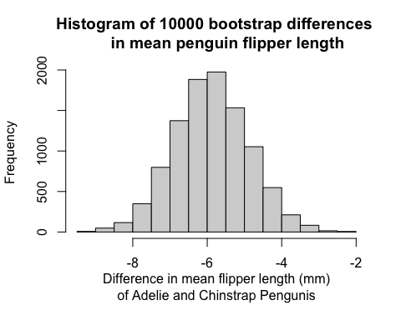

mean(t)

## [1] -5.883202

median(t)

## [1] -5.891703

##########Q3##########  
quantile(  
 pen_boot$t,  
 c(0.025, 0.975))

## 2.5% 97.5%   
## -7.843715 -3.895663

#95% bootstrap CI = -7.897064, -3.855186   
##########Q4##########  
#I think the resampled differences in means do not follow a skewed distribution. The mean is similar to the median and the peak of the histogram centers around the mean/median.   
##########Q5##########  
pen_ecdf = ecdf(t)  
##########Q6##########  
1 - pen_ecdf(-4.5)

## [1] 0.0864

#0.088  
##########Q7##########  
pen_ecdf(-8)

## [1] 0.0171

#0.02  
##########Q8##########  
#null: There is no difference in mean flipper lengths between Adelie and Chinstrap Pengunis.  
#alternative: There is difference in mean flipper lengths between Adelie and Chinstrap Pengunis.  
head(veg)

## block plot date treatment birch pine fern  
## 1 A A3 1995 control 0 4 260  
## 2 A A7 1995 control 0 0 186  
## 3 A A4 1995 removed 8 8 46  
## 4 A A6 1995 removed 6 28 1  
## 5 A A5 1995 mixed 0 1 309  
## 6 A A8 1995 mixed 0 0 258

boxplot(pine ~ treatment, dat = veg)

dat_tree = droplevels(subset(veg, treatment %in% c("control", "clipped")))  
boxplot(pine ~ treatment, dat = dat_tree)

table(dat_tree$treatment)

##   
## clipped control   
## 8 8

##########Q9##########  
wilcox.test(pine ~ treatment, data = dat_tree, alternative = "two.sided")

## Warning in wilcox.test.default(x = c(11L, 0L, 16L, 3L, 49L, 17L, 0L, 47L: cannot  
## compute exact p-value with ties

##   
## Wilcoxon rank sum test with continuity correction  
##   
## data: pine by treatment  
## W = 48, p-value = 0.1005  
## alternative hypothesis: true location shift is not equal to 0

#p-value = 0.1005  
#Bootstrap  
dat_clipped = subset(dat_tree, treatment == "clipped")  
dat_control = subset(dat_tree, treatment == "control")  
tree_boot = two.boot(dat_clipped$pine, dat_control$pine, boot_mean, 10000, student = FALSE, weight = NULL)  
##########Q10##########  
quantile(  
 tree_boot$t,  
 c(0.025, 0.975))

## 2.5% 97.5%   
## 4.125 29.750

#4.25000 29.50312  
##########Q11##########  
observed_difference = mean(dat_clipped$pine) - mean(dat_control$pine)  
#The observed difference in mean tree counts is 16 and it falls within the 95% bootstrap CI.  
  
dat_all = merge(  
 dat_bird,   
 dat_habitat,  
 by = c("basin", "sub"))  
  
head(dat_all[, c("b.sidi", "s.sidi")])

## b.sidi s.sidi  
## 1 0.06678912 0.12  
## 2 0.06509689 0.34  
## 3 0.06092608 0.78  
## 4 0.06012721 0.57  
## 5 0.04112905 0.84  
## 6 0.06086158 0.73

#Simpson’s diversity index for breeding birds: b.sidi  
#Simpson’s diversity index for vegetation cover types: s.sidi  
  
# Calculate the sample mean and sd:  
b_sidi_mean = mean(dat_all$b.sidi, na.rm = TRUE)  
b_sidi_sd = sd(dat_all$b.sidi, na.rm = TRUE)  
# Use the subset-by-name symbol ($) to create a   
# new column of z-standardized values.  
dat_all$b.sidi.standardized = (dat_all$b.sidi - b_sidi_mean)/b_sidi_sd  
mean(dat_all$b.sidi.standardized)

## [1] 7.166938e-17

sd(dat_all$b.sidi.standardized)

## [1] 1

##########Q12##########  
#Simpson diversity index measures diversity. It quantifies the number of species and the relative abundance of each species.  
##########Q13##########  
s_sidi_mean = mean(dat_all$s.sidi, na.rm = TRUE)  
s_sidi_sd = sd(dat_all$s.sidi, na.rm = TRUE)  
dat_all$s.sidi.standardized = (dat_all$s.sidi - s_sidi_mean)/s_sidi_sd  
mean(dat_all$s.sidi.standardized)

## [1] 2.984718e-17

sd(dat_all$s.sidi.standardized)

## [1] 1

fit_1 = lm(b.sidi ~ s.sidi, data = dat_all)  
coef(fit_1)

## (Intercept) s.sidi   
## 0.07116980 -0.02437131

slope_observed = coef(fit_1)[2]  
plot(  
 b.sidi ~ s.sidi, data = dat_all,  
 main = "Simpson's diversity indices",  
 xlab = "Vegetation cover diversity",  
 ylab = "Bird diversity")  
abline(fit_1)

dat_1 =   
 subset(  
 dat_all,  
 select = c(b.sidi, s.sidi))  
  
set.seed(123)  
index_1 = sample(nrow(dat_1), replace = TRUE)  
index_2 = sample(nrow(dat_1), replace = TRUE)  
  
dat_resampled_i =   
 data.frame(  
 b.sidi = dat_1$b.sidi[index_1],  
 s.sidi = dat_1$s.sidi[index_2]  
 )  
  
fit_resampled_i = lm(b.sidi ~ s.sidi, data = dat_resampled_i)  
slope_resampled_i = coef(fit_resampled_i)[2]  
  
print(slope_resampled_i)

## s.sidi   
## 0.006235381

plot(  
 b.sidi ~ s.sidi, data = dat_resampled_i,  
 main = "Simpson's diversity indices (MC resampled data)",  
 xlab = "Vegetation cover diversity",  
 ylab = "Bird diversity")  
abline(fit_resampled_i)

##########Q14##########  
m = 10000   
result_mc = numeric(m)   
for(i in 1:m)  
{  
 index_1 = sample(nrow(dat_1), replace = TRUE)  
 index_2 = sample(nrow(dat_1), replace = TRUE)  
   
 dat_resampled_i =   
 data.frame(  
 b.sidi = dat_1$b.sidi[index_1],  
 s.sidi = dat_1$s.sidi[index_2]  
 )  
 fit_resampled_i = lm(b.sidi ~ s.sidi, data = dat_resampled_i)  
 result_mc[i] = coef(fit_resampled_i)[2]  
}   
##########Q15##########  
hist(  
 result_mc,  
 main = "Null Distribution of Regression Slope",  
 xlab = "Slope Parameter")  
abline(v = slope_observed, lty = 1, col = "blue", lwd = 2)  
abline(v = quantile(result_mc, c(.05)), lty = 2, col = "red", lwd = 2)

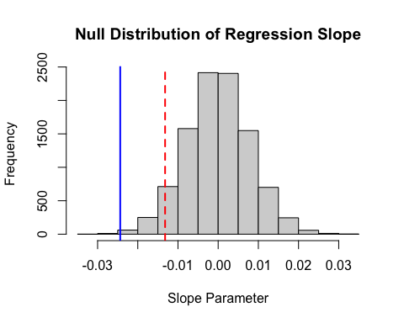

quantile(result_mc, c(.05))

## 5%   
## -0.01320388

##########Q16##########

#-0.01320388. The observed slope is less than the critical value.

##########Q17##########  
#The chance of getting the observed value only by chance is very low (<5%), which provides evidence to reject the null hypothesis. It is likely that a negative relationship between vegetation cover diversity and bird diversity exists.  
  
set.seed(345)  
index_1 = sample(nrow(dat_1), replace = TRUE)  
  
dat_boot = dat_1[index_1, ]  
head(dat_boot)

## b.sidi s.sidi  
## 29 0.08263485 0.00  
## 23 0.05705873 0.62  
## 19 0.05820778 0.54  
## 21 0.07254766 0.41  
## 18 0.06365076 0.49  
## 28 0.06284046 0.36

fit_bs1 = lm(b.sidi ~ s.sidi, data = dat_boot)  
  
coef(fit_bs1)

## (Intercept) s.sidi   
## 0.07489893 -0.03146039

##########Q18##########  
b = 10000   
result_boot = numeric(b)   
for(i in 1:b)  
{  
 index = sample(nrow(dat_1), replace = TRUE)  
   
 dat_boot_i =   
 data.frame(  
 b.sidi = dat_1$b.sidi[index],  
 s.sidi = dat_1$s.sidi[index]  
 )  
 fit_bs1 = lm(b.sidi ~ s.sidi, data = dat_boot_i)  
 result_boot[i] = coef(fit_bs1)[2]  
}   
hist(  
 result_boot,  
 main = "Alternative Distribution of Regression Slope",  
 xlab = "Slope Parameter")  
abline(v = slope_observed, lty = 2, col = "red", lwd = 2)  
abline(v = 0, lty = 2, col = 1, lwd = 2)

##########Q19##########  
plot(  
 density(result_mc),  
 main = "Null and Alternative Distributions",  
 xlab = "Slope Coefficient",  
 xlim = c(-0.05, 0.04),  
 ylim = c(0, 65),  
 col = "blue",  
 lwd = 2  
 )  
lines(density(result_boot), col = "red", lwd = 2)  
legend(c("Null", "Alt."), lty = 1, lwd = 2, col = c("blue", "red"), x = "topright", bty = "n")

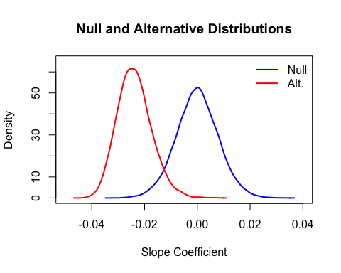

##########Q20##########  
#The region that falls under both curves is a region of uncertainty. If we observe a slope there, we are not sure if we can reject the null hypothesis.