🧠 Project Report: Linear Regression on Mall Customer Dataset

1. Introduction
This project aims to predict the Spending Score (1–100) of mall customers based on demographic and income-related factors such as Gender, Age, and Annual Income. The dataset used is the Mall Customer Dataset. A Linear Regression model was applied to understand how these features influence customer spending behavior.



2. Hypothesis
Linear Regression cannot fully explain human spending behavior because human decisions are influenced by complex, non-linear, and psychological factors that extend beyond measurable demographic or economic variables.

3. Model Description
The model uses three predictor variables:
- Gender
- Age
- Annual Income (k$)
and one target variable:
- Spending Score (1–100)
A simple Linear Regression model was trained using an 80/20 train-test split, and performance was evaluated using R² Score and Mean Squared Error (MSE).



4. Observations and Results
- The model achieved an R² score of approximately 0.25, indicating that only 25% of the variation in spending score is explained by the input features.
- The scatter plot of actual vs. predicted spending scores shows a weak correlation, suggesting that predictions do not align closely with real-world data.

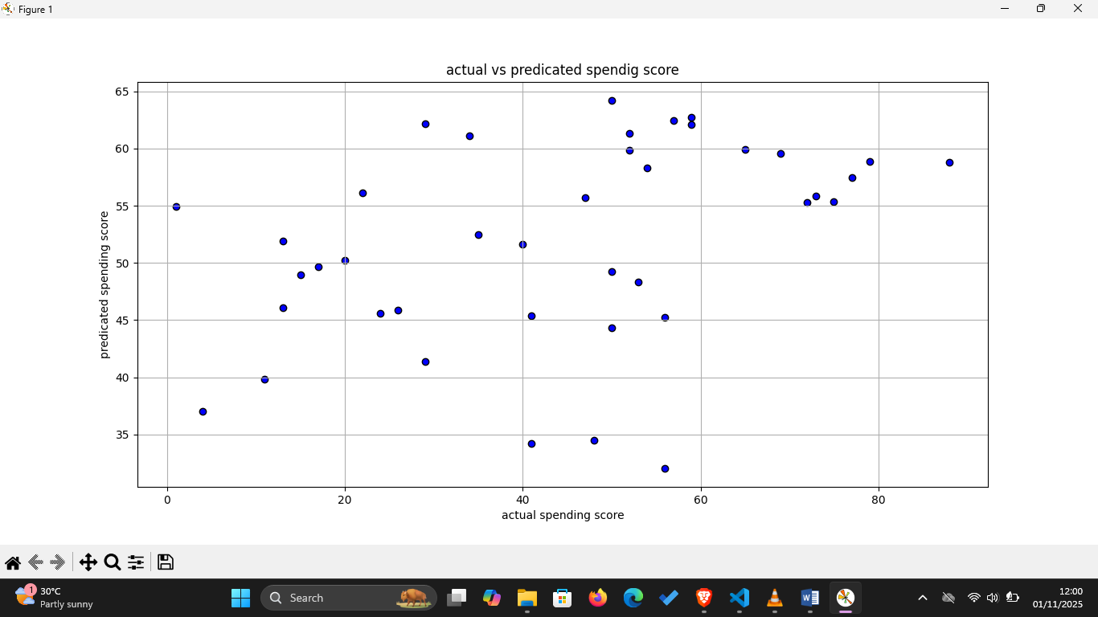

5. Discussion

a. Limitation of Linearity
Linear Regression assumes a straight-line relationship between inputs and outputs. In reality, customer behavior is rarely linear. For instance:
- Spending may increase with income up to a certain threshold, then plateau.
- Younger and older customers might have similar spending scores for completely different reasons.
These non-linear patterns are not well captured by a simple linear model.

b. Missing Psychological and Behavioral Factors
The dataset includes only basic demographic data.
Human spending decisions depend on many other variables such as:
- Lifestyle and personal preferences
- Emotional state or impulse buying tendencies
- Social influence, marketing exposure, and brand loyalty
Since these are not quantifiable or included, the model cannot explain much of the variability in customer spending.

c. Lack of Interaction Effects
Linear Regression treats predictors as acting independently.
However, interactions (e.g., the combined effect of Age and Income) can strongly influence spending. Without modeling such interactions explicitly, accuracy remains limited.

d. Human Behavior is Heterogeneous
Different customers exhibit distinct spending patterns that do not follow a single mathematical rule.
Clustering-based approaches (like K-Means) or non-linear models (like Random Forests or Neural Networks) are better suited for capturing such variation.

6. Conclusion
While Linear Regression is a simple and interpretable starting point, it cannot fully capture the complexity of human spending behavior. The low accuracy (R² ≈ 0.25) suggests that most behavioral variation arises from unobserved or non-linear influences.
To improve predictive performance:
- Include additional behavioral, psychological, or categorical features (e.g., shopping frequency, product preferences, family size).
- Try non-linear models (Decision Trees, Random Forests, XGBoost, Neural Networks).
- Apply customer segmentation (e.g., K-Means Clustering) before modeling.
Such steps can reveal deeper patterns and better reflect the true dynamics of customer behavior

