Demo2-隐式Intent的使用

1. layout

activity_main.xml

*<?***xml version="1.0" encoding="utf-8"***?>*<**LinearLayout  
 xmlns:android="http://schemas.android.com/apk/res/android"  
 android:layout_width="match_parent"  
 android:layout_height="match_parent"  
 android:orientation="vertical"**>  
  
 <**Button  
 android:id="@+id/btn_1"  
 android:layout_width="match_parent"  
 android:layout_height="wrap_content"  
 android:text="打开系统浏览器"**/>  
  
 <**Button  
 android:id="@+id/btn_2"  
 android:layout_width="match_parent"  
 android:layout_height="wrap_content"  
 android:text="打开系统电话"**/>  
  
  
  
</**LinearLayout**>

1. MainActivity.java

**import** android.content.Intent;  
**import** android.net.Uri;  
**import** android.support.v7.app.AppCompatActivity;  
**import** android.os.Bundle;  
**import** android.view.View;  
**import** android.widget.Button;  
  
**public class** MainActivity **extends** AppCompatActivity **implements** View.OnClickListener {  
  
 **private** Button **btn_1**;  
 **private** Button **btn_2**;  
 @Override  
 **protected void** onCreate(Bundle savedInstanceState) {  
 **super**.onCreate(savedInstanceState);  
 setContentView(R.layout.***activity_main***);  
  
 initView();  
 initData();  
 }  
  
 **private void** initView() {  
  
 **btn_1**= (Button) findViewById(R.id.***btn_1***);  
 **btn_2**= (Button) findViewById(R.id.***btn_2***);  
 }  
  
 **private void** initData() {  
  
 **btn_1**.setOnClickListener(**this**);  
 **btn_2**.setOnClickListener(**this**);  
 }  
 @Override  
 **public void** onClick(View view) {  
  
 **switch** (view.getId()){  
  
 **case** R.id.***btn_1***:  
 *//1、传入隐式Intent的action值，构造Intent对象  
 //action值一般是传入Android系统可以响应的action值  
 //当然也可以在某个Activity的action值配置Intent-filter就可以响应此Intent* Intent intent=**new** Intent(Intent.***ACTION_VIEW***);  
  
 *//调用象方：initData()，传入Uri对象* intent.setData(Uri.*parse*(**"http://www.baidu.com"**));  
  
 *//开启可以响应此Intent的Activity(可能是系统应用的Activity)* startActivity(intent);  
 **break**;  
  
 **case** R.id.***btn_2***:  
 Intent intent2=**new** Intent(Intent.***ACTION_DIAL***);  
 intent2.setData(Uri.*parse*(**"tel:15622391415"**));  
 startActivity(intent2);  
 **break**;  
 } }  
}

1. 架构图

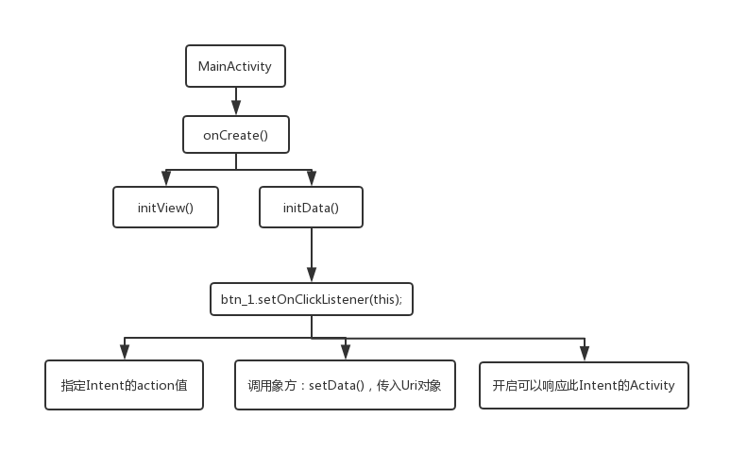

备注：常用的action值

// 调用浏览器

Uri webViewUri = Uri.parse("http://blog.csdn.net/zuolongsnail");

Intent intent = new Intent(Intent.ACTION_VIEW, webViewUri);

// 调用地图

Uri mapUri = Uri.parse("geo:100,100");

Intent intent = new Intent(Intent.ACTION_VIEW, mapUri);

// 播放mp3

Uri playUri = Uri.parse("file:///sdcard/test.mp3");

Intent intent = new Intent(Intent.ACTION_VIEW, playUri);

intent.setDataAndType(playUri, "audio/mp3");

// 调用拨打电话

Uri dialUri = Uri.parse("tel:10086");

Intent intent = new Intent(Intent.ACTION_DIAL, dialUri);

// 直接拨打电话，需要加上权限<uses-permission id="android.permission.CALL_PHONE" />

Uri callUri = Uri.parse("tel:10086");

Intent intent = new Intent(Intent.ACTION_CALL, callUri);

// 调用发邮件（这里要事先配置好的系统Email，否则是调不出发邮件界面的）

Uri emailUri = Uri.parse("mailto:zuolongsnail@163.com");

Intent intent = new Intent(Intent.ACTION_SENDTO, emailUri);

// 直接发邮件

Intent intent = new Intent(Intent.ACTION_SEND);

String[] tos = { "zuolongsnail@gmail.com" };

String[] ccs = { "zuolongsnail@163.com" };

intent.putExtra(Intent.EXTRA_EMAIL, tos);

intent.putExtra(Intent.EXTRA_CC, ccs);

intent.putExtra(Intent.EXTRA_TEXT, "the email text");

intent.putExtra(Intent.EXTRA_SUBJECT, "subject");

intent.setType("text/plain");

Intent.createChooser(intent, "Choose Email Client");

// 发短信

Intent intent = new Intent(Intent.ACTION_VIEW);

intent.putExtra("sms_body", "the sms text");

intent.setType("vnd.android-dir/mms-sms");

// 直接发短信

Uri smsToUri = Uri.parse("smsto:10086");

Intent intent = new Intent(Intent.ACTION_SENDTO, smsToUri);

intent.putExtra("sms_body", "the sms text");

// 发彩信

Uri mmsUri = Uri.parse("content://media/external/images/media/23");

Intent intent = new Intent(Intent.ACTION_SEND);

intent.putExtra("sms_body", "the sms text");

intent.putExtra(Intent.EXTRA_STREAM, mmsUri);

intent.setType("image/png");

// 卸载应用

Uri uninstallUri = Uri.fromParts("package", "com.app.test", null);

Intent intent = new Intent(Intent.ACTION_DELETE, uninstallUri);

// 安装应用

Intent intent = new Intent(Intent.ACTION_VIEW);

intent.setDataAndType(Uri.fromFile(new File("/sdcard/test.apk"), "application/vnd.android.package-archive");

// 在Android Market中查找应用

Uri uri = Uri.parse("market://search?q=愤怒的小鸟");

Intent intent = new Intent(Intent.ACTION_VIEW, uri);

作者：xiaoxin3839519  
链接：http://www.imooc.com/article/18136?block_id=tuijian_wz  
来源：慕课网