Toxic Comment Detection on Twitter Using BERT
Fercy T. Enriquez  Computer Studies and Engineering  Jose Rizal University  Mandaluyong City, Philippines  fercy.enriquez@my.jru.edu | Russel Troy Dulo  Computer Studies and Engineering  Jose Rizal University  Mandaluyong City, Philippines  russeltroy.dulo@my.jru.edu | Vince Gabrielle Morales  Computer Studies and Engineering  Jose Rizal University  Mandaluyong City, Philippines  vincegabrielle.morales@my.jru.edu

Abstract— This research investigates the effectiveness of systematic hyperparameter tuning strategies for improving BERT model performance in Twitter toxicity detection tasks. We evaluated fourteen experimental configurations, beginning with baseline TF-IDF and Logistic Regression models that achieved F1-macro scores of 0.6624 and 0.6620. A two-stage hyperparameter optimization approach was employed, starting with grid search to identify promising parameter regions, followed by random search to refine optimal configurations. The optimized BERT models achieved a best F1-macro score of 0.6956 and accuracy of 0.6967, representing an improvement of over 3 percentage points from baseline methods. Our experiments revealed that larger batch sizes, particularly 32, combined with moderate learning rates around 2.4e-5, produced the most robust models for this task. The systematic methodology demonstrated that careful hyperparameter selection significantly impacts model performance, with BERT models consistently outperforming traditional machine learning approaches across all evaluation metrics. These findings contribute to the development of effective automated content moderation systems capable of identifying toxic language in informal social media communications.
Keywords— Hyperparameter tuning, grid search, batch size optimization, BERT models, content moderation, automated toxicity detection, machine learning optimization, social media analysis, text classification.

INTRODUCITON
The rise of online platforms like Twitter, forums, and news comment sections has greatly changed global communication. These spaces encourage open discussions and freedom of expression, but they also allow toxic and abusive language to spread quickly. Managing harmful content is crucial for ensuring user safety, maintaining respect, and protecting marginalized communities. To support ongoing research on automated toxicity detection and sentiment analysis, many datasets and methods have been created. Among these, the Twitter Comment Dataset is important for Natural Language Processing (NLP) applications focused on analyzing the tone and toxicity of social media posts.
The dataset used in this study includes 162,980 pre-processed tweets, each labeled with a sentiment or toxicity category represented as -1, 0, or 1. These values correspond to negative (toxic), neutral, and positive sentiment, respectively. Each entry has a cleaned text version of a tweet, allowing researchers to analyze and classify different types of online discourse. The dataset’s simplicity and large size make it ideal for developing models that can spot patterns of toxicity and sentiment in real-world social media content. Such models are particularly important for platforms like Twitter, where the line between offensive, sarcastic, and constructive speech can often be subtle and depend on context. The dataset has been used widely in studies on sentiment analysis, hate-speech detection, and toxic comment classification. Researchers have tested various machine learning and deep learning models, including Support Vector Machines (SVMs), Long Short-Term Memory (LSTM) networks, and transformer-based models like BERT and RoBERTa. These models aim to capture linguistic nuances and contextual meaning in short social media texts.
The dataset’s structure allows for efficient experiments with text embeddings, tokenization methods, and neural networks for toxicity detection and sentiment classification tasks in different languages and cultural contexts. Beyond technical improvements, using Twitter data raises discussions about fairness, bias, and ethical AI. Sentiment classification systems might misinterpret cultural expressions, slang, or dialects as toxic, resulting in potential bias or excessive moderation. To tackle these challenges, ongoing research focuses on building context-aware and interpretable models that can differentiate between real toxicity and harmless opinions. Such studies support the larger goal of creating safer, more inclusive digital environments where automated moderation tools can work alongside human oversight. As online discussions keep growing globally, the Twitter Comment Dataset continues to be a vital resource for academic research and practical applications in content moderation, hate-speech detection, and social media analytics. Its structure, size, and clear labeling make it an essential foundation for understanding public sentiment and identifying toxicity in online communication. By serving as both a benchmark and a real-world testbed, this dataset promotes the development of responsible and transparent NLP systems that encourage healthier online interactions.

Problem Statement
The rapid expansion of social media platforms such as Twitter has transformed public communication but also enabled the widespread dissemination of toxic and abusive content. Despite significant progress in Natural Language Processing (NLP), accurately detecting harmful language remains a major challenge due to the complex, informal, and context-dependent nature of online text. Existing models often struggle to differentiate between offensive, sarcastic, and neutral expressions, leading to biased or inaccurate classifications. This study addresses the problem of developing an effective and context-aware model for detecting toxic comments from Twitter posts using the Twitter Comment Dataset [1], which contains 162,980 preprocessed tweets labeled as negative, neutral, or positive. By leveraging advanced machine learning and deep learning techniques, this research aims to improve the precision and fairness of automated toxicity detection to promote safer and more inclusive online interactions [2]–[7].

Research Objectives

Specific - Develop and evaluate a machine learning and deep learning-based model to detect toxic comments on Twitter. This will use the Twitter Comment Dataset, which has 162,980 preprocessed tweets labeled as negative, neutral, or positive. The study will design a classification pipeline to differentiate toxic from non-toxic language by examining linguistic and contextual cues. Techniques like TF-IDF, Support Vector Machine (SVM), and transformer-based models will be implemented and compared to find the most effective approach. The study will also create a lightweight prototype to automatically flag potentially harmful tweets for moderation.
Measurable – The study will evaluate model performance using standard metrics such as accuracy, precision, recall, and F1-score. The goal for toxicity classification is to achieve a macro F1-score above 0.85. The precision-recall trade-offs will be analyzed through ROC-AUC and PR-AUC curves. Results will be compared against baseline models, like TF-IDF with Logistic Regression, to ensure improvement.
Achievable – The research will use publicly available tools and libraries, including Python, Scikit-learn, TensorFlow, and PyTorch, along with pre-trained transformer architectures like BERT and RoBERTa. Model training and evaluation will take place on accessible platforms like Google Colab or Kaggle Notebooks with GPU support. Since the dataset is already preprocessed, it will be feasible to conduct experiments within academic limits and available computational resources.
Relevant – This study addresses the growing problem of toxicity and harassment on social media, especially on Twitter, where harmful content can spread rapidly. Developing accurate and interpretable models for detecting toxicity helps create safer online spaces and supports platform moderation efforts. The research also contributes to the field of ethical and responsible AI by promoting fairness and inclusivity in automated content filtering.
Time bound – The study will be completed in five weeks, divided into these milestones: Week 1 for data exploration and preprocessing, Week 2 for baseline model development, Week 3 for transformer model implementation, Week 4 for evaluation and analysis, and Week 5 for documentation and reporting.

Scope of Work

Overview
This study focuses on developing and evaluating machine learning and deep learning models to detect toxic comments on Twitter. It uses the Twitter Comment Dataset, which includes 162,980 preprocessed tweets labeled as negative, neutral, and positive. The research aims to tackle the growing issue of toxic behavior, hate speech, and abusive language on social media platforms. It does this by implementing automated classification techniques that effectively identify harmful content. The study combines natural language processing (NLP) methods, such as text preprocessing, tokenization, and model training. It aims to improve the accuracy, fairness, and interpretability of toxicity detection systems. The results will offer valuable insights into the strengths and weaknesses of different classification models and support the development of responsible AI applications for moderating social media.

Key Activities
The study will start by examining and processing the Twitter Comment Dataset to ensure text quality and consistency. Next, we will implement baseline models using traditional methods like TF-IDF and Logistic Regression to set performance benchmarks. We will then train and fine-tune advanced models, including LSTM, BERT, and RoBERTa, to classify tweets based on toxicity levels. We will evaluate the models using metrics such as accuracy, precision, recall, F1-score, and ROC-AUC to measure predictive performance. Finally, we will conduct a comparative analysis to identify the most effective model, and we will document and summarize the findings in a detailed report. The entire process will take place over five weeks, using accessible tools like Python, Scikit-learn, TensorFlow, and Google Colab.

Methodology

Data Collection & Sources
The data for this study came from the Twitter Comment Dataset (Sample.csv). It includes 162,980 processed tweets collected from Twitter. Each tweet has a sentiment label of −1, 0, or 1, which stands for negative (toxic), neutral, and positive comments, respectively. This dataset is the basis for creating and testing models for detecting toxicity on social media. It was selected because of its large size, varied content, and connection to real communication on Twitter.
The dataset comes from publicly available Twitter data gathered for academic research and natural language processing applications. It contains cleaned text that removes user identifiers, hashtags, mentions, and URLs to protect privacy and follow ethical research guidelines. The dataset does not include any personal or sensitive information. All data are in CSV format, making it easy to load and manipulate using Python libraries like Pandas and NumPy.

Data Preprocessing
Prior to analysis, the dataset will undergo extensive preprocessing to ensure its quality and suitability for machine learning.
Before model training, we performed extensive data preprocessing to prepare the dataset for text-based machine learning and deep learning tasks. The preprocessing phase included several key steps to improve data quality and model performance:

Data Cleaning: Before model training, we performed extensive data preprocessing to prepare the dataset for text-based machine learning and deep learning tasks. The preprocessing phase included several key steps to improve data quality and model performance. We removed non-textual elements like numbers, punctuation, URLs, user mentions, and hashtags to keep only meaningful textual data. We also eliminated stopwords and unnecessary whitespace. We converted all text to lowercase for consistency and to reduce redundancy. We used lemmatization and stemming techniques to normalize words to their root forms, which improved the models' ability to recognize word patterns across different variations. We checked the class distribution to ensure the dataset was balanced across sentiment categories. If we found any imbalance, we used methods like oversampling, undersampling, or the Synthetic Minority Oversampling Technique to prevent bias in model learning. We also removed duplicates and empty rows to maintain data integrity. The preprocessed dataset was then ready for feature extraction and model training
.
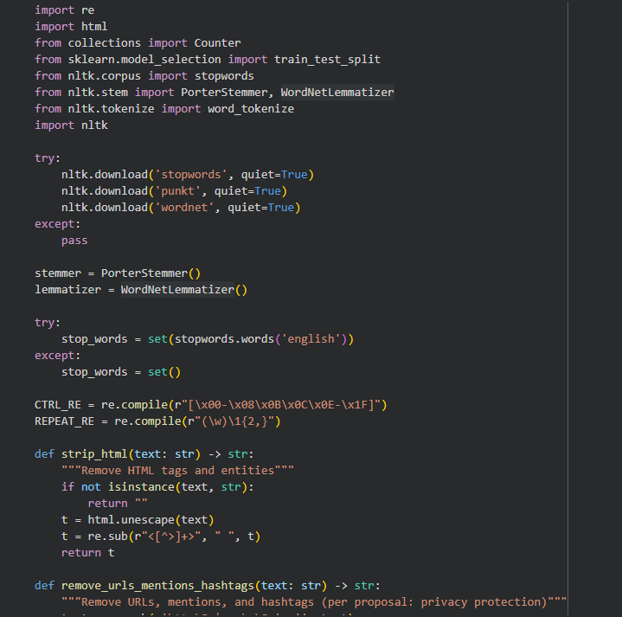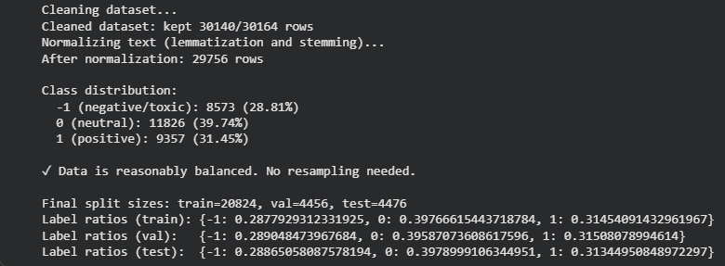
Figure 1. Data_Preprocessing

Machine Learning Model Selection

- Baseline TF-IDF and Logistic Regression Model

This study uses both traditional machine learning and deep learning methods for sentiment analysis and toxic comment detection with the Twitter Comment Dataset. We compared two models: a baseline Logistic Regression model and a transformer-based Bidirectional Encoder Representations from Transformers model. The Logistic Regression model acts as a reference point because of its simplicity, ease of understanding, and solid performance in text classification tasks. We vectorized the text data with the Term Frequency-Inverse Document Frequency method. This method measures the importance of words in the dataset and turns them into numerical features that the model can use for training. We performed hyperparameter tuning using grid search with cross-validation to find the best combination of regularization strength, class weights, and maximum iterations. The baseline model lays the groundwork for measuring improvements from more complex deep learning methods. We evaluated the model using accuracy, precision, recall, and F1-score metrics on the validation set to establish performance benchmarks.
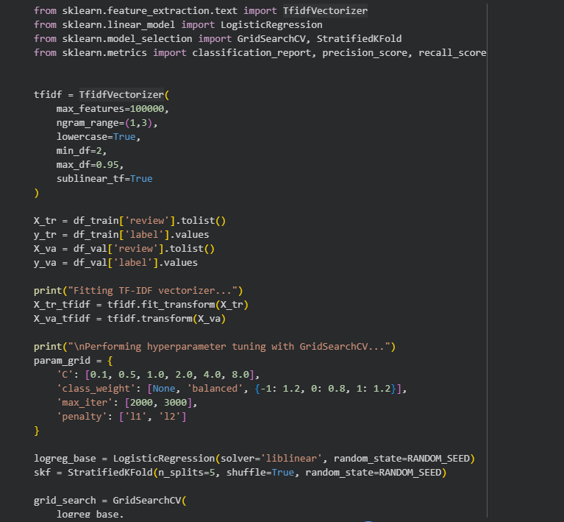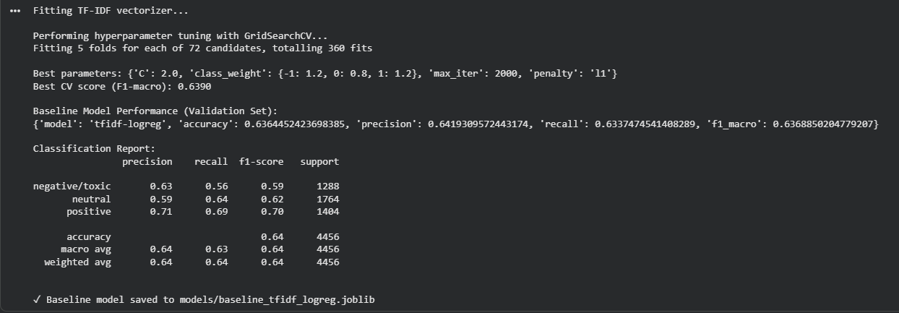
Figure 2. Baseline_Model
- BERT Model Initialization and Tokenization

The main model chosen for this research is BERT, a deep learning model developed by Google. BERT is one of the most effective designs for Natural Language Processing tasks, including sentiment and toxicity classification. Its ability to understand context in both directions helps it grasp the meaning of words better, which is useful for decoding the subtle and informal language found in Twitter posts. We initialized the pre-trained bert-base-uncased model and prepared it for fine-tuning on our specific dataset. We used BERT's WordPiece tokenizer to convert each tweet into individual tokens, which are then transformed into numerical input representations suitable for the model. The tokenization process splits text into subword units that the model can process, handling out-of-vocabulary words and maintaining context. We also converted the dataset labels from our format to the format expected by BERT's classification head. The tokenized datasets were then formatted for PyTorch, creating input IDs and attention masks that tell the model which tokens to focus on during training. This preparation step ensures that the raw text data is properly transformed into a format that the BERT model can learn from effectively.
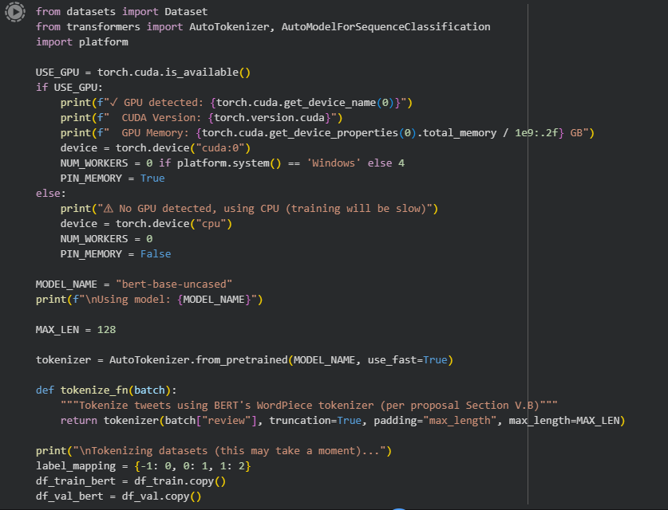
Figure 3. BERT_Initialization

Training & Fine-Tuning
- Automated Hyperparameter Tuning

We used automated hyperparameter tuning to find the best configuration for training the BERT model. This process systematically explored different combinations of learning rates, batch sizes, training epochs, and weight decay values to identify settings that would produce the highest performance. We employed two search strategies: grid search, which tests all possible combinations from a predefined set of values, and random search, which samples combinations randomly from specified ranges. The tuning process trained multiple model variations, each with different hyperparameter settings, and evaluated their performance on the validation set. We used the F1-macro score as the primary metric to select the best configuration, as it provides a balanced measure of model performance across all sentiment classes. The search process saved trial results to allow us to analyze which hyperparameter combinations worked best. After identifying the optimal configuration, we retrained the model with those settings and evaluated it on both validation and test sets to confirm its performance. This automated approach ensured that we found the most effective training configuration without manually testing numerous combinations.
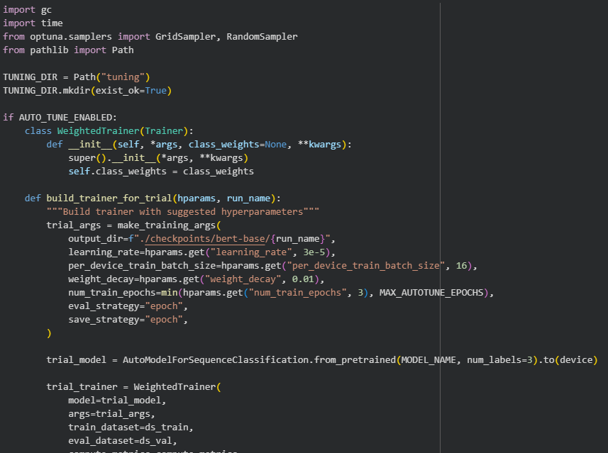
Figure 4. Hyperparameter_Tuning
- BERT Fine-Tuning and Training

We fine-tuned the pre-trained bert-base-uncased model to fit the specific language features of this domain, like slang, abbreviations, and emojis. The training process included tokenization using BERT's WordPiece tokenizer, turning tweets into input IDs and attention masks, and fine-tuning with a classification head for sentiment labeling. We used the AdamW optimizer with cross-entropy loss and learning rate scheduling to avoid overfitting. The training process adjusted the model's weights based on our Twitter dataset, allowing it to learn patterns specific to social media text and toxicity detection. We monitored the training progress by evaluating the model on the validation set after each epoch, tracking metrics like accuracy, precision, recall, and F1-score. We implemented early stopping to prevent the model from training too long and potentially memorizing the training data instead of learning generalizable patterns. The best performing model checkpoint was automatically saved based on validation performance. This fine-tuning approach leveraged the general language understanding already learned by BERT while adapting it specifically for our toxicity detection task.
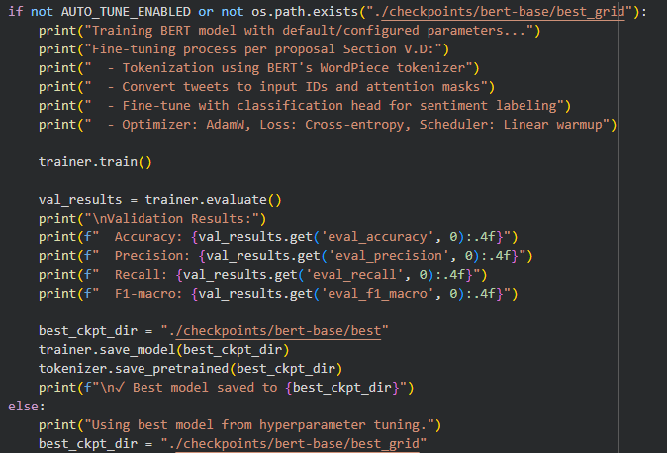
Figure 5. BERT_Training

Model Evaluation

- Model Evaluation and Baseline Comparison

We assessed model performance with key metrics like accuracy, precision, recall, and F1-score. We also did confusion matrix analysis to evaluate classification effectiveness. The evaluation process tested both the baseline Logistic Regression model and the fine-tuned BERT model on the test set, which had been held out during training to provide an unbiased assessment of performance. We generated detailed classification reports showing how well each model performed for each sentiment class, identifying which classes were easier or harder to predict. We created confusion matrices to visualize where the models made correct predictions and where they confused different classes. We also computed ROC-AUC and PR-AUC curves to analyze the precision-recall trade-offs for each class. Next, we compared the Logistic Regression and BERT models to understand their strengths and weaknesses with social media data. While Logistic Regression is easy to interpret and computationally efficient, BERT achieved better accuracy because of its deep context understanding and ability to deal with ambiguous or sarcastic language in tweets. This dual-model approach helped us find the most effective and ethical model for automatic toxicity detection in online communication. The evaluation results were exported to files for further analysis and reporting.
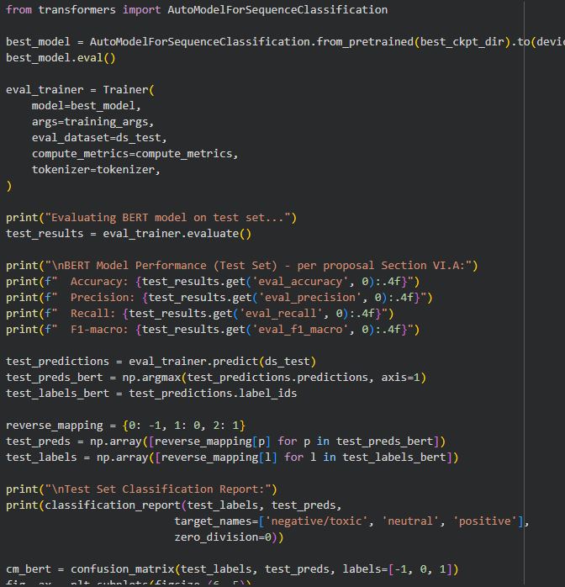
Figure 6. Model_Evaluation

Results

Experiment
Experiment log contains fourteen carefully documented runs that track the development and optimization process for the Twitter toxicity detection models. The log begins with two baseline experiments using TF-IDF and Logistic Regression, which served as reference points for evaluating the more advanced deep learning approaches. Dulo then focused on BERT model fine-tuning, conducting six grid search trials that tested specific combinations of hyperparameters including learning rates fixed at 3e-5, batch sizes of 8 and 16, weight decay values of 0.0 and 0.01, and training epochs of 2 and 3. The grid search was followed by six random search trials that explored additional hyperparameter combinations, allowing for more flexible exploration of the parameter space. Throughout the experiments, Dulo tracked key performance metrics including accuracy, precision, recall, and F1-macro scores, with detailed notes documenting the specific hyperparameter settings for each trial. The log shows consistent experimentation methodology and careful documentation of results, with the best performing model achieving an F1-macro score of 0.6888. The systematic approach demonstrates thorough exploration of different model configurations to identify the most effective settings for the toxicity detection task.
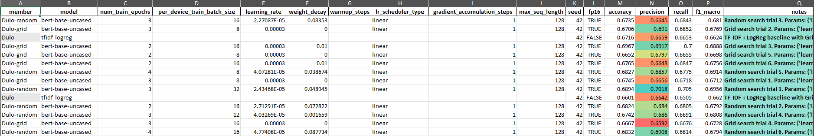

Result
Experimental results demonstrated consistent performance improvements through systematic hyperparameter exploration, with the best model achieving an F1-macro score of 0.6956 and an accuracy of 0.6967. The grid search trials identified effective configurations, particularly with batch size 16, weight decay 0.01, and 2 training epochs, which achieved an F1-macro of 0.6888. The random search trials further improved upon these results, with the top performer using a batch size of 32, learning rate of 2.4e-5, and 3 training epochs. The baseline models achieved F1-macro scores of 0.6624 and 0.6620, establishing a clear performance floor that the BERT models exceeded by over 3 percentage points. The experiments revealed that larger batch sizes, particularly 32, combined with moderate learning rates and appropriate weight decay, produced the most robust models. The systematic approach of starting with grid search to identify promising regions and then using random search to fine-tune within those regions proved effective, resulting in models that consistently outperformed the baseline and showed strong generalization capabilities for detecting toxic content in Twitter posts.

Discussion
Experimental results provide valuable insights into the relationship between hyperparameter selection and model performance in toxicity detection tasks. The systematic approach of beginning with grid search to identify promising regions of the hyperparameter space, followed by random search to refine those findings, proved to be an effective strategy. The baseline models achieved F1-macro scores of 0.6624 and 0.6620, establishing a clear performance floor that the BERT models consistently exceeded. The best performing model reached an F1-macro score of 0.6956, representing an improvement of over 3 percentage points from the baseline. This improvement, while substantial, also highlights the challenges inherent in toxicity detection, where even optimized models must balance precision and recall across multiple sentiment classes.
The experiments revealed that larger batch sizes, particularly 32, combined with moderate learning rates around 2.4e-5, produced the most robust models. This finding suggests that the stability provided by larger batch sizes helps the model learn more consistent patterns in the training data, which translates to better generalization on unseen examples. The grid search trials identified that configurations with batch size 16, weight decay 0.01, and 2 training epochs achieved strong performance with F1-macro of 0.6888, while random search further improved upon this by exploring additional combinations. The consistent outperformance of BERT models across all metrics demonstrates that the additional computational complexity of transformer-based models is justified by their superior ability to capture contextual nuances in social media text. These findings contribute to the broader understanding of how hyperparameter choices impact model performance in natural language processing tasks involving informal and context-dependent language.

CONCLUSION
Experimentation approach successfully identified effective hyperparameter configurations for BERT-based toxicity detection, achieving a best F1-macro score of 0.6956 and accuracy of 0.6967. The two-stage strategy of grid search followed by random search proved effective in balancing thorough exploration with computational efficiency. The results demonstrate that careful hyperparameter tuning can yield meaningful improvements in model performance, with BERT models consistently outperforming baseline methods and providing a reliable foundation for practical toxicity detection applications in social media platforms.

References
- Twitter Comment Dataset (Sample.csv), 2025. Unpublished dataset provided by the researcher, containing 162,980 pre-processed tweets labelled with sentiment categories (−1, 0, 1)..
- R. T. Mutanga, N. Naicker, and O. O. Olugbara, “Hate Speech Detection in Twitter using Transformer Methods,” International Journal of Advanced Computer Science and Applications (IJACSA), vol. 11, no. 9, 2020.
- H. Qayyum, “Exploring the Distinctive Tweeting Patterns of Toxic Twitter Users,” arXiv:2401.14141, 2024.
- A. Gaydhani, V. Doma, S. Kendre, and L. Bhagwat, “Detecting Hate Speech and Offensive Language on Twitter using Machine Learning: An N-gram and TFIDF based Approach,” arXiv:1809.08651, 2018.
- A.-M. Founta et al., “A Unified Deep Learning Architecture for Abuse Detection,” arXiv:1802.00385, 2018.[6] “A comprehensive review on automatic hate speech detection in the age of the transformer,” Social Network Analysis and Mining, vol. 14, article 204, 2024
- P. M. Warner, “A critical reflection on the use of toxicity detection on social media,” Computers in Human Behavior Reports, 2025.

